Function

**Function Call by value and Call by reference**

Actual Parameters: Parameters passed to a function

Formal Parameters: Parameters received by a function.

add(m,n) : Actual Parameters

int add(int a, int b): Formal Parameters

**Call by Value:**

Here values of actual parameters will be copied to formal parameters and two different parameters store values in different locations.

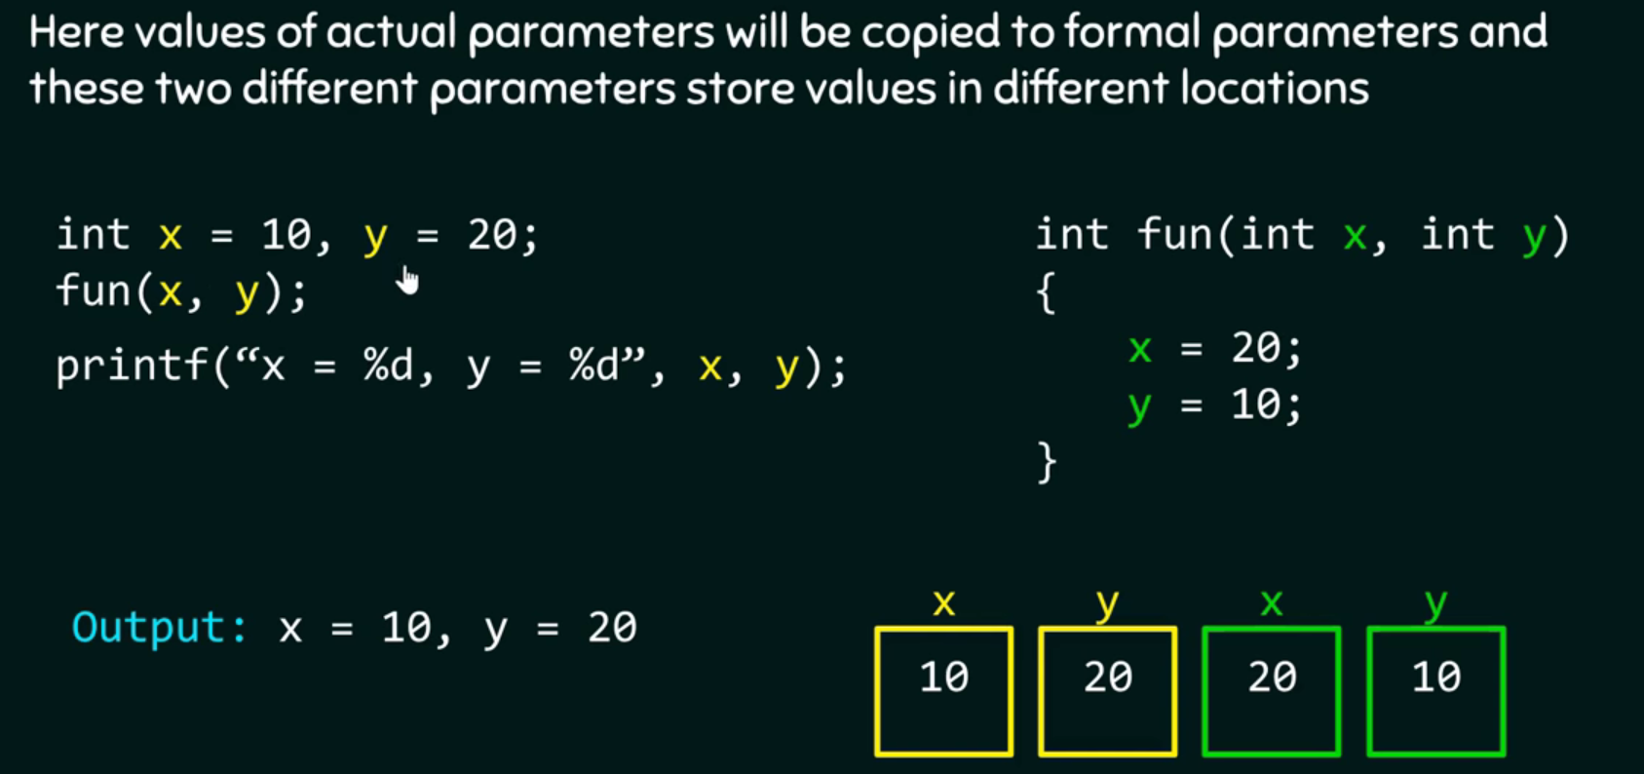

**Call by Reference:**

Here values of actual and formal parameters points to a same locations. Therefore any changes made to formal parameters are also reflected to actual parameters.

