Lakshay Seth

NE 255

Homework 3

**Problem 1:** Attached in the end of this document.

**Problem 2:**

a) Attached in the end of this document.

b) Attached in the end of this document.

c) Quadrature are defined by directional cosines µl and their weight w. Order of the quadrature n specifies number of µ levels in [-1,1] interval. Because of quadrature being symmetric, finding values of the angles in half the range is sufficient. Hence number of µ levels is n/2. Also sum of all w in an octant is 1, since there are 8 octants in a sphere, w for the whole sphere is 8. Evaluated S4, S6, S8, S10, S12 and all of them came out to be 4π. This makes sense, as all the µ are unit vectors on the sphere.,

**Problem 3:**

1. Diffusion equation gives only ϕ as a solution and removes the angle dependence meaning the rates will only depend on scalar flux. When deriving the assumptions made that are made are: azimuthally symmetric, scattering is linearly anisotropic, angular flux is at most linearly anisotropic. To increase accuracy diffusion theory has discretized and homogenized space, discretized energy (few-group).

Deterministic method discretizes all independent variables, which obtain equation and then solve the using a numerical method. These solutions include truncation errors. Increase accuracy in deterministic methods requires discretized space, direction, and energy.

Monte Carlo methods require huge number of samples. In this method physics of every interaction of every particle is sampled until something statistically valid can be presented. In order to increase accuracy and runtime Monte Carlo methods need to have: continuous spatial resolution, continuous direction and energy representation.

1. Deterministic methods are used by discretizing all variables, then solving the resulting equations which yield a solution with truncation errors. Deterministic methods require selecting grids for all independent variables. Commonly, this is easier than choosing parameters for Monte Carlo problems. Another advantage of deterministic method is that they are fast and solution is of same quality everywhere.

Disadvantages of deterministic method are that they are memory intensive, and difficult to parallelize on CPU. They are constrained by what you can mesh and as mentioned above solutions contain truncation errors. Lastly, solution qualities are governed by variable discretization.

**Problem 4:**

1. Plots:

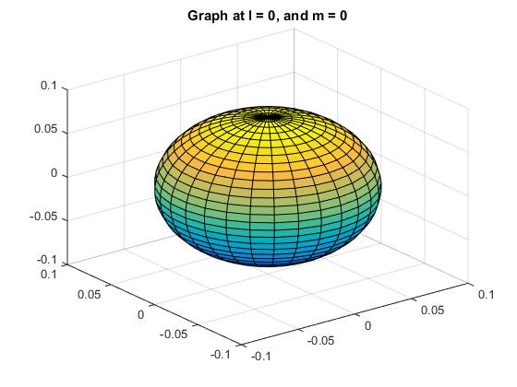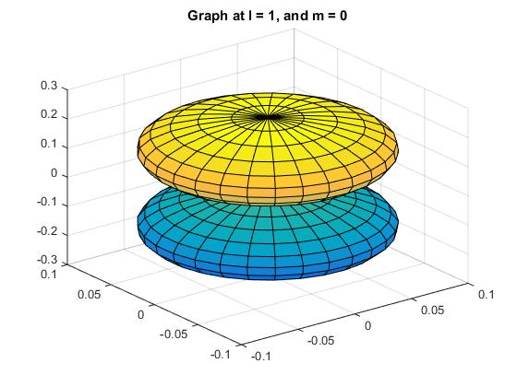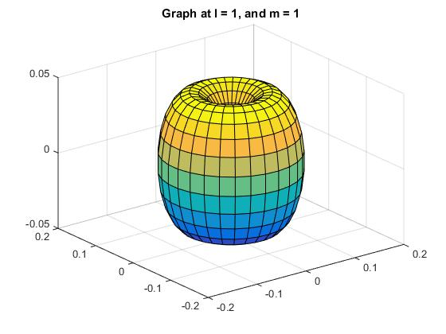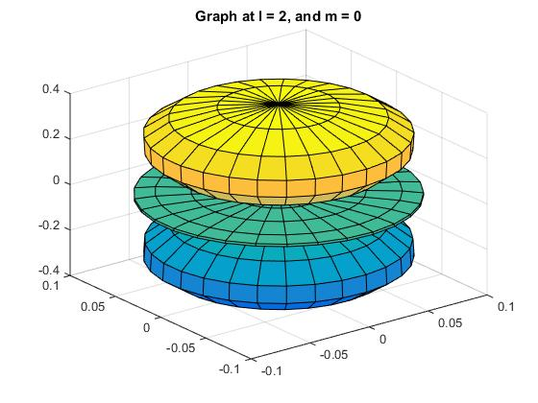

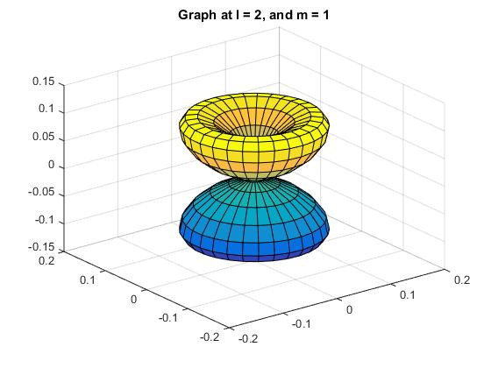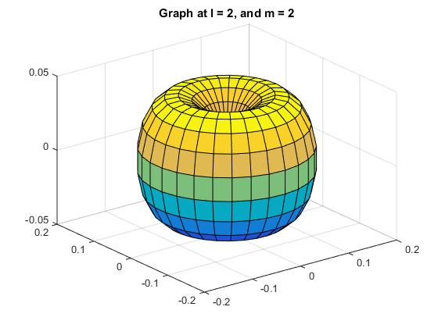

1. L = 0:

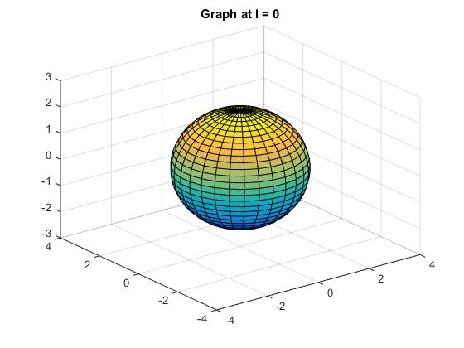

L = 1:

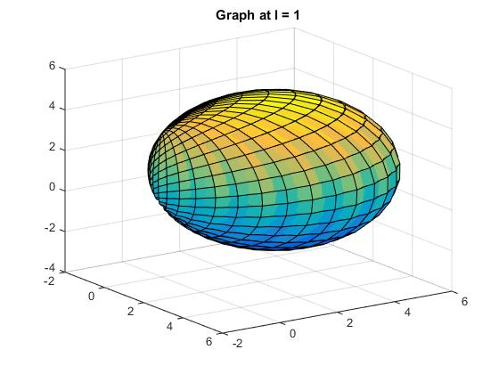

L = 2:

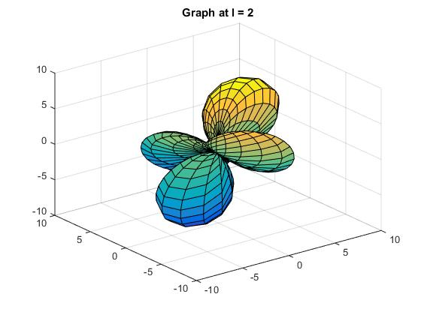

**Problem 5:**

List of major data libraries and countries that manage them:

|  |  |  |
| --- | --- | --- |
| *Acronym* | *Name* | *Country/Agency* |
| ENDF | Evaluated Nuclear Data File | US and Canada |
| JEFF | Joint Evaluated Fission and Fusion File | Nuclear Energy Agency |
| JENDL | Japanese Evaluated Nuclear Data | Japan |
| CENDL | China Evaluated Nuclear Data Library | China |
| BROND | Library of Recommended Evaluated Neutron Data | Russia |