  School of Computing and Information Technology | Project 2  ISCG6420 IWD  Semester 1, 2019 | 1
Create an Interactive Application.
Total Marks 100
Course Weighting 50%
Check Point: 9 May 2019
Due: 8.30am on Friday,
May 30, 2019

Learning outcomes:
1. Explain and apply the fundamentals of CSS (Cascading Style Sheets).
2. Explain and apply the fundamentals of JavaScript.
3. Use current client-side website development languages/technologies create a complex commercial or educational website.
4. Use the features of Web/Multimedia authoring packages to create a complex commercial or educational website with effective navigational interface.

Project instructions:
- You will work in pairs to create a website in your designated dochyper space.
- Project consist of two parts
Part 1 – Create an online booking system for Cinema
Part 2 – Create interactive game for children
- You will present your part 1 and 2 of the project to the class. There are total 10 marks for presentation. Each pair will have 15 minutes to present their work.
- Your project homepage should include links to both parts. The example of project homepage layout is given below:

Example:

Hari Whakangahau Cinema

Book Movie
Play Game
Documentation Part1
Documentation Part2
Content

Project submission instructions:
- Your Project 2 web site is due by 8.30am on Thursday, May 30, 2019.
  - Please put all your files in one folder. In the folder also include a signed cover sheet, this sheet includes declaration that “this submission is my own work, except where clearly referenced”.
  - re-name the folder with this format - example project2_FirstStudentName_ID_ SecondStudentName_ID.
  - ZIP this folder - using zip program. (DON'T use 7_zip. Don’t use rar!)
  - Upload on Moodle link “Submission for Project 2”.
  - Don’t put your project 2 on dochyper yet.
- PLEASE put your solution on Dochyper on 2 June 2019
- A copy of your submission will be kept by School of Computing and Information Technology for future reference and audit purposes.

Part 1 –Online seat reservation system for cinema [40 marks]

You will develop an online booking system for Hari Whakangahau Cinema, using XML as external storage. This Cinema has 2 screening room. Each room screens only one movie for a week or a month.

- Provide documentation for your application. Make the document link available on landing page.
- Consider the following criteria given below while developing an online booking system:
- User should be able to select a date, time and cinema room (minimum two different movie sessions per day for each cinema room). Layout of each room is given below.
- Load cinema room settings from XML files.
- Populate each room layout dynamically on the webpage. When populating each room layout consider the following:
  - User must be able to dynamically see row number, seat number and cost
  - Already booked seats clearly indicated in your layout and user should not be able to select them for booking.
  - Seats from different rows must have different price range. Seats price for first two rows is $20, for next three rows it is $23, and rest of the rows are $25.
- If user wants to change their booking selection they system should be able to update dynamically.
- On user conformation the booking system should calculate price of dynamically. User should be able to see summary for booking with date, time, name of cinema room, seats numbers, cost for each seat and total cost
- After booking conformation is done seats should be unavailable. User should be able view the fully summary of their booking.

Cinema Puru room layout

Cinema Whero room layout

Part 2 –Interactive online game [40 Mark]

You will design and develop an interactive online game for young children using HTML5 elements including Canvas.

Game story:
The game has an animated character (let’s call it Mr K for now) who will collect apples falling from tree. Mr K can be a person, or an animal or imaginary character. Mr K’s task is to collect apples in the basket. Every apple collected in the basket will get a score of one. If an apple falls on Mr K’s head, then a score will be deducted by one.

The story board for the game is as follows:

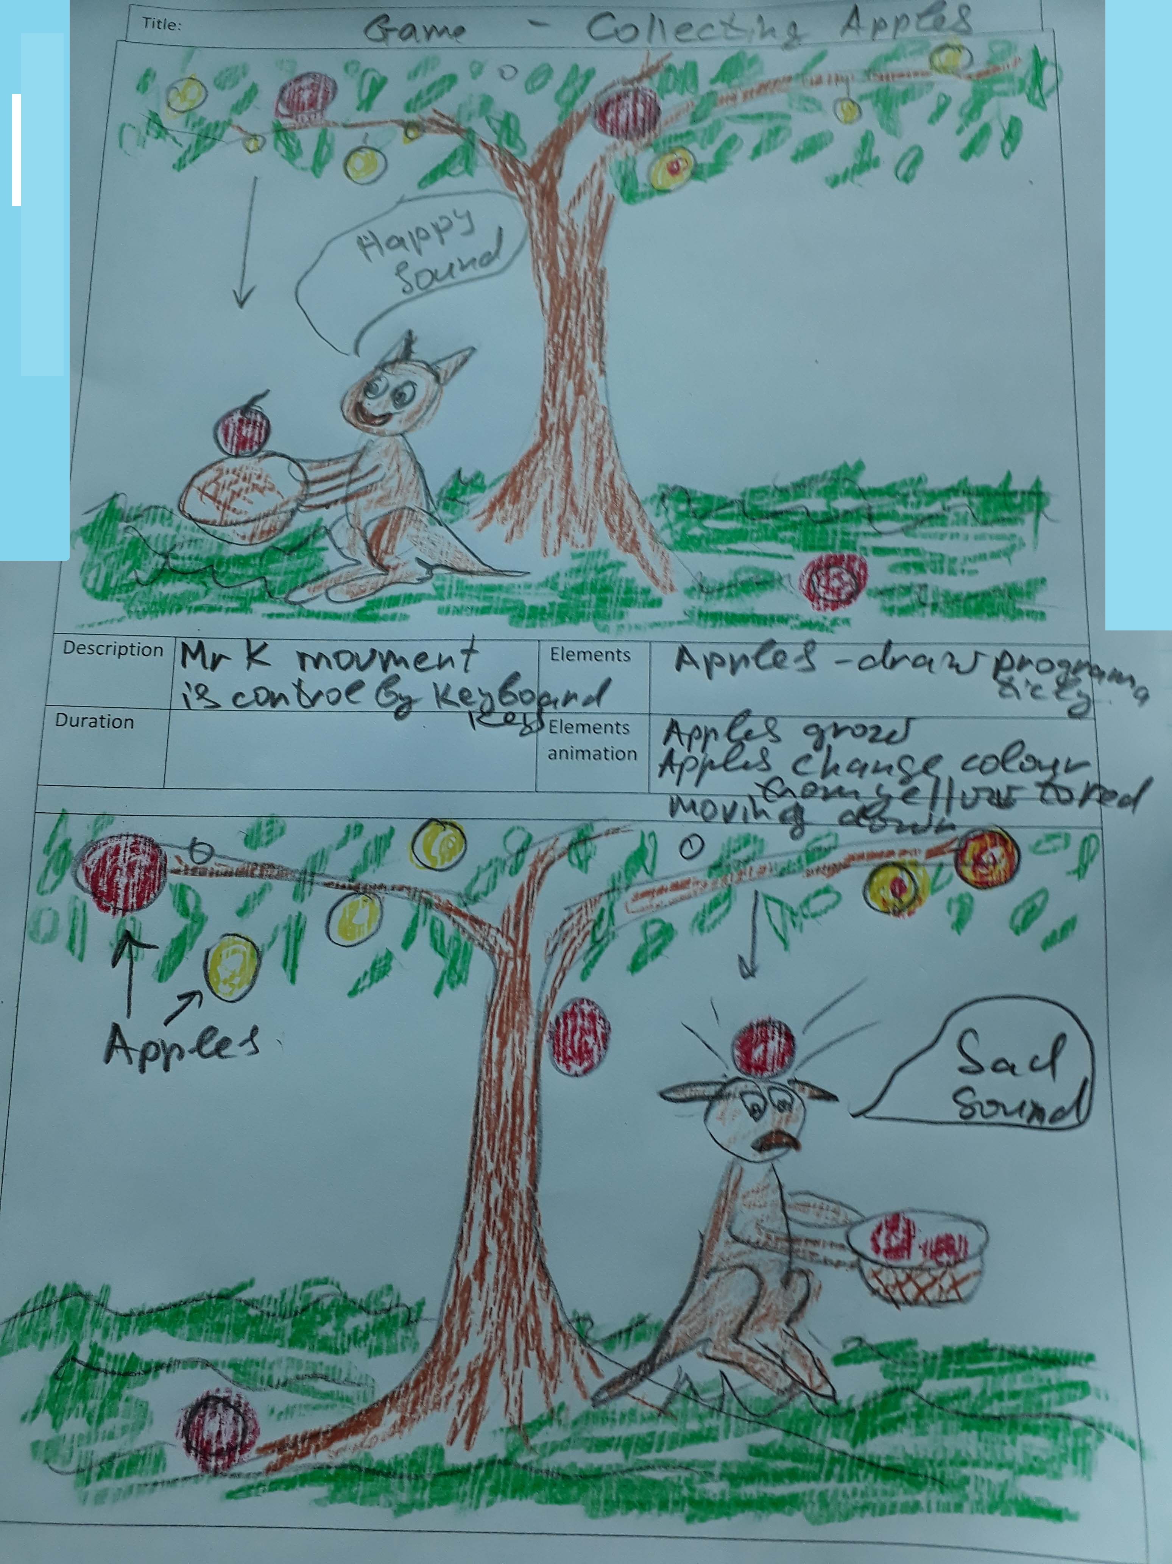

Game development requirements:

Character (Mr K):
- Mr K’s movement is controlled by using the keyboard arrow keys (up, down, left, right). It also needs additional key to turn the basket (for example- blank space).
- Mr K’s direction changes, when Mr K moves left or right. Each time Mr K changes direction the basket should be in front of Mr K.
- Mr K’s movement is restricted inside the canvas.
- Mr K’s head should always stay under the tree branches.
- Every time Mr K successfully catches an apple, a score of one is added to the current score and a ‘happy’ sound is played. However, if an apple falls on Mr K’s head, an ‘unhappy’ sound will be played and current score will be deducted by one.
- Define and implement Mr K’s animation (leg’s movement, tail movement, eyes movement)

Each apple has a life cycle which is described below:
Stage 1: a small yellow apple with a radius = 5px will appear randomly on the tree.
Stage 2: growing time for each apple is 5 seconds. Each apple grows to size of radius = 25px
Stage 3: apple’s colour changes gradually from yellow to red in a duration of 4 seconds. Use radial gradient in diagonal direction for the colour change.
Stage 4: Each red apple will stay on the tree for a duration of 3 seconds and will then fall down.
Stage 5: falling time for each apple is 6 sec.
Stage 6: apple falls and stays on the ground if Mr K is unable to catch it. Or if it falls on the head of Mr K it should disappear or if Mr K catches an apple, it should be displayed in the basket.

Additional requirements for the game:
- Minimum 4 different sounds in the game (like two different collision beeps, start and end game sounds) and users should be able to control the volume of the sounds.
- Provide feedback with appropriate text messages and sound to the player. For example, a mechanism to display the score to the player or text message in the end of game.
- Time settings which can be changed by player. Default time setting for duration of game is 5 minutes. Other possible value for the duration of the game is 1, 3 and 7 minutes.
- Start button and restart button.
- Overall design and complexity of scenery – background.
- Provide documentation for your application. Make the document link available on landing page.

Part 3 – Individual Task 20%

The grading for this component is weighted depending on how you performed in your homework tasks submitted on time, 10% contribution to the course grade will be taken for each homework’s across all IWD course; 10 homework - 10 marks; each mark is 2%.
Each homework task must be done by required day and any delay up to 3 days will be result in 50%-mark deduction, all other delay is 0% marks.

Marking Guide
Marks for your work will be given according to the following marking schedule:
No | Item | Criteria | Marks
 | Part 1
 | Provide documentation for your application.  (5 marks)  - XML data design  - User booking design page  - Link on the landing page | 5 marks = both the design are in Pdf format and link(s) to the landing page is working. Clear explanation of presented data for XML data dictionary and wireframe provided for User booking design page, which has all details required for booking.  2-4 marks = one or two details in documents are missing or link(s) not working or quality of documentation is not up to standard.  1 mark = one of the document is submitted with number of errors, second document is not submitted.
 | User should be able to select a date, time and cinema room (minimum two different movie sessions per day for each cinema room)  (3 marks) | 3 marks = all three input elements correctly used to develop desired functionality.  2 marks = as above with minor problems. Or one input element missing completely.  1 mark = minimum one element working
 | Load cinema room settings from XML files. (4 marks)  - XML files are defined and linked in the code.  - java-script reading from XML files.  - Class for seat is defined.  - Array of instances for each seat are populated dynamically. | 4 marks = all the criteria are met.  2-4 marks = one or two minor details are missing  1 mark = number of details are missing  0 = hard coded values for seat array
 | Populate each room layout dynamically on the webpage. Layout for each room is correct as per requirements. (10 marks)  - User must be able to dynamically see row number, seat number and cost  - Already booked seats clearly indicated in your layout and user should not be able to select them for booking.  - Seats from different rows must have different price range. Seats price for first two rows is $20, for next three rows it is $23, and rest of the rows are $25. | Total 5 marks = for each room layout  For each room layout  5 marks = all criteria are met.  2- 4 marks = up to three minor functionally not working based on the requirements.  1-2 marks = more than three of functionally not working based on the requirements
 | If user wants to change their booking selection they system should be able to update dynamically. (3 marks) | 3 marks = booking price is correctly calculated by the system based on the user selection.  1-2 marks – some error(s)
 | On user conformation the booking system should calculate price of dynamically. User should be able to see summary for booking with date, time, name of cinema room, seats numbers, cost for each seat and total cost  (6 marks) | 6 marks = booking price is correctly calculated by the system based on the user interaction. User can see a correct summary for his booking  2-5 marks = booking price is correctly calculated by the system based on the user selection. User can see a summary but some or number of details are missing.  1 marks = only total is provided and other details are missing
 | After booking conformation is done seats should be unavailable. (4 marks) | 4 marks = criteria are met.  2-3 mark if minor error in implementation. Like seats booked for all week.
 | Part 2
 | Mr K’s movement is controlled by using the keyboard arrow keys (up, down, left, right).  (10 marks)  - It also needs additional key to turn the basket (for example- blank space).  - Mr K’s direction changes, when Mr K moves left or right. Each time Mr K changes direction the basket should be in front of Mr K.  - Mr K’s movement is restricted inside the canvas.  - Mr K’s head should always stay under the tree branches.  - Every time Mr K successfully catches an apple, a score of one is added to the current score and a ‘happy’ sound is played. | 10 marks =All criteria are met.  8-9 marks =All criteria are met with minor error or errors in implementation. For example: Mr K can run out of one side of canvas.  5-8 marks =Most criteria are met with a few errors in implementation.  2-4 marks =Some criteria are met with a number of errors in implementation.  1 marks = A number of problems in program only a few things work with minor error.
 | However, if an apple falls on Mr K’s head, an ‘unhappy’ sound will be played and current score will be deducted by one.  (12 marks)  Stage 1: a small yellow apple with a radius = 5px will appear randomly on the tree.  Stage 2: growing time for each apple is 5 seconds. Each apple grows to size of radius = 25px  Stage 3: apple’s colour changes gradually from yellow to red in a duration of 4 seconds. Use radial gradient in diagonal direction for the colour change.  then fall down  Stage 4: Each red apple will stay on the tree for a duration of 3 seconds and will then fall down.  Stage 5: falling time for each apple is 6 sec.  Stage 6: apple falls and stays on the ground if Mr K is unable to catch it. Or if it falls on the head of Mr K it should disappear Or if Mr K catches an apple, it should be displayed in the basket. | 12 marks = Apple’s life cycle met all criteria described.  9-11 marks = Apple’s life cycle met all criteria described with some minor error or errors in one or two apple’s stage.  5-8 marks =Most criteria are met with one of stages missing and some minor error in other apple’s stage implementation.  .  2-4 marks =Only some criteria are met with a number of errors in implementation.  1 marks = A number of problems in apples stage’s.
 | Additional criteria for the game: (10 mark)  - Minimum 4 different sounds in the game (like two different collision beeps, start and end game sounds) and users should be able to control the volume of the sounds.  - Provide feedback with appropriate text messages and sound to the player. For example, a mechanism to display the score to the player or text message in the end of game.  - Time settings which can be changed by player. Default time setting for duration of game is 5 minutes. Other possible value for the duration of the game is 1, 3 and 7 minutes  - Start button and restart button.  - Overall design and complexity of scenery – background. | 10= all additional game’s criteria are met.  7-9=if one or two additional criteria are missing and/or functionality work partly  2-6 = if more than 2 additional criteria are missing  1 = only one additional criteria implemented with some minor error.
 | Additional criteria for the game:  Provide documentation for your application.  (4 mark)  - Your own game storyboard  - Testing (Test Cases) | 4 marks = both the design are in Pdf format and link(s) to the landing page is working.  2-4 marks = one or two details in documents are missing or link(s) not working or quality of documentation is not up to standard.  1 mark = one of the document is submitted with number of errors, second document is not submitted.
 | Presentation (10 mark) | Lecturer will use oral presentation marking sheet.
Check Point: Complete
Part 1 – 1, 2,3 Plus one cinema layout must be displayed correctly
Part 2 -1(1.1-1.4), 2(1.2-1.2) 3 (3.3 and 3,4) plus storyboard
 | Total marks

Rules for Late Submission of Assignments
a. The due dates of assessment work will be notified in course information.
b. Assignments submitted after the due date and time without having received an extension through Special Assessment Circumstances (SAC) will be penalised according to the following:
• 10% of marks deducted if submitted within 24hrs of the deadline
• 20% of marks deducted if submitted after 24hrs and up to 48hrs of the deadline
• 30% of marks deducted if submitted after 48hrs and up to 72hrs of the deadline
• No grade will be awarded for an assignment that is submitted later than 72hrs after the deadline.

c. Students submitting assignments after the due date and time will be ineligible to resubmit a failed assignment.

Special Assessment Circumstances – Process
1)
In the first instance, the Student shall complete the approved form to apply for consideration of affected performance and submit the application to Student Central. Except in exceptional circumstances this must be no later than 5 working days after the due date of the Summative Assessment, and with appropriate documentary evidence of both the circumstances and the effect on performance. Except in exceptional circumstances appropriate documentary evidence such as a medical certificate must be dated within 24 hours or one working day of the due time of that Assessment item.

https://ds.unitec.ac.nz/dsweb/Get/Document-632

Academic Misconduct
Cheating and Plagiarism are considered Academic Dishonesty and will be dealt with under the provisions of the Student Disciplinary Statute.

Do you want to do the best that you can do on this assignment and improve your grades?
You could:
• Talk it over with your lecturer
• Visit Te Tari Awhina or Maia for learning advice and support
• Visit the Centre for Pacific Development and Support
• Contact the USU Advocate for independent advice
• For contact details and more information, go to www.usu.co.nz

