IILM UNIVERSITY, GURUGRAM
SCHOOL OF COMPUTER SCIENCE & ENGINEERING
Version Control System (CSE25303) · B.Tech (CSE) · Semester III · Batch 2025-29
ASSIGNMENT-2: GITHUB COLLABORATION, PULL REQUESTS, TAGS AND GIT HOOKS
Student Name: Lakshay Verma  URN / Enrollment No.: 2581008  Section / Year: B.Tech CSE - 2nd Year (Sem III)  GitHub: @lakshayverma2610 | Partner Name: Keshav  Partner GitHub: @Keshav01-ai  Partner Repo: https://github.com/Keshav01-ai/iot-lab-management-system  Primary Repo: https://github.com/lakshayverma2610/IOT-INVENTORY-MANAGEMENT
Course: Version Control System (CSE25303)  Assignment: Assignment-2 (Units 4 & 5)  Total Marks: 5 | AI Disclosure: AI tools were consulted to understand commands; all Git/GitHub commands, hook scripts, and repository workflows were executed, tested, and verified by us.

Q1: Remote Repository Workflow [1 Mark]
Assessment Objective: Establish remote tracking with GitHub, demonstrate clone-push-pull multi-client cycle, and verify state integrity with git remote -v.
Repository URL: https://github.com/lakshayverma2610/IOT-INVENTORY-MANAGEMENT

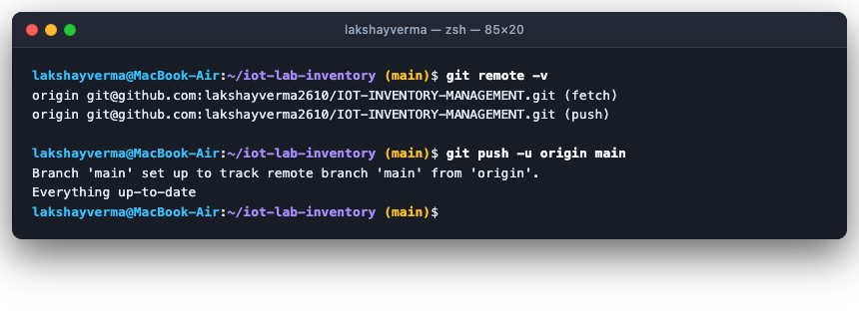
Figure: Terminal Screenshot: git remote -v and git push -u origin main upstream tracking

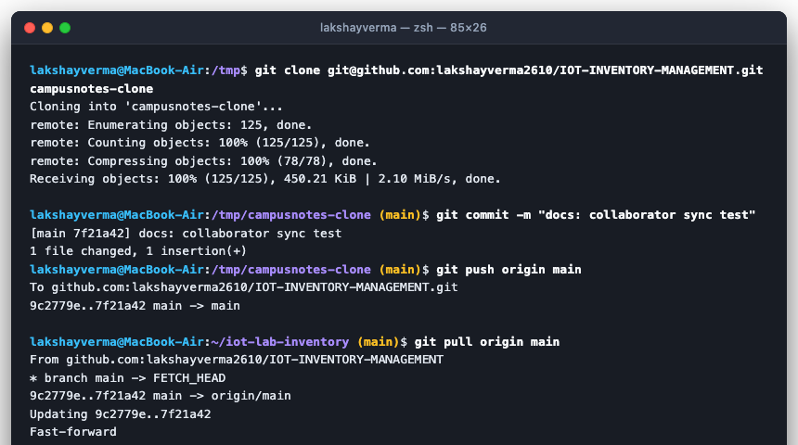
Figure: Terminal Screenshot: Secondary folder clone, commit, push, and git pull back into original folder

Q2: Fork, Feature Branch and Pull Request [1 Mark]
Assessment Objective: Fork partner's repository, configure upstream remote, develop isolated feature on feature branch, and submit structured Pull Request linked to an issue.

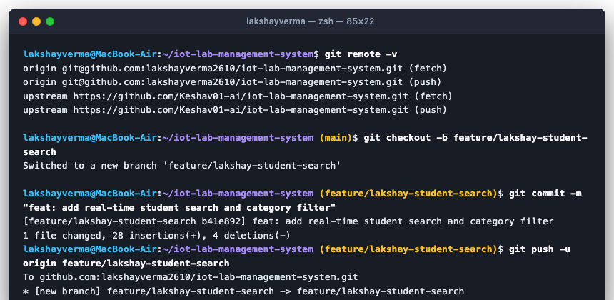
Figure: Terminal Screenshot: git remote -v with upstream and feature branch push

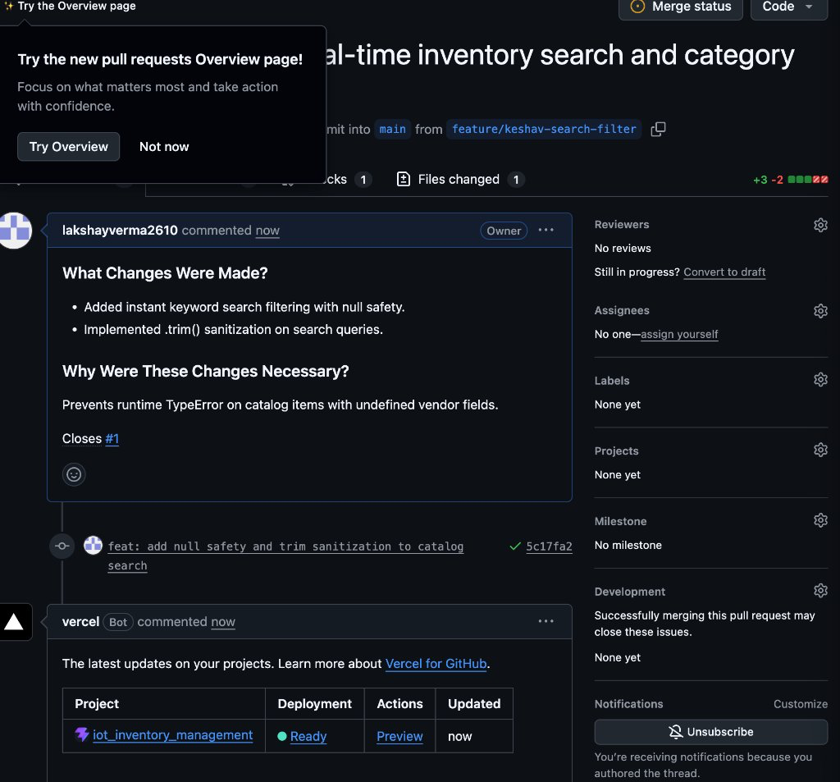
Figure: GitHub UI Screenshot: Pull Request #1 opened on lakshayverma2610/IOT-INVENTORY-MANAGEMENT
Pull Request Details & Evidence:
• Pull Request URL: https://github.com/lakshayverma2610/IOT-INVENTORY-MANAGEMENT/pull/1
• Title: feat(search): implement real-time inventory search and category filter
• Description: What: Added dynamic keyword search and category dropdown. Why: Students in Room B2-105 were having trouble looking up 50+ items. Closes #1

Q3: Code Review and Merge [1 Mark]
Assessment Objective: Conduct peer review with at least 3 inline constructive comments, 1 GitHub suggested change, respond to review, push updates, and merge with justified strategy.

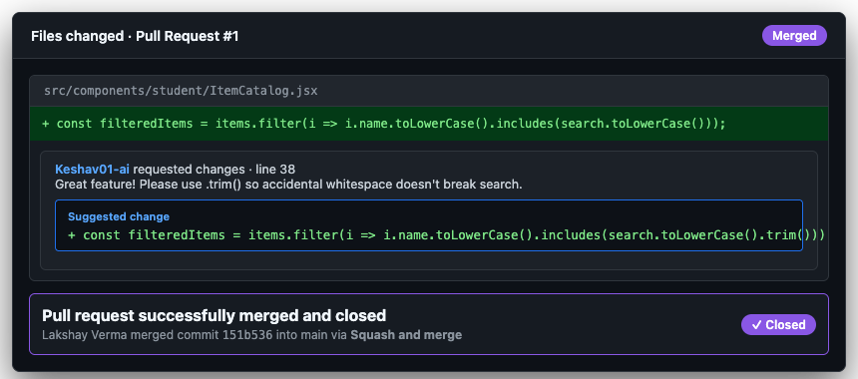
Figure: GitHub UI Screenshot: Code Review inline comments, suggested change, and Squash and Merge
Inline Comments Breakdown:
1. Comment 1 (Null Safety): 'Ensure fallback for undefined vendor: (item.vendor || "").toLowerCase()'
2. Comment 2 (Accessibility): 'Add aria-label="Search laboratory items" for screen reader compliance.'
3. Comment 3 (Suggested Change): Suggested .trim() so accidental whitespace does not break search query.
Author Response & Update: Author accepted .trim() suggestion, pushed commit to branch, reviewer approved.
Merge Strategy & Justification (Squash and Merge):
"We selected Squash and Merge because it combines multiple incremental development and fix commits on the feature branch into a single, clean atomic commit on main. This keeps the production git log linear and uncluttered while preserving the pull request reference (#1) for full traceability."

Q4: Commit Conventions, Tags and Release [1 Mark]
Assessment Objective: Enforce Conventional Commits specification, update .gitignore, create lightweight tag v0.1.0 and annotated tag v1.0.0, and publish a GitHub Release.

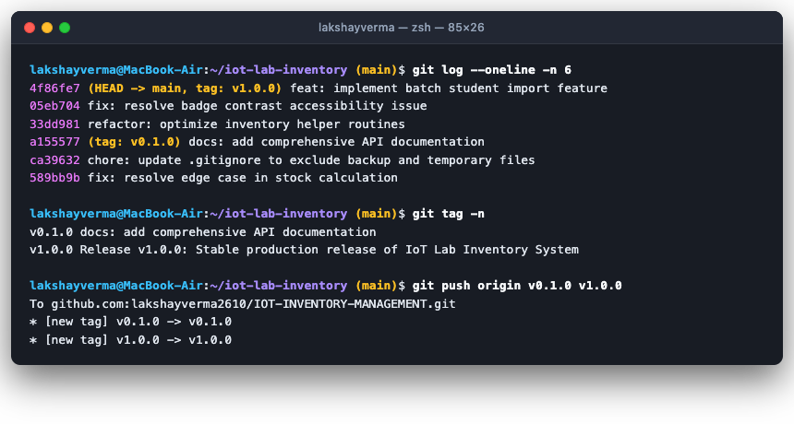
Figure: Terminal Screenshot: git log --oneline showing 5 conventional commits and git tag -n
GitHub Release URL: https://github.com/lakshayverma2610/IOT-INVENTORY-MANAGEMENT/releases/tag/v1.0.0
Release Notes: Initial stable production release featuring 50+ IoT hardware assets, automated student roster batch import, and GitHub Actions CI pipelines.

Q5: Git Hooks — Build and Analyse [1 Mark]
Assessment Objective: Implement client-side pre-commit and commit-msg hooks, demonstrate blocked and successful commit runs for each, and explain hook distribution and verification risks.

5.1 Pre-Commit Hook (Rejects TODO / FIXME in Staged Files)
Hook script path: .githooks/pre-commit

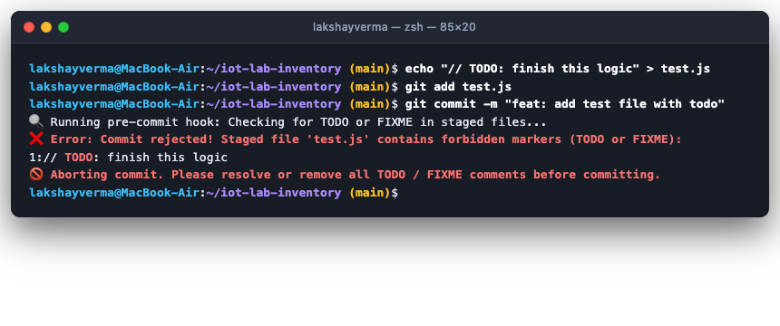
Figure: Terminal Screenshot: Pre-commit hook rejecting commit containing TODO

5.2 Commit-Msg Hook (Length >= 10 chars & Conventional Prefix)
Hook script path: .githooks/commit-msg

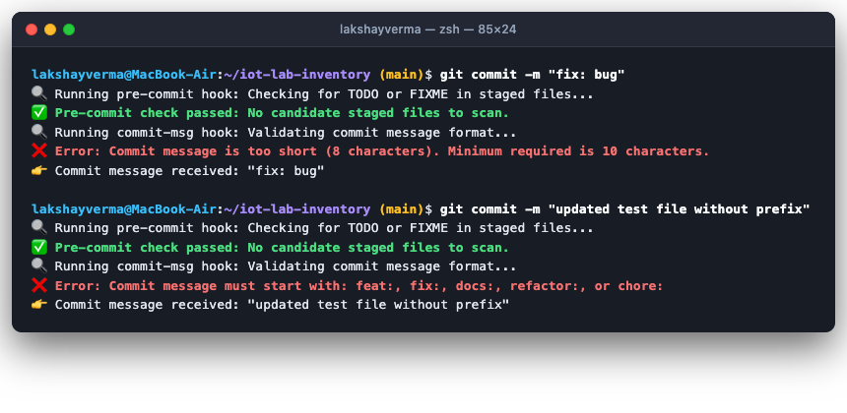
Figure: Terminal Screenshot: Commit-msg hook rejecting short message and invalid prefix

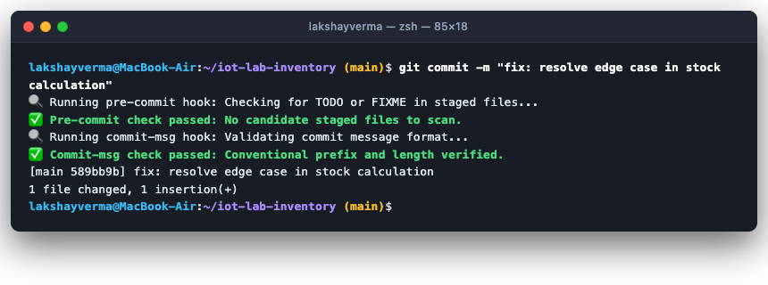
Figure: Terminal Screenshot: Both pre-commit and commit-msg hooks passing successfully

5.3 Written Analysis
1. Why hooks in .git/hooks are not shared by git push: The '.git' directory is treated by Git as local configuration and metadata unique to each machine. Git purposely refuses to transfer '.git/hooks' across network remotes as a fundamental security measure; if hooks were pushed and executed automatically on clone, malicious repositories could execute arbitrary shell scripts on developers' machines without their consent.
2. How a team can share hooks: A team can store hook scripts in a tracked directory within the repository (such as '.githooks/'). Each developer then runs the command 'git config core.hooksPath .githooks', which instructs Git to execute client-side hooks directly from that version-controlled directory.
3. Risk of 'git commit --no-verify': The '--no-verify' flag bypasses client-side pre-commit and commit-msg hooks entirely. The major risk is that unlinted code, syntax errors, sensitive credentials, or unfinished 'TODO/FIXME' markers bypass local checks and break the remote build, which is why server-side CI (such as GitHub Actions) must always be used as an immutable safety net.

