ConnectHub – Contact Manager Backend Application

- Project Overview
ConnectHub is a backend web application designed to solve the common problem of scattered contact information across multiple platforms. It provides users with a centralized and organized system to store, search, and categorize their professional and personal contacts.

The application focuses on secure user authentication, efficient contact management, and fast search capabilities. By using modern backend technologies such as Node.js, Express.js, and MongoDB, ConnectHub provides a scalable and reliable contact management solution.

- Key Objectives
  - Provide secure user authentication and data isolation
  - Enable efficient contact management through CRUD operations
  - Implement flexible categorization using tags
  - Offer fast search and filtering capabilities
  - Deliver a responsive, cross-device user experience

- Target Users
  - Freelancers and consultants managing client relationships
  - Small business owners tracking vendor and customer contacts
  - Students and young professionals building their network
  - Event organizers managing attendee and volunteer information
  - Anyone seeking a simple and privacy-focused contact management solution

- Project Instruction
Step 1: Install Node.js
- Download and install Node.js from:
[https://nodejs.org/](https://nodejs.org/
- Verify installation using:
node -v
npm -v
Step 2: Create Backend Project Folder
1. Choose a directory where you want to create the backend project.
2. Open terminal or command prompt.
3. Navigate to the folder.
Step 3: Initialize Node Project
Run the following command:
npm init -y
This creates a **package.json** file for managing project dependencies.
Step 4: Install Required Dependencies
Install Express:
npm install express
Install MongoDB library:
npm install mongoose
Install development dependency:
npm install nodemon --save-dev
Step 5: Create Basic Server File
Inside the server folder create:
server.js
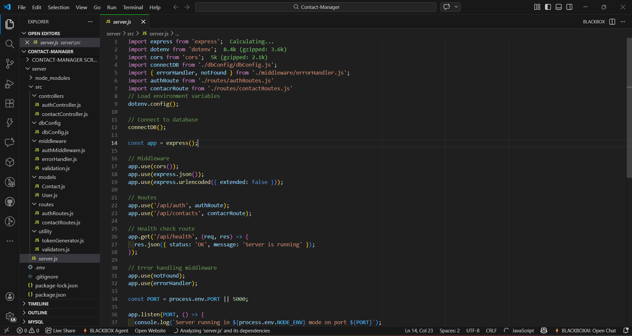
Step 6: Enable ES Modules
Open package.json and add:
"type": "module"
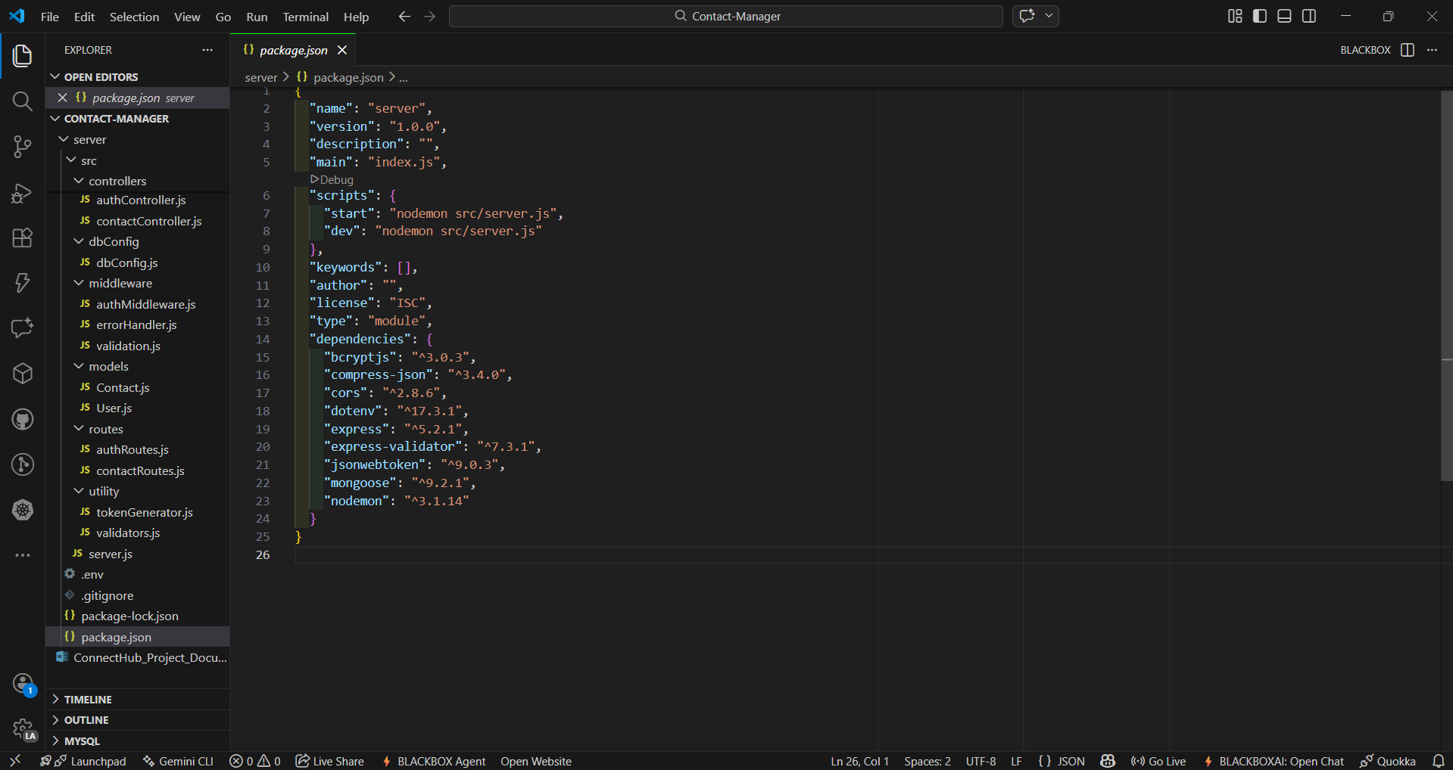
Step 7: Start the Backend Server
Run:
npm run dev
or
node server.js
Step 8: Open in Browser
Open: http://localhost:5000
Output: Backend is running

PRE-REQUISITES

Software Requirements
Software | Purpose
Node.js | JavaScript runtime for backend
MongoDB | NoSQL database for data storage
npm | Package manager
Git | Version control
Code Editor | VS Code / WebStorm

Knowledge Requirements
- JavaScript ES6+ syntax and concepts
- Node.js and Express.js for REST API development
- MongoDB and Mongoose ODM
- JWT authentication and bcrypt password hashing
- Git version control workflow

- Project Architecture

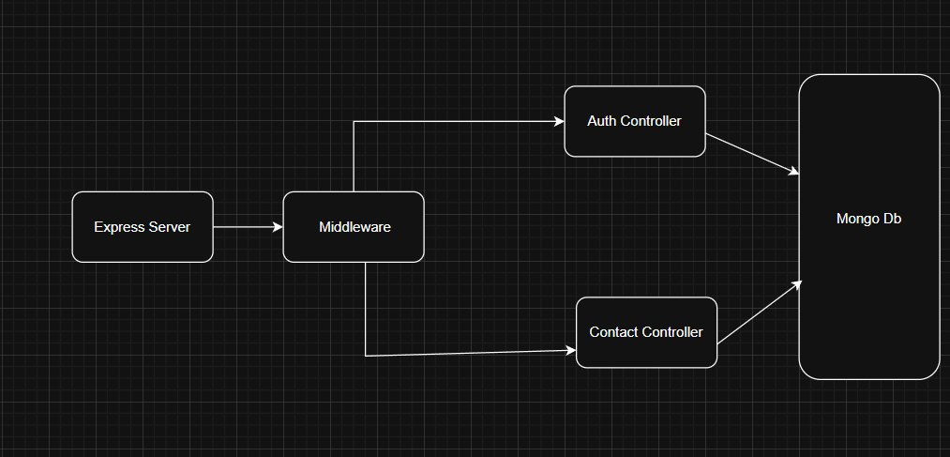
The application follows a three-tier backend architecture.

- Node.js + Express Backend
* RESTful API architecture
* JWT authentication middleware
* MVC pattern (Models, Controllers, Routes)
* Input validation and error handling

- MongoDB Database
* Document-based NoSQL storage
* Mongoose ODM for schema modelling
* Two collections:
- Users
- Contacts
* Indexed fields for optimized queries

- Technical Architecture
Backend Architecture (Node.js + Express)
- Controllers – Business logic for authentication and CRUD operations
- Models – Mongoose schemas defining database structure
- Routes – API endpoints with HTTP methods
- Middleware – JWT verification and error handling
- Configuration – Database connection and environment variables

Database Architecture (MongoDB)
- Users Collection
- Fields:
- _id
- name
- email
- password (hashed)
- timestamps

- Contacts Collection
- Fields:
- _id
- userId (Foreign Key)
- name
- email
- phone
- notes
- tags[]
- timestamps

- Relationship:
One User → Many Contacts
- Indexes:
- name
- userId
- tags
- email (unique)

- ER Diagram

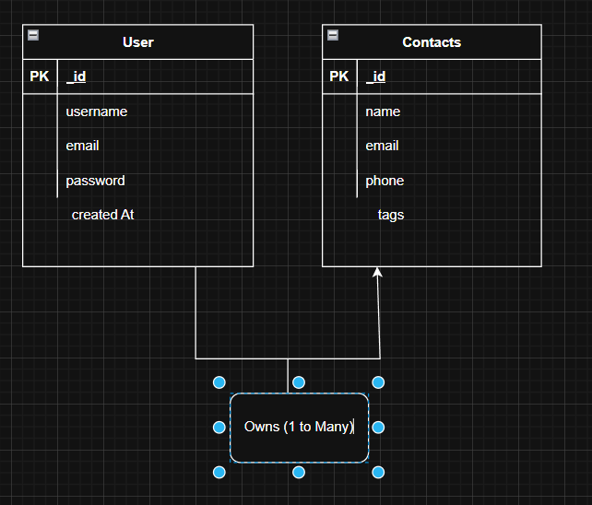

Entities:
- User
- _id
- name
- email
- password
- createdAt

- Contacts
- _id
- name
- email
- userId
- phone
- notes
- tags
- createdAt
- Relationship
One User → Many Contacts

- Features
Feature | Description
User Authentication | JWT based registration and login
Contact CRUD | Create, Read, Update, Delete contacts
Tag Categorization | Organize contacts with tags
Real-time Search | Search by name, email or tags

- Roles and Responsibilities
User
1. Registration– Register using name, email and password
2. Login– Login using registered email and password
3. Search Contact – Search using name, email or tags
4. Add Contact – Add new contact information
5. Edit Contact – Modify contact details
6. Delete Contact – Remove contacts
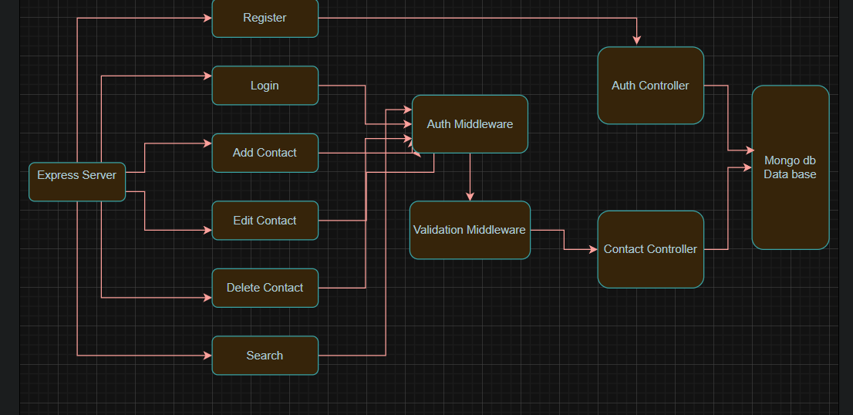

11. Project Setup and Configuration
Folder Structure
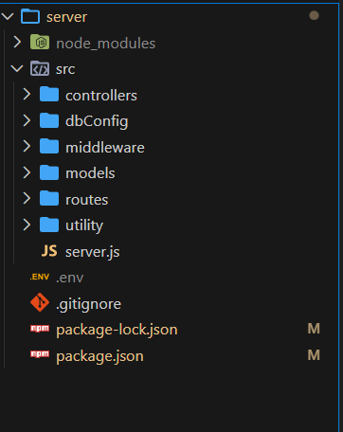

Install Required Tools
- Node.js
- MongoDB
Install Backend Packages
- npm install express
- npm install mongoose
- npm install cors

12. Backend Development
Setup Express Server
Create index.js inside server folder.
Add middleware:
- cors
- body-parser
- express.json()
User Authentication
- Create registration route
- Create login route
- Implement JWT authentication middleware
- Protect private routes
API Routes
Create separate route files:
routes/
authRoutes.js
contactRoutes.js
Routes will handle:
- User registration
- User login
- Contact CRUD operations
Data Models
Create Mongoose schemas
models/
User.js
Contact.js
Implement CRUD operations:
- Create contact
- Read contacts
- Update contact
- Delete contact
Error Handling
Create error handling middleware to:
- Catch API errors
- Return HTTP status codes
- Send meaningful error messages

13. Database Configuration
Configure MongoDB
Steps:
- Install mongoose
- Create database connection
- Create schemas and models

14. Project Execution
Execution Steps
- Open project folder in terminal
- Ensure start script exists in package.json
- Run server: npm start
- Server message appears: Server running on PORT
- Database connection message: Database connected successfully
- Test APIs using: Thunder Client & Postman

15. Output Screenshots
Register API
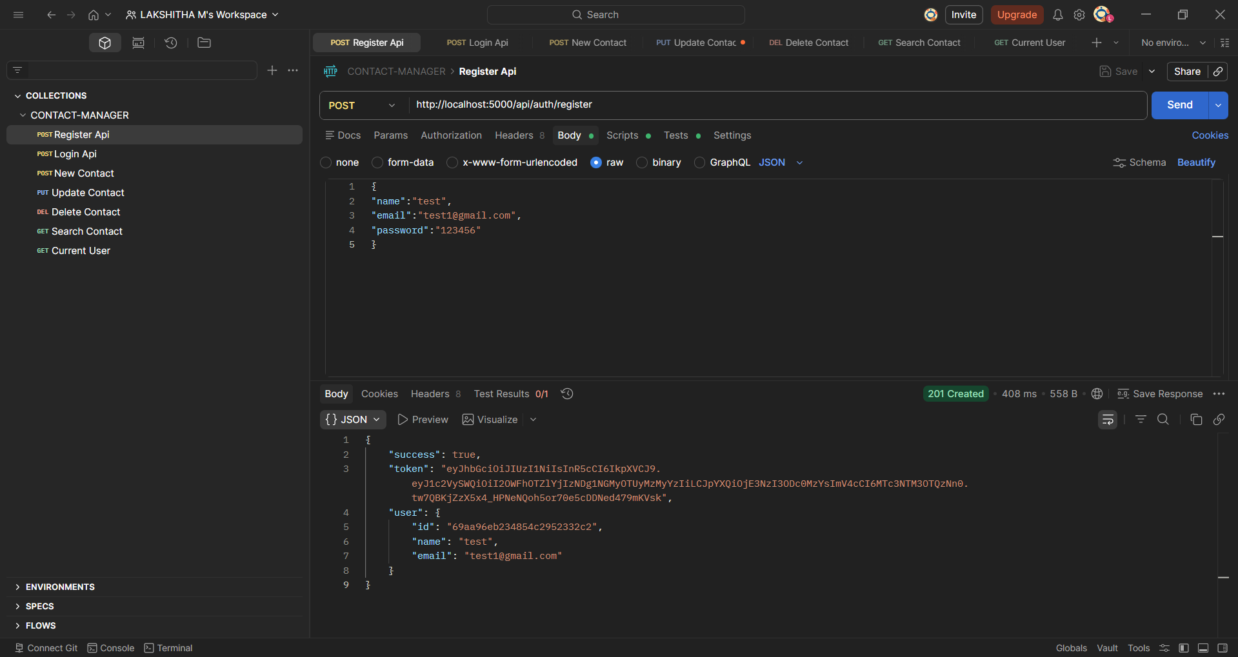
Login API
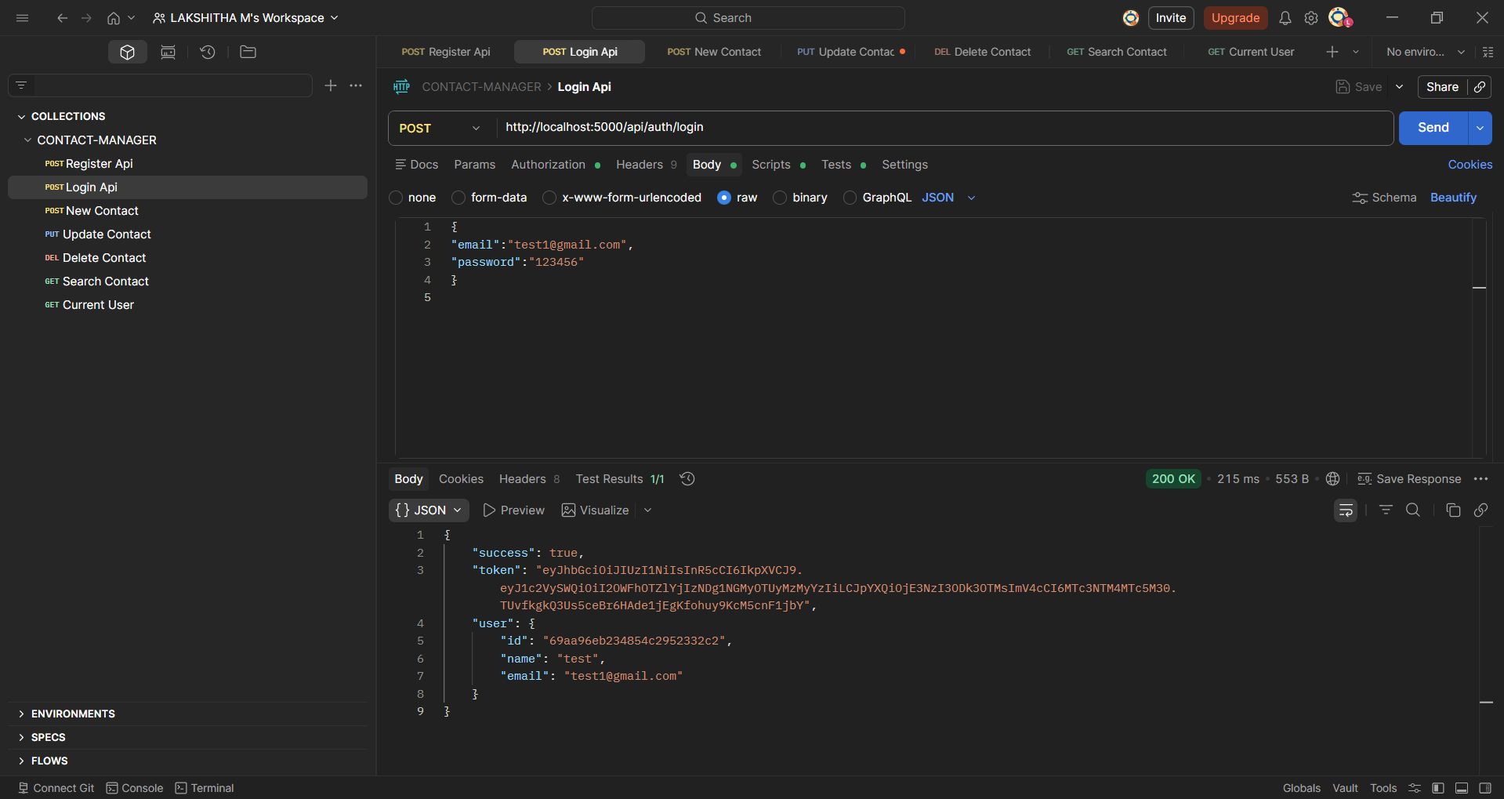
Create New Contact
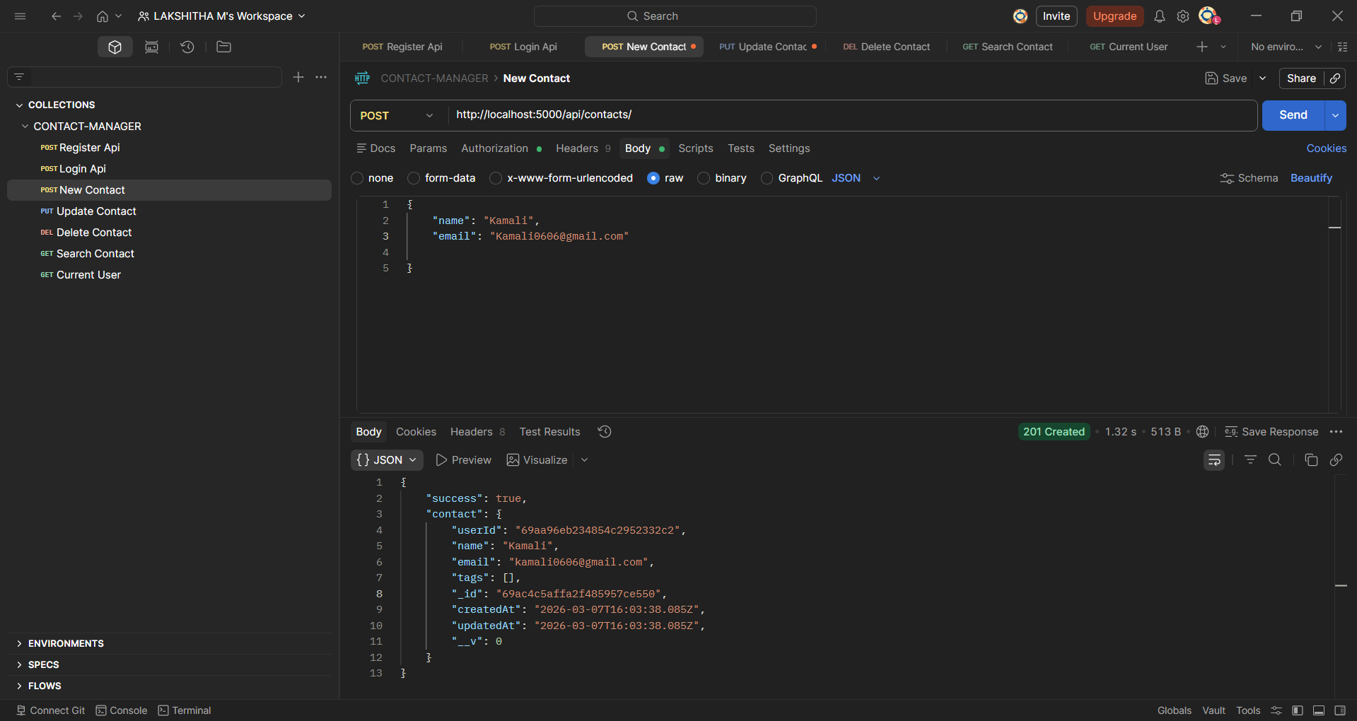
Update Contact
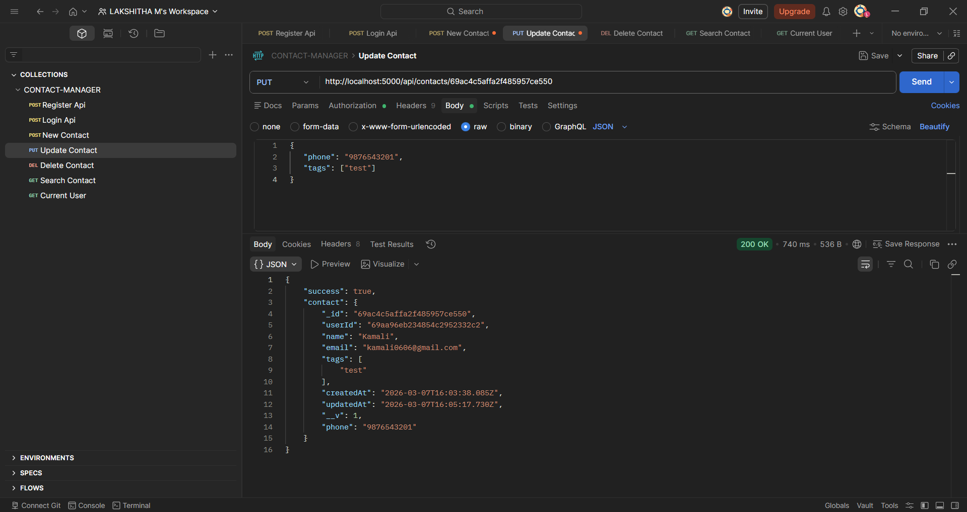
Delete Contact
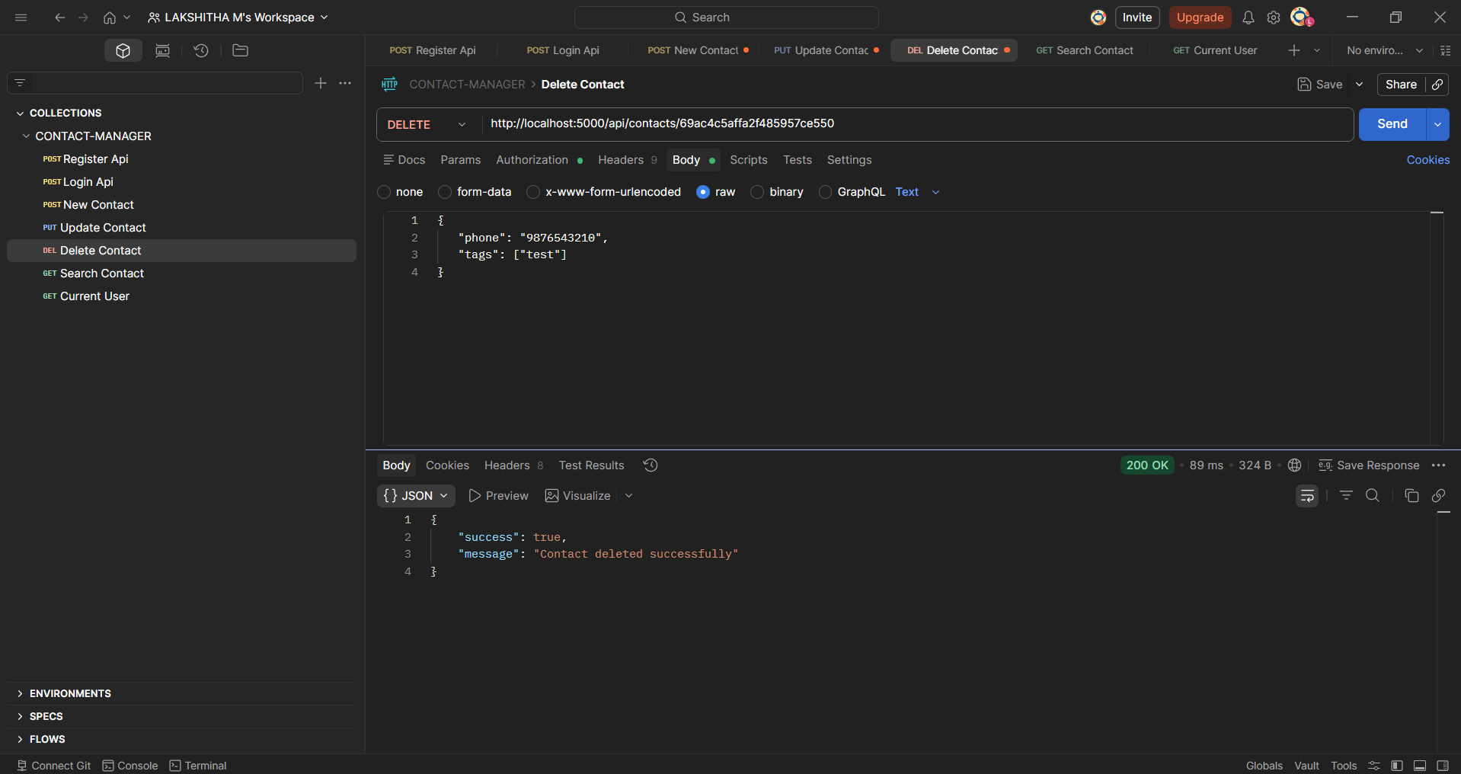
Search Contact
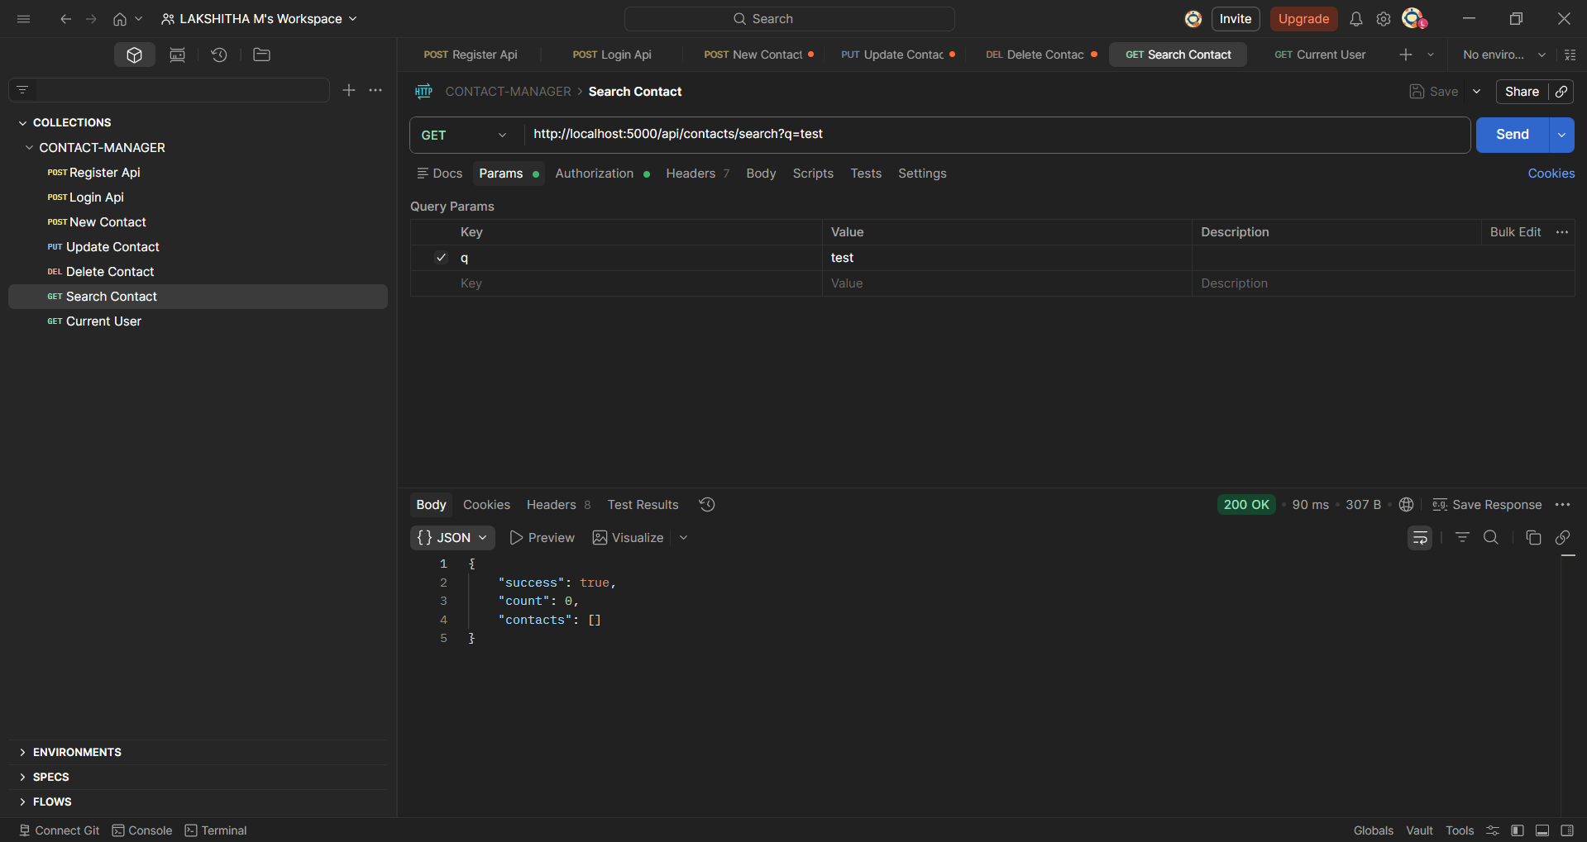
Get Current User
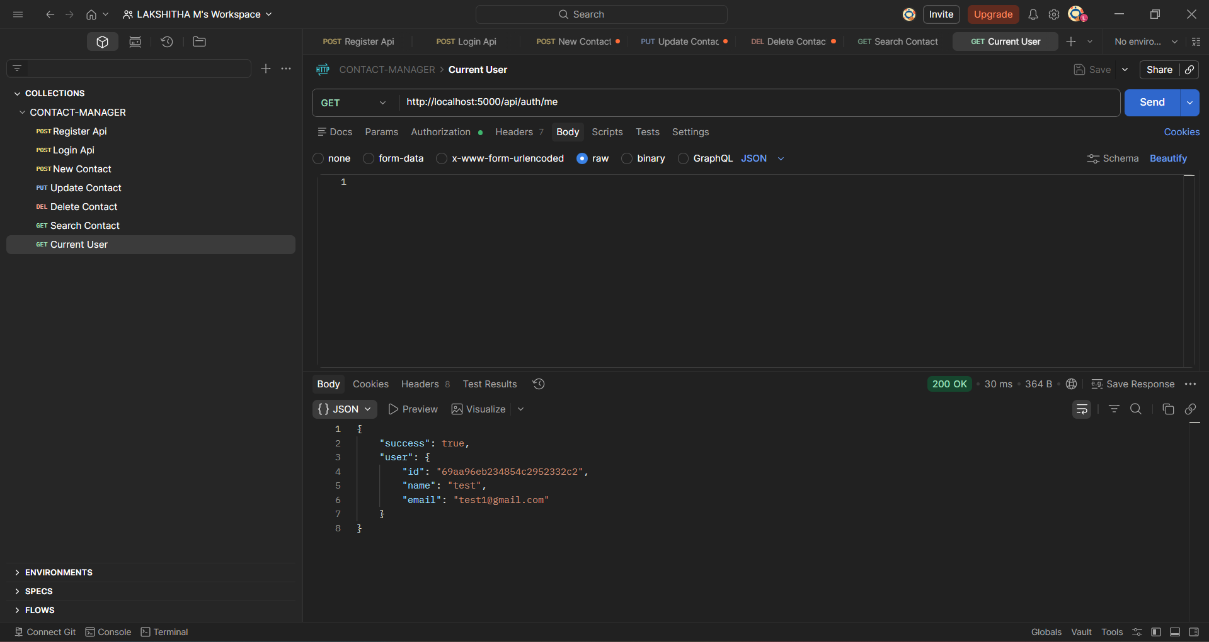

16. Project Demo
https://drive.google.com/file/d/1bm5dM2WrnxpCmHBPnA1QkiyQw4RT7LDL/view?usp=sharing
17. Code Link
https://github.com/lakshi2323/CONTACT-MANAGER.git

