**1. Project Title** Cell Block Manager

**2. Problem in Brief**

* In the current situation, there’s very poor communication between RNO Team Requestor and INOC Team Leader and most of the time INOC Team Leader is not aware of their Request.
* No single system to capture cell block requests.
* Cellblock affects users and gives bad user experience, user unsatisfaction.
* Affect VIP users.
* High-risk operation.
* Previous bad experience on vendor cell block activities.
* Captured long term blocked cells.
* When considering the current system, the occurrence of human errors is ordinary and hard to handle manual data.

**3. Proposed Solution**

* We are going to develop a system that facilitates the interconnection between RNO Team Requestor and INOC Team Leader by a web application.
* It needs a central system to monitor and handle cell block requests properly.
* Maintain cell block requests.
* Monitor the response of the cell block requests.
* Clear view and searching facility of the block requests.
* Follow up pending works. (pending approval, pending block, pending unblock)
* Give the beep tone in new pending works.
* Analysis of cell block request. (request count, block pending request count, deblock pending request count, block count, deblock count)
* INOC Team Leader marks the request, bock or unblock by the system and sending the email to the Requestor.
* Vendor block requests need to be processed through the RNO Team Requestor. so, through this web, RNO Team Requestor can view vendor requests and approve for the process.

**4. Requirements identification**

4.1   Functional requirement

* Add and remove requests by RNO Team Requestor and Vendor. (single request or multi request)
* The vendor requests approval by the RNO Team Requestor.
* View all requests and responses of the requests.
* View and playing beep tone the new pending block and deblock counts.
* Keep records and update records of the cell block details. (block or unblock)
* Update cell block request single and multi-selection. (block or unblock)
* Search request, view all requests in the log table, view complete requests highlighted.
* Mail and SMS function-> A message is sent to the requestor about the response of the cell block request.
* Can export the records. (date range or all records as the excel sheet)
  + View the analysis of cell block requests. (request count, block pending request count, deblock pending request count, block count, deblock count)

4.2 Non-functional requirements

* Usability. (Color combination is valid for even color-blind people, User interface responsive to any device)
* User-friendliness – adding icons and information messages.
* Increasing Performance. (AJAX form submit use to data insert and search, using table plugging)
* Security- prevent unauthorized access and SQL injection by using security functions.
* Data adding and update are not reflecting with other accounts.
* Reliability.

4.3 User levels

* Admin
* INOC Team Leader
* RNO Team Requestor
* Vendor

4.4 User Roles

* Admin
* Admin can handle every user details including insert, delete and update.
* Show the requests pending count.
* Search the details of the cell block requests
* Add or update cell block requests.
* Export the excel sheet.
* View the analysis of cell block requests.
* Add users and reset the password.
* INOC Team Leader
* Show the requests pending count.
* Search the details of the cell block requests.
* Update cell block requests. (block or deblock)
* Sent a message to the requestor about the response of the cell block request.
* Export the excel sheet.
* View the analysis of cell block requests.
* RNO Team Requestor
* Add the requests (single request or multi requests)
* Remove the wrong requests.
* View all user's requests and responses of the user requests.
* Show the pending approval requests.
* Give approval to the vendor requests.
* Vendor
* Add the requests (single request or multi requests).
* Remove the wrong requests.
* 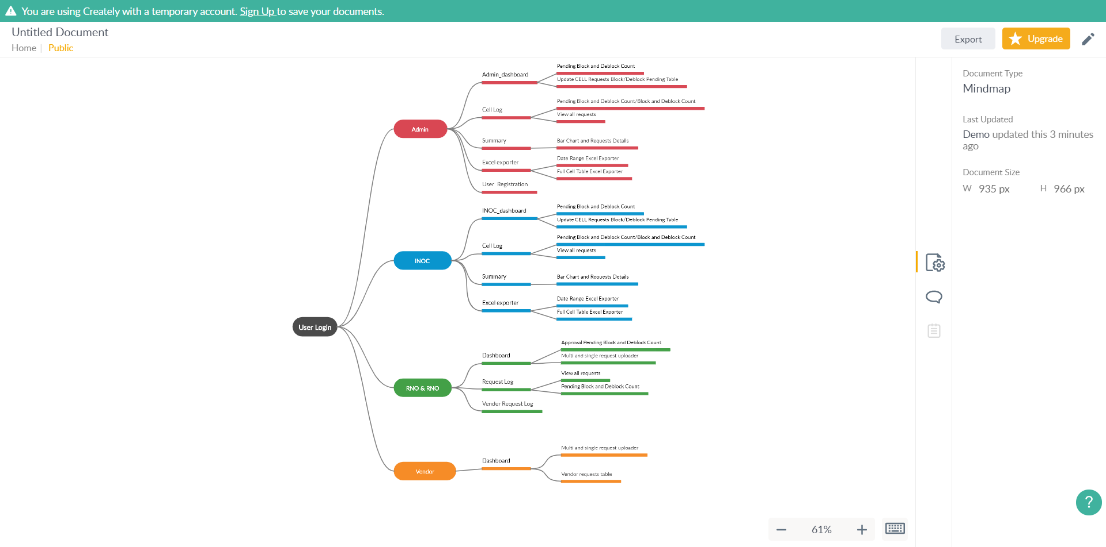View all requests and responses of the user requests.

**5. Interfaces**

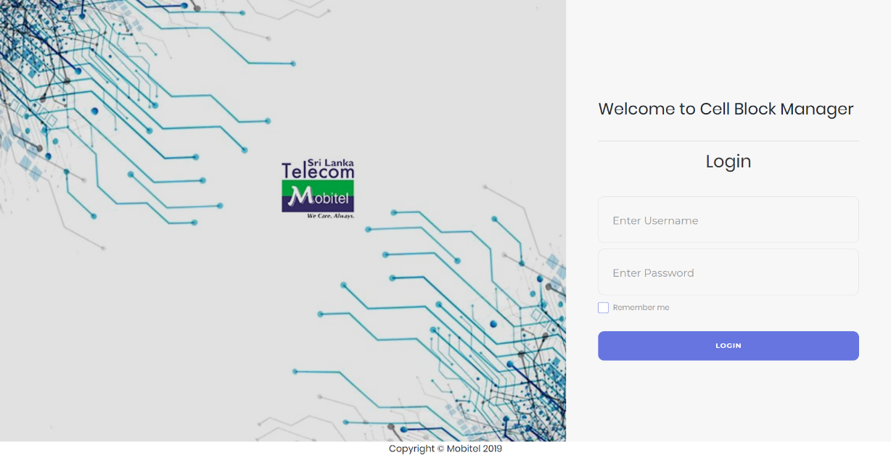

Figure 1: User Login

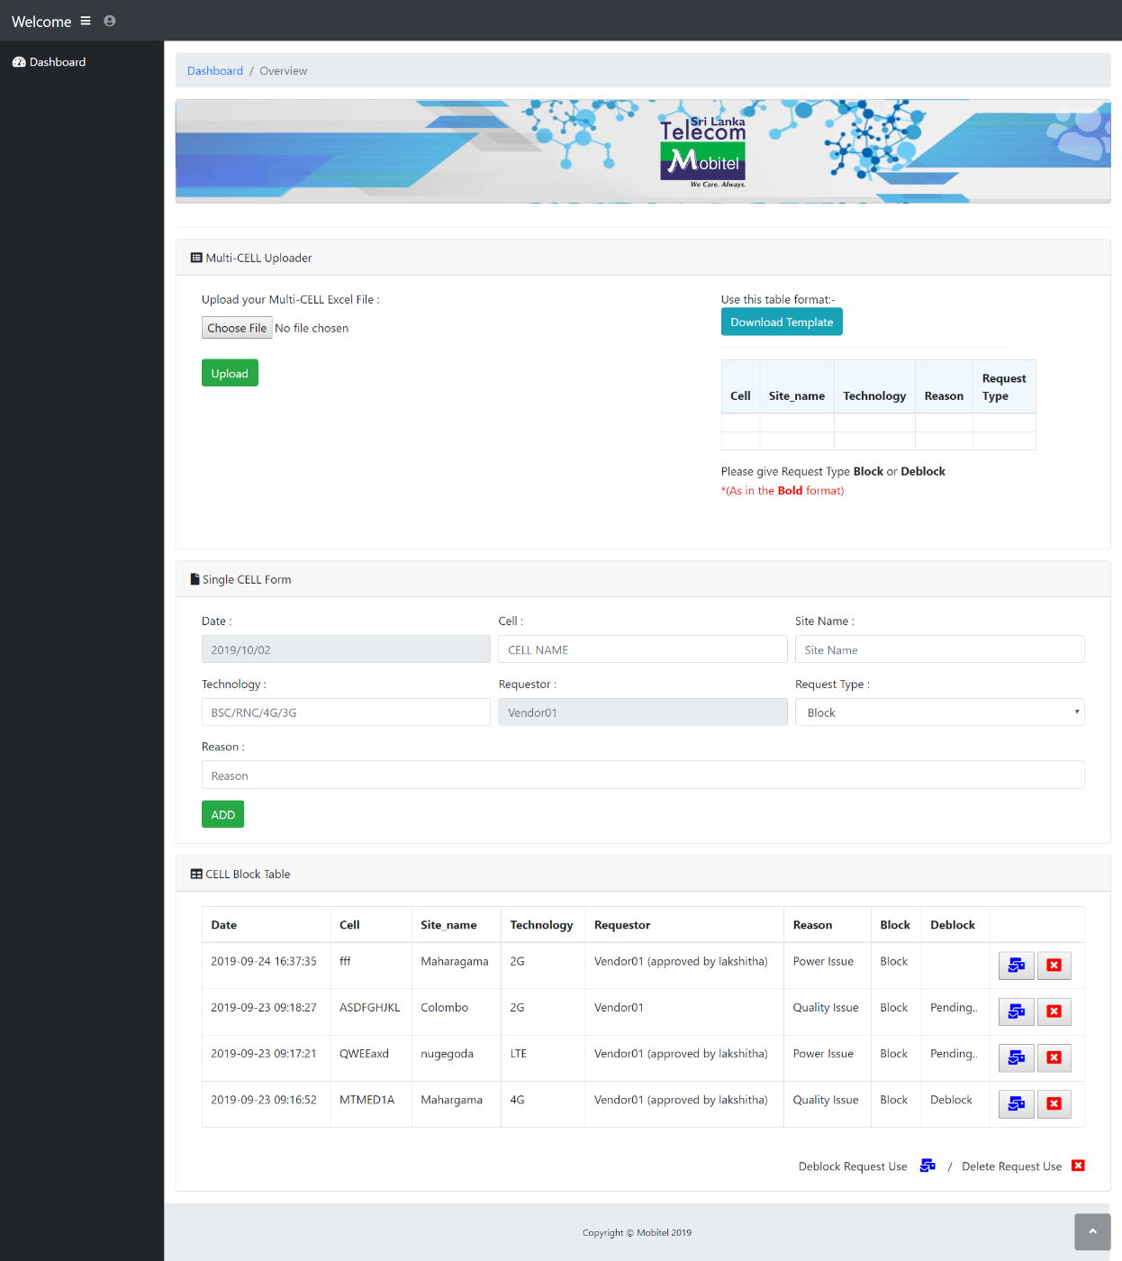

Figure 2: Vendor Dashboard

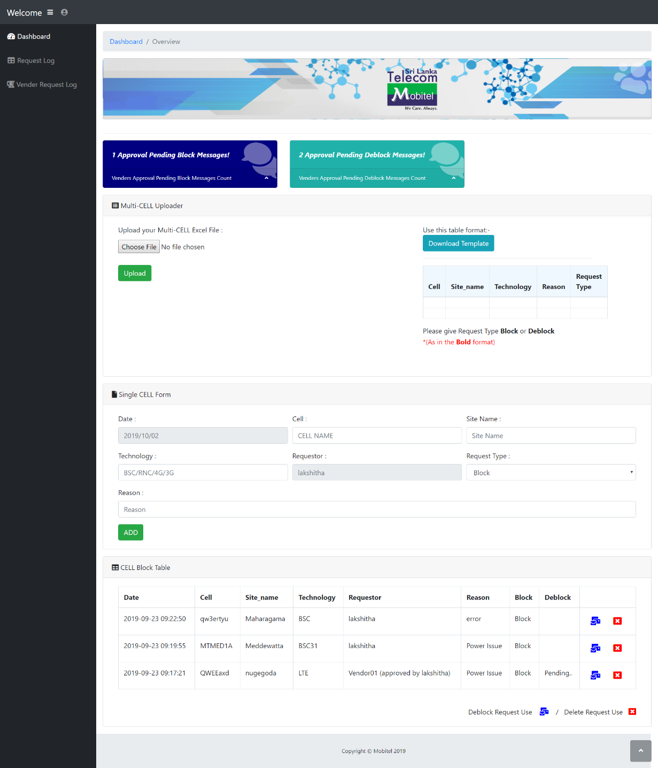

Figure 3: Requestor Dashboard

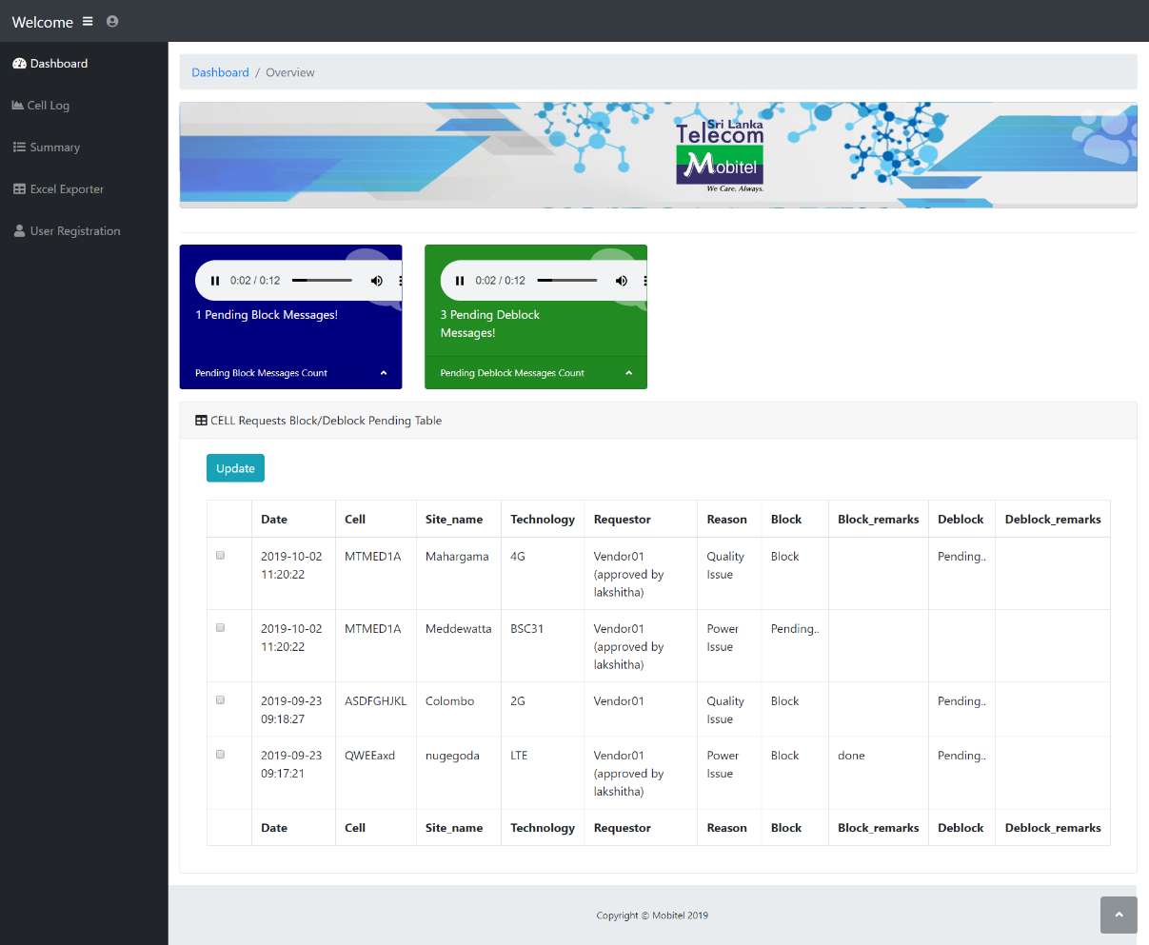

Figure 4: INOC/Admin Dashboard

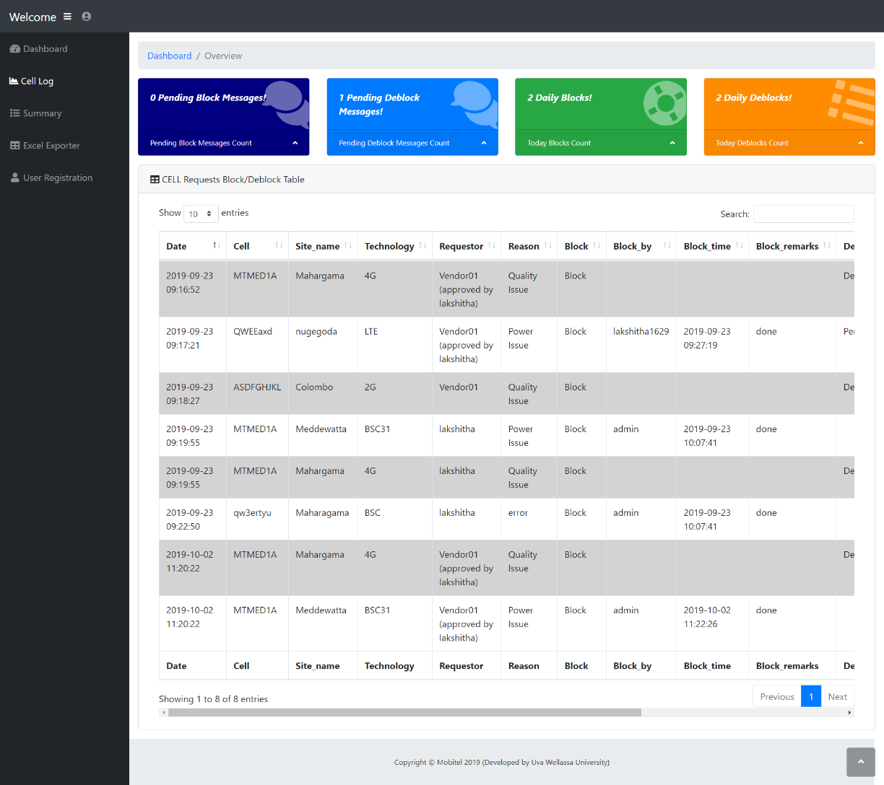

Figure 5: INOC/Admin Cell Log

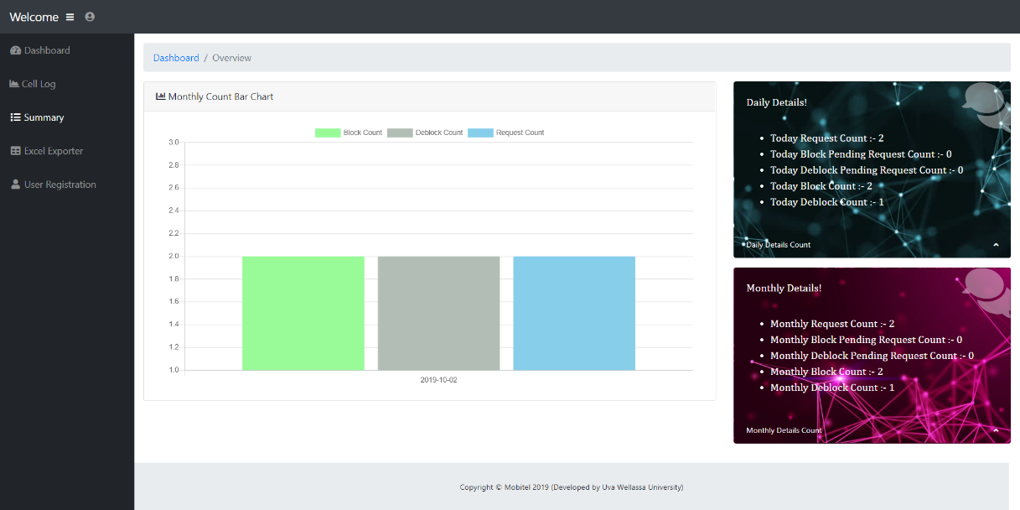

Figure 6: INOC/Admin Summary

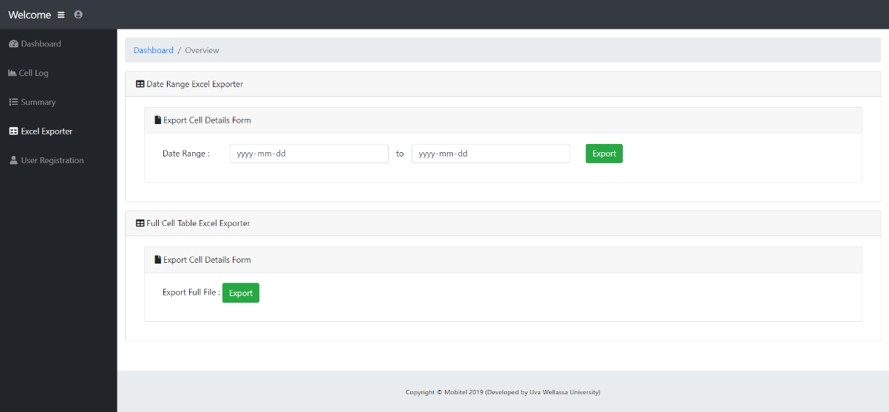

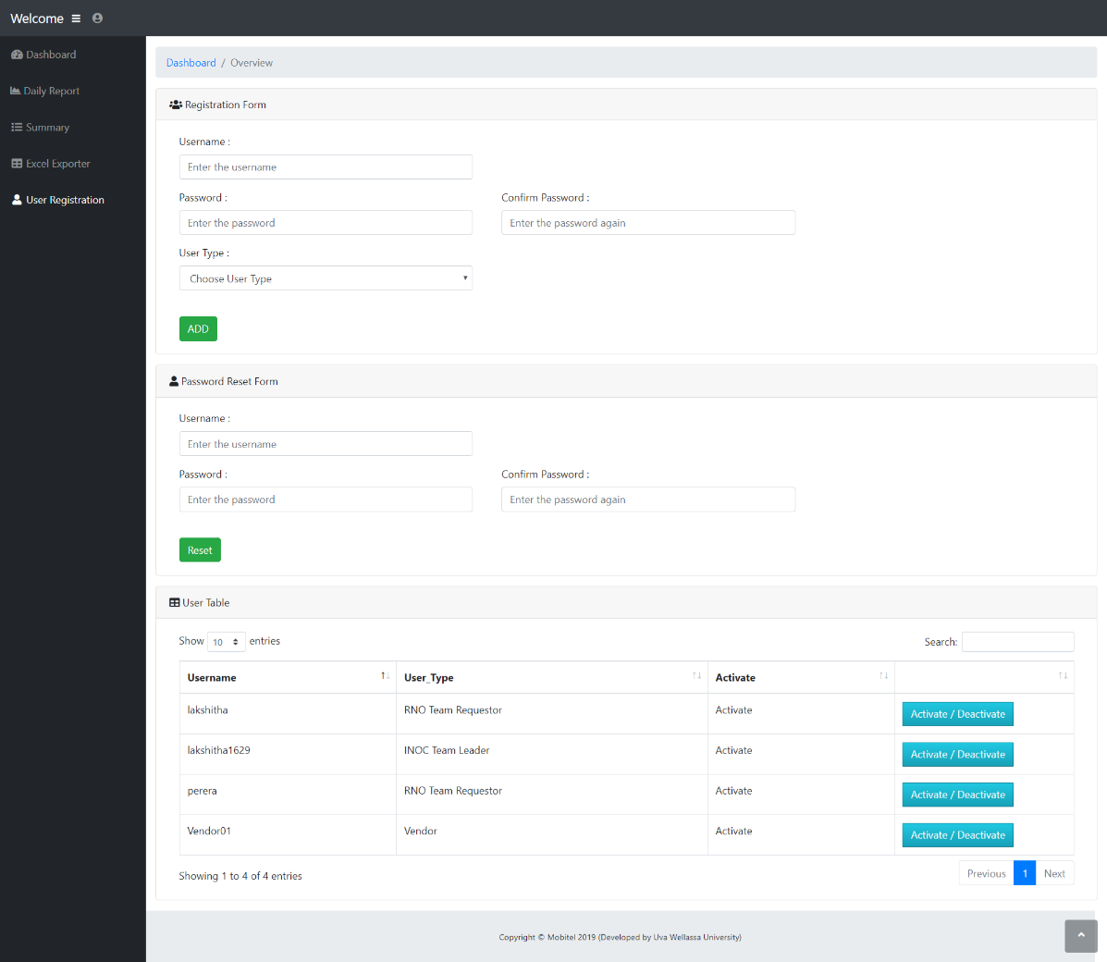

Figure 8: User Registration

Figure 7: INOC/Admin Excel Exporter