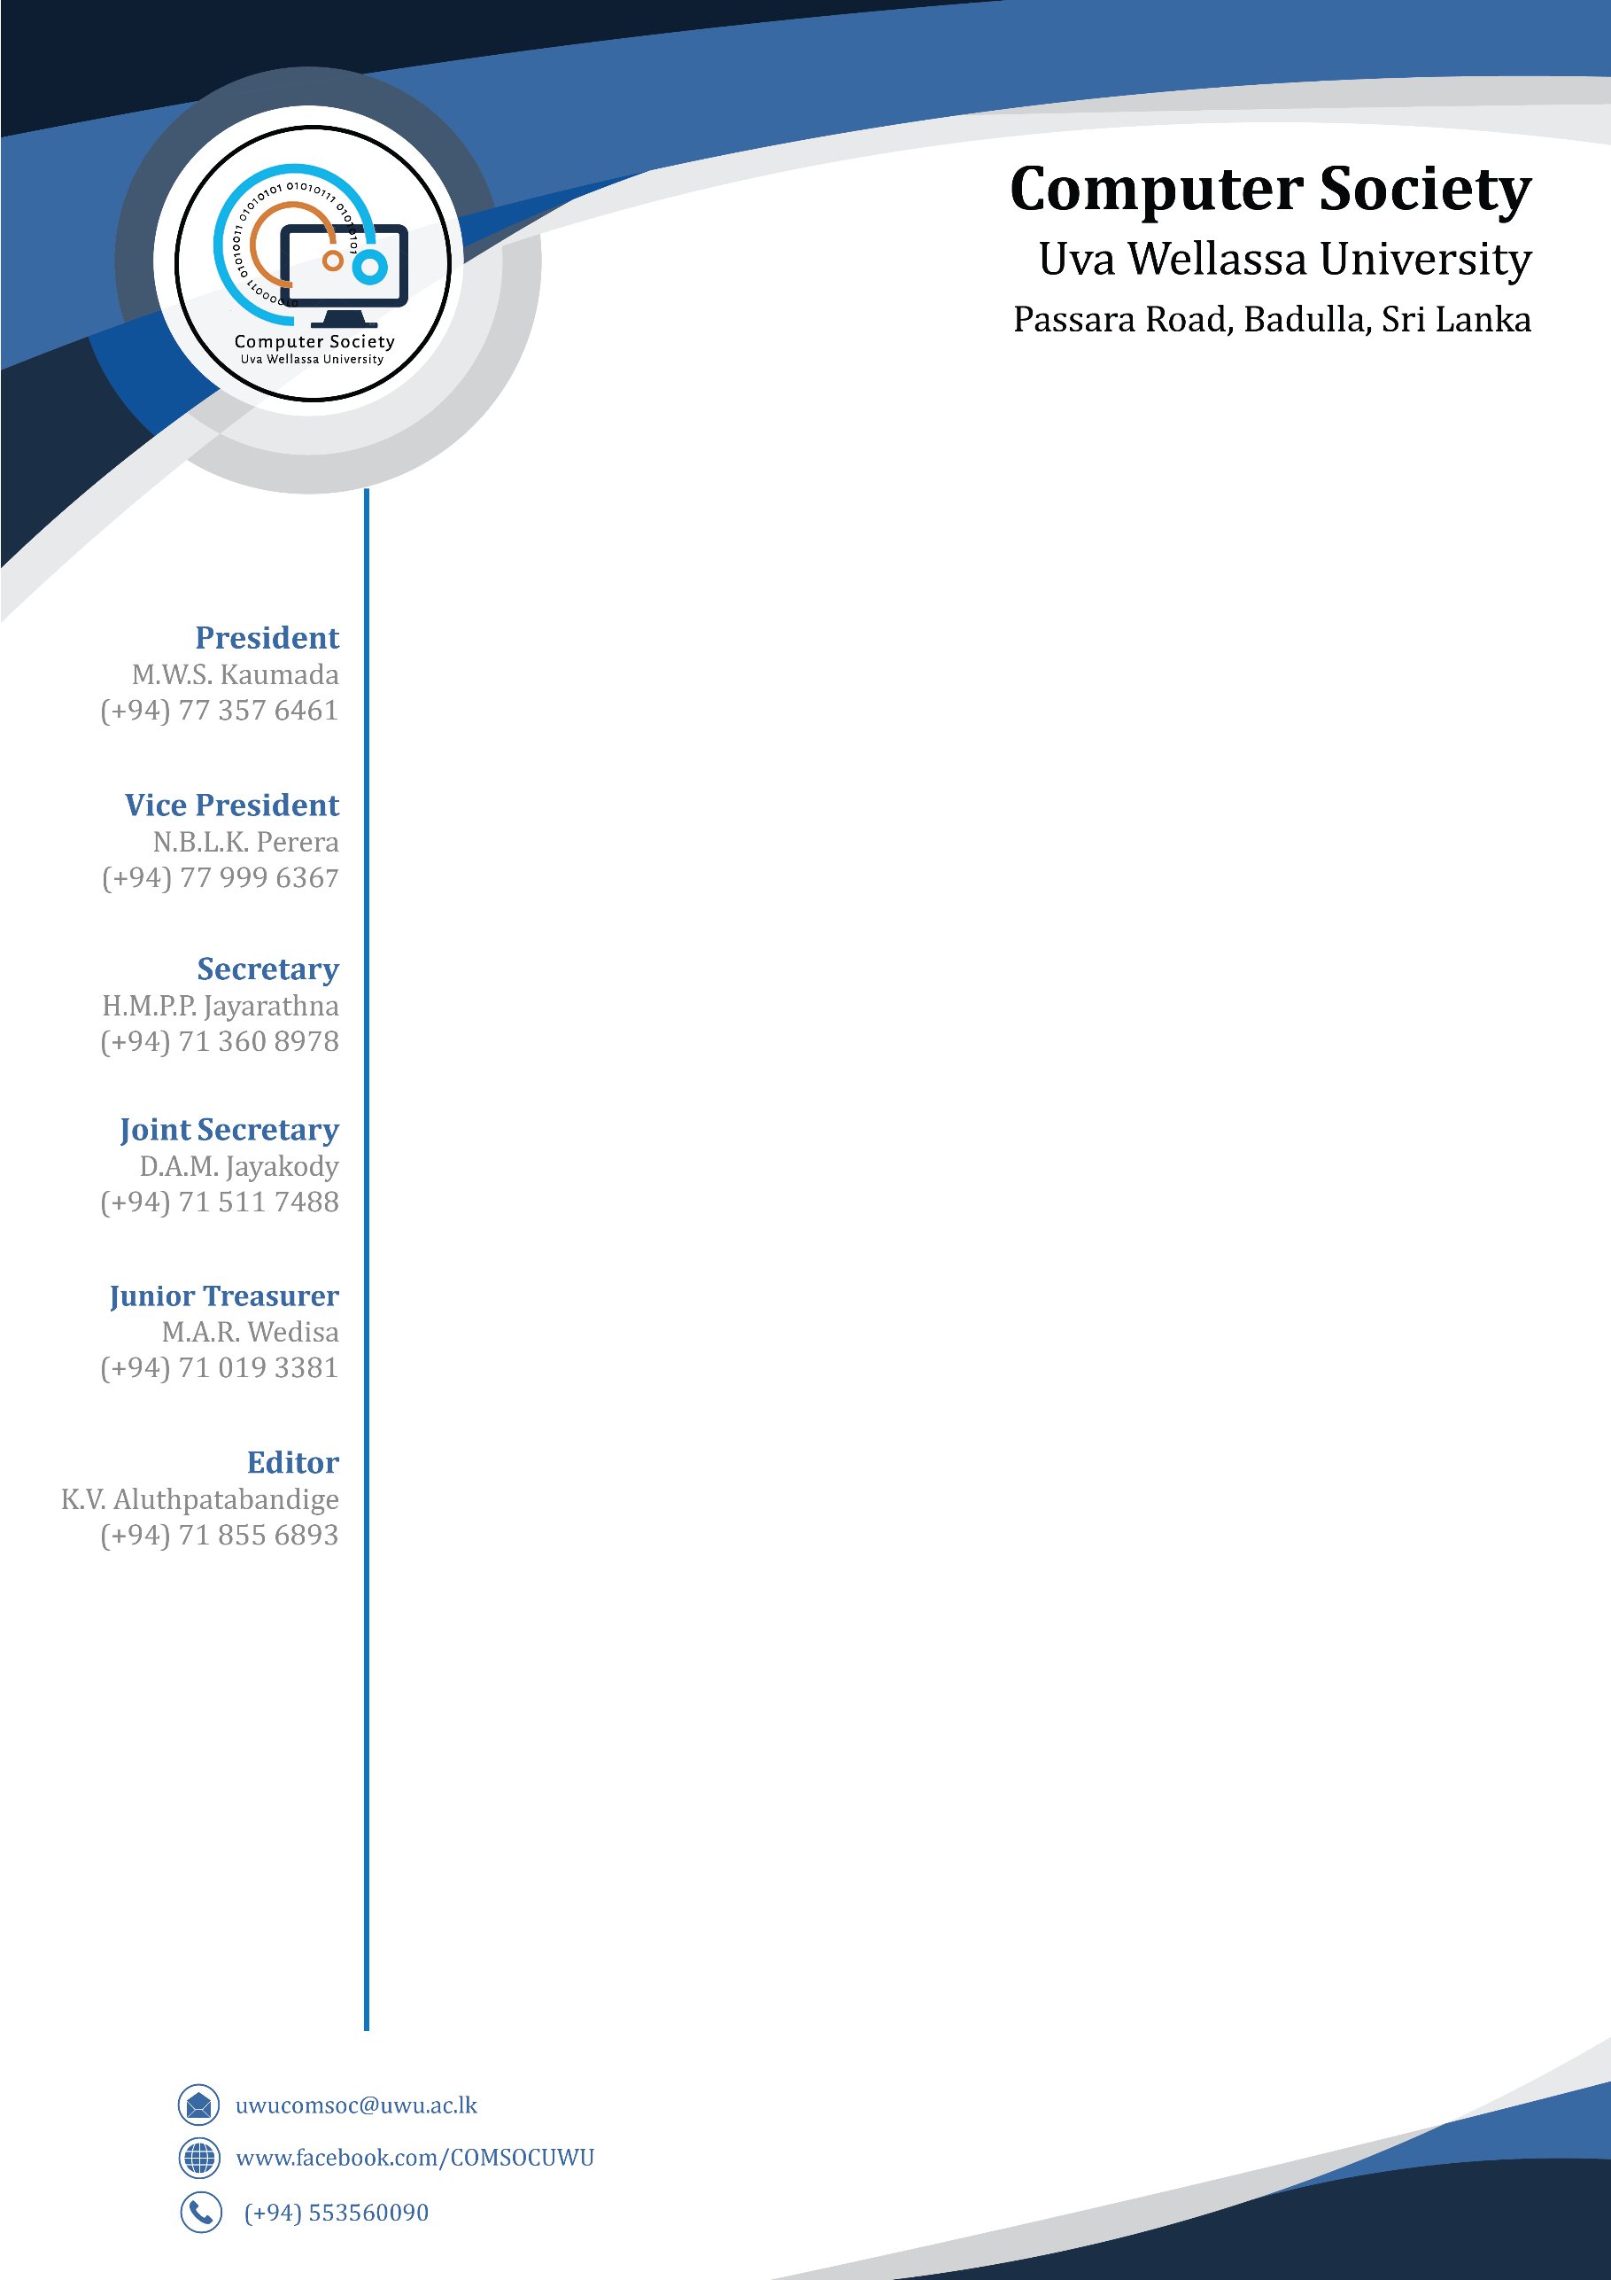

Secretary,

Computer Society,

Uva Wellassa University,

Badulla.

25th of June, 2019.

Dr.M.M.S.N.Premetilake,

Head of the Department,

Department of Computer Science and Informatics,

Uva Wellassa University,

Badulla.

Dear Madam,

**Letter of Appreciation**

The Computer Society of Uva Wellassa University would like to thank you for your immense support in making Deftcoders V6.0 which was held on the 22nd of June a success. We would like to appreciate the time you spared despite the busy schedules of your own to consider our letters and give the consent for the event.

Thanking You

Yours Sincerely,

……………………

H.M.P.P.Jayarathna

Secretary,

Computer Society of Uva Wellassa University.