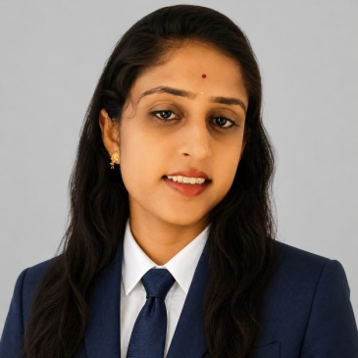
lakshitha
  - Final year Bca

Career Objective  Motivated and detail-oriented final-year BCA student seeking an opportunity to apply programming, database, and problem-solving skills in a software development or IT role. Eager to contribute to a growth-oriented organization while learning modern technologies.  Education  Bachelor of Computer Applications (BCA)  College :government first grade women’s college ,Tumkur  Expected Graduatin: 2026  CGPA/Percentage:8.23  PUC / 12th Standard  College:Girlspucollege,sira  Year: 2023  Percentage: 82%  SSLC / 10th Standard  School Name  Year: 2021  Percentage: 88.96% |  | Technical Skills  - Programming Languages: C, C++, Java, Python  - Web Technologies: HTML, CSS, JavaScript  - Database: MySQL  - Tools: VS Code, Git, GitHub  - Operating Systems: Windows, Linux  - Soft Skills: Communication, Teamwork, Problem Solving  Internships / Training  AIKSHETRA| Duration  - Assisted in frontend development using HTML, CSS, and JavaScript.  - Worked with team members to debug and improve website performance.  Certifications  - Python Programming Certification  - Web Development Course  - Java Basics Certification  Contact  Bhavani S  Princess07121009@gmail.com

