**Task 1. Create an HTML page as shown below using ordered and nested ordered lists.**

Html Code

<!DOCTYPE html>

<html lang="en">

<head>

    <meta charset="UTF-8">

    <meta http-equiv="X-UA-Compatible" content="IE=edge">

    <meta name="viewport" content="width=device-width, initial-scale=1.0">

    <title>Task 1</title>

</head>

<body>

    <center><b>Web Site Outline</b></center>

    <ol>

        <li>Home page</li>

        <li>Link Page</li>

        <ol type="I">

            <li>Links to Search Engines</li>

            <li>Links to information Site</li>

            <ol type="A">

                <li>News site</li>

                <ol type="i">

                    <li>Tv Based</li>

                    <ol type="a">

                        <li>CNN</li>

                        <li>headLine</li>

                    </ol>

                </ol>

                <li>Stock site</li>

            </ol>

            <li>links to fun site</li>

        </ol>

        <li>Contact Page</li>

    </ol>

</body>

</html>

**Output**

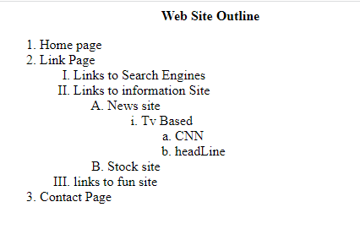

**Task 2. Create a login form as shown below:**

Html Code

<!DOCTYPE html>

<html lang="en">

<head>

    <meta charset="UTF-8">

    <meta http-equiv="X-UA-Compatible" content="IE=edge">

    <meta name="viewport" content="width=device-width, initial-scale=1.0">

    <title>Task 2</title>

</head>

<body>

    <img src="./person.png" alt="person logo"><br>

    <form>

        <label for="username">Username</label>

        <input type="text" id="username" placeholder="Username"><br><br>

        <label for="password">Password</label>

        <input type="text" id="password" placeholder="password"><br><br>

        <button>login</button>

        <button>Cancel</button><br><br>

        <input type="checkbox" name="checkbox" checked ="checked">

        <label for="rememberme">Remember me</label><br>

        <label>forgot <a href="www.google.com">Password?</a></label>

    </form>

</body>

</html>

**Output**

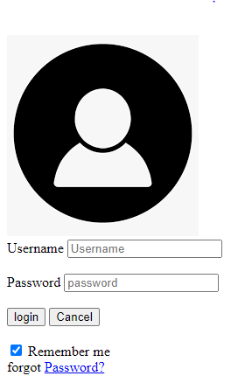

**Task 3 Create following tables using rowspan & colspan.**

Html Code

<!DOCTYPE html>

<html lang="en">

<head>

    <meta charset="UTF-8">

    <meta http-equiv="X-UA-Compatible" content="IE=edge">

    <meta name="viewport" content="width=device-width, initial-scale=1.0">

    <title>Task 3</title>

    <style>

        table,

        tr,

        td,

        th {

            border: 1px solid black;

        }

    </style>

</head>

<body>

    <Table>

        <tr>

            <td rowspan="3">User Info</td>

            <td>1</td>

            <td>John Carter</td>

            <td>johncarter@mail.com</td>

        </tr>

        <tr>

            <td>2</td>

            <td>Peter Parker</td>

            <td>peterparker@mail.com</td>

        </tr>

        <tr>

            <td>3</td>

            <td>John Rambo</td>

            <td>johnrambo@mail.com</td>

        </tr>

    </Table>

    <Table>

        <tr>

            <td colspan="3">

                <center>User Info</center>

            </td>

        </tr>

        <tr>

            <td>1</td>

            <td>John Carter</td>

            <td>johncarter@mail.com</td>

        </tr>

        <tr>

            <td>2</td>

            <td>Peter Parker</td>

            <td>peterparker@mail.com</td>

        </tr>

        <tr>

            <td>3</td>

            <td>John Rambo</td>

            <td>johnrambo@mail.com</td>

        </tr>

    </Table>

    <Table>

        <tr>

            <td rowspan="2"></td>

            <td colspan="3">

                <center>User Info</center>

            </td>

        </tr>

        <tr>

            <th>Apple</th>

            <th>Orange</th>

            <th>ScrewDriver</th>

        </tr>

        <tr>

            <th>Breakfast</th>

            <td>0</td>

            <td>1</td>

            <td>0</td>

        </tr>

        <tr>

            <th>Lunch</th>

            <td>1</td>

            <td>0</td>

            <td>0</td>

        </tr>

        <tr>

            <th>Dinner</th>

            <td>0</td>

            <td>0</td>

            <td>1</td>

        </tr>

    </Table>

</body>

</html>

**Output**

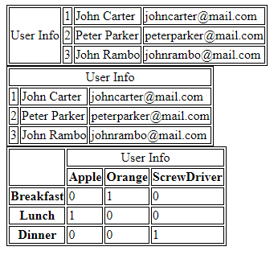

**Task 4. Create webpage about a recipe. Your page should have a description of the recipe, an image showing its output, list of ingredients, and steps/instructions to be followed in sequence to prepare that recipe.**

HTML code

<!DOCTYPE html>

<html lang="en">

<head>

    <meta charset="UTF-8">

    <meta http-equiv="X-UA-Compatible" content="IE=edge">

    <meta name="viewport" content="width=, initial-scale=1.0">

    <title>Document</title>

</head>

<body>

    <h1>This is your first HTML Page!</h1>

    <h3>Seems like things are going pretty well so far</h3>

    <h5>lets add a recipe for some delicios chinese noodles</h5>

    <h3>we are going to borrow a nice picture from internet</h3>

    <img src="./noodles.jpg" alt="foodimage">

    <p>Here is what the receipe calls for</p>

    <p><b>Ingredients</b>(Probably not right)

    <ul>

        <li>2 cups of water</li>

        <li>2 Tea spoon oil</li>

        <li>1 boied Egg</li>

        <li>peas</li>

        <li>carrot</li>

    </ul>

    <p><b>Istruction</b>(may or may not be correct)</p>

    <ol>

        <li>Add Water into pan and boil it for 5 mintues</li>

        <li>Add Peas and Carrot</li>

        <li>After sometime add some masala and noodles</li>

        <li>Cut Egg into small peices and and add into noodles</li>

    </ol>

</body>

</html>

**Output**

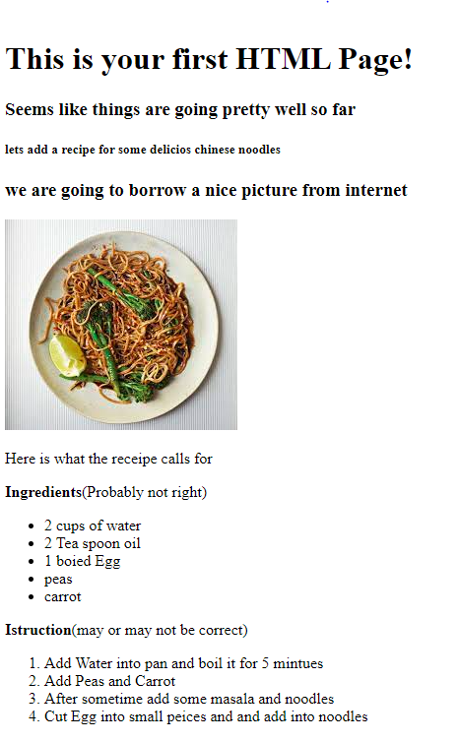

**Task 5. Create the following form using only HTML**.

Html Code

<!DOCTYPE html>

<html lang="en">

<head>

    <meta charset="UTF-8">

    <meta http-equiv="X-UA-Compatible" content="IE=edge">

    <meta name="viewport" content="width=device-width, initial-scale=1.0">

    <title>Task 5</title>

</head>

<body>

    <h3>Welcome to millennium Gymnatic Booster Club Popcorn sales</h3>

    <form>

        <label for="buyername">Buyer's Name</label>

        <input type="text" name="name" id="name"><br>

        <label for="streetaddress">Street Address</label>

        <input type="text" name="streetaddress" id="streetaddress"><br>

        <label for="zip">City State Zip</label>

        <input type="text" name="zip" id="zip">

        <table>

            <tr>

                <th>Product Name</th>

                <th>Price</th>

                <th>Quality</th>

            </tr>

            <tr>

                <td>Unpoped Popcorn(1 lb.)</td>

                <td>$3.00</td>

                <td><input type="text" size="3"></td>

            </tr>

            <tr>

                <td>Caremsl Popcorn(1 lb.)</td>

                <td>$3.50</td>

                <td><input type="text" size="3"></td>

            </tr>

            <tr>

                <td>Caramel nut Popcorn(1 lb.)</td>

                <td>$4.50</td>

                <td><input type="text" size="3"></td>

            </tr>

            <tr>

                <td>Toffee nut Popcorn(1 lb.)</td>

                <td>$5.00</td>

                <td><input type="text" size="3"></td>

            </tr>

        </table>

        <h3>Payment Method</h3>

        <input type="radio" name="A" value="">

        <label for="visa">Visa</label><br>

        <input type="radio" name="B" value="">

        <label for="mastercard"> Master card</label><br>

        <input type="radio" name="C" value="">

        <label for="discover">Discover</label><br>

        <input type="radio" name="D" value="" checked="checked">

        <label for="cheque">Cheque</label><br>

        <button>Submit order</button>

        <button>Clean Order From </button>

    </form>

</body>

</html>

**Output**

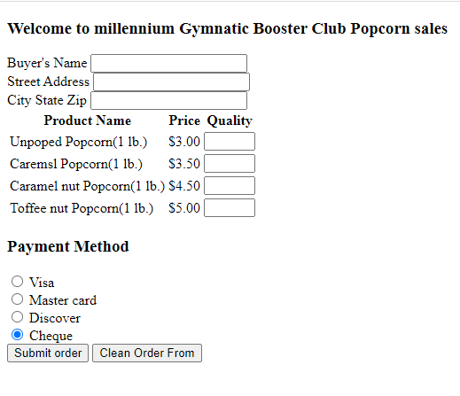

**Task 6 Create the following timetable using HTML table tags. Note: 1. Ignore the SIBAU Logo (i.e., do NOT insert image). Just focus on the textual data 2. Inside the cells that contain subject names, only write/put subject names. Do NOT write batch name or section or location/room number (just subject name is enough). 3. Also, do NOT worry about the vertical text mentioning Lunch Break. You can just write horizontal text there.**

HTML Code

<!DOCTYPE html>

<html lang="en">

<head>

    <meta charset="UTF-8">

    <meta http-equiv="X-UA-Compatible" content="IE=edge">

    <meta name="viewport" content="width=device-width, initial-scale=1.0">

    <title>Task 6</title>

</head>

<body>

    <center><h3>Teacher Riaz Ahmed Soomoro</h3></center>

    <table border="1" cellspacing="0" align="center">

        <tr>

            <td></td>

            <th style="text-align:center">1 <br> 09:00 <br> 10:00AM</th>

            <th style="text-align:center">2 <br> 10:00 <br> 11:00AM</th>

            <th style="text-align:center">Break <br> 11:00 <br> 11:300AM</th>

            <th style="text-align:center">3 <br> 11:30 <br> 12:30PM</th>

            <th style="text-align:center">4 <br> 12:30 <br> 01:30PM</th>

            <th style="text-align:center">Lunch <br> 01:30 <br> 02:00PM</th>

            <th style="text-align:center">5 <br> 02:00 <br> 03:00PM</th>

            <th style="text-align:center">6 <br> 03:00 <br> 04:00PM</th>

            <th style="text-align:center">7 <br> 04:10 <br> 05:25PM</th>

            <th style="text-align:center">8 <br> 05:30 <br> 06:50PM</th>

            <th style="text-align:center">9 <br> 06:50 <br> 7:50PM</th>

            <th style="text-align:center">10 <br> 07:50 <br> 08:50PM</th>

        </tr>

        <tr cellpadding="5">

            <td style="text-align:center">Mo</td>

            <td></td>

            <td></td>

            <td rowspan="6"></td>

            <td></td>

            <td ></td>

            <td style="text-align: center;" rowspan="6">L<br>u<br>n<br>c<br>h<br><br> B<br>r<br>e<br>a<br>k</td>

            <td></td>

            <td></td>

            <td style="text-align: center;" colspan="2">Introduction to <br> Programming <br> R-205 B-ll</td>

            <td></td>

            <td></td>

        </tr>

        <tr>

            <td style="text-align:center">Tu</td>

            <td></td>

            <td></td>

            <td></td>

            <td></td>

            <td></td>

            <td></td>

            <td></td>

            <td style="text-align: center;" colspan="2">Introduction to <br> Programming <br> R-17 B-l</td>

            <td></td>

        </tr>

        <tr>

            <td style="text-align:center">We</td>

            <td style="text-align: center;" colspan="2">Web Engineering- <br>Lab <br>R-108 b-ll</td>

            <td style="text-align: center;">Web<br> Engineering- <br>Lab <br>R-108 b-ll</td>

            <td></td>

            <td></td>

            <td></td>

            <td></td>

            <td></td>

            <td></td>

            <td></td>

        </tr>

        <tr >

            <td style="text-align:center">Th</td>

            <td></td>

            <td></td>

            <td></td>

            <td></td>

            <td></td>

            <td></td>

            <td></td>

            <td style="text-align: center;" colspan="2">Introduction to <br> Programming <br> R-17 B-l</td>

            <td></td>

        </tr>

        <tr >

            <td style="text-align:center">Fr</td>

            <td></td>

            <td></td>

            <td></td>

            <td></td>

            <td></td>

            <td></td>

            <td></td>

            <td style="text-align: center;" colspan="2">Introduction to <br> Programming <br> R-17 B-l</td>

            <td></td>

        </tr>

        <tr>

            <td style="text-align:center">Sa</td>

            <td></td>

            <td></td>

            <td style="text-align: center;" colspan="2">Web Engineering- <br>Lab <br>R-108 b-ll</td>

            <td style="text-align: center;" >Web <br>Engineering- <br>Lab <br>R-108 b-ll</td>

            <td></td>

            <td></td>

            <td></td>

            <td></td>

            <td></td>

        </tr>

    </table>

</body>

</html>

Output

