# Problem Statement:

*Introduction****:*** The main idea is tobuild a global communication network for protecting the drug distribution supply chain and investigating drug counterfeit crimes. The network requires the participation of public and private organization, doctor, patient, law enforcement agencies, pharmaceutical companies, pharmacies and whole sale distributors.

Basic Functionality:

1. Promoting the pending Senate Bill and to stop illegitimate drugs from infiltrating the pharmaceutical drug distribution supply chain.
2. Must implement all use cases for pharma companies, doctor, patient, distributors and law enforcement agencies.
3. Patient can report suspected product as well as adverse event.
4. Implement ordering work flow between the pharma company, distributors, hospitals and pharmacies
5. Capture product history and movement of product through different ownership.
6. Maintain Medication inventory for pharma companies, pharmacies, distributors etc.
7. Different type of licensing issued by law enforcement agencies to pharmacy companies, distributors.
8. Must provide alert mechanisms which will allow for the immediate notification of suspect drug products to buyers.
9. Law enforcement agencies has a power to cancel the license of distributor or Pharm Company.
10. Law enforcement can extend or revoke the license of pharma Company or any distributors.
11. . Pharma Company can issue order to valid license distributors only

# How your system provides solution to the problem

Built system do the following functionalities:

1. FULL FORENSIC AND DISTRIBUTION SYSTEM ON GLOBAL SCALE.  
   -GLOBAL FDI SYSTEM MANAGES GLOBAL PHARMA COMPANY.  
   -REGIONAL FDI MANAGES REGIONAL DISTRIBUTORS AND REGIONAL PHARMA COMPANY.

-NATIONAL FDI MANAGES NATIONAL DISTRIBUTORS AND NATIONAL PHARMA COMPANY.

-STATE FDI MANAGES STATE DISTRIBUTORS AND STATE PHARMA COMPANY.

-STATE FDI MANAGES CITY DISTRIBUTORS AND CITY ORGANIZATIONS.

1. Patient can report suspected product as well as adverse event.
2. Pharma Company can issue order to valid license distributors only
3. Law enforcement can extend or revoke the license of pharma Company or any distributors.
4. Implement ordering work flow between the pharma company, distributors, hospitals and pharmacies
5. Capture product history and movement of product through different ownership.
6. Maintain Medication inventory for pharma companies, pharmacies, distributors etc.
7. Different type of licensing issued by law enforcement agencies to pharmacy companies, distributors.
8. Alert mechanisms which will allow for the immediate notification of suspect drug products to buyers.
9. Each organization maintain its own drug inventory.
10. FULL ORDERING LIFE CYCLE includes ORDERING ,INVOICE, DELIVERY AND CANCEL ORDER.
11. Logging MECHANISM  
    -helps in Troubleshooting during Production.  
    -HELPS IN DEBUGGING THE CODE.
12. SPECIAL VALIDATION.(EXTENSIVE USE OF COLOR)
13. NOTIFICATION MAIL TO PHARAMA COMPANY.
14. GENERATION OF INVOICE IN PDF FORM.
15. PRODUCT REQUEST CAN BE ARRANGED BASED ON THE FOLLOWING ATTRIBUTES:

-PRIORITY(CRITICAL, HIGH, MEDIUM, LOW)

-QUANTITY OF PRODUCT.

-REQUESTED DATE.

# Scope of your project

Scope of this project is globally, Full Fledged Law Agency System has been built from international to City Level FDI. And Each Law Agency is responsible for its own region pharma-company and distributors.

Full access is given to Law Agency to the pharma product and pharma company itself. They can revoke the license for pharma-company or any of its medicine.

Pharma Company can be of four types:

International: Proximity is throughout the globe.

REGIONAL PHARMA COMPANY: Proximity is throughout the REGION.

NATIONAL PHARMA COMPANY: Proximity is throughout the NATION.

STATE PHARMA COMPANY: Proximity is throughout the STATE.

I have made fours layer of Distributor: which can distribute the product of their own proximity.

At each City we have five different organization which can sell the product to the registered patient:

PHARMACY, CLINIC, HOSPITAL, DISPENSARIES, DOCTOR.

# Details about your assumptions

1. There is only one person (admin) which is the face of each organization.
2. Pharmaceutical companies have registered distributers and they can supply product to that distributors only.
3. Law Agencies handled all the license related issues and can check the product history of any distributors under their region.
4. International FDI is the super duper user. Which creates the regional (Continental) FDI as well as International Pharma Company.
5. Built the full-fledged LAW Agency system from FDI SYSTEM to CITY FDI SYSTEM. FDI SYTEM contains Regional FDI(Each Continent belong to one Region), Regional FDI contains National FDI, National FDI contains STATE FDI and STATE FDI Contains City FDI. Each of the Agency is fully responsible of their own distributors and Pharma Company.
6. Each Medical Product have proper license and expiry and medicine will be retrieved from the MARKET if its license has been cancelled.
7. Each organization has its own lower channel distributors and product can be sold to its registered distributors only.
8. Distributors can send request to Pharma Company and it higher distributor only, if it is registered under that organization.

# Object Model with a brief explanation of the components

Work Flow Model:

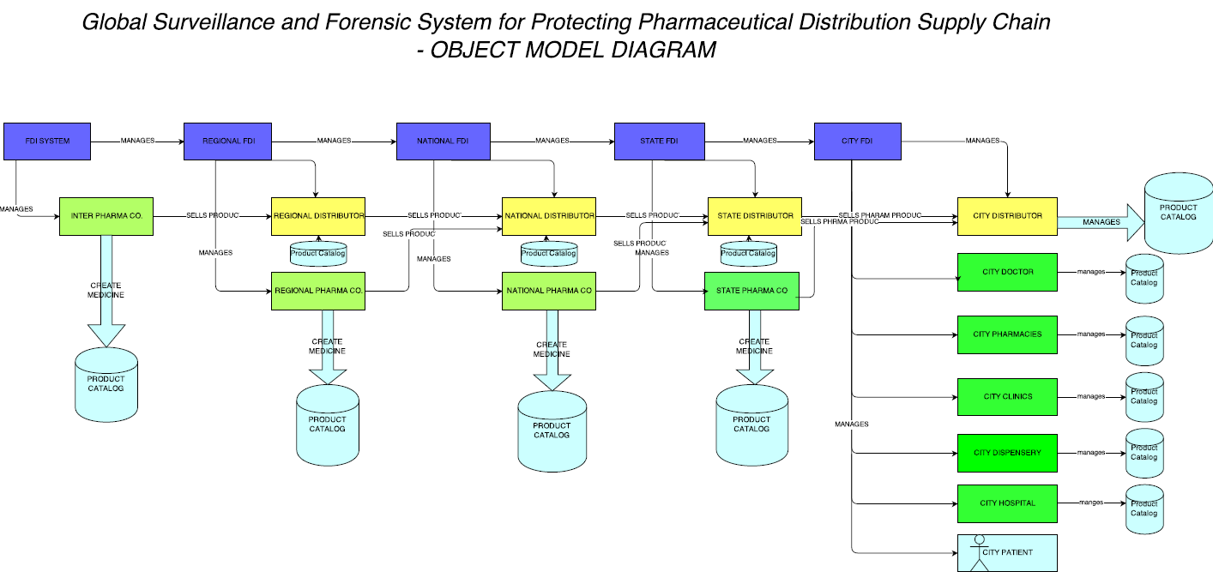

Basic Object Model:

# 

# Use cases describing the roles and responsibilities

Main Players and their roles:

1. ***Law Enforcement Agencies :***

**International Law Agencies:**

Manage Global Pharmaceutical Company, Issue Licenses to Pharma Company. Approve and Look up for Regional Level reported cases.

**Regional Law Agencies:**

Manage Regional level Pharma Company. Manage and Licensing for Regional level distributors. Approve and Look up for National level reported cases. Send unresolved cases to International level Agencies.

**National Law Agencies:**

Manage National level Pharma Company. Issue Licenses to National Level distributors. Approve and Look up for State level reported cases. Send unresolved cases to Regional level Agencies.

**State Law Agencies:**

Manage State level Pharma Company. Issue Licenses to State Level distributors. Approve and Look up for City level reported cases. Send unresolved cases to National level Agencies.

**City Law Agencies:**

Manage City level Pharma Company. Issue Licenses to City Level distributors. Approve and Look up for reported cases by patient, doctor pharmacist and other health organization. Send unresolved cases to State level Agencies.

**Pharmaceutical Company:**

View Report of tested product. Main Inventory of medication. Fulfill order of licensed distributors.

Help in giving details to law agencies as per requested. View selling product. View product Ingredients. Must hold the valid license number.

Distribute product at Global, Regional, National or State level as per company.

**Distributors:**

Maintain medication inventory. Hold valid distribution license. Create order to Pharma Company. Fulfill order of licensed lower level distributors, pharmacies, hospitals, clinics and healthcare institutes. Send call back message revert back medicines.

**Doctor:**

Check Patient. Prescribe medicine. Report cases to city law agencies in case of adverse events of medicine on patient. Order medicine product. Works at hospital or clinic.

**Patient:**

Order on counter medicine. Order prescribe medicine. Report case to city law agencies.

**Pharmacy:**

Create order. Report case to city agencies. Maintain medication inventory. Holding proper license

**Hospital:**

Create Order. Main Inventory. Report cases if adverse event on patient. Hold proper license**.** Prescribe medicine to patient. Main patient and Doctor Directory.

**Clinic:**

Create Order. Report cases if adverse event on patient. Hold proper license**.** Prescribe medicine to patient. Main patient Directory.

**Other Health Institutes:**

Create Order. Main Inventory. Report cases if adverse event on patient. Hold proper license**.** Prescribe medicine to patient. Main patient and Doctor Directory.

References:

1. Draft of Drug Distribution Security Bill.
2. <http://www.fda.gov/downloads/Drugs/DrugSafety/DrugShortages/UCM277651.pdf>
3. <http://www.deloitte.com/assets/Dcom-UnitedStates/Local%20Assets/Documents/us_lshc_SecureSupplyChain_091109.pdf>
4. <http://www.cardinal.com/us/en/community-pharmacy-advantage/solutions/supply-chain-and-pharmaceutical-distribution>
5. <http://www.avalerehealth.net/research/docs/Follow_the_Pill.pdf>