Industrial Internship Report on
”Agriculture Production prediction”
Prepared by
S.Lakshman

Executive Summary
This report provides details of the Industrial Internship provided by upskill Campus and The IoT Academy in collaboration with Industrial Partner UniConverge Technologies Pvt Ltd (UCT).
This internship was focused on a project/problem statement provided by UCT. We had to finish the project including the report in 6 weeks’ time.
My project was (Tell about ur Project)
This internship gave me a very good opportunity to get exposure to Industrial problems and design/implement solution for that. It was an overall great experience to have this internship.

TABLE OF CONTENTS
1 Preface 3
2 Introduction 4
2.1 About UniConverge Technologies Pvt Ltd 4
2.2 About upskill Campus 8
2.3 Objective 9
2.4 Reference 9
2.5 Glossary 10
3 Problem Statement 11
4 Existing and Proposed solution 12
5 Proposed Design/ Model 13
5.1 High Level Diagram (if applicable) 13
5.2 Low Level Diagram (if applicable) 13
5.3 Interfaces (if applicable) 13
6 Performance Test 14
6.1 Test Plan/ Test Cases 14
6.2 Test Procedure 14
6.3 Performance Outcome 14
7 My learnings 15
8 Future work scope 16

Preface
Summary of the whole 6 weeks’ work.
About need of relevant Internship in career development.
Brief about Your project/problem statement.
Opportunity given by USC/UCT.
How Program was planned
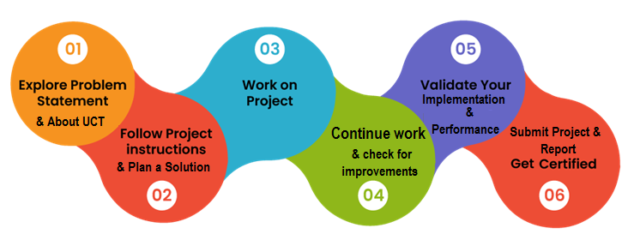
Your Learnings and overall experience.
Thank to all (with names), who have helped you directly or indirectly.
Your message to your juniors and peers.

Introduction

About UniConverge Technologies Pvt Ltd
A company established in 2013 and working in Digital Transformation domain and providing Industrial solutions with prime focus on sustainability and RoI.
For developing its products and solutions it is leveraging various Cutting Edge Technologies e.g. Internet of Things (IoT), Cyber Security, Cloud computing (AWS, Azure), Machine Learning, Communication Technologies (4G/5G/LoRaWAN), Java Full Stack, Python, Front end etc.
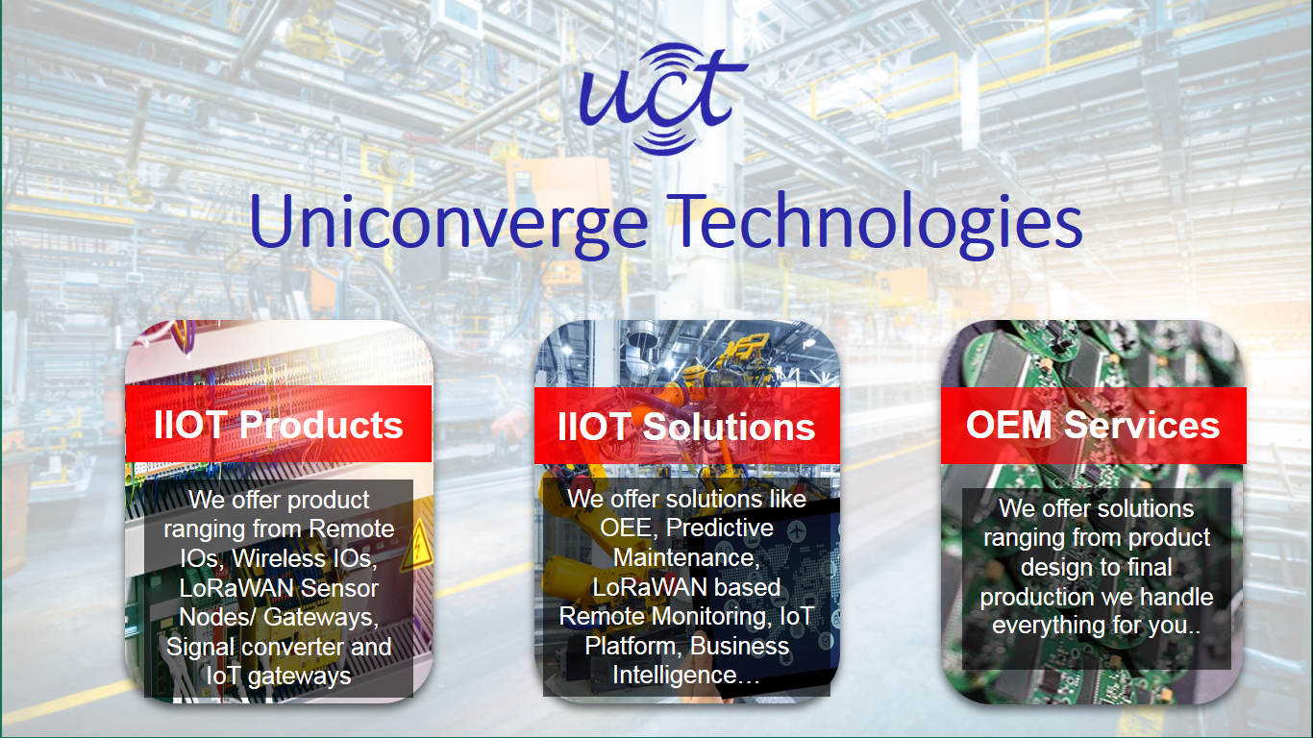
- UCT IoT Platform ()
UCT Insight is an IOT platform designed for quick deployment of IOT applications on the same time providing valuable “insight” for your process/business. It has been built in Java for backend and ReactJS for Front end. It has support for MySQL and various NoSql Databases.
- It enables device connectivity via industry standard IoT protocols - MQTT, CoAP, HTTP, Modbus TCP, OPC UA
- It supports both cloud and on-premises deployments.
It has features to
• Build Your own dashboard
• Analytics and Reporting
• Alert and Notification
• Integration with third party application(Power BI, SAP, ERP)
• Rule Engine

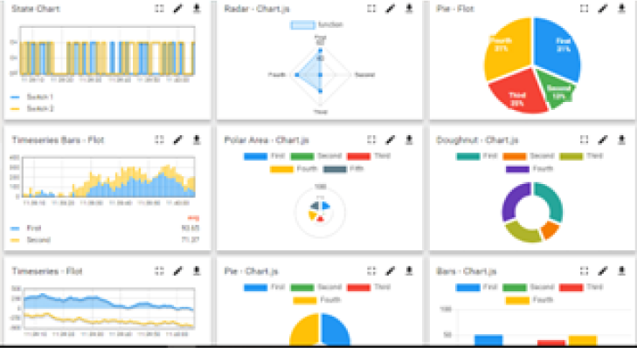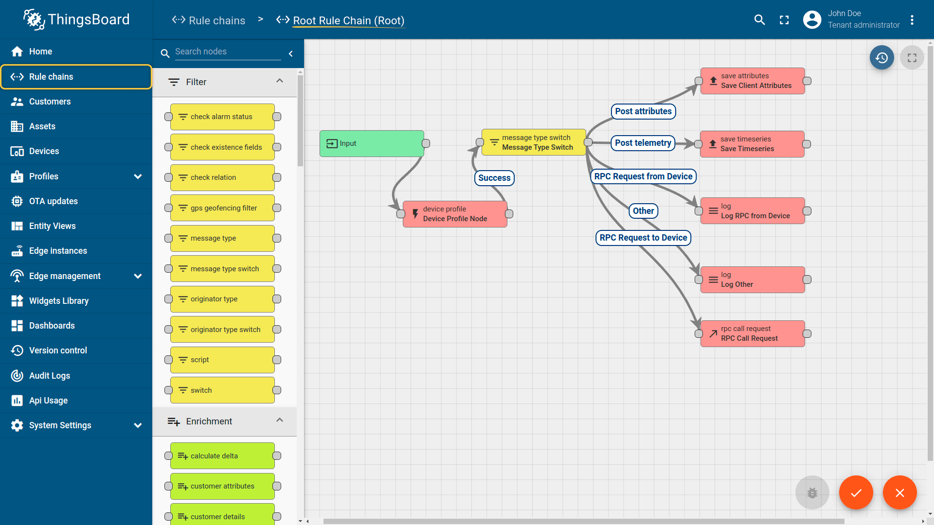

- Smart Factory Platform ()
Factory watch is a platform for smart factory needs.
It provides Users/ Factory
- with a scalable solution for their Production and asset monitoring
- OEE and predictive maintenance solution scaling up to digital twin for your assets.
- to unleased the true potential of the data that their machines are generating and helps to identify the KPIs and also improve them.
- A modular architecture that allows users to choose the service that they what to start and then can scale to more complex solutions as per their demands.
Its unique SaaS model helps users to save time, cost and money.
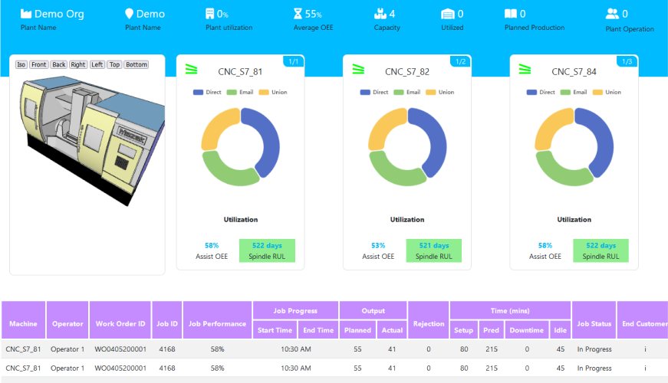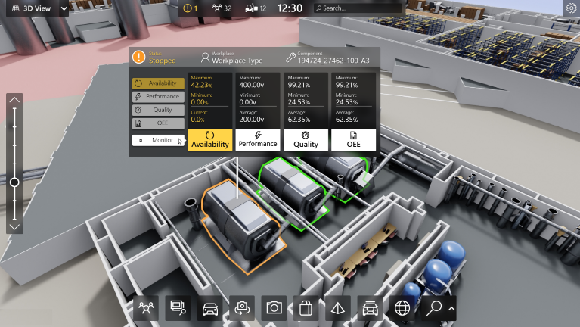

- 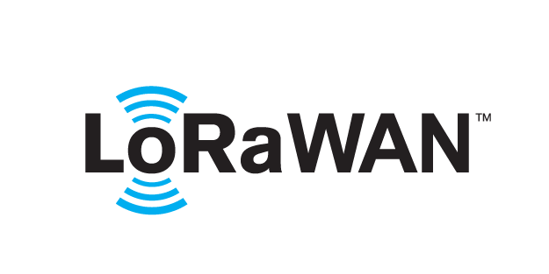 based Solution
UCT is one of the early adopters of LoRAWAN teschnology and providing solution in Agritech, Smart cities, Industrial Monitoring, Smart Street Light, Smart Water/ Gas/ Electricity metering solutions etc.
- Predictive Maintenance
UCT is providing Industrial Machine health monitoring and Predictive maintenance solution leveraging Embedded system, Industrial IoT and Machine Learning Technologies by finding Remaining useful life time of various Machines used in production process.
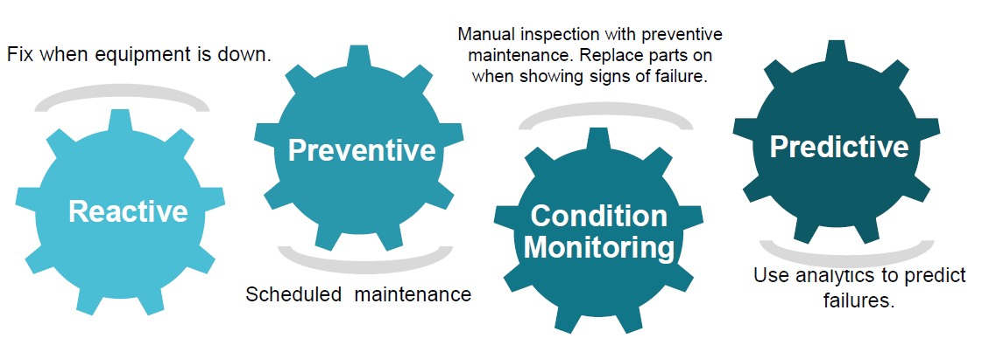

About upskill Campus (USC)
upskill Campus along with The IoT Academy and in association with Uniconverge technologies has facilitated the smooth execution of the complete internship process.
USC is a career development platform that delivers personalized executive coaching in a more affordable, scalable and measurable way.




Seeing need of upskilling in self paced manner along-with additional support services e.g. Internship, projects, interaction with Industry experts, Career growth Services
https://www.upskillcampus.com/
upSkill Campus aiming to upskill 1 million learners in next 5 year

The IoT Academy
The IoT academy is EdTech Division of UCT that is running long executive certification programs in collaboration with EICT Academy, IITK, IITR and IITG in multiple domains.

Objectives of this Internship program
The objective for this internship program was to
☛ get practical experience of working in the industry.
☛ to solve real world problems.
☛ to have improved job prospects.
☛ to have Improved understanding of our field and its applications.
☛ to have Personal growth like better communication and problem solving.

Reference
[1]
[2]
[3]

Glossary
Terms | Acronym

Problem Statement

Project : Prediction of Agriculture Crop Production in India

Context
Agricuture Production in India from 2001-2014

Content
This Dataset Describes the Agricuture Crops Cultivation/Production in india. This is from https://data.gov.in/ fully Licensed

Acknowledgements
This Dataset can solves the problems of various crops Cultivation/production in india.

Columns
Crop: string, crop name
Variety:string,crop subsidary name
state: string,Crops Cultivation/production Place
Quantity:Integer,no of Quintals/Hectars
production:Integer,no of years Production
Season:DateTime,medium(no of days),long(no of days)
Unit:String , Tons
Cost:Integer, cost of cutivation and Production
Recommended Zone:String ,place(State,Mandal,Village)

Inspiration
Across The Globe India Is The Second Largest Country having People more than 1.3 Billion.
Many People Are Dependent On The Agricuture And it is the Main Resource.
In Agricuturce Cultivation/Production Having More Problems.
I want to solve the Big problem in india and usefull to many more people

Existing and Proposed solution

Existing Solution
Traditional approaches for crop production estimation primarily rely on historical averages, manual surveys, and expert-based analysis. These methods often consider limited parameters and do not effectively capture the complex relationships between multiple factors such as crop type, region, season, cultivation cost, and yield-related attributes. As a result, predictions made using existing approaches may lack accuracy and adaptability to changing agricultural conditions.
Additionally, existing solutions do not efficiently utilize large historical datasets or advanced analytical techniques, making them less suitable for data-driven decision-making in modern agricultural practices.

Proposed Solution
The proposed solution leverages machine learning techniques, specifically a Random Forest regression model, to predict crop production using historical agricultural data. The solution involves preprocessing and integrating multiple datasets, performing feature engineering, and training a regression model capable of learning non-linear relationships between input features and crop production.
By using a data-driven approach, the proposed system provides more accurate and reliable predictions, helping stakeholders make informed decisions related to agricultural planning, resource allocation, and productivity improvement.
Code Submission (GitHub Link):
https://github.com/lakshman2006/upskillcampus/blob/master/train.py
Report Submission (GitHub Link):
https://github.com/lakshman2006/upskillcampus/blob/master/Agricultureproductionprediction_S.Lakshman_USC_UCT.pdf

Proposed Design/ Model

The proposed system follows a structured machine learning pipeline consisting of multiple stages, starting from raw data processing to final prediction output.

Design Flow
- Data collection and integration from multiple agricultural datasets
- Data preprocessing, including cleaning, encoding, and feature scaling
- Feature engineering and target variable creation
- Train–test split of the dataset
- Model training using Random Forest regression
- Model evaluation using standard performance metrics
- Final prediction and result analysis

High-Level Design
The system takes agricultural parameters such as crop type, state, season, cost, quantity, and zone as inputs and processes them through a machine learning model to predict average crop production.
Figure 1: High-Level Diagram of the System
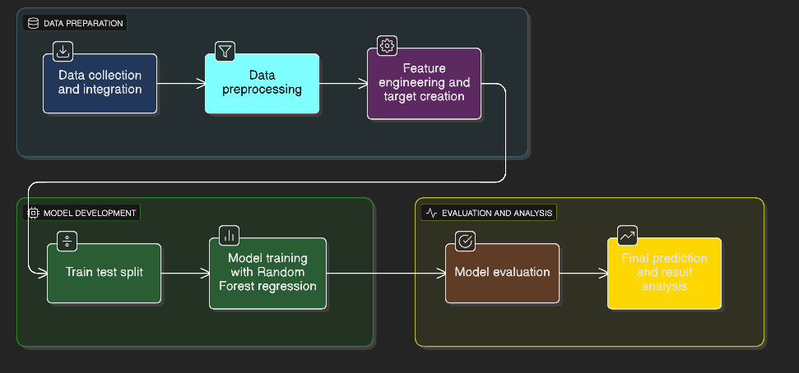

Low-Level Design
At the low level, the system performs data preprocessing operations such as categorical encoding, normalization, derived feature creation, and aggregation of year-wise production values. The processed data is then passed to the Random Forest regression model for training and prediction.

Interfaces
The system interface includes data input through CSV files and output in the form of predicted production values and evaluation metrics. The workflow is implemented using Python libraries such as pandas, NumPy, and scikit-learn.

Performance Test

Performance testing was conducted to evaluate the effectiveness and reliability of the proposed machine learning model.

6.1 Test Plan / Test Cases
- Validate data preprocessing and feature transformation
- Train the Random Forest model on training data
- Evaluate predictions on unseen test data
- Measure accuracy using regression performance metrics

6.2 Test Procedure
The dataset was split into training and testing subsets. The Random Forest regression model was trained using the training data, and predictions were generated on the test dataset. Performance metrics were calculated to assess prediction accuracy.

6.3 Performance Outcome
The model performance was evaluated using:
- Mean Absolute Error (MAE)
- Root Mean Squared Error (RMSE)
- R² Score
The results indicate that the Random Forest model effectively captures patterns in agricultural data and provides reliable predictions of crop production.

My learnings

This internship provided valuable hands-on experience in applying machine learning techniques to real-world agricultural data. I gained a strong understanding of data preprocessing, exploratory data analysis, feature engineering, and regression modeling. Working with Random Forest helped me understand how ensemble learning techniques improve prediction accuracy and handle complex datasets.
The project also enhanced my problem-solving skills, Python programming proficiency, and ability to interpret model performance metrics. Overall, this experience strengthened my confidence in developing end-to-end machine learning solutions.

Future work scope
This internship provided valuable hands-on experience in applying machine learning techniques to real-world agricultural data. I gained a strong understanding of data preprocessing, exploratory data analysis, feature engineering, and regression modeling. Working with Random Forest helped me understand how ensemble learning techniques improve prediction accuracy and handle complex datasets.
The project also enhanced my problem-solving skills, Python programming proficiency, and ability to interpret model performance metrics. Overall, this experience strengthened my confidence in developing end-to-end machine learning solutions.

