What is Java?

|  |
| --- |
| 1. Java is a general-purpose object-oriented programming language. |

**Features**

1. Java is an object-oriented programming language
2. Java is compiled-interpreted programming language (or a two-stage system)
3. Java platform-independent programming language
4. Java robust and secure programming language
5. Java is distributed programming language
6. Java is multithreaded programming language
7. Java is simple & familiar language.
8. Java is dynamic and extensible programming language.

What is a language?

|  |
| --- |
| It is a medium which is used to communicate/interact with others |

What is a programming language?

|  |
| --- |
| It is also a medium which is used to communicate/interact with a computer. |

What is the difference between a language and a programming language?

|  |  |
| --- | --- |
| Language (English) | Programming language(Java) |
| In English we have 26 characters | Java supports Unicode character set |
| We form words by using characters  Ex: java, learning, we, I, am, are, playing, cricket, watching, tv. | We form tokens by using characters  int, float, 100, “madhu”, ‘a’, 100.50, = , , , ;, *, &, +,/, a |
| We can form sentences by using words  Example: I am watching cricket.  I am learning java. | We can form statements by using tokens.  Ex: int a=100;  Ex: String name=”SambaSiva”; |
| We can form a paragraph by using sentences | We can write a program by using statements.  Example:  class One{  public static void main(String args[]){  int a=100,b=200,c=0;  c=a+b;  System.out.println(“Welcome”);  }  } |
| We can write or form essay, article, stories, circular etc.. | We can develop a s/w by using programs. |

What is a program?

|  |
| --- |
| 1. Collection of statements or instructions or commands |

What is a Unicode value?

|  |
| --- |
| It is a number which is allotted to every character of the Unicode character set. In C or C++ this value is called as ASCII value. |

What is the use of Unicode or ASCII value?

|  |
| --- |
| Used to convert characters into binary code (computer understandable code) |

What is a token?

|  |
| --- |
| 1. Each and every individual unit in a program is called as a token 2. We can form a token by using characters |

What is a statement?

|  |
| --- |
| It is an instruction or instructions given to a computer. |

What is a software?

|  |
| --- |
| Collection of programs |

Types of software?

|  |
| --- |
| There 2 types of software   1. System s/w 2. Application s/w |

1. What is system s/w?

|  |
| --- |
| **1. System software** is a type of computer software designed to manage and control hardware components, provide a platform for application software, and facilitate the overall operation of a computer system.  2. It acts as an intermediary between hardware and user applications, ensuring smooth functioning.  **Types of System Software:**   1. **Operating System (OS):** Manages hardware resources, provides a user interface, and runs application software.    * Examples: Windows, macOS, Linux, Android, iOS 2. **Utility Software:** Helps in system maintenance and performance optimization.    * Examples: Antivirus software, disk cleanup tools, file compression software 3. **Device Drivers:** Allow the OS to communicate with hardware components.    * Examples: Printer drivers, graphics card drivers 4. **Firmware:** Embedded software stored in hardware devices to control their functions.    * Examples: BIOS, router firmware 5. **Language Translators:** Convert programming code into machine code for execution.    * Examples: Compilers, Interpreters, Assemblers   **BIOS (Basic Input/Output System)**  BIOS is firmware stored on a small memory chip on the motherboard of a computer. It is responsible for initializing and testing hardware components during the boot process before handing control over to the operating system.  **Functions of BIOS:**   1. **Power-On Self Test (POST):** Checks if essential hardware (RAM, CPU, keyboard, etc.) is functioning properly. 2. **Bootstrap Loader:** Locates and loads the operating system from storage (HDD, SSD). 3. **BIOS Setup Utility:** Allows users to configure system settings such as boot order, date/time, and hardware configurations. 4. **Driver Initialization:** Provides basic drivers for input/output devices (keyboard, display, storage). 5. **Security Features:** May include password protection and secure boot settings.   **Modern Alternative to BIOS:**  BIOS has largely been replaced by **UEFI (Unified Extensible Firmware Interface)**, which offers faster boot times, better security, and support for larger storage drives. |

What is firmware?

|  |
| --- |
| **Firmware**  Firmware is a specialized type of **software** that is embedded into **hardware devices** to control their functions. It acts as the **bridge between hardware and software**, enabling the hardware to operate as intended. Unlike regular software, firmware is stored in **non-volatile memory** (such as ROM, EEPROM, or Flash memory) and remains on the device even when it is powered off. |

What is volatile memory?

|  |
| --- |
| Temporary  Ex: RAM |

What is non-volatile memory?

|  |
| --- |
| Permanent memory  Ex: ROM, EEPROM, flash memory, hard disk, SSD |

What is application software?

|  |
| --- |
| Application software is a type of computer program designed to perform specific **tasks** or **functions** for users. It runs on top of **system software** (such as an operating system) and helps users accomplish tasks like writing documents, browsing the web, or editing photos.  **characteristics of Application Software:**  ✅ **User-Oriented:** Designed for end-users to perform specific tasks. ✅ **Runs on System Software:** Requires an operating system to function. ✅ **Customizable:** Some applications allow users to modify settings based on their needs. ✅ **Variety of Types:** Available in different categories like productivity, entertainment, business, and education.  **Types of Application Software:**   1. **Productivity Software** – Helps users complete work-related tasks.    * 📄 **Examples:** Microsoft Word, Excel, Google Docs, Notepad 2. **Web Browsers** – Allows users to access the internet.    * 🌐 **Examples:** Google Chrome, Mozilla Firefox, Microsoft Edge 3. **Multimedia Software** – Used for creating and editing audio, video, and images.    * 🎬 **Examples:** Adobe Photoshop, VLC Media Player, iMovie 4. **Communication Software** – Facilitates messaging and video calls.    * 💬 **Examples:** WhatsApp, Zoom, Microsoft Teams 5. **Business Software** – Helps businesses manage operations.    * 💼 **Examples:** SAP, QuickBooks, Salesforce 6. **Gaming Software** – Designed for entertainment and interactive gameplay.    * 🎮 **Examples:** PUBG, Minecraft, FIFA 7. **Education Software** – Helps in learning and teaching.    * 📚 **Examples:** Duolingo, Khan Academy, Coursera 8. **Antivirus Software** – Protects devices from malware and threats.    * 🛡 **Examples:** Norton, McAfee, Avast |

What is a translator?

|  |
| --- |
| A translator is a program or a software which translates high level languages into machine language.  **There are 3 types of translators**   1. Compiler (used to translate high-level languages into machine code) 2. Interpreter (used to translate high-level languages into machine code) 3. Assembler (used to translate assembly language into machine language) |

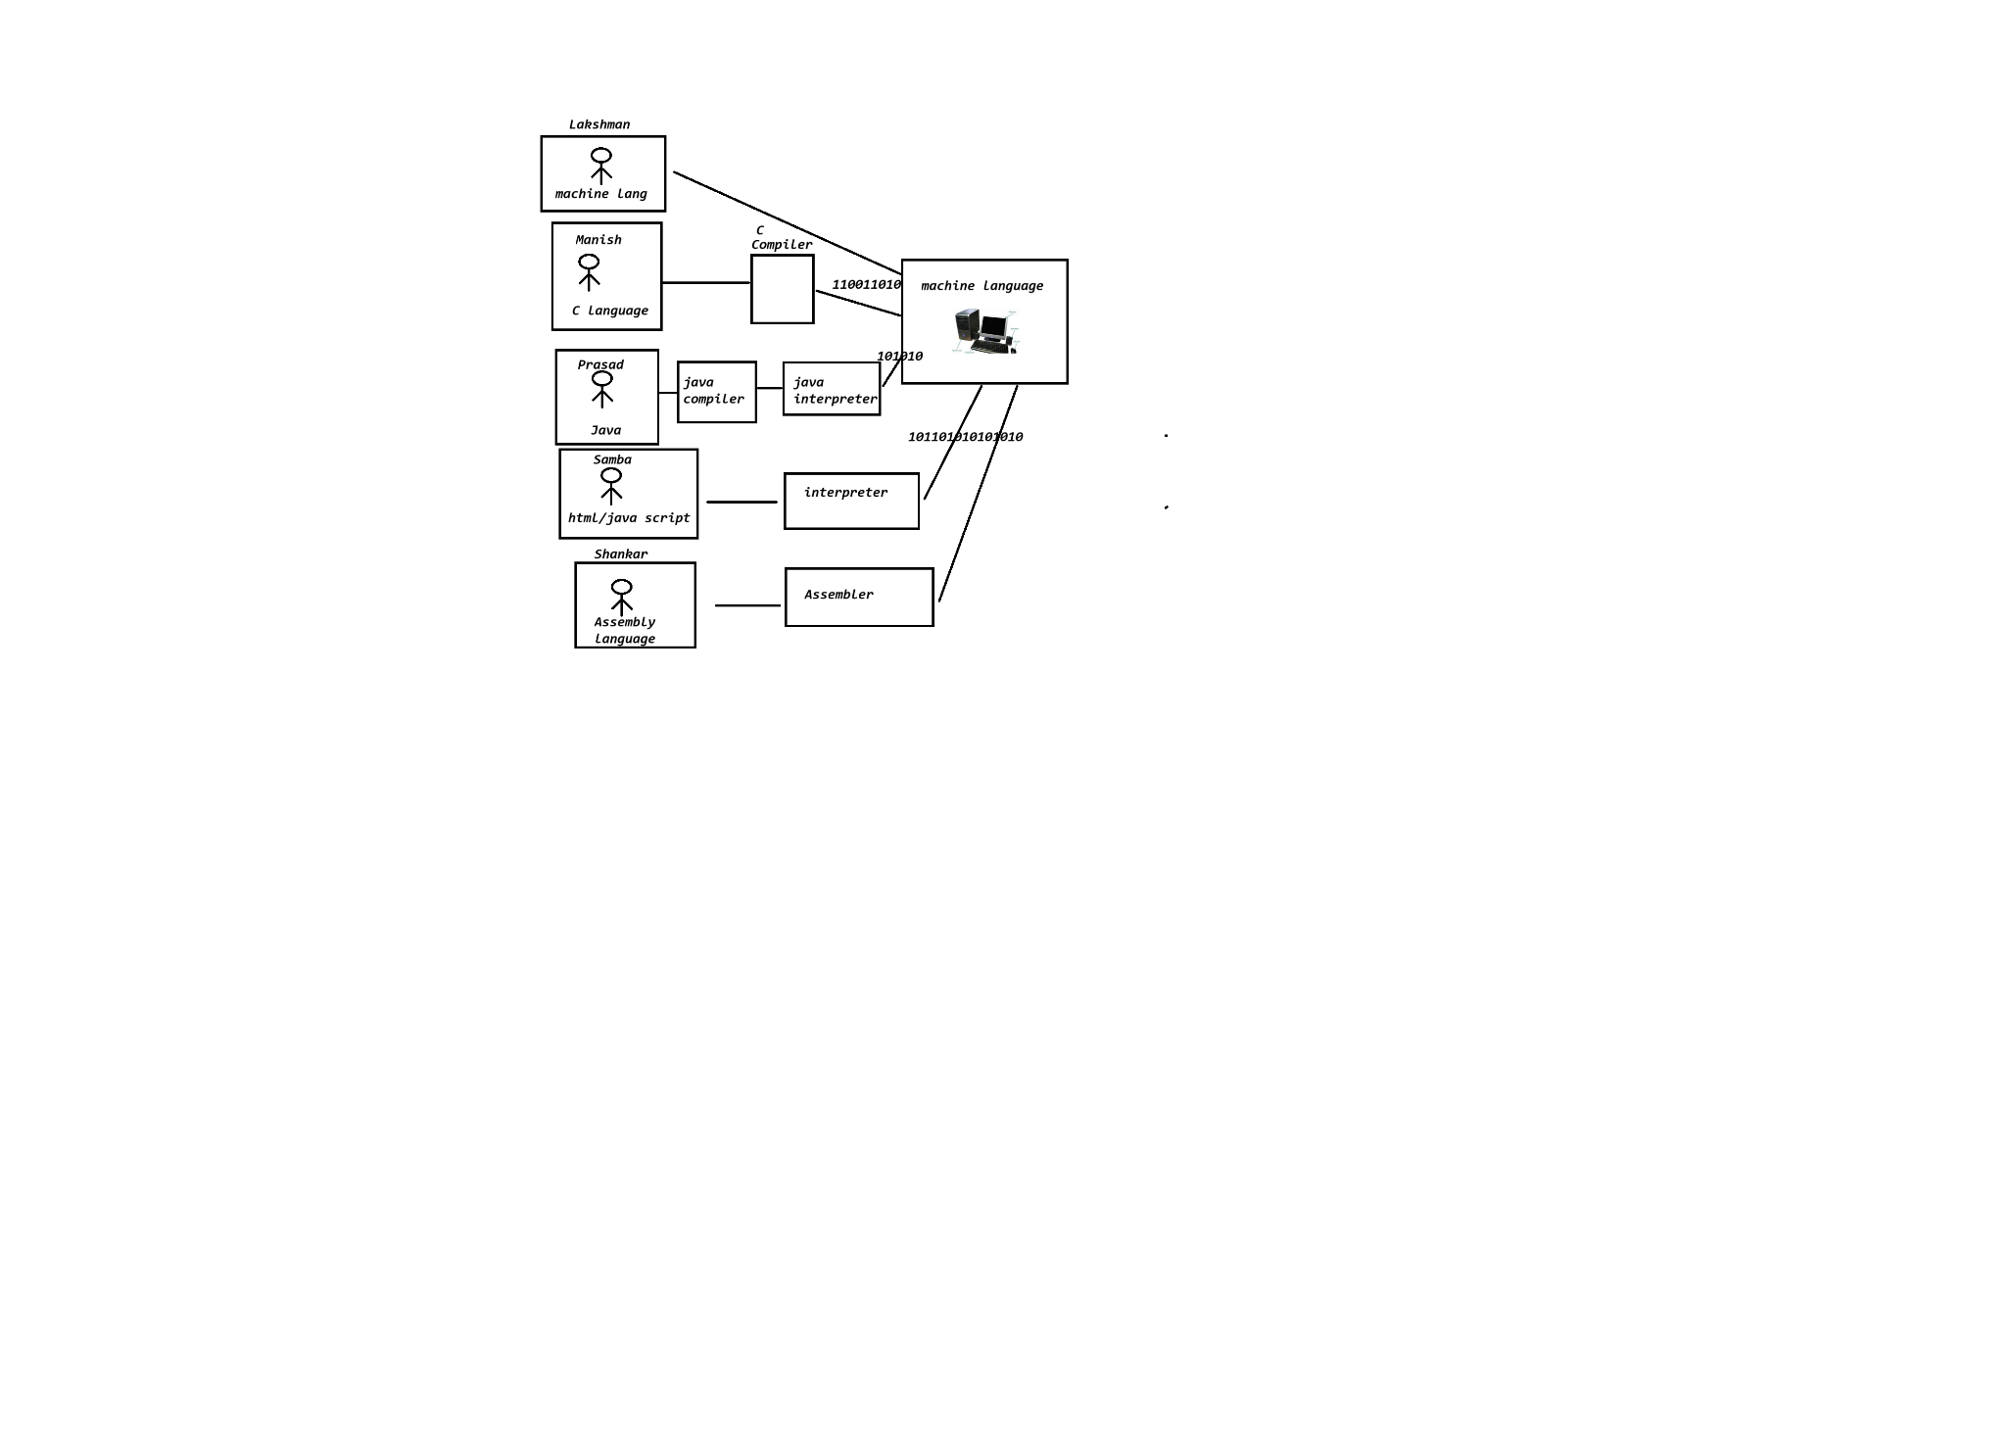

Who invented Java?

|  |
| --- |
| 1. James Gosling invented java in 1991 in a company called Sun Micro Systems of U.S.A and its initial name is “oak” named by James Gosling. 2. In 1992 java people invented a remote controller called “*7” 3. Oak was renamed as Java because of some legal problems in 1995 4. In 1995 1st version of Java was released with a feature called “WORA”. 5. In 2010 Jan oracle company purchased Java 6. **JDK** 23 is the latest version of Java 7. Other team members of Green Team who invented Java are    1. Patrick Naughton    2. Chris warth    3. Mike sheridon    4. Ed frank |

WORA: Write Once Run Anywhere

How java program executes?

What is the job of java compiler?

|  |
| --- |
| 1. *it checks about syntax errors in our program.* 2. *if errors found it displays those errors without performing translation* 3. *if no errors are found then it translated the source code into byte code.* 4. *It puts the translated code in one or more .class files.* |

Compiler mannerism?

|  |
| --- |
| 1. It can check for syntax errors 2. It displays all the errors at a time 3. It translates the total code at a time 4. It also puts the translated code in one or more files or in a buffer(temporary storage area) |

Interpreter mannerism?

|  |
| --- |
| 1. It translates and executes line by line 2. It won’t store the translated code anywhere 3. The translated code(line) will be directly given to processor to execute. 4. It displays only one error at a time. 5. If we got an error the program will be terminated from the statement where the error is occurred.   **Advantage** |

**C or C++ program execute process**

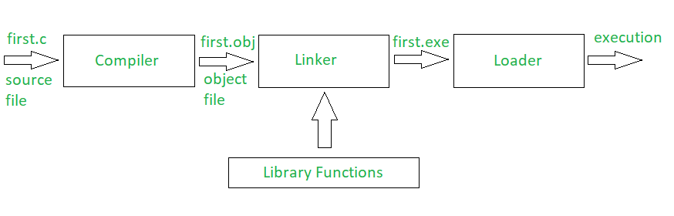

Program execution flow

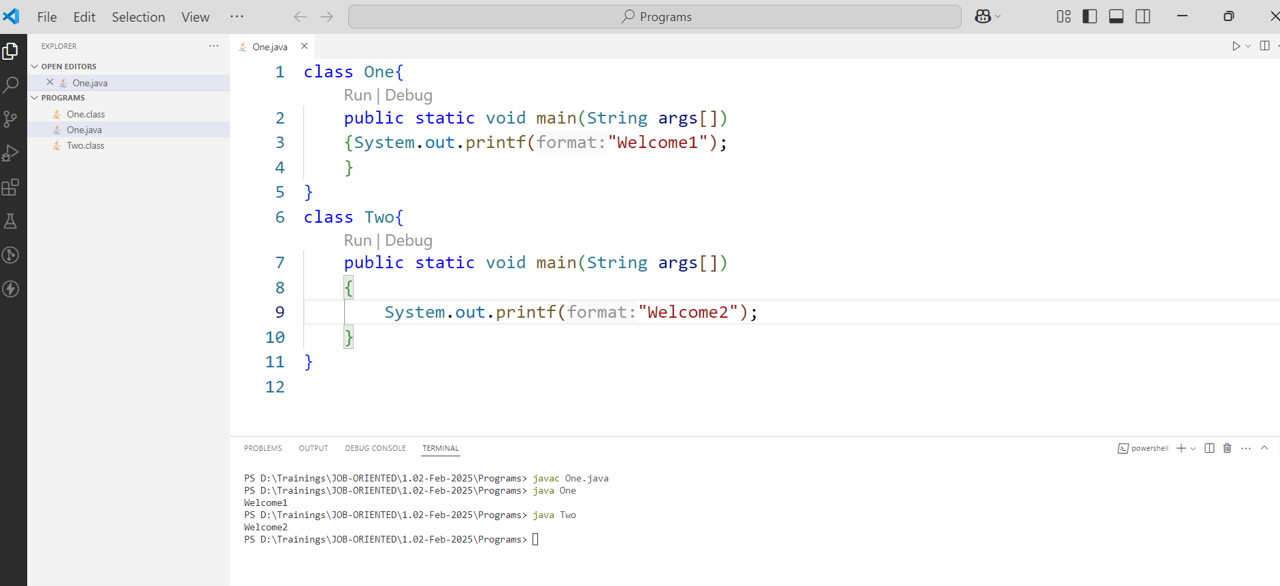

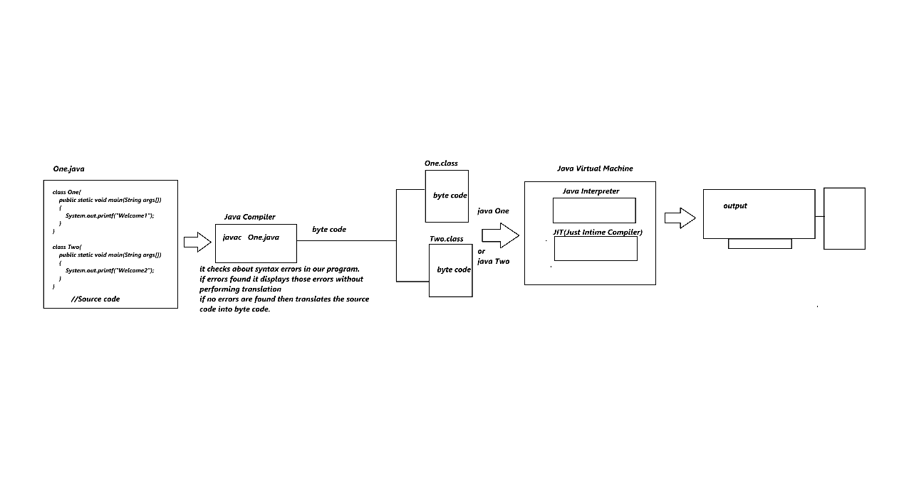

What is the use of JIT compiler?

|  |
| --- |
| 1. It is a partial compiler, which was introduces to make the program execute little bit faster especially while executing looping statements. 2. It puts the translated code in a buffer whenever the iterative statement(looping stmt) executes first. From next time onwards it directly executes the code from buffer so program execution becomes faster. |

What is the command to compile the code?

|  |
| --- |
| We use javac <file-name> command to compile the program  javac One.java  we are invoking the compiler using javac command and telling it to compile the One.java program. |

What is the command to run the program?

|  |
| --- |
| Syntax: java <.class file name which contains main method>  Example: java One  Exampl2: java Two |

Why Java is called as Object-Oriented Programming Language?

|  |
| --- |
| If a language supports Object Oriented Programming Concepts, then that programming language is called as Object-Oriented Programming Language.  **OOP’s concepts are**   1. Class 2. Object 3. Data Abstraction & Encapsulation 4. Polymorphism 5. Inheritance |

What is byte code?

|  |
| --- |
| JVM understandable code |

Why byte code is called as byte code?

|  |
| --- |
| It is called as byte code because each character existed in .class file occupies 1 byte memory so it is called as byte code. |

Why Java is called as platform independent programming language?

|  |
| --- |
| Once the program is compiled byte code will be generated we can run that byte code (which is generated after compiling the source code) in any operation system(OS). |

What is automatic memory management?

|  |
| --- |
| 1. Java supports automatic memory management so allocated memory will be de-allocated automatically by the Garbage collector. |

What is heap memory?

|  |
| --- |
| 1. Heap memory also called as dynamic memory 2. Heap memory is expandable memory whenever needed. 3. Once the memory is allocated in heap it won’t get deleted automatically |

What is JVM memory?

|  |
| --- |
| 1. Whenever we invoke the JVM, then it occupies some part of the RAM, It is called as JVM memory 2. JVM memory is divided into 5 parts    1. Method Area    2. Heap Memory    3. Java Stack Memory    4. PCR (Program Counter Register)    5. Native Method Stacks |

What is GC (Garbage Collector)?

|  |
| --- |
| 1. It is used to allocate and de-allocate from the heap memory. |

What is the starting point of the java program?

|  |
| --- |
| Main method is the starting point of the program |

Can I write a main() method outside the class?

|  |
| --- |
| 1. No 2. In Java we have to write every statement inside the class except import statement and package statement |

What is keyword?

|  |
| --- |
| 1. It is a pre-defined word 2. Every keyword has a meaning and used for a specific purpose   If is a keyword used to write conditions  byte,short,int,long,float,double, char and boolean are used to declare a variable.  for is a keyword used to write iterative statement(looping statement) |

List of tokens supported by java

|  |
| --- |
| 1. Keyword 2. Identifier 3. Operator 4. Literal 5. Separator 6. Comments |

Example:

|  |
| --- |
| //public :  keyword  //class: keyword  //Two: Identifier  //{ :  special symbol or separator  //static: keyword  //void: keyword  //main: identifier  //(),[]: separators  //String: identifier  //args: identifier  public class Two {          public static void main(String[] args) {              //int: keyword              //a is an identifier              //= is an operator              //100 is a literal              //; is a separator or special symbol              int a=100;              int b=200;              int c=a+b;              System.out.println(c);          }  }  Output:  300 |