**Name: Lakshmana Kumar Mettu**

**Class ID: 11**

**Introduction:**

* This ICP would help you to get insights on how JSON data extracting using API's in android.
* And It will help understand how async class is used in android to handle the errors along with using list view and adapter class.

**Programming elements:**

* Android Studio
* Android Emulator

**Objective:**

* The main objective of this task are given below.

1. The main activity must show list of earthquakes using USGS Earthquake API.
2. And when user click on any earthquake info it will redirect to corresponding ur in USGS website.

* It has four Activities.

1. **Earthquake.java**

* Defines the required information using get request for location, time, magnitude and get request to obtain the URL.
* Code snippets for Earthquake.java is given below.

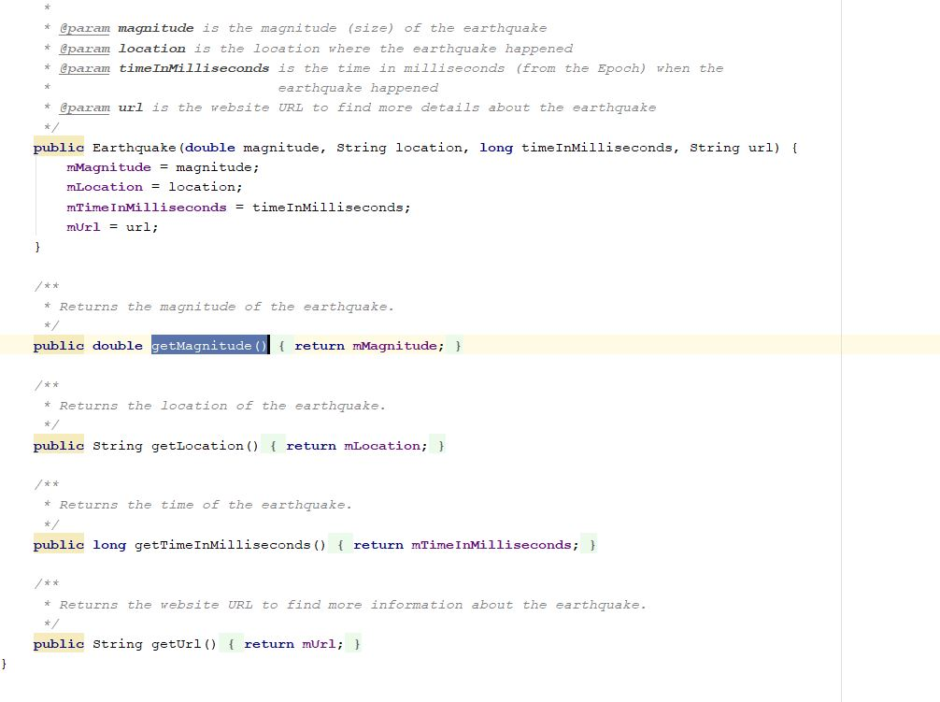

1. **EarthquakeActivity.java**

* It is used to define the API URL to obtain earthquake list.
* It contains the list view in order to view the earthquake data into list format.
* It has async task to handle the errors while obtaining the json response from URL String.
* It redirects to Queryutils.java to get the required data.
* It uses the adapter class also. The description for this is given below.
* Corresponding code is shown below.

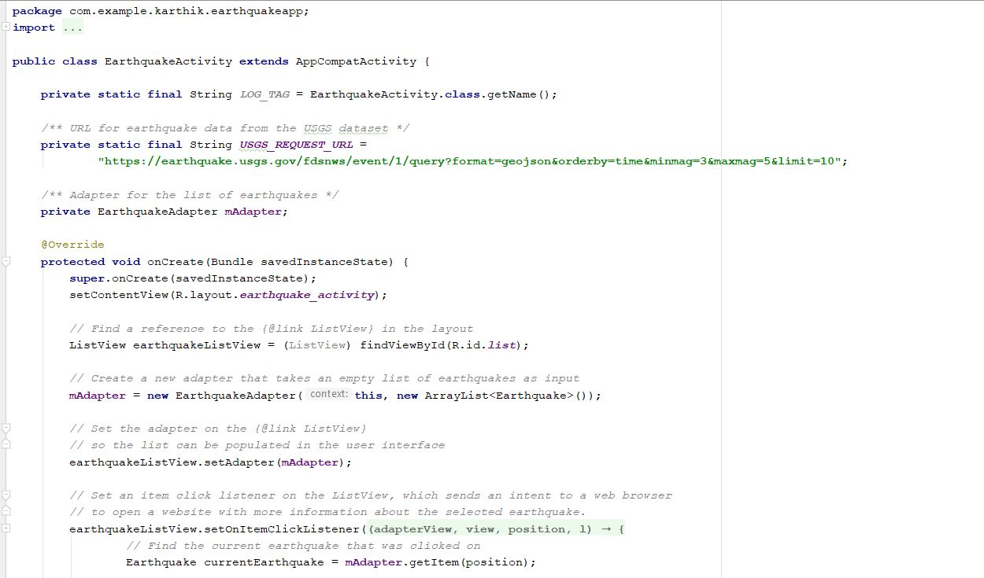

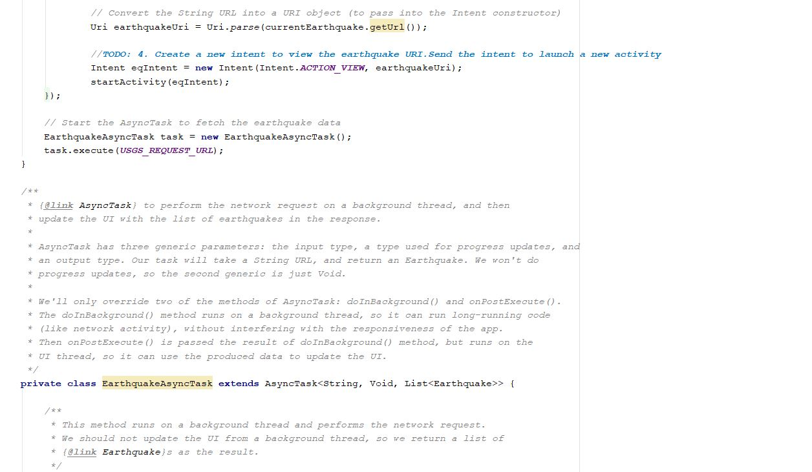

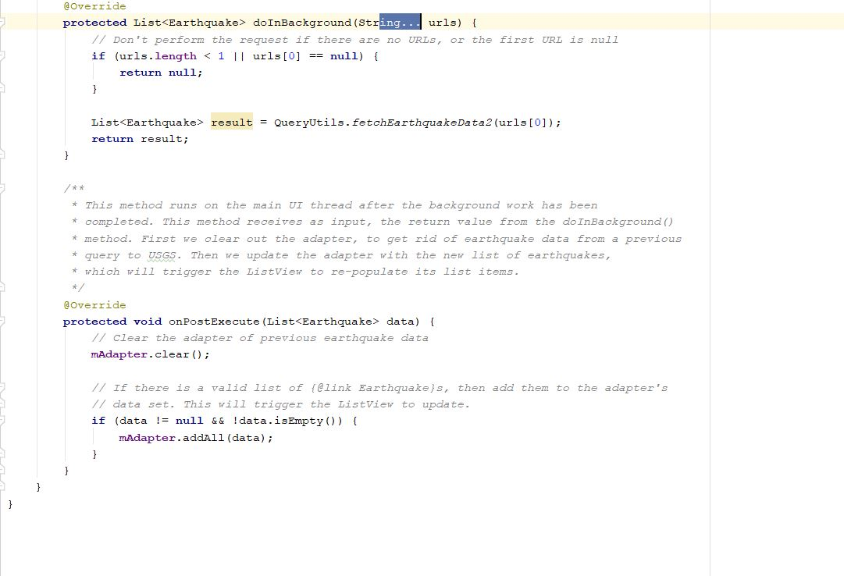

1. **EarthquakeAdapter.java**

* The main function of Adapter is used to convert the data to list view.
* Here It directs earthquake data to earthquake list.
* Code snippet is shown here.

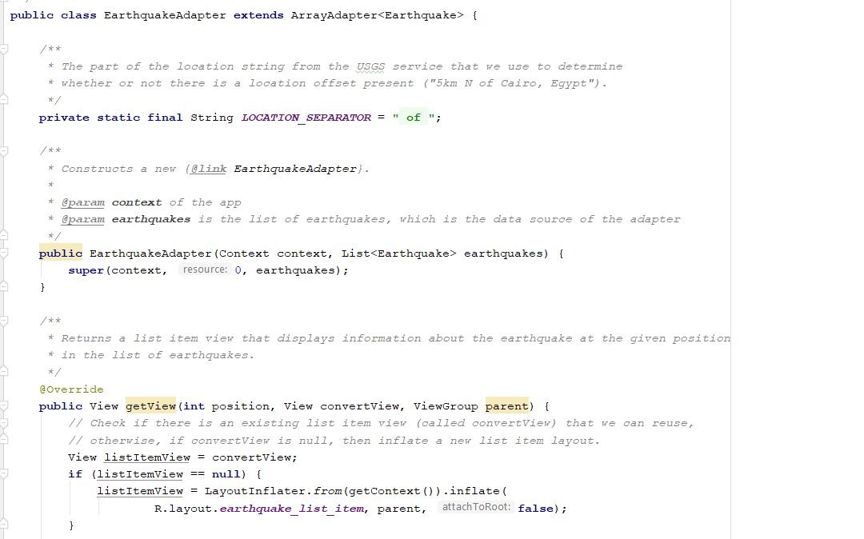

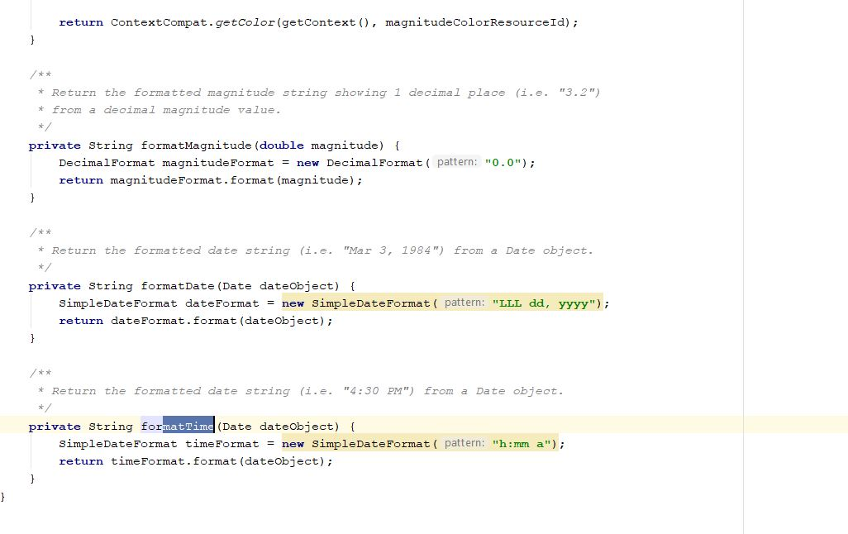

**4.Queryutils.java**

* It plays a major role in this task.
* Usually It converts the URL String to JSON data using get url request.
* Similarly It will obtain time,location,magnitude for particular earthquake using get json request.
* Code snippets are given below.

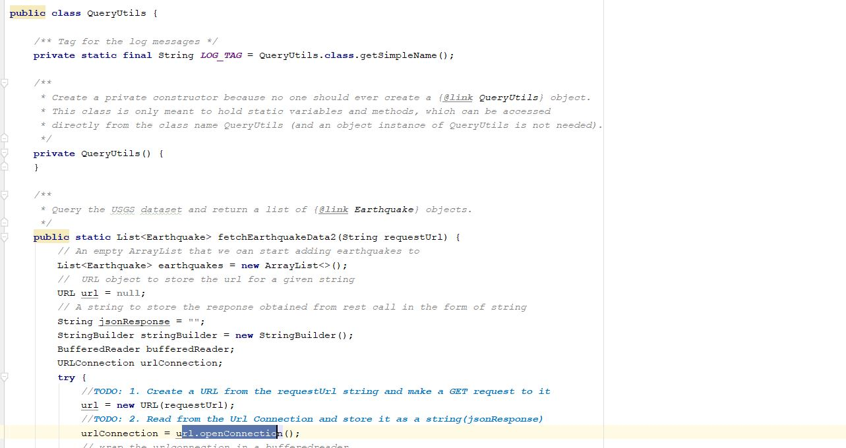

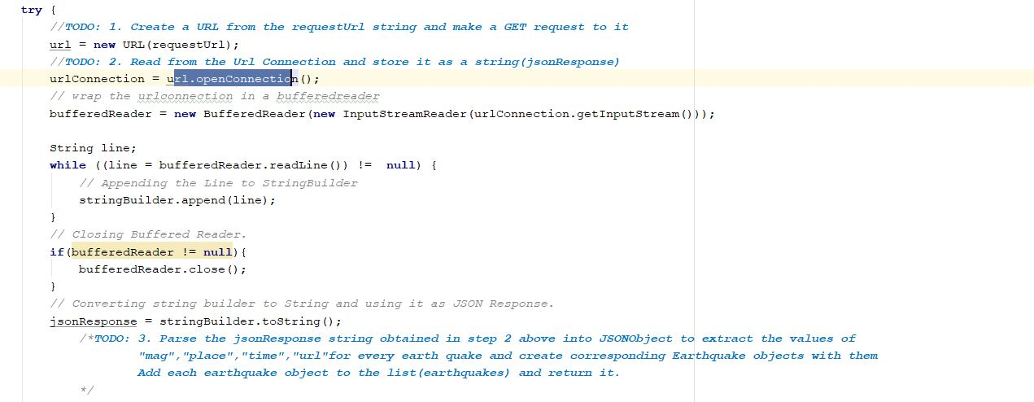

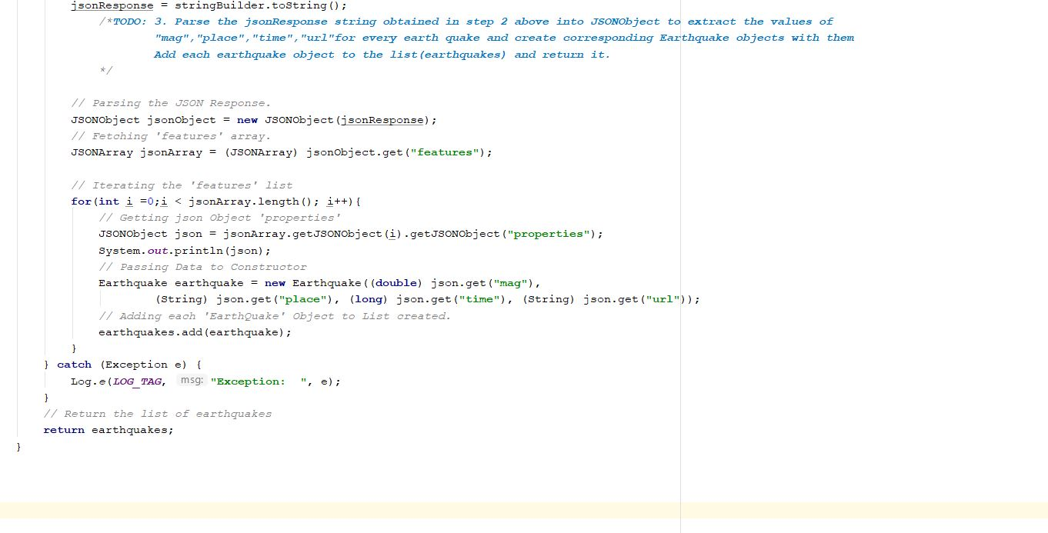

* And Accessing internet using manifest.xml file shown below.

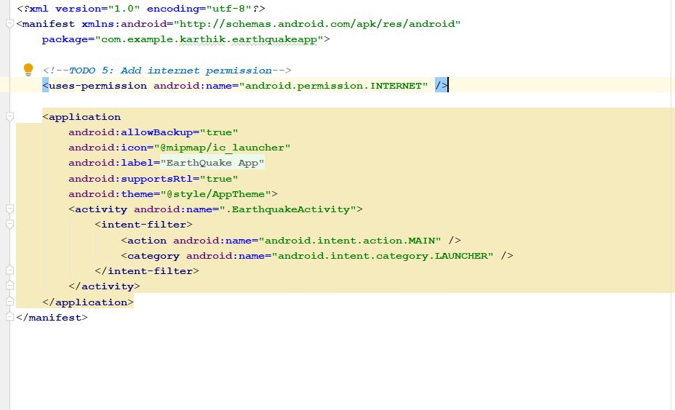

* Corresponding outputs to show the list of earthquake information and when user click on particular earthquake, fetching the respective URL are given below.

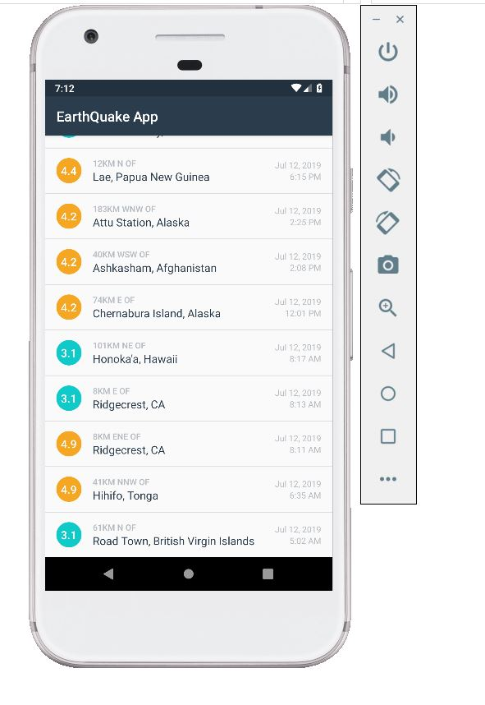

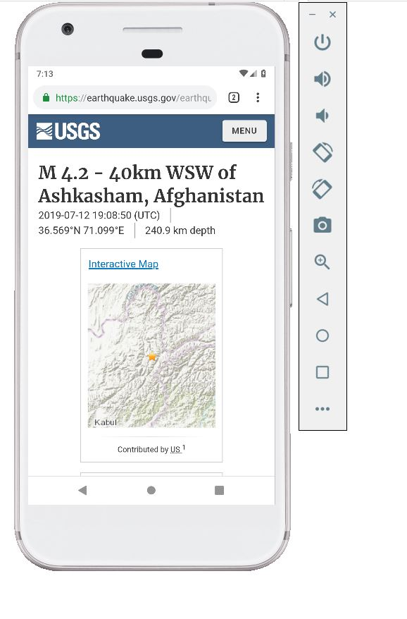

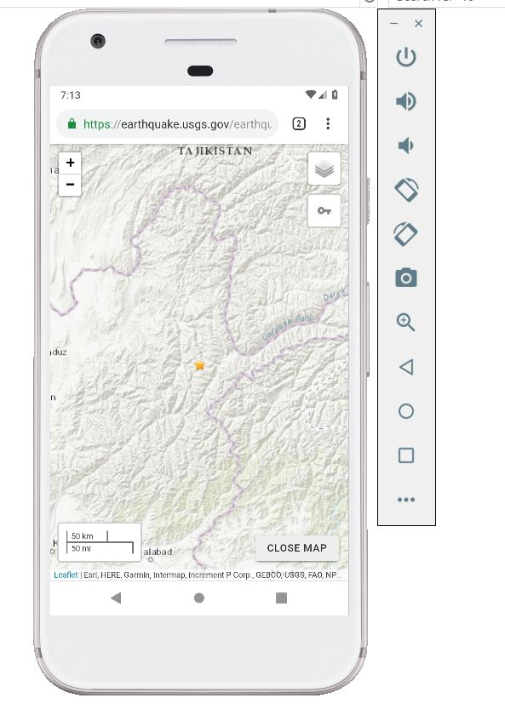

**Conclusion:**

* Hence Using this application learnt how to fetch the json data using API's and handling errors using async task along with parsing json data.