**Name: Lakshmana Kumar Mettu**

**Class ID:11**

**Introduction:**

* This ICP is got to know about usage of API's like google maps and usage of components like sensors, accelerometer sensor in android devices.

**Programming elements:**

* Android Studio
* Google Maps API

**Objective:**

* Display the user current location
* Providing line from source to destination on maps using google API
* Using Accelerometer sensor providing readings
* The corresponding code snippets for this ICP is given below.
* My maps activity which is having google API along with key is shown below.

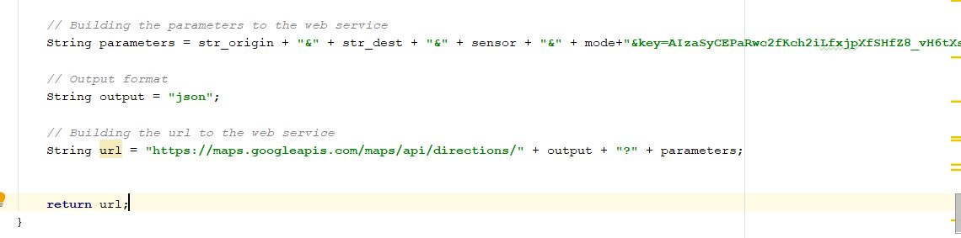

* Accelerometer activity to obtain the parameters like x,y,z readings shown below.

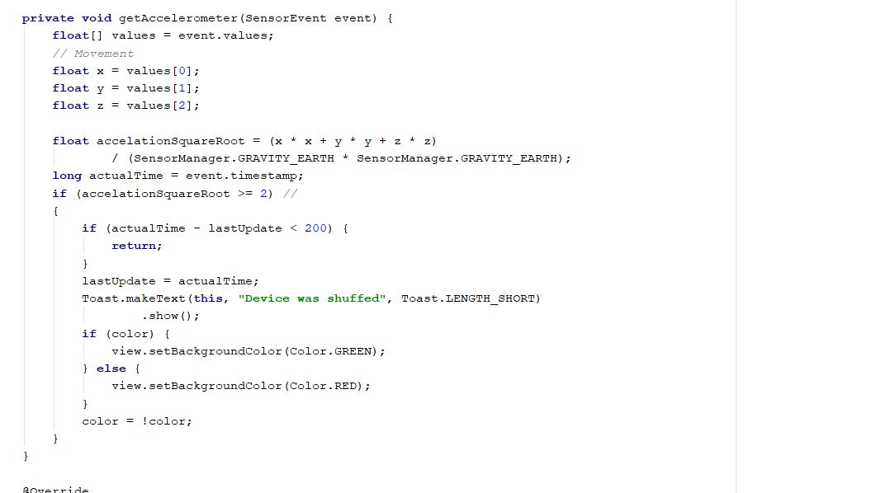

* Main Activity which uses the onclick location method to display user current location and providing the line from source to destination given below.

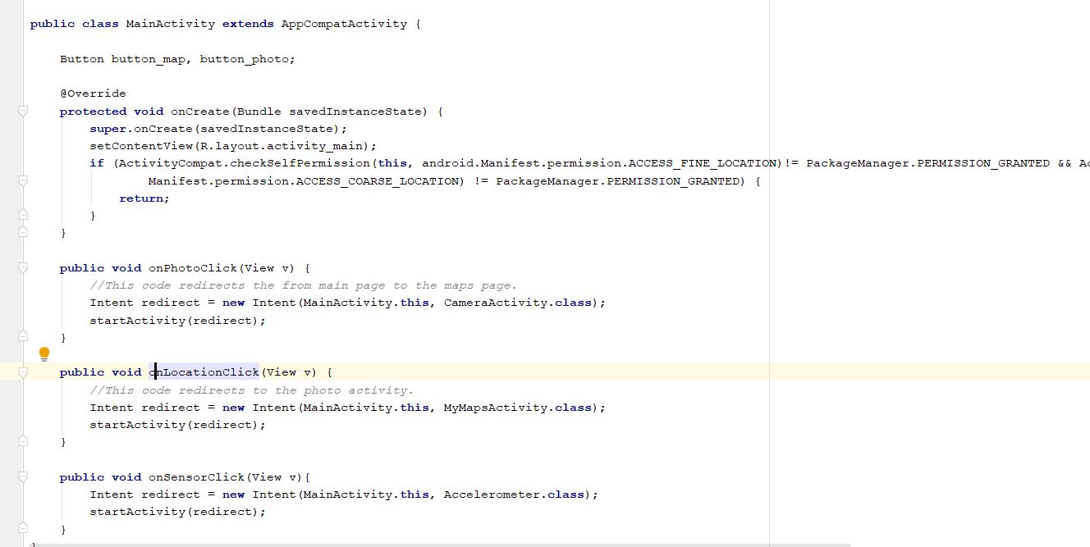

* It has additional feature like usage of camera in order to get snaps.

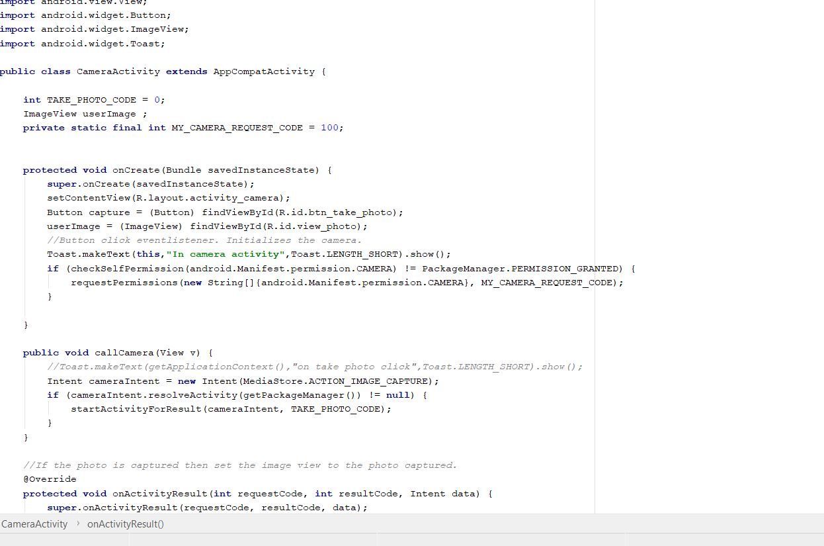

* Google maps API obtaining method

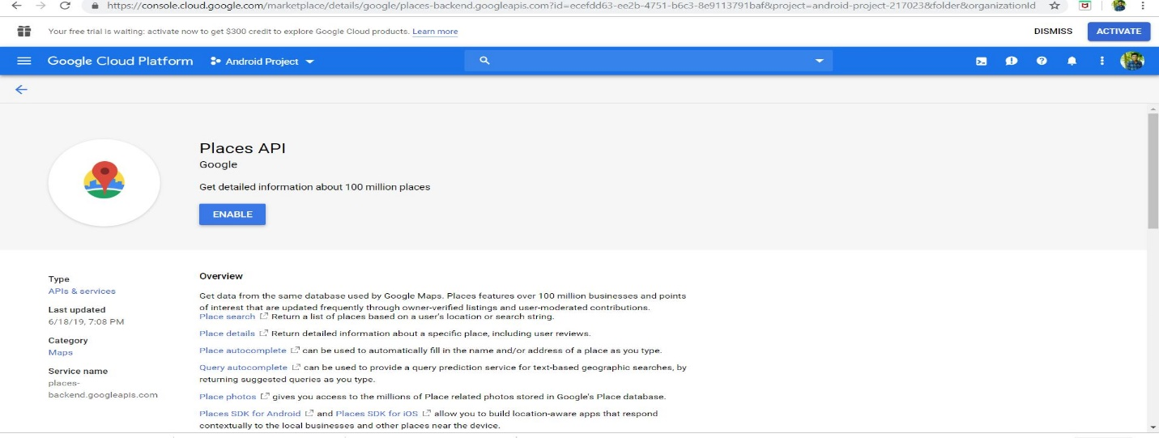

**Output:**

* Displaying current location of user with marker

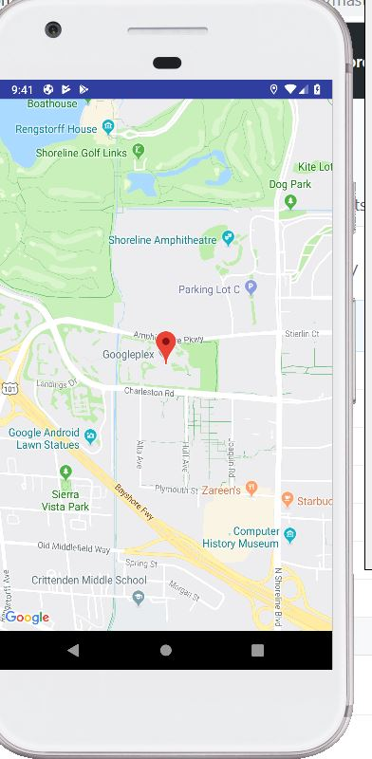

* Providing line from required point lo location

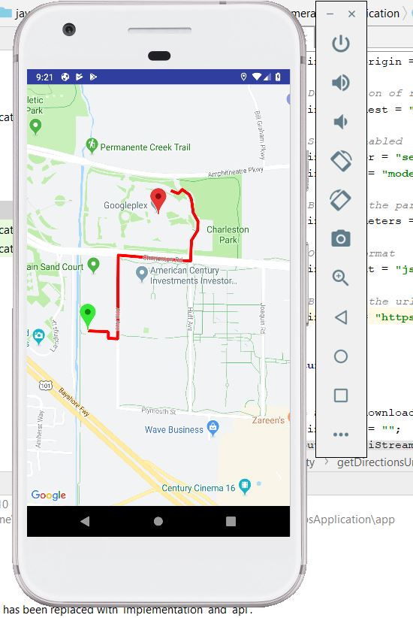

* Displaying accelerometer sensor readings like x,y,z readings

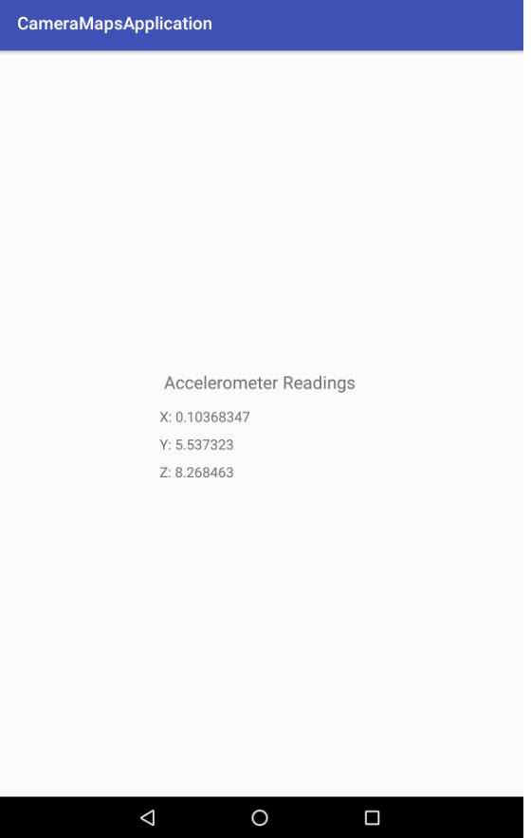

**Conclusion:**

* Hence learnt how to use API's and sensors in android devices and developed an application using android studio.