**Name: Lakshmana Kumar Mettu**

**Class ID: 11**

**Introduction:**

* This ICP is to know about fire-base connections and sample database connections and also adding features for the real time database in android applications.

**Programming elements:**

* Android Studio
* Firebase Database
* SQLite Database

**Part-1 Objective:**

* The main objective of part-1 is to implementation of update and delete functionalities for employee and employer given in source code.
* For this task I am using SQLite database to store the details of both employee and employer before updating and after updating.
* The corresponding code snippets and output screen shots for Part-1 is given below.
* Both has search and save buttons.
* The main activity which connects to database shown below.

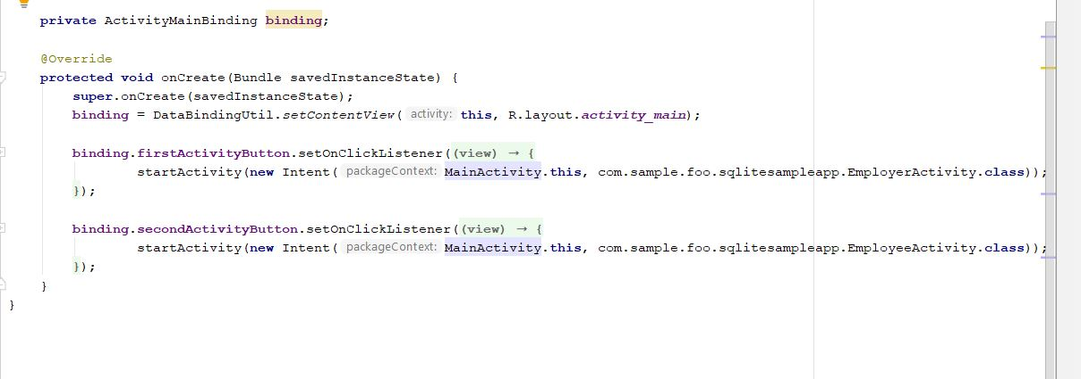

* Implementation of delete and update functionalities in employee and employer are shown below.

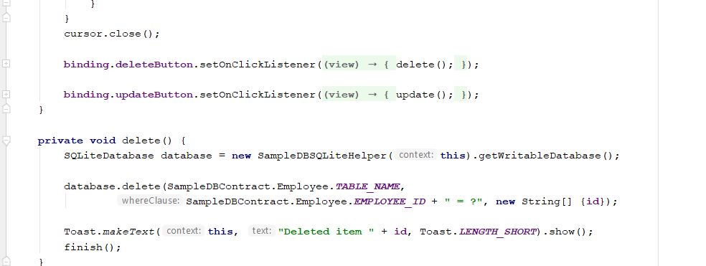

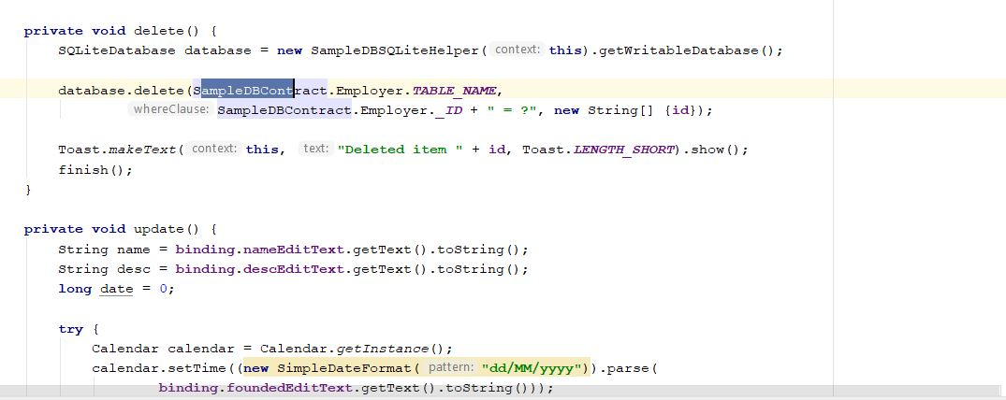

* And Database storing details code snippet given below.

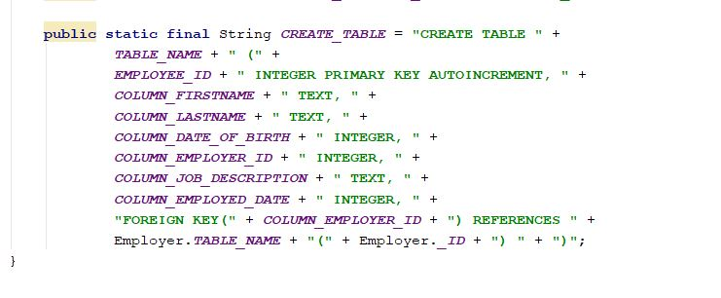

* Reading details from database has given below.

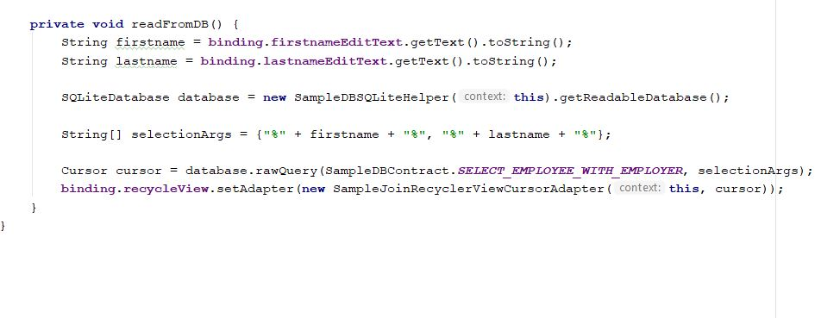

* Both are having relative layout corresponding code snippet is given below.

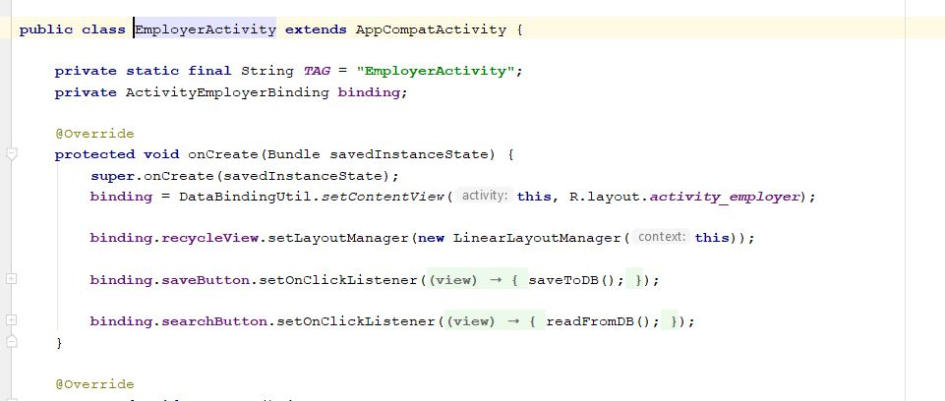

* Brief explanation about code and output given in video.

**Part-1 Output:**

* Having both activity welcome page

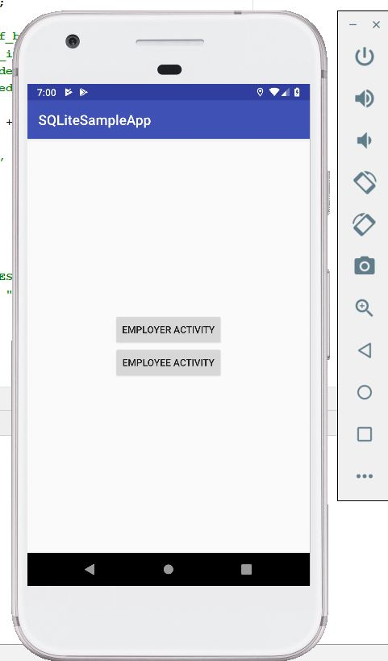

* Employer Activity

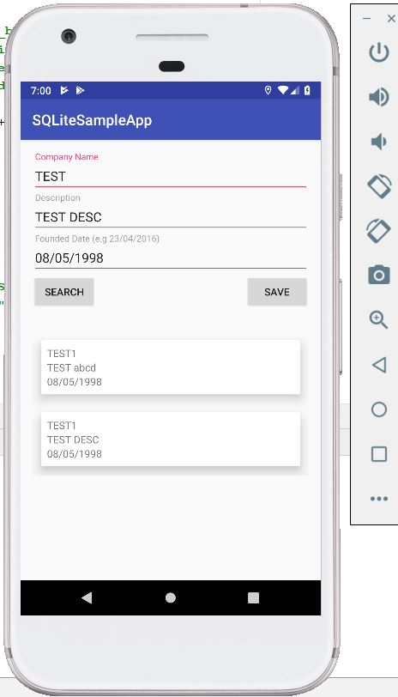

* Employer activity having update and delete features for storing details.

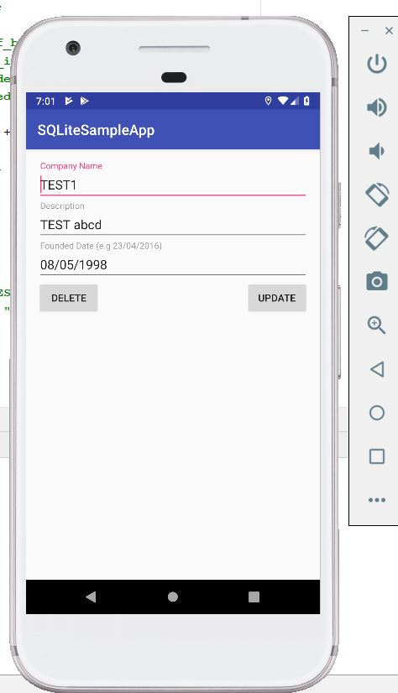

* Updating feature example

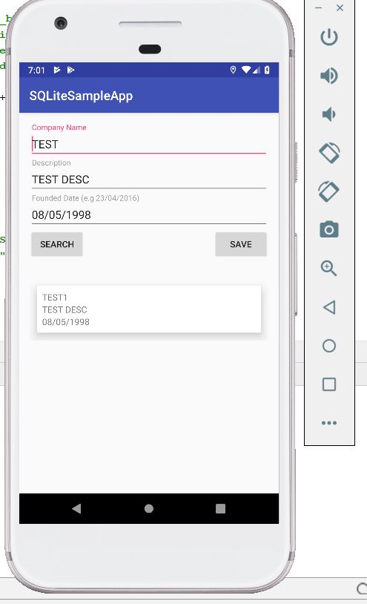

* Employee activity storing details along with save and search options.

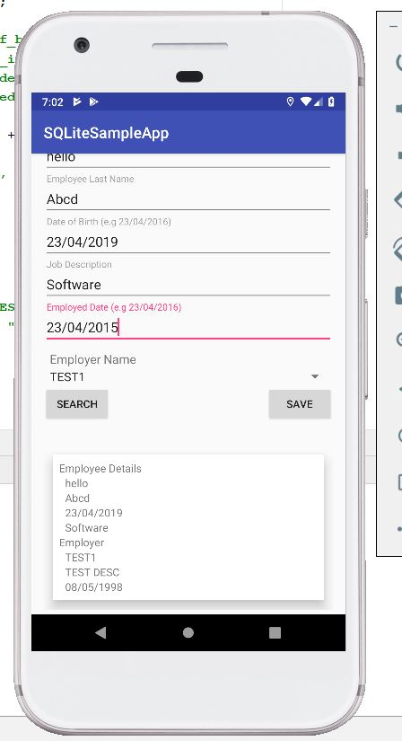

* Employee also having delete and update features.

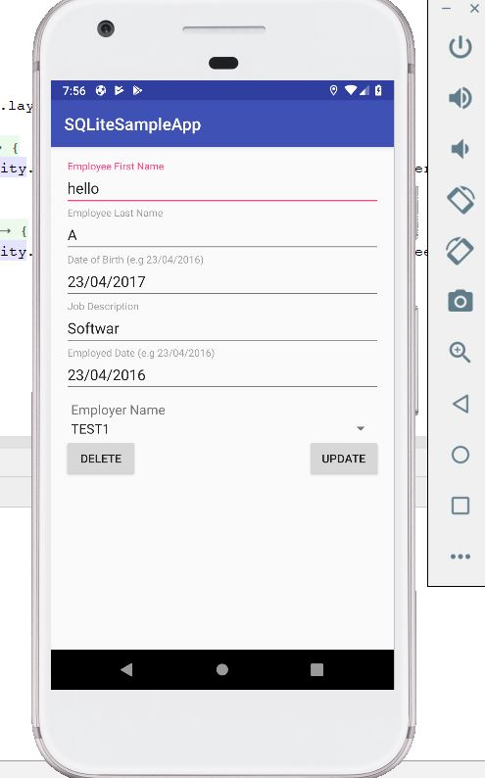

* Updated from hello to hello123 in first name and stored in database.

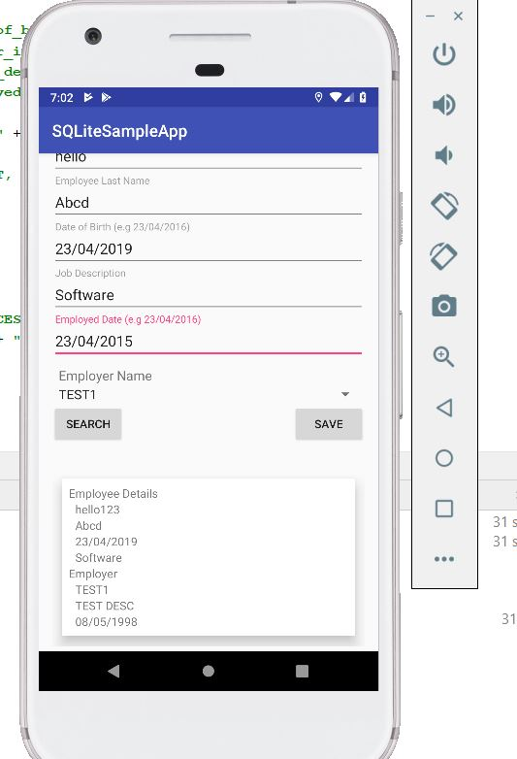

* Deleting the stored details from database.

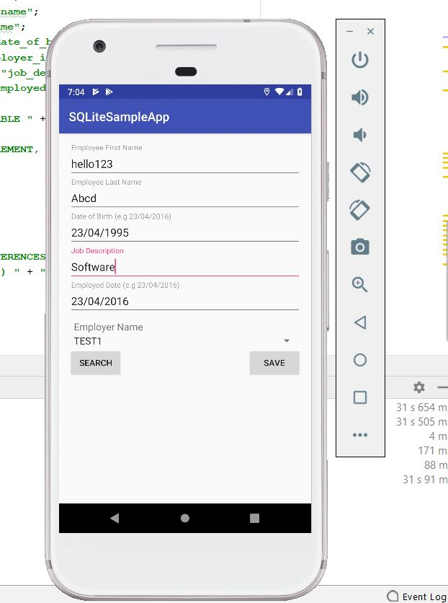

**Part-2&3 Objective:**

* To create firebase database authentication.
* Adding images into the database.
* Deleting the images from application
* Creating logout button
* Corresponding code snippets for this one is shown below.
* Welcome activity having both signin and signup features shown below.

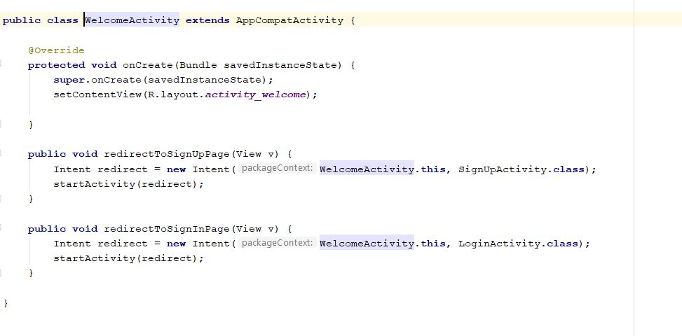

* Home activity having firebase instance and also camera accessing along with connecting to remaining activities are shown below.

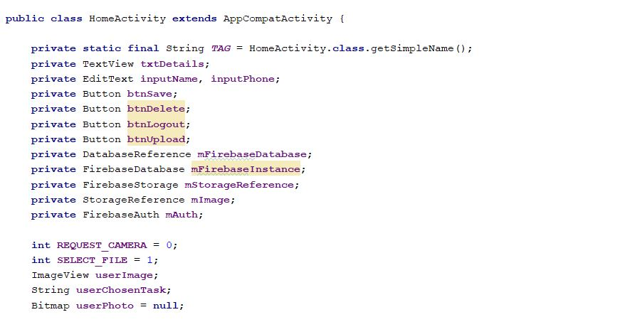

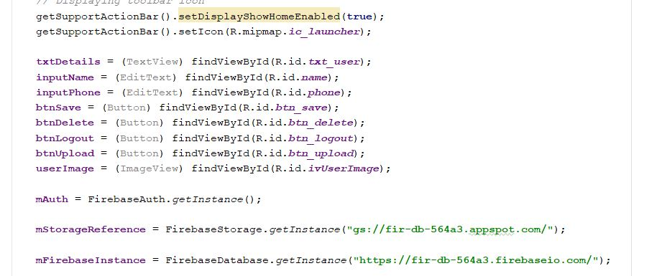

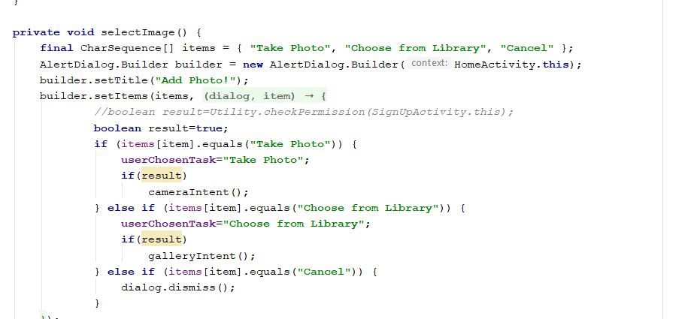

* Login Activity having mail and password options shown below.

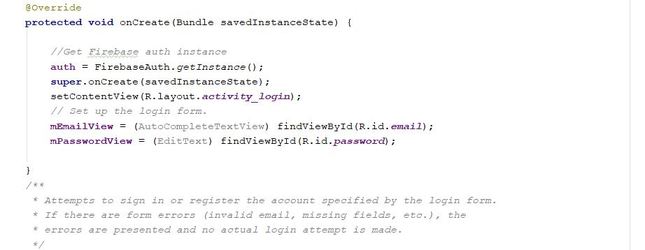

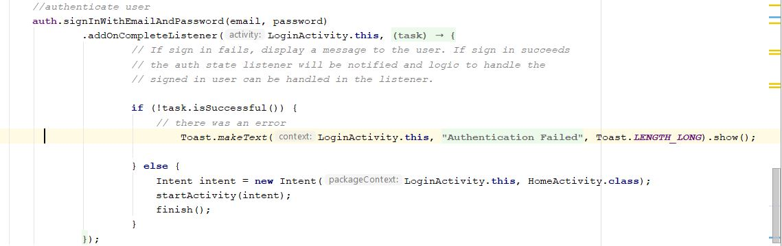

* Signupactivity.java has given below.

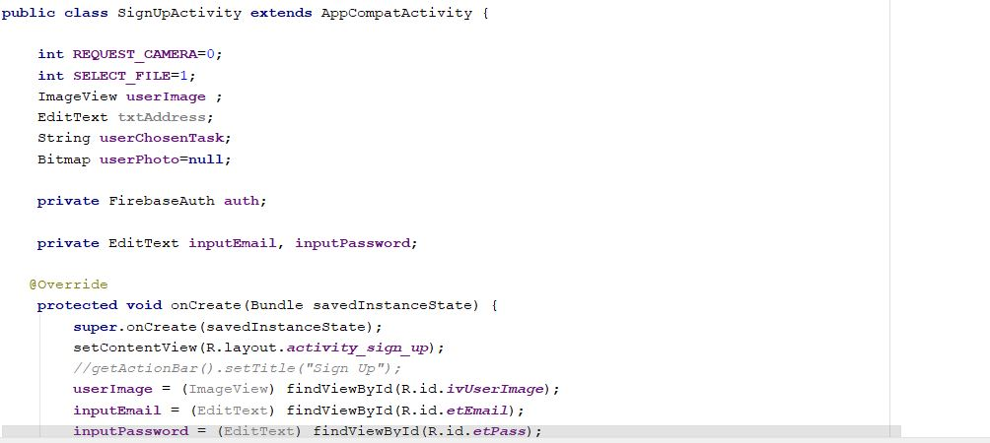

* User has string name and password in home page.

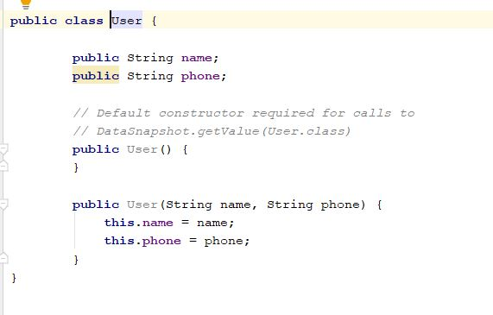

* User can recreate the password if they forget their password shown in forget password activity.

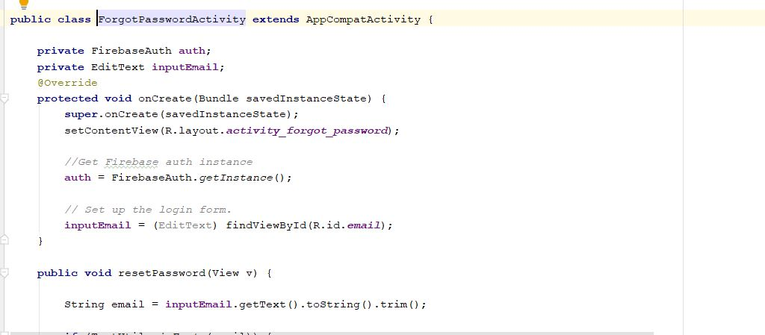

**Part 2&3 Output:**

* Welcome page

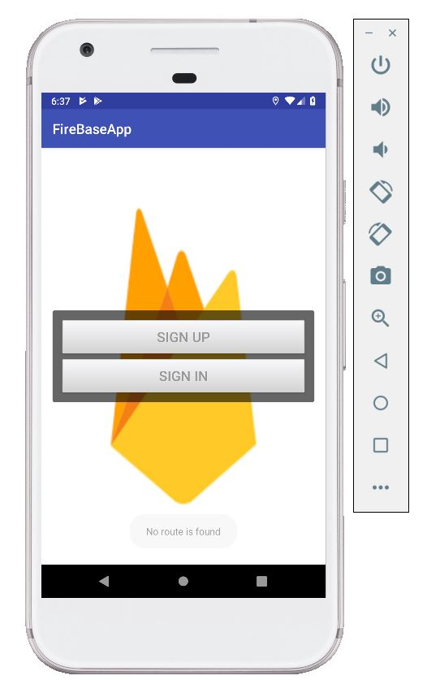

* Signup activity

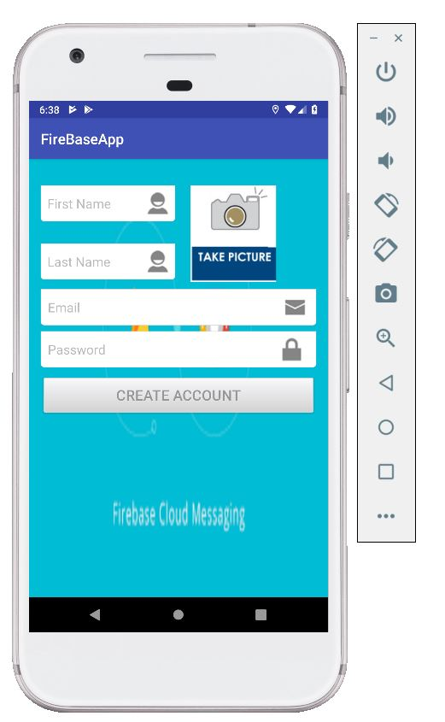

* Signin or Register

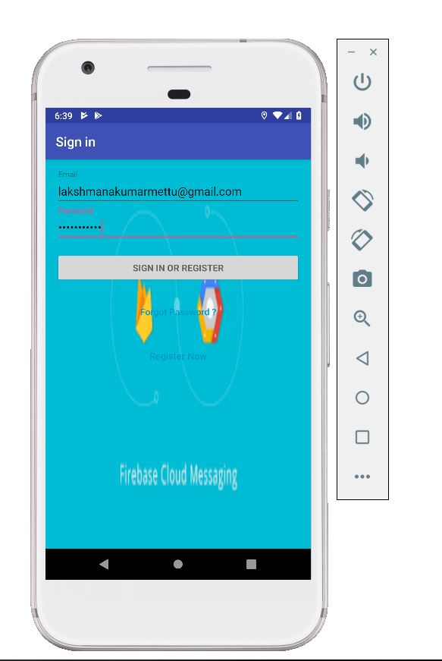

* Home activity having photo uploading feature.

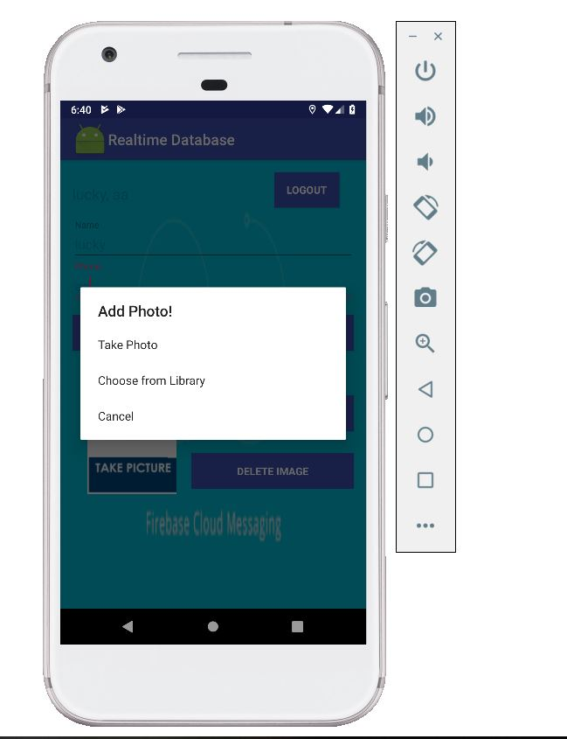

* Uploaded image and also having delete image feature.

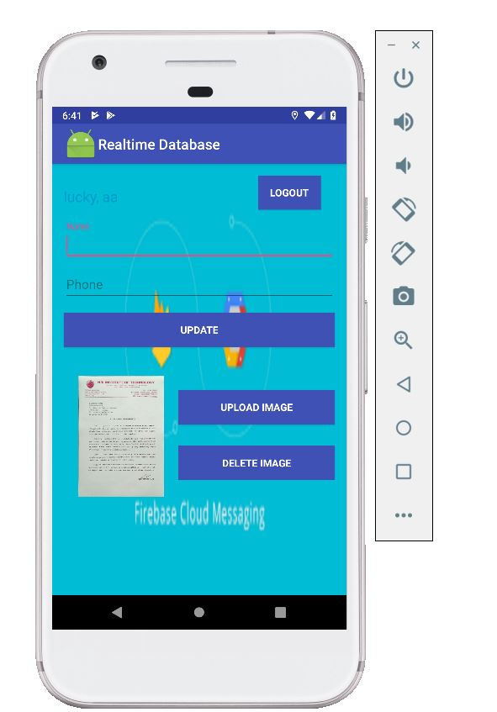

* When you click on logout button it redirects to welcome activity.



* Forget password option

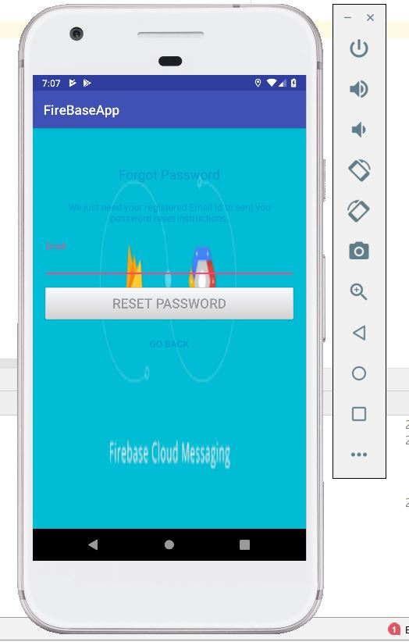

**Conclusion:**

* Hence Using this ICP, learnt about real database applications in android and usage of android elements like camera and modification of details in real time database.