**Name: Lakshmana Kumar Mettu**

**class ID:11**

**Introduction:**

* To introduce about android calendar elements and using those elements in the given projects

**Programming Elements:**

* Android Studio
* Google-android calendar

**Objective:**

* The main objective of this ICP is to create Calendar application in android device
* Create an event using this calendar
* Display the Event
* Providing mail to the guest about event details

**Workflow-Approaches:**

* It has two activities

1. Calendar Activity
2. Main Activity

* Calendar activity is used to create calendar using calendar elements in android
* Usually it displays the current date when you open
* User will create an event on any date by clicking on the create event
* After selecting dates for any event, the page will navigate to main activity
* Main activity has button to display the event and it has guest mail ID to send mail about event details.
* User can strike the event if he is not having interest to go to the event.
* Corresponding code snippets for Calendar Activity and Main activity are given below.
* Generated APK file
* Calendar Activity

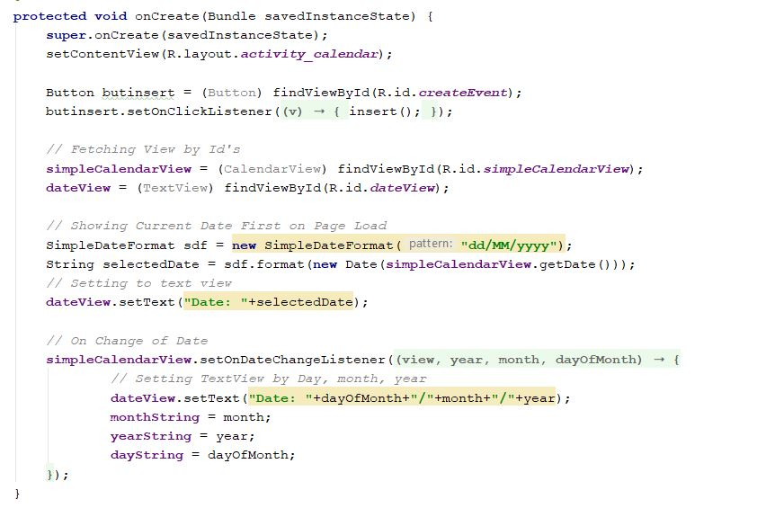

* Guest Details and date format

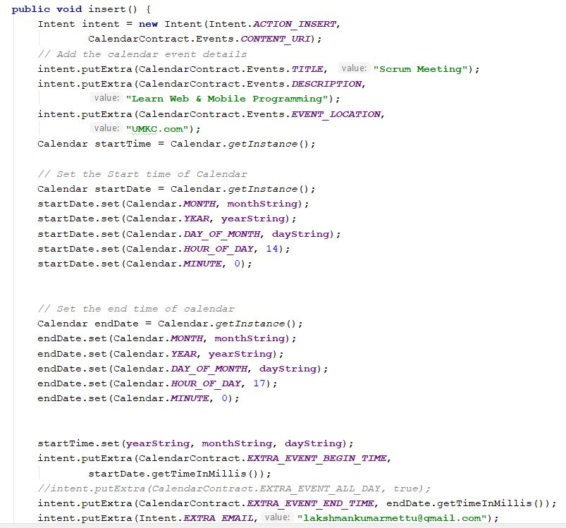

* Main Activity

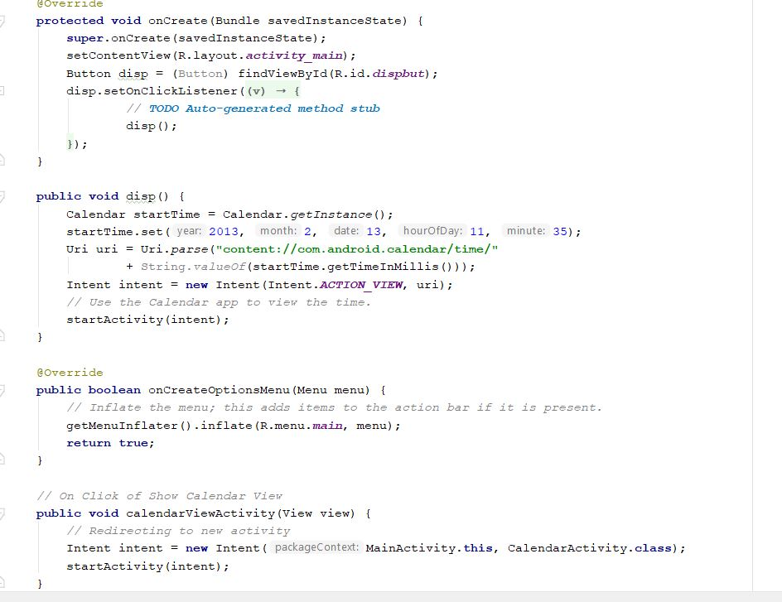

* XML file to show calendar view

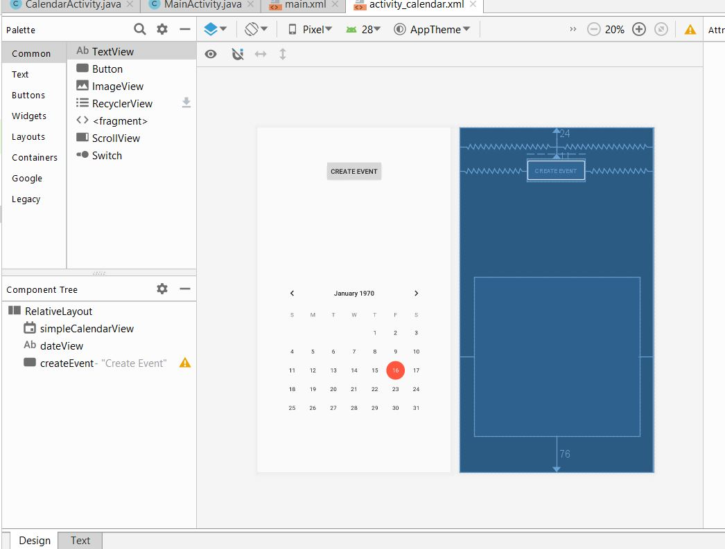

**Output:**

* Welcome page

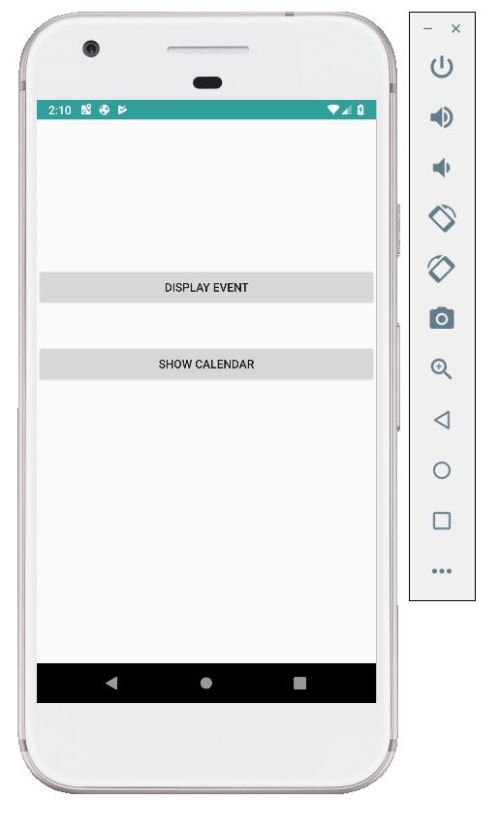

* Calendar showing the current date and having create event button in show calendar page

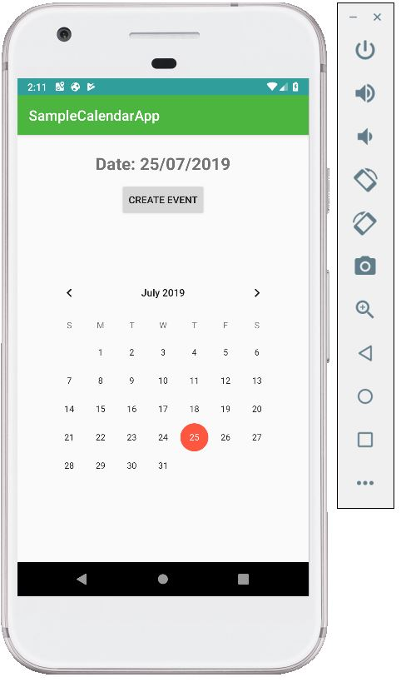

* Creating an event and showing it in display event page

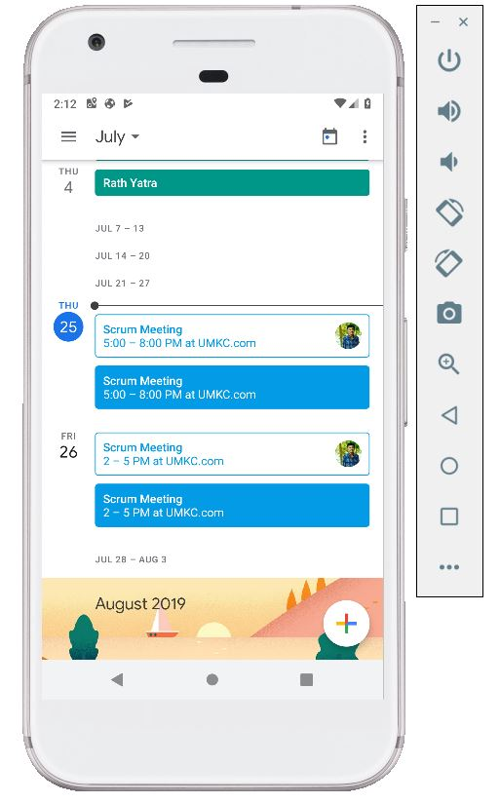

* Showing the images of saved events along with user interests

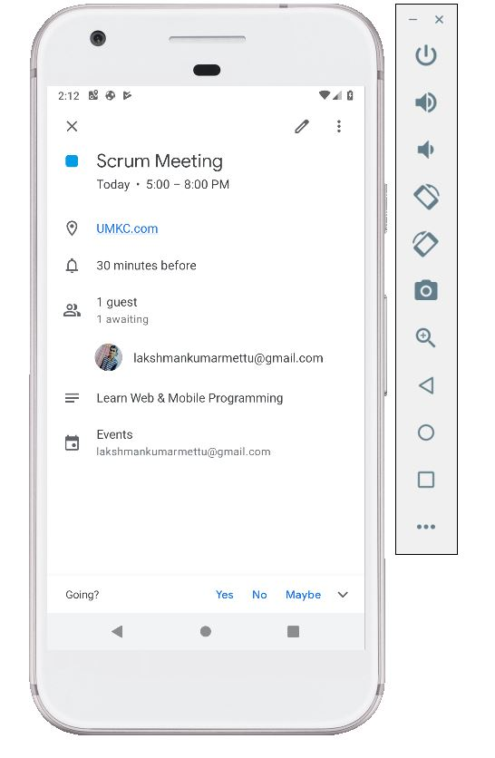

* If User Interest is not willing to go then event get strikes

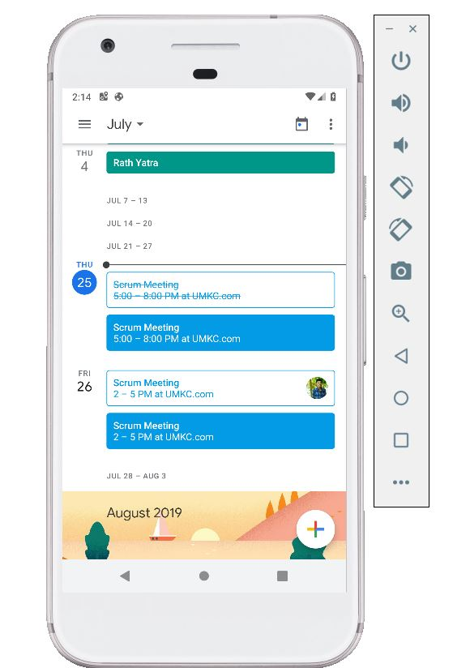

**Conclusion:**

* Learnt how to create and usage of calendar in android applications for any projects.