**Name :Lakshmana Kumar Mettu**

**Class ID:11**

**Introduction:**

This ICP is about to learn angular JS and elements of Angular JS (directives, expressions, filters, modules, and controllers).

**Programming elements:**Angular JS,html5,css.

**Platfrom Required:** Jetbrains-Webstorm

**Objective1: This task is understanding of anjular JS by developing basic TO-DO list.**

* Here for developing the application I have created a text field to capture the to do items and a button to add the item to the list. Whenever user selects an Add Item, Todo controller is invoked and the view will change accordingly by the push items presented. Also provided check box and delete option for the list items. Once the item is deleted a counter is automatically set to the current count in the list.
* Todo App:The code snippets along with comments are given below. 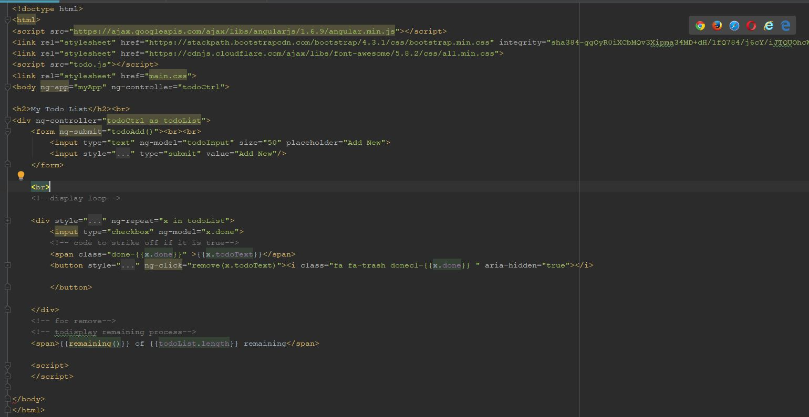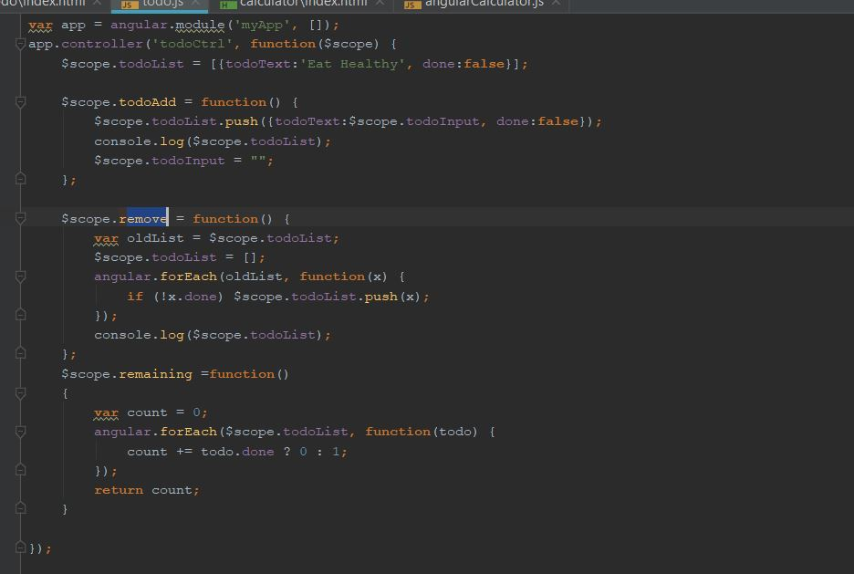
* Output: 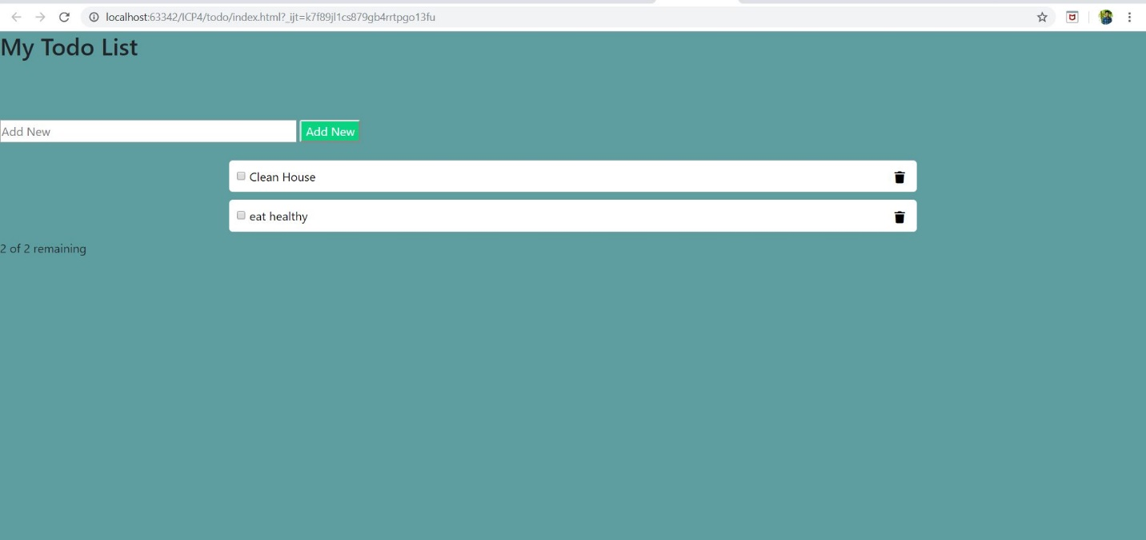

**Obejective-2:To develop a basic calculator application using Angular JS elements.**

* The code snippets which are described about angular elements such are ng-app(my application),ng-controller(To provide write access to application),ng-repeat(To repeat defined task for ng-app),ng-click(on click button),$scope(to create functions to object),ng-submit(to submit the required action) explained below.

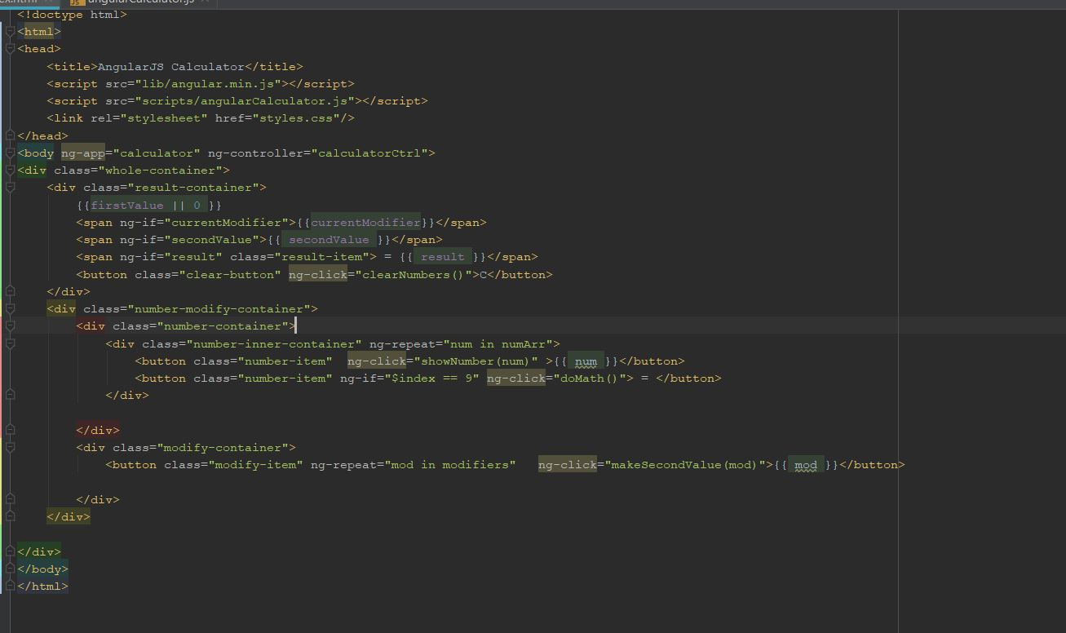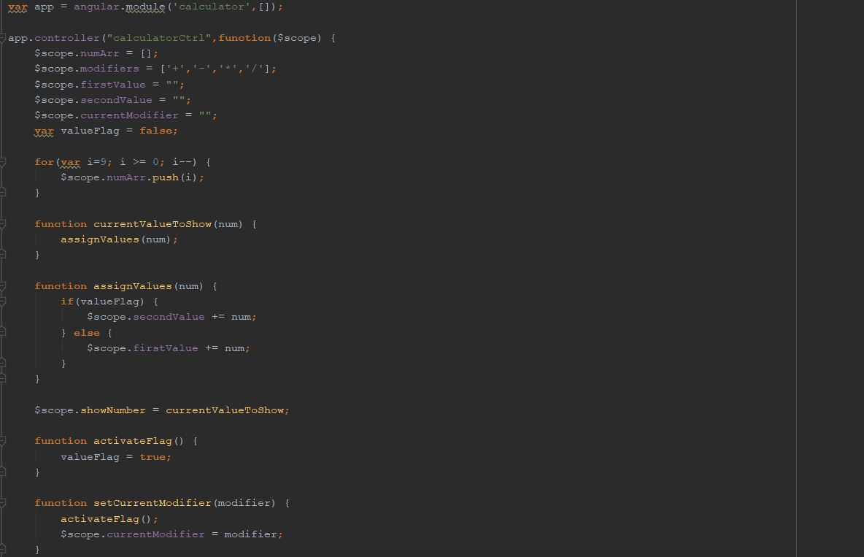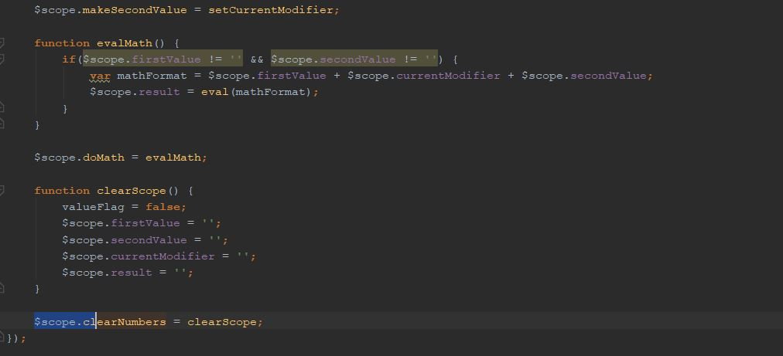

* Output: 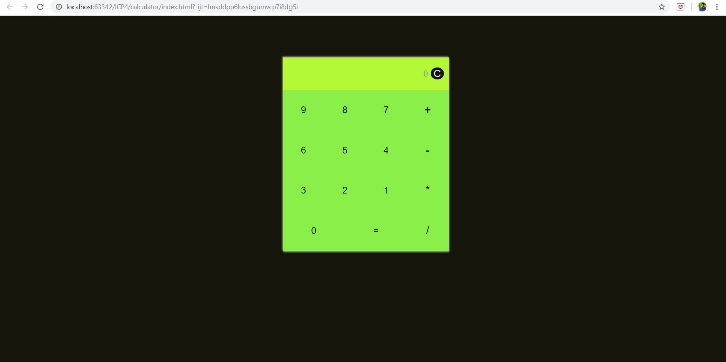

**Coclusion:**Learnt how to develop responsive web pages using angular JS.