**Name: Lakshmana Kumar Mettu**

**Class ID:11**

**Introduction: Implementation and understanding of REST API's using angular JS elements.**

### Programming elements:

* Angular JS
* html5
* CSS.

**Tools Used:**

* JetBrains-Webstorm

**API's used:**

* Yandex Translator API for language translation
* Four Square API to display nearby Restaurants.

**Objective-1: To develop a web application that has to display restaurants depending on the place that you entered.**

* The code snippet for corresponding UI implementation and angular elements are shown below along with comments.
* Here I am using four square API to obtain the venue list of restaurants.
* ng-controller directive attaches a controller class to the view. This is a key aspect of how angular supports the principles behind the Model-View-Controller design pattern.The ng-Click directive allows you to specify custom behavior when an element is clicked.

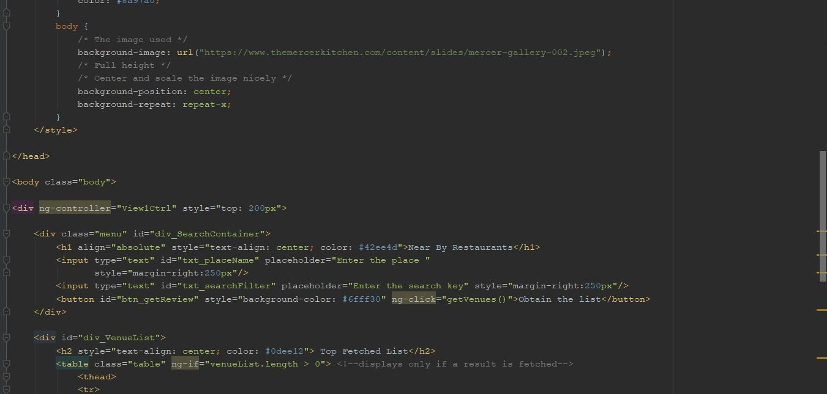

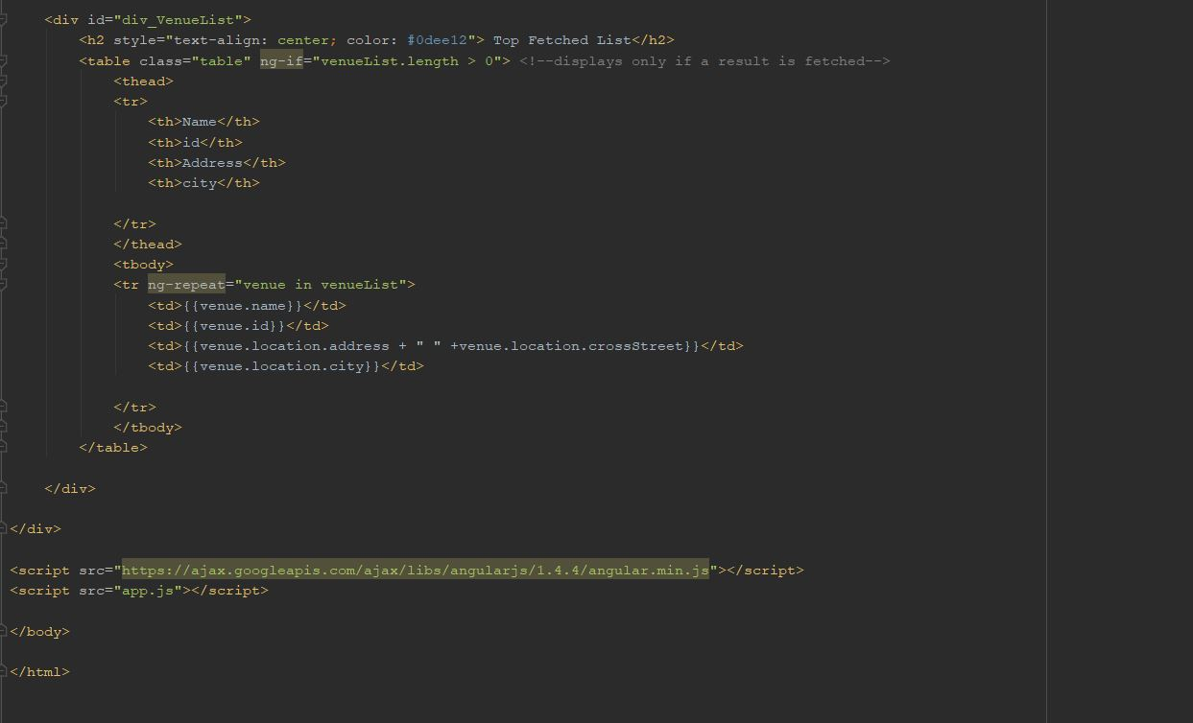

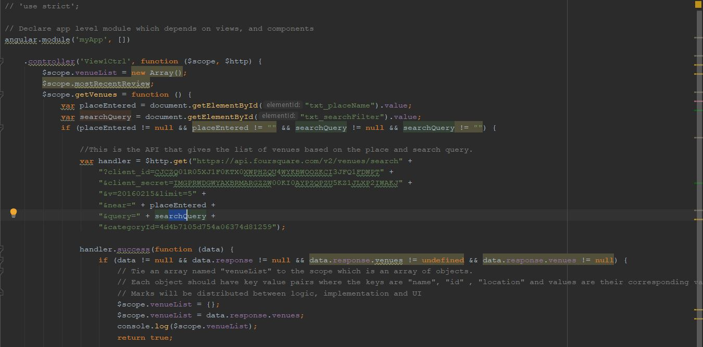

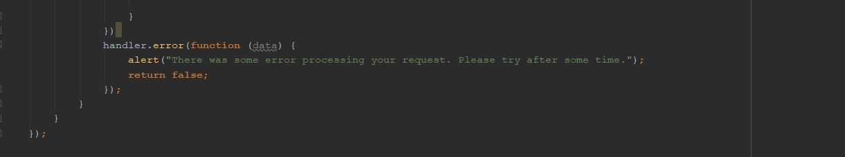

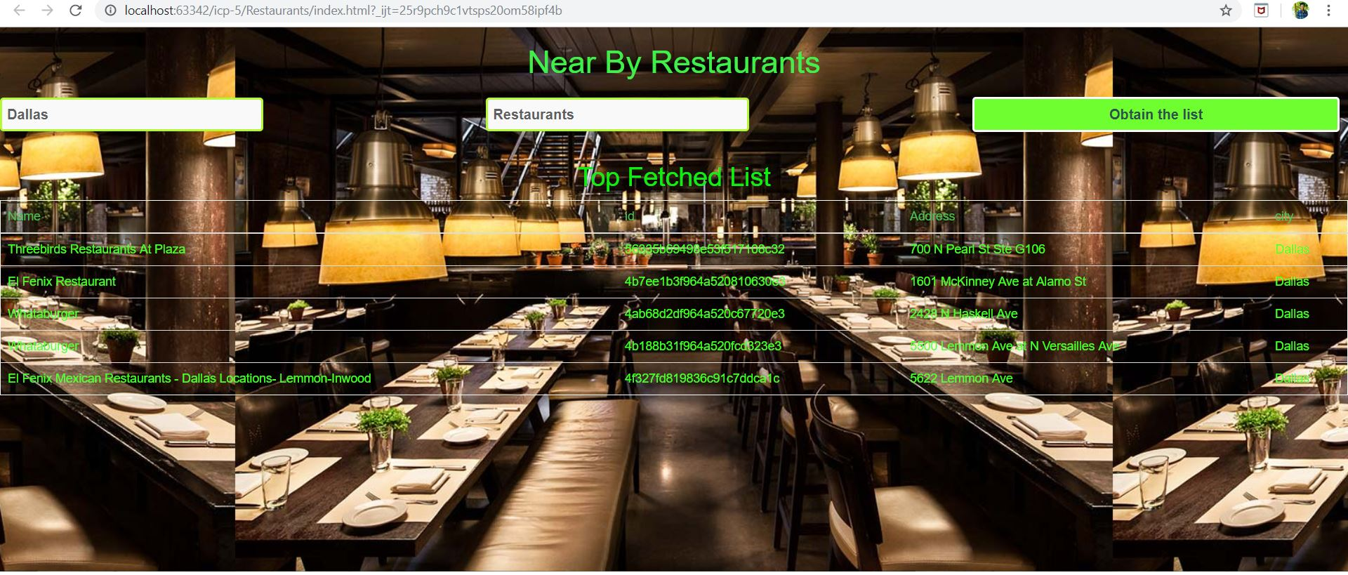

**Objective-2:To implement Language Translator web application using Yandex Translation API using angular JS elements.**

* The code and output snippets along with comments have shown below.
* the translate.js file which is a javascript file. The Document method getElementById() returns an Element object representing the element whose id property matches the specified string. The $http service is a core AngularJS service that facilitates communication with the remote HTTP servers via the browser's XMLHttpRequest object or via JSONP.

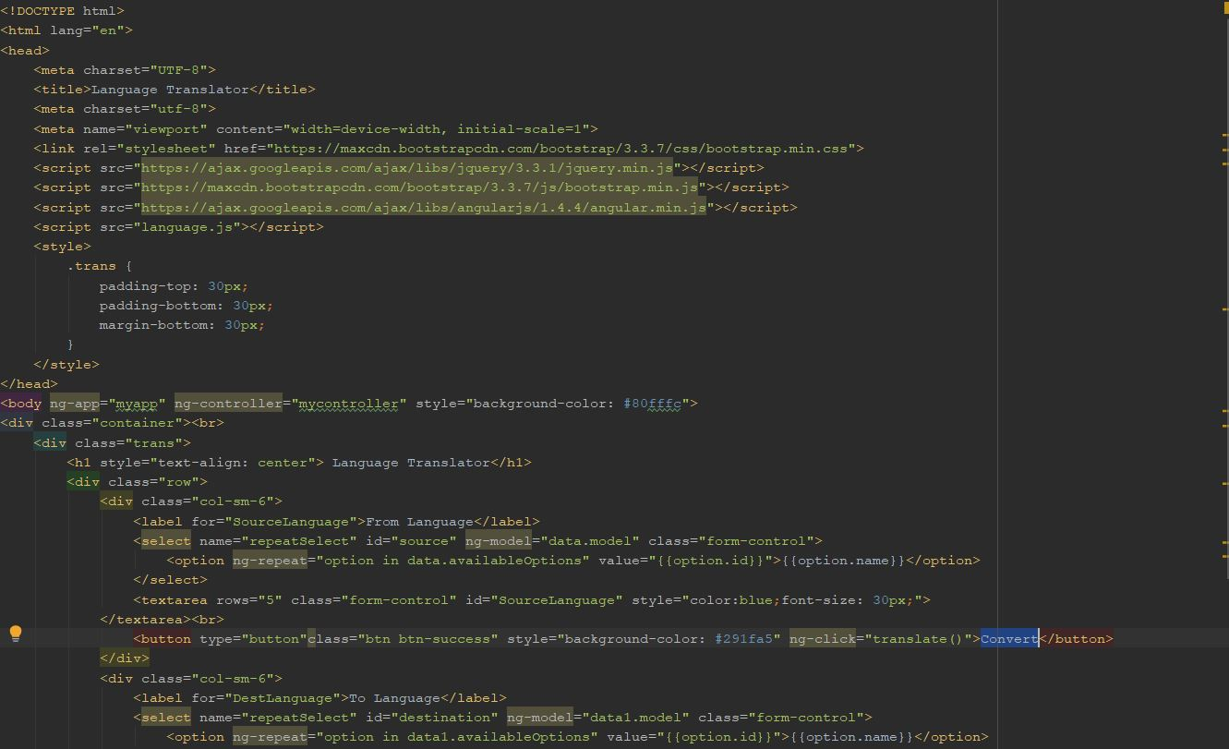

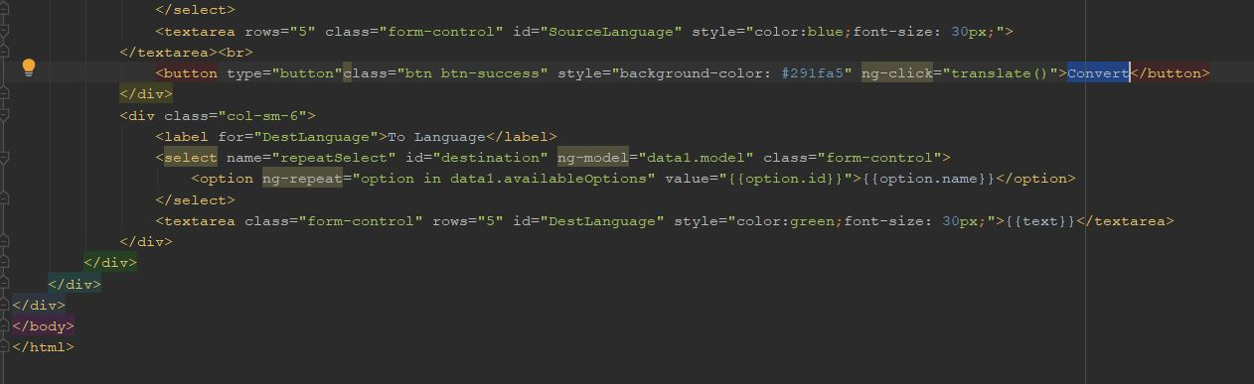

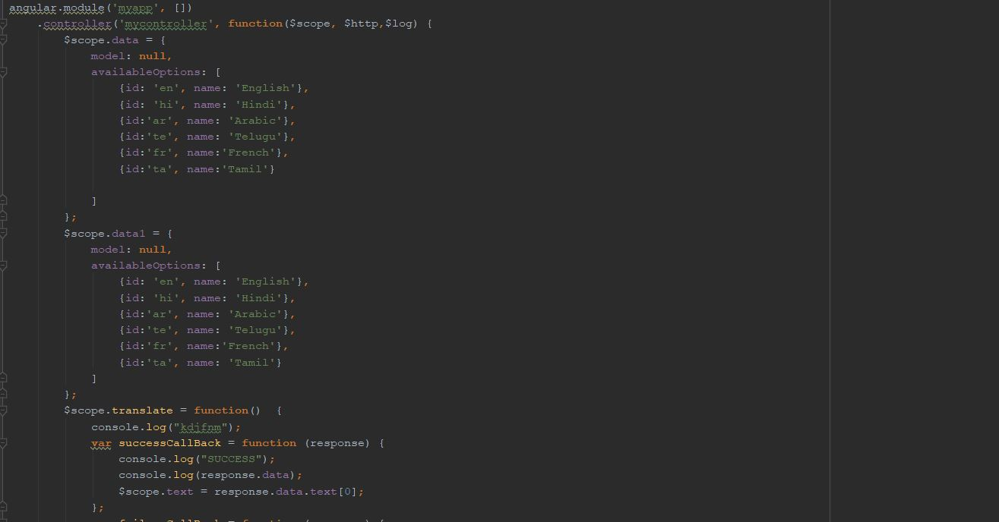

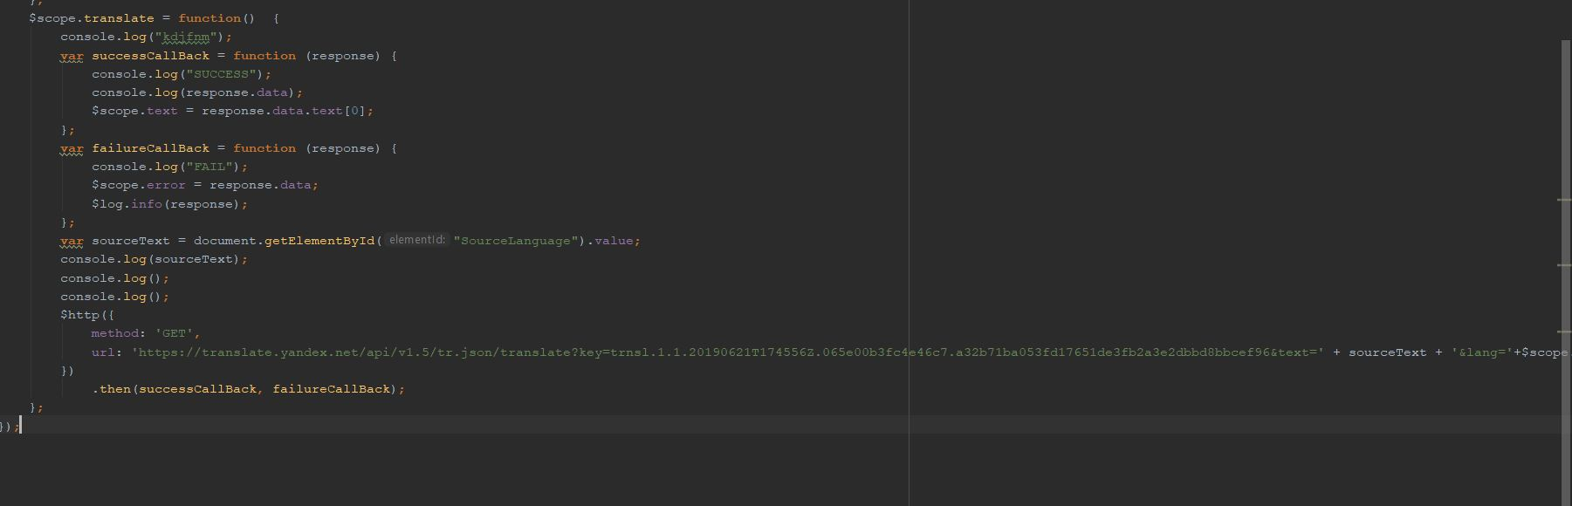

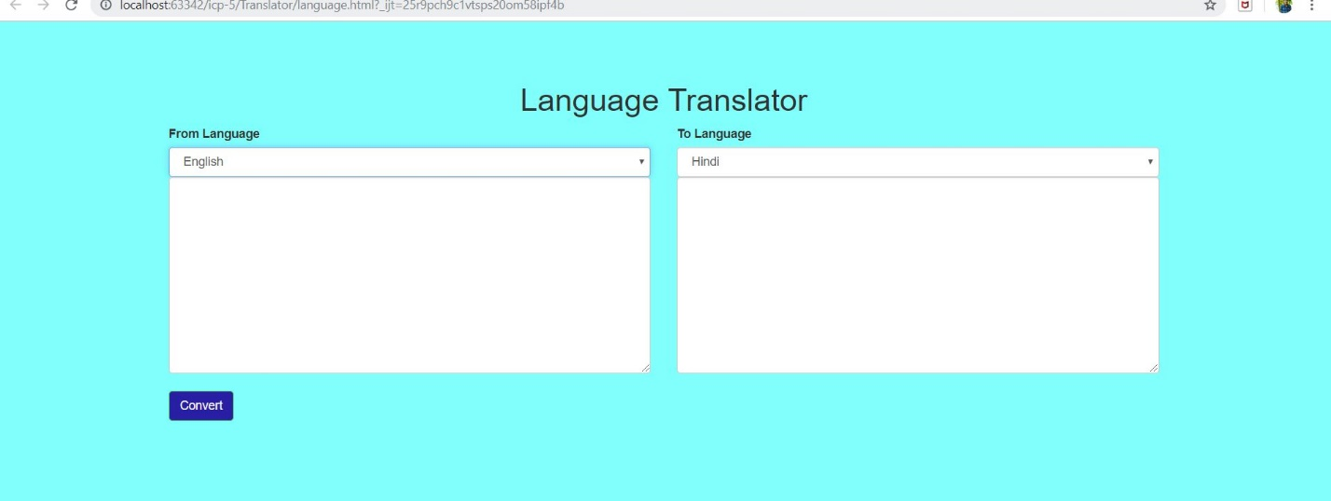

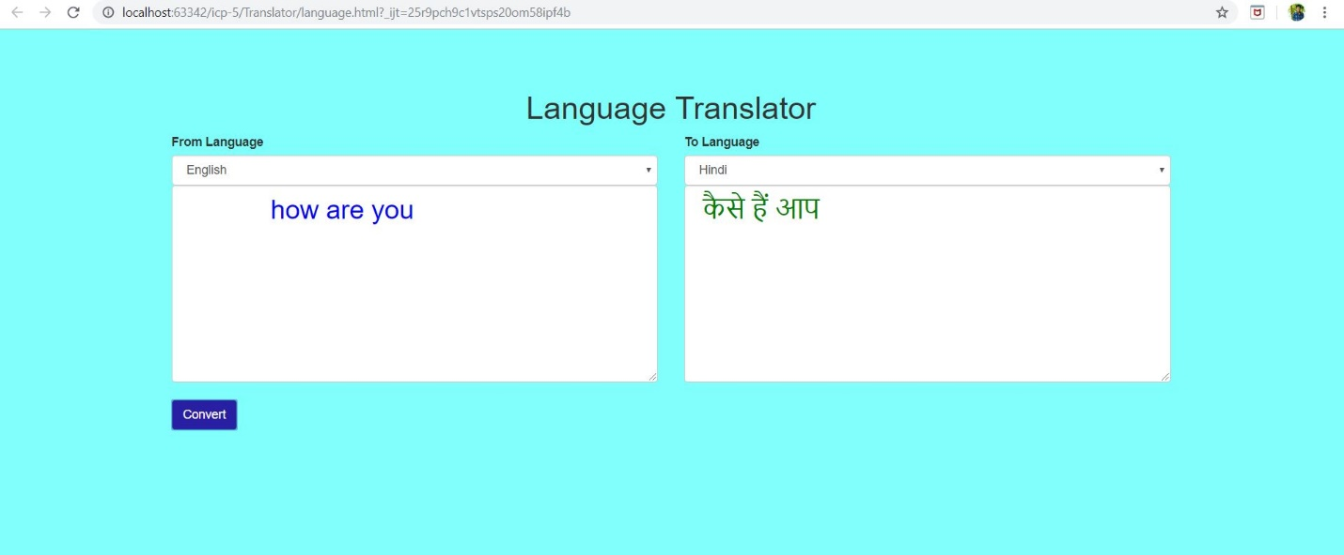

**Conclusion:**

* Hence learnt how to use REST API's to develop web applications using angularJS elements.