**Name: Lakshmana Kumar Mettu**

**Class ID:11**

**Introduction:**

* This ICP is get to know about D3(Data Driven Documents) creation and usage of data formats in given code and constructing a tree diagram in DOM model as well as creation of MongoDB account.
* Performing CRUD(create,Read,Update,Delete) operations on student deatils.

**Programming Languages:**

* HTML5
* Java script
* CSS

**Software and platforms used:**

* Jetbrains-webstorm
* Database in MongoDB

**Objective1:**

* For the given Use case D3 need to create of drag,drop,autosizing and collapse functions.
* For this D3 model data format as json is used.
* Functions for drag,drop,auto-sizing,collapse are created.
* The code snippets along with comments and output are given below.

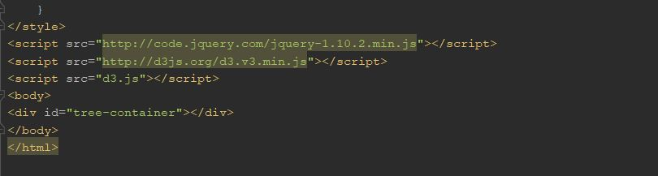

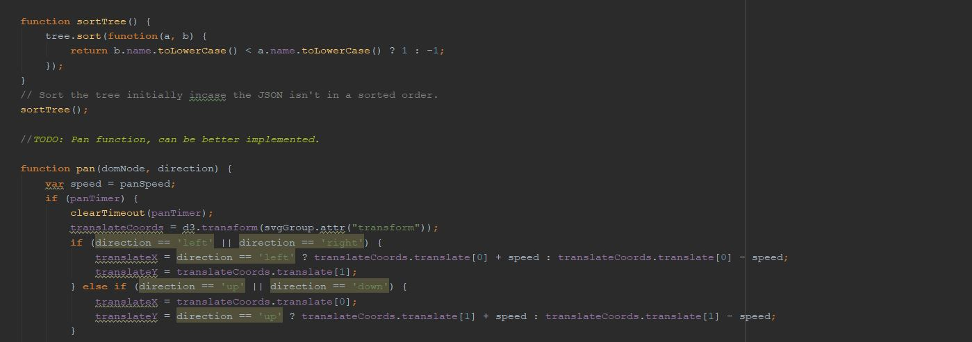

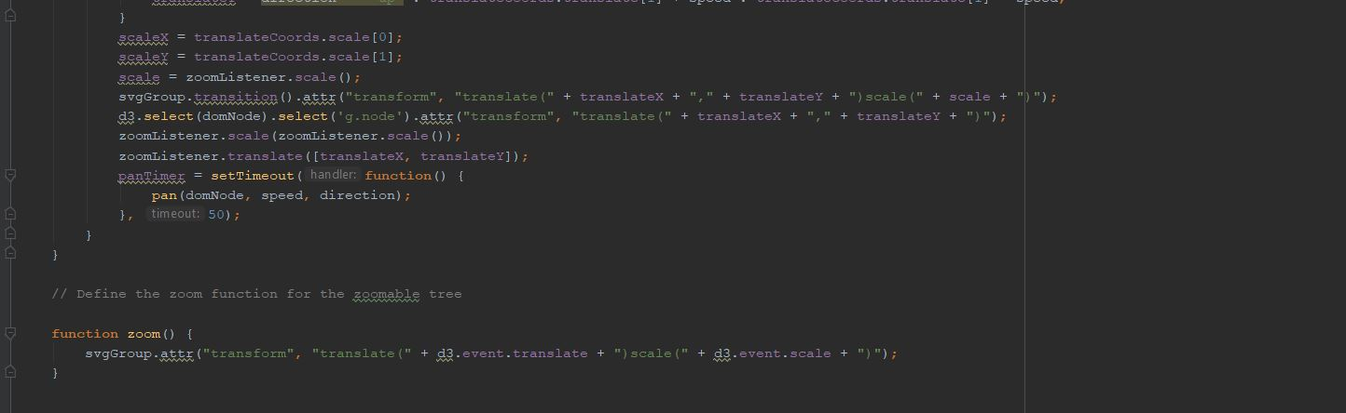

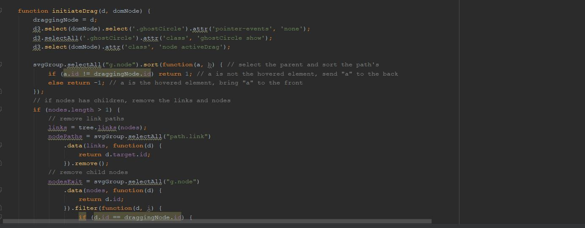

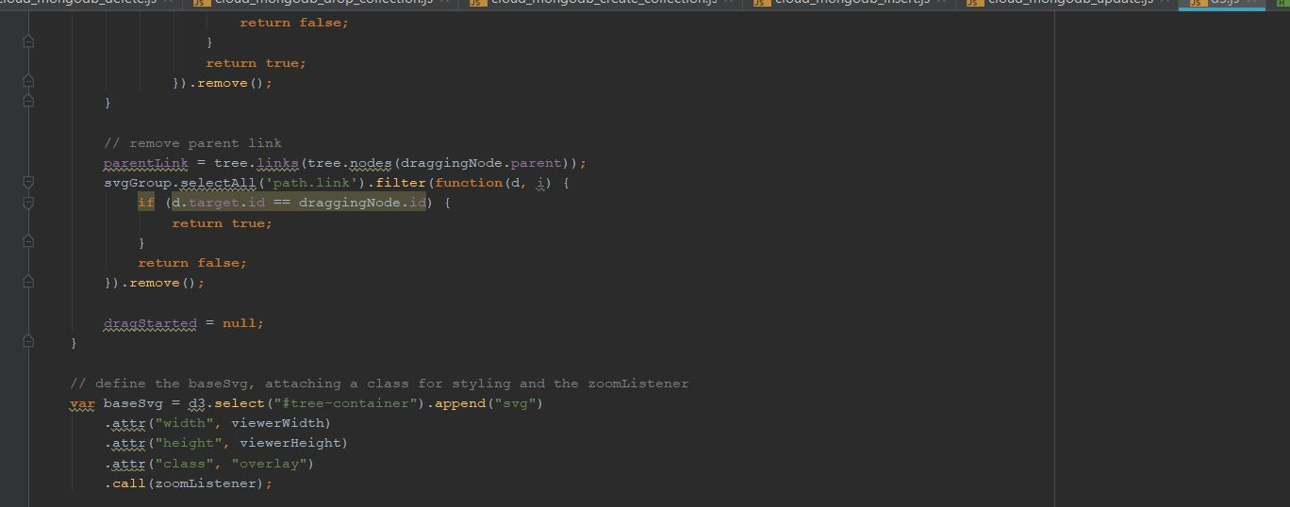

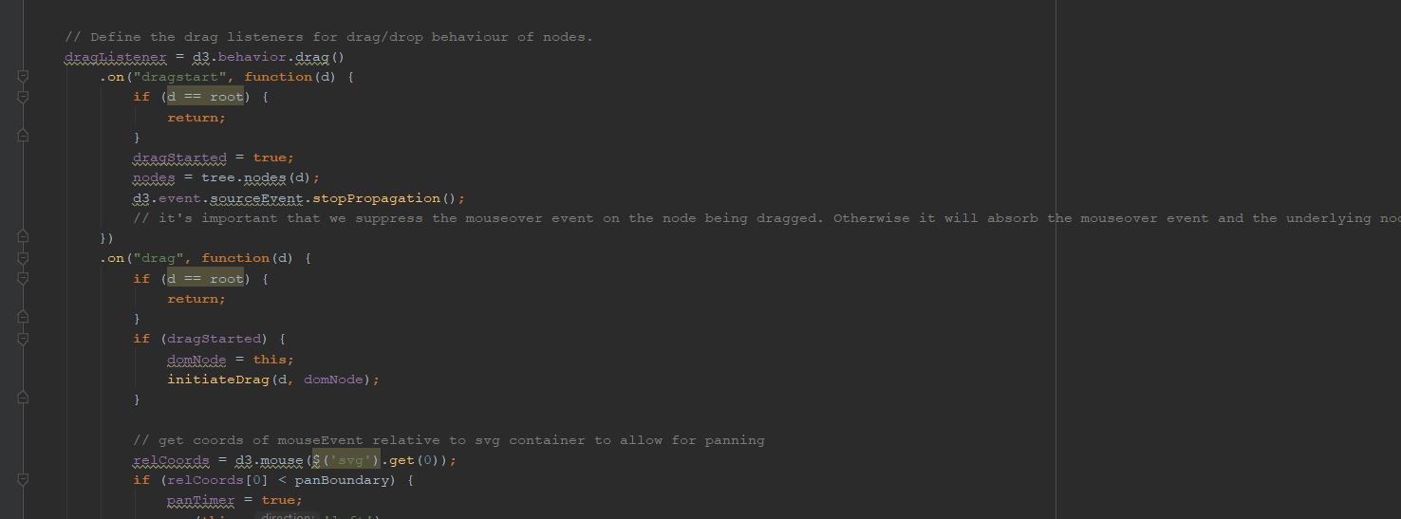

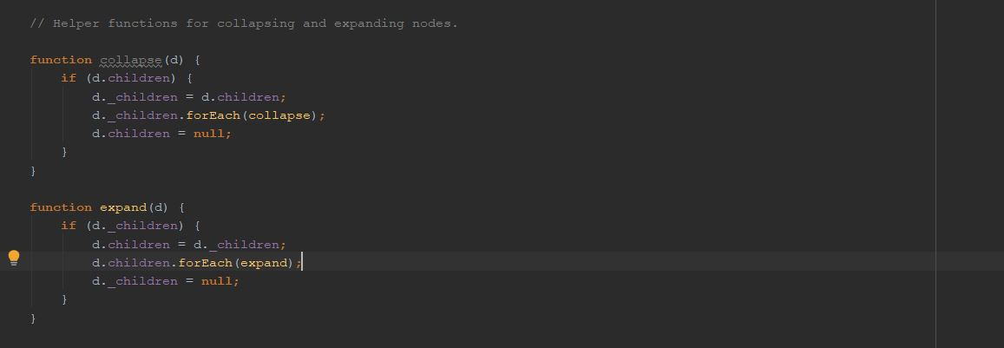

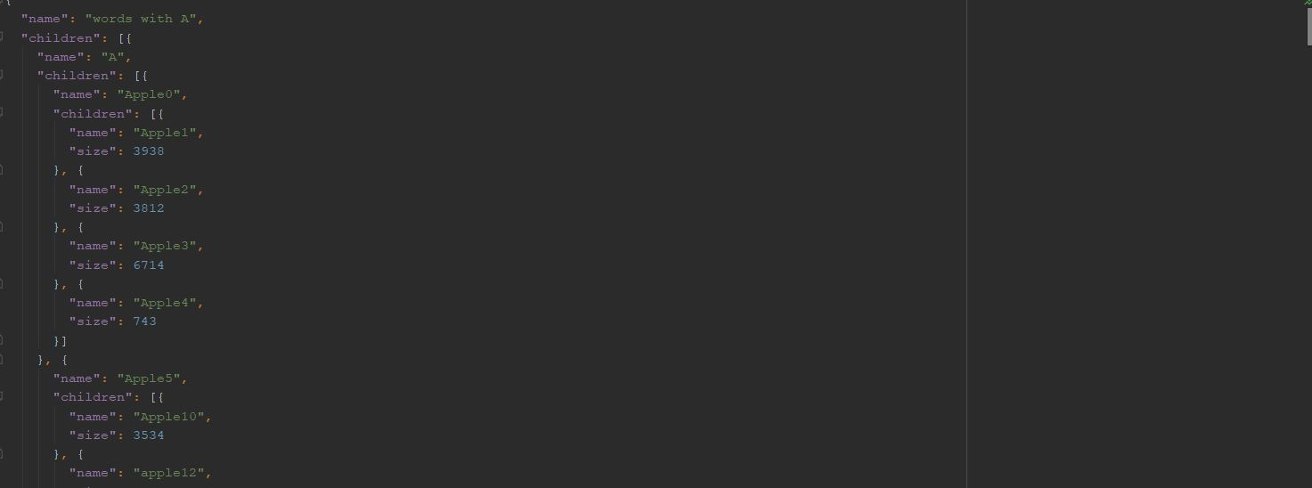

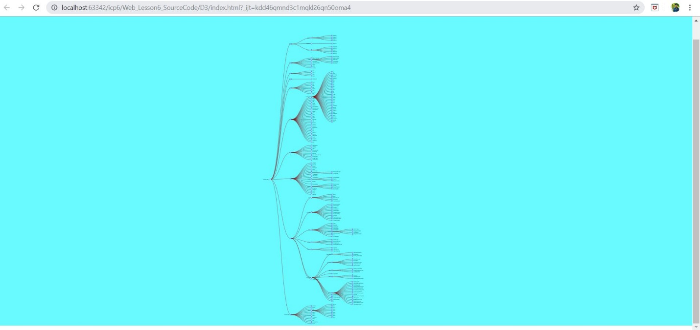

**Objective-2:**

* To Create MongoDB account and create student database to perform CRUD operations.
* The code snippets along with output for each operation is given below.

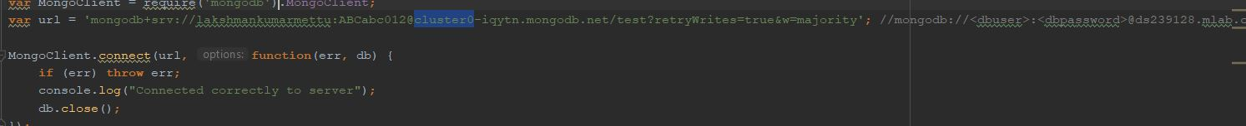



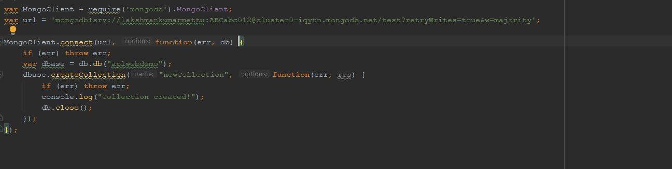

* Database Created and shown in snippet.

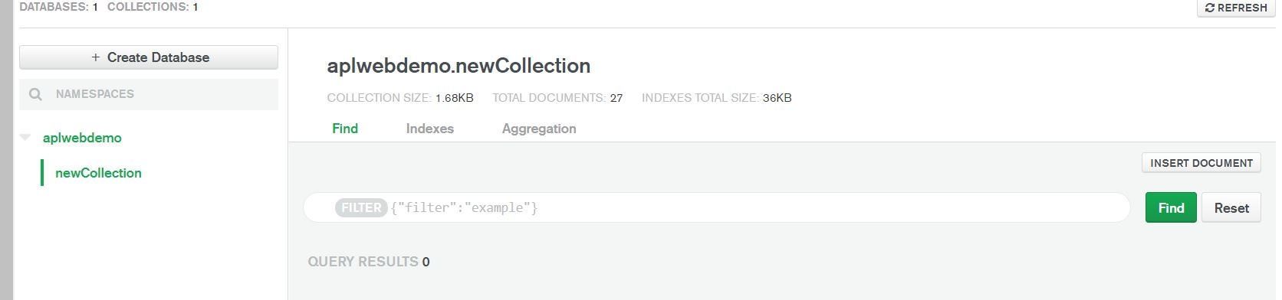

* Inserting Records In database.

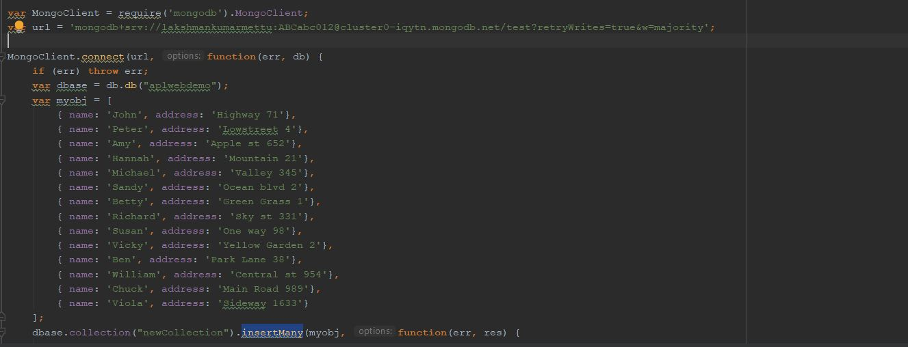

* Output Snippet for record insertion

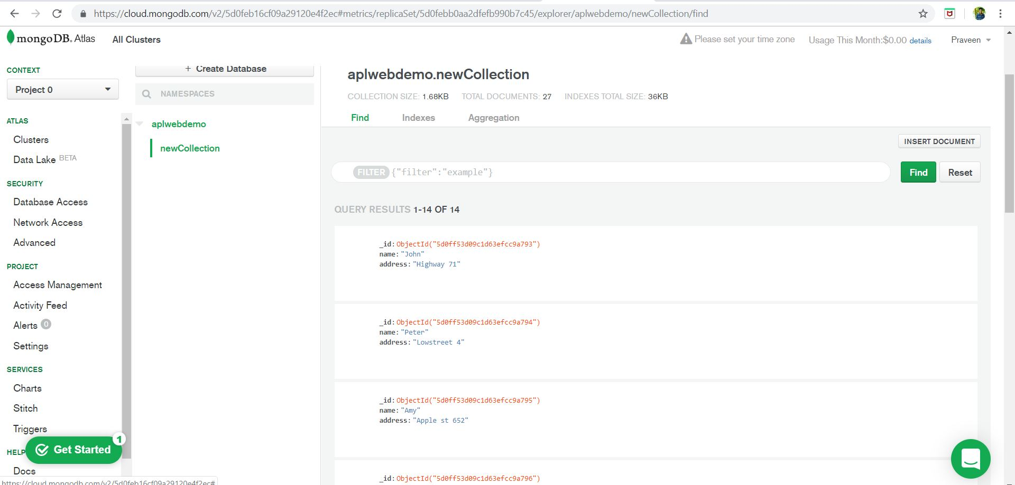

* Updating the Records

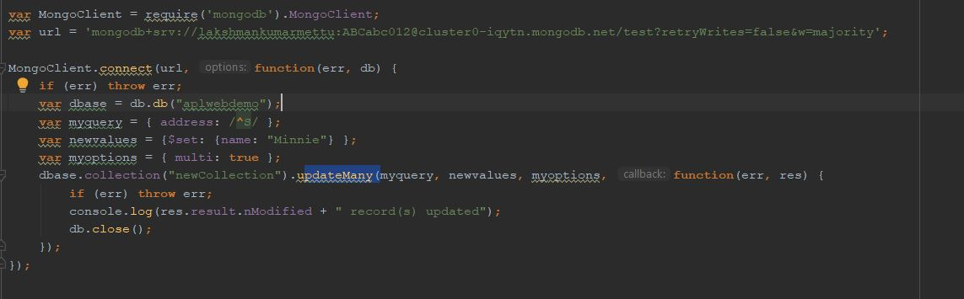

* Deleting 1 record

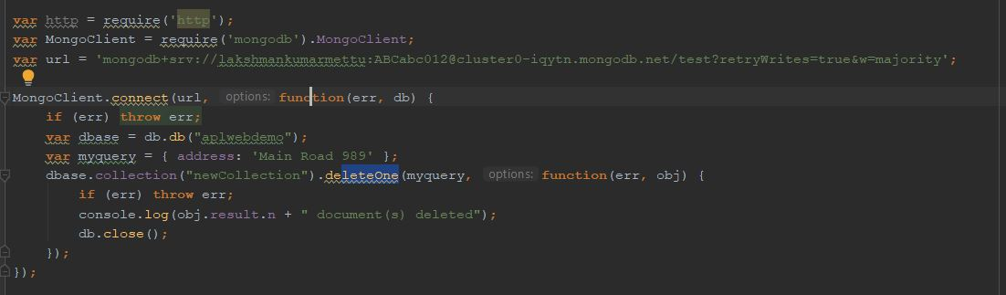

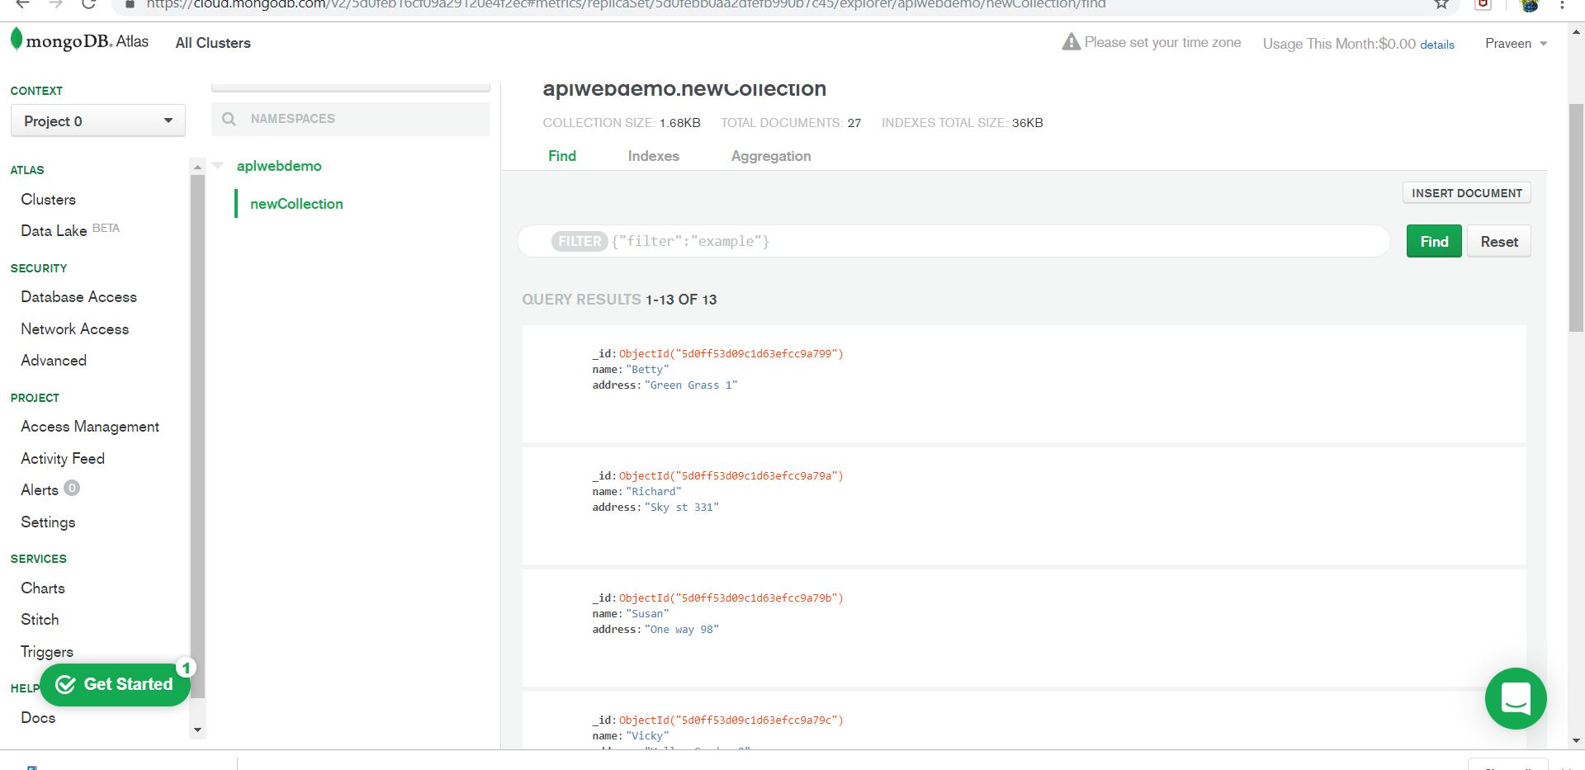

* Dropping Records

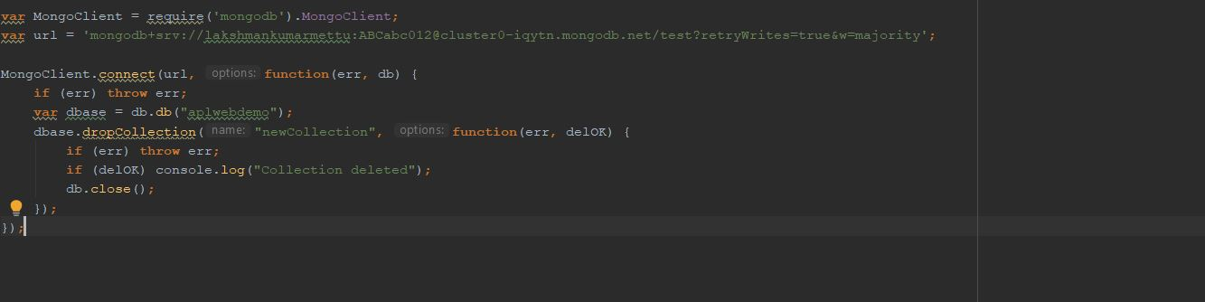

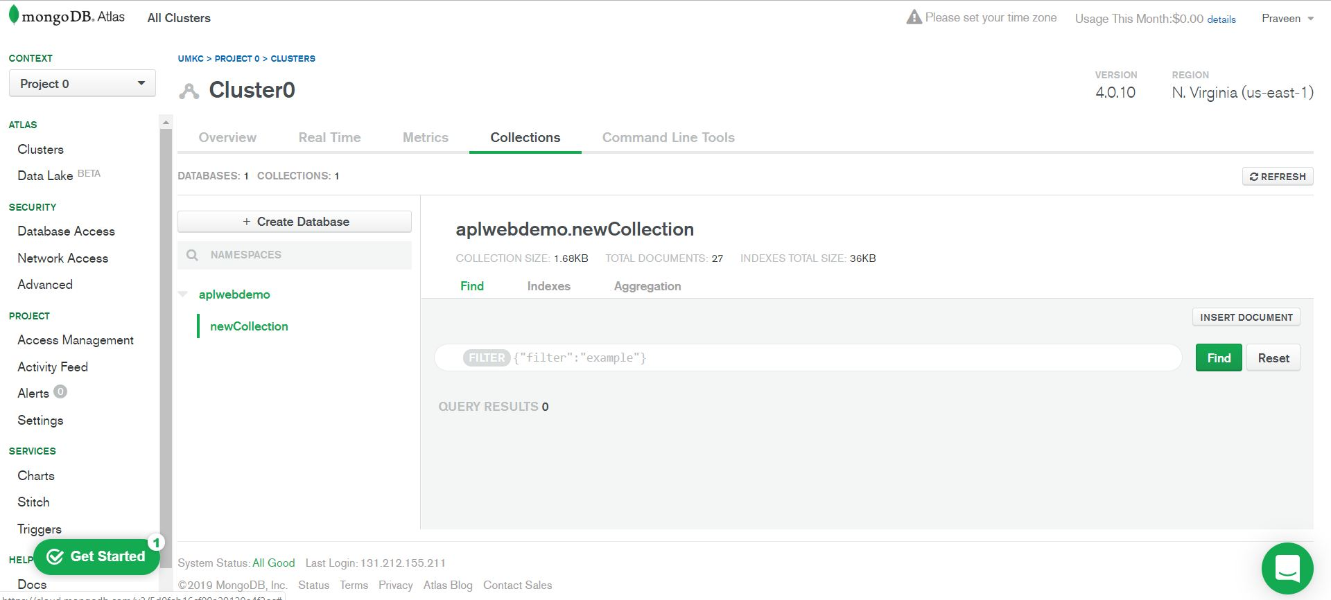

**Discussions:**

* Got keen knowledge on different data formats using D3 and also performing CRUD operations and learnt different data inserting techniques to cloud.

**Conclusion:**

* Hence learnt how to create Document Object Model(DOM) using Data Driven Document((D3) and also learnt to perform CRUD operations using MongoDB.