**Name: Lakshmana Kumar Mettu**

**Class ID:11**

**Introduction:**

* Performing create, update and delete operations for library management system using meanstack.

**Programming elements:**

* Mongo-DB
* Java script
* HTML5
* CSS

**Tools Required:**

* JetBrains WebStorm

**Objective:**

* Understanding how to create mean stack application through local-host.
* Created database name Library and connected to database using mongodb url.
* Collection name as books created in library database.
* Corresponding code snippets for update and delete functionalities have shown below along with the output snippets.

1.Connection to Mongo DB.

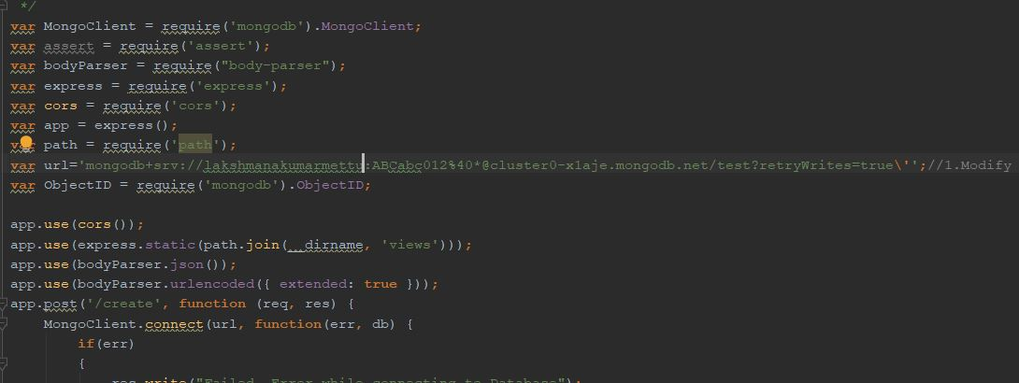

2.Update functionality

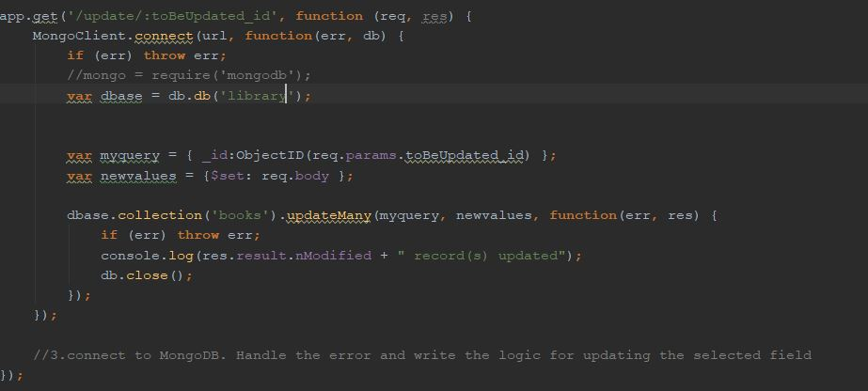

3.Delete Functionality

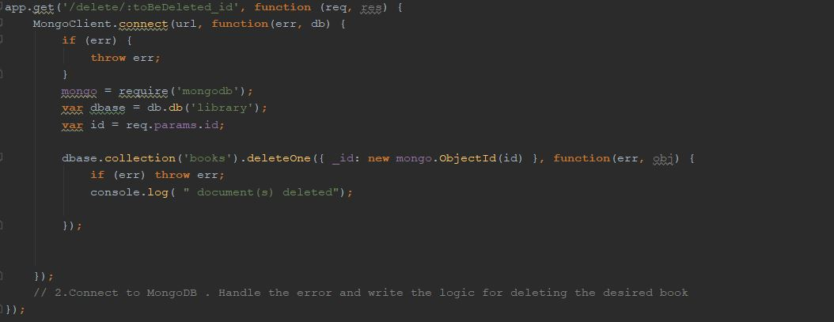

4.Console

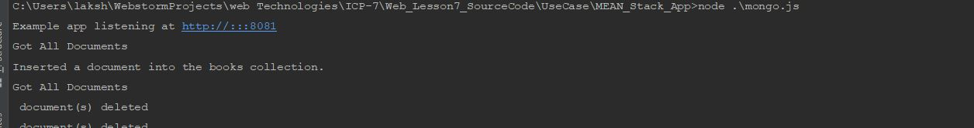

5.User Interface

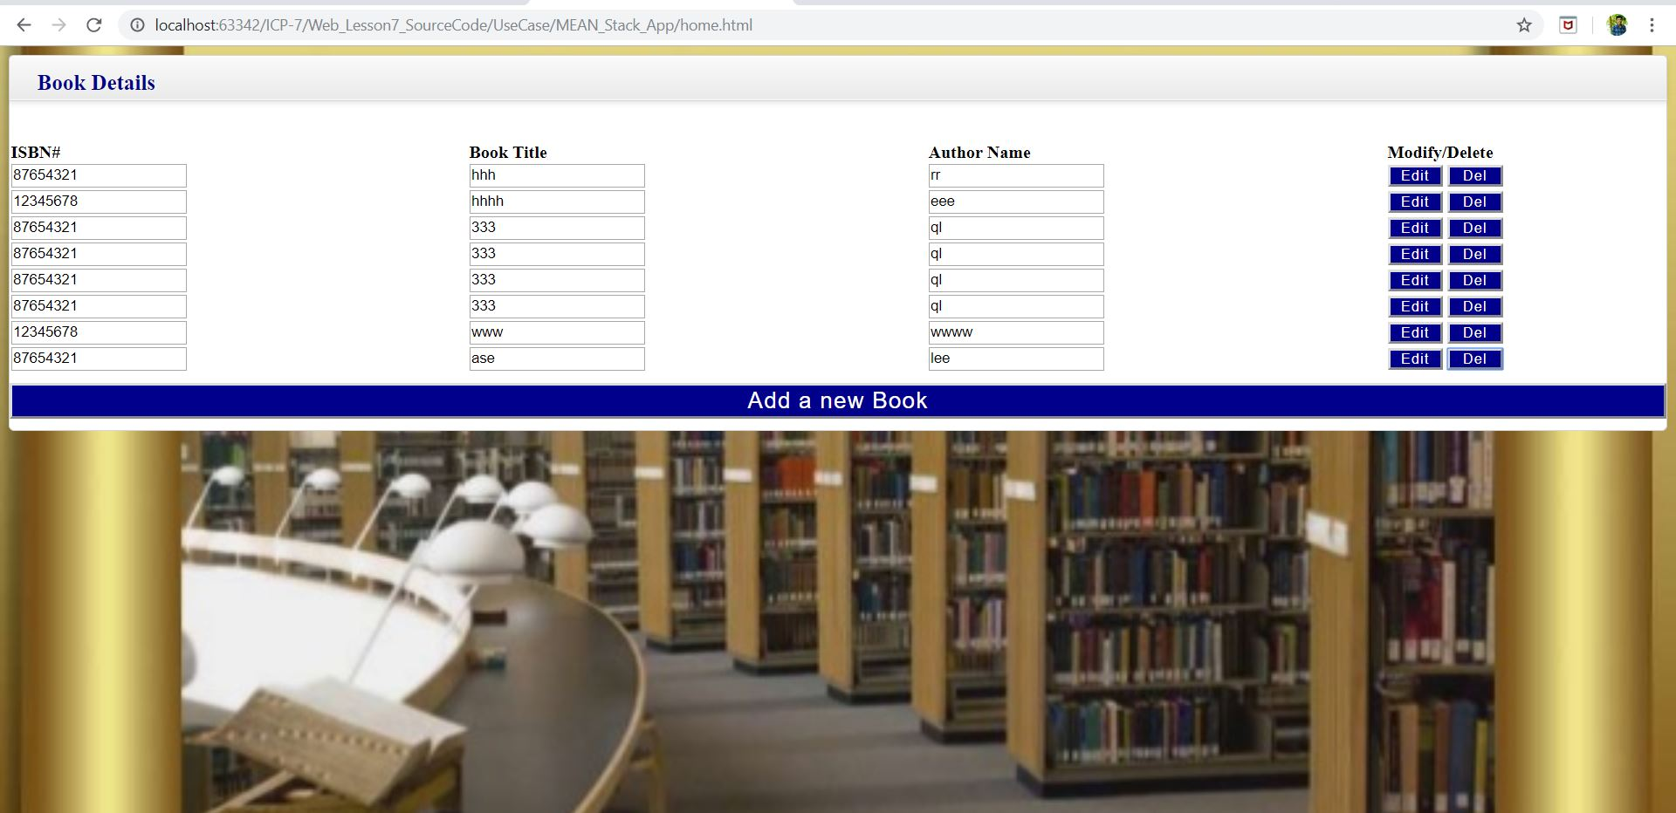

6.library database with collection name books

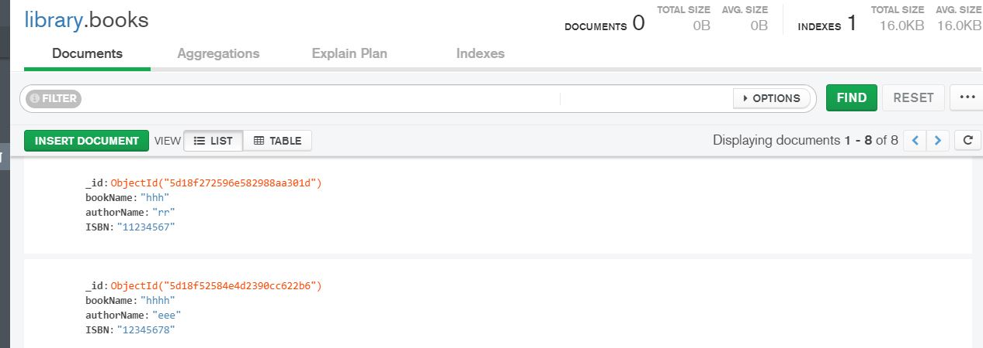

**Conclusion:**

* Hence learnt how to create meanstack application using mongodb.