**Name: Lakshmana Kumar Mettu**

**Class ID:11**

**Introduction:**

* This ICP is to introduce android elements and building simple android applications.

**Programming elements and Tools required:**

* Android Studio
* Basic Android Emulator

**Objective:**

* In this assignment the main objective is to create android login application.
* It has two activities.
  1. Main Activity.java
  2. Home Activity.java
* Coming to the main activity It has two fields to enter username and password for login to homepage.
* The code snippet for main activity is given below.

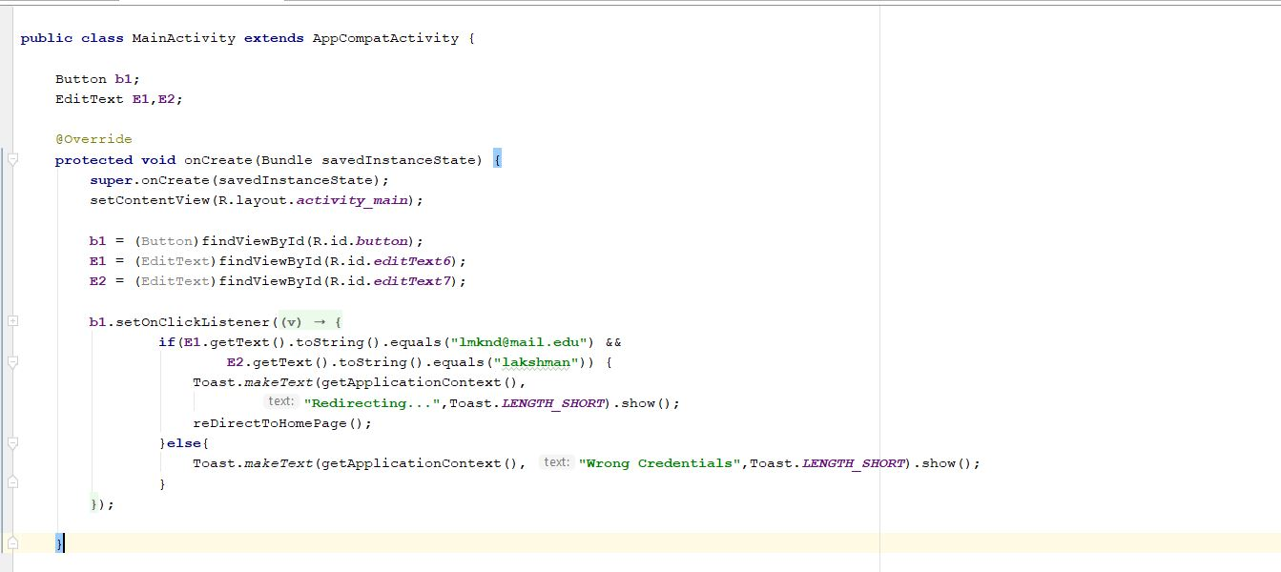

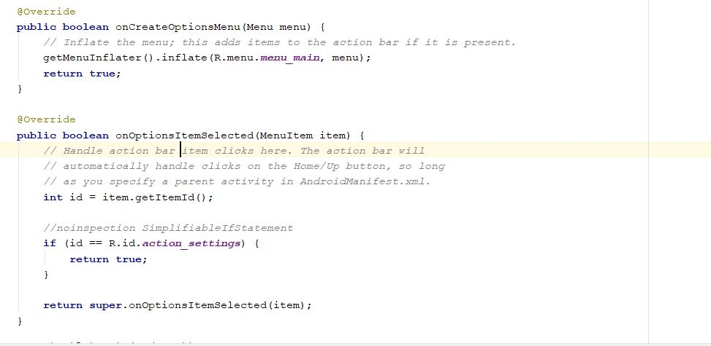

* Here Relative layout is used in order to relate all the parameters that are used in this application.
* Now when user enters their credentials It will re-direct to home page.
* If they enter wrong username or password it shows wrong credentials.
* Corresponding code snippet for home page is shown below.

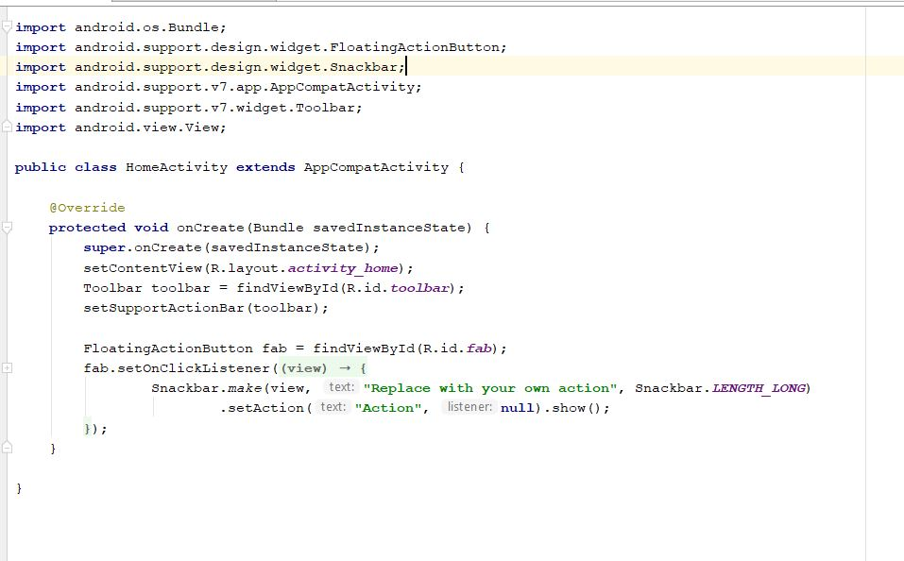

* And move on to manifestfile.xml where I have given permission to access to internet and it uses all the declared parameters. Code snippet for this one is given below.

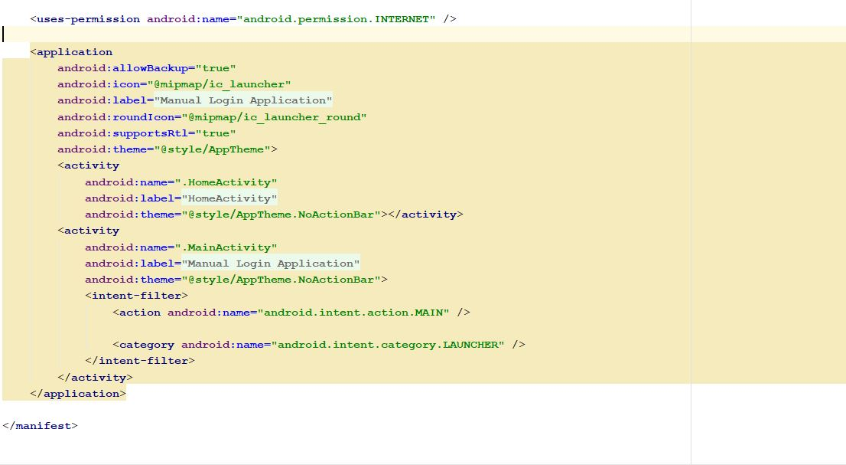

* Finally, I was created an emulator and run the file successfully and also tested in my android mobile.
* Output Snippets for login application are shown here.

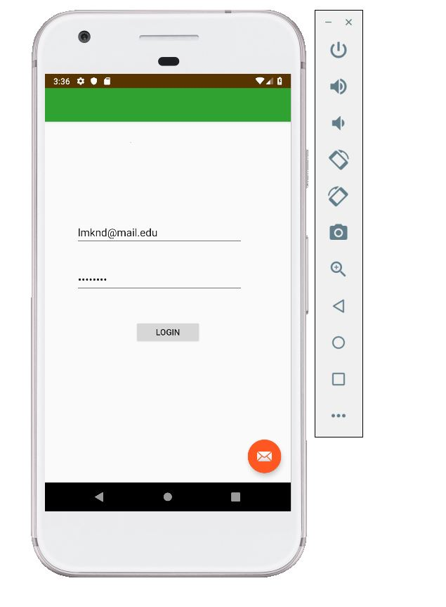

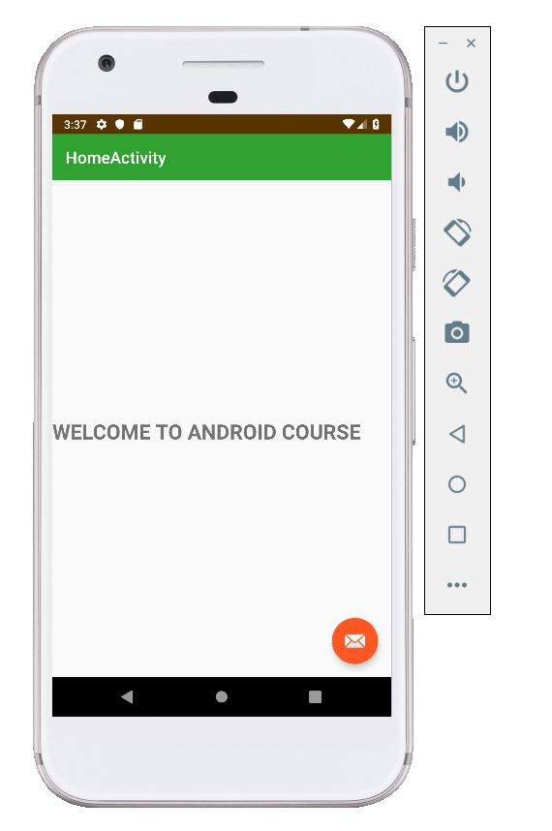

**Conclusion:**

* Hence learnt how to create simple android login application.