**Name: Lakshmana Kumar Mettu**

**Class ID: 11**

**Introduction:**

* This exercise is get to know about android layouts like relative, linear etc. and also to know about different intent styles like spinner, check boxes etc.

**Programming Tools:**

* Android Studio
* Android Emulator

**Objective:**

* The main objective of this ICP is to design Food Ordering Application and get the details through mail using android studio.
* It has two activities.

1. Main Activity
2. Order Activity

* Coming to the main activity It has different types of coffee flavors along with the prices. And When user select their list it has two buttons one for summary and another one for order.
* The code snippets for main activity is given below.

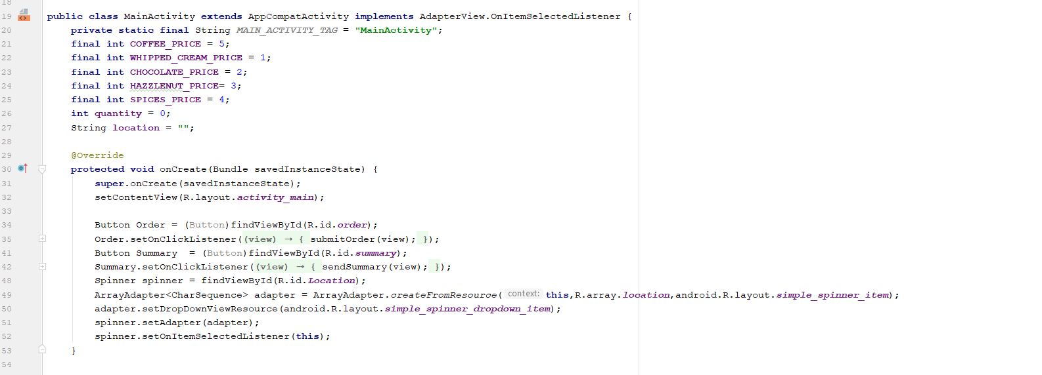

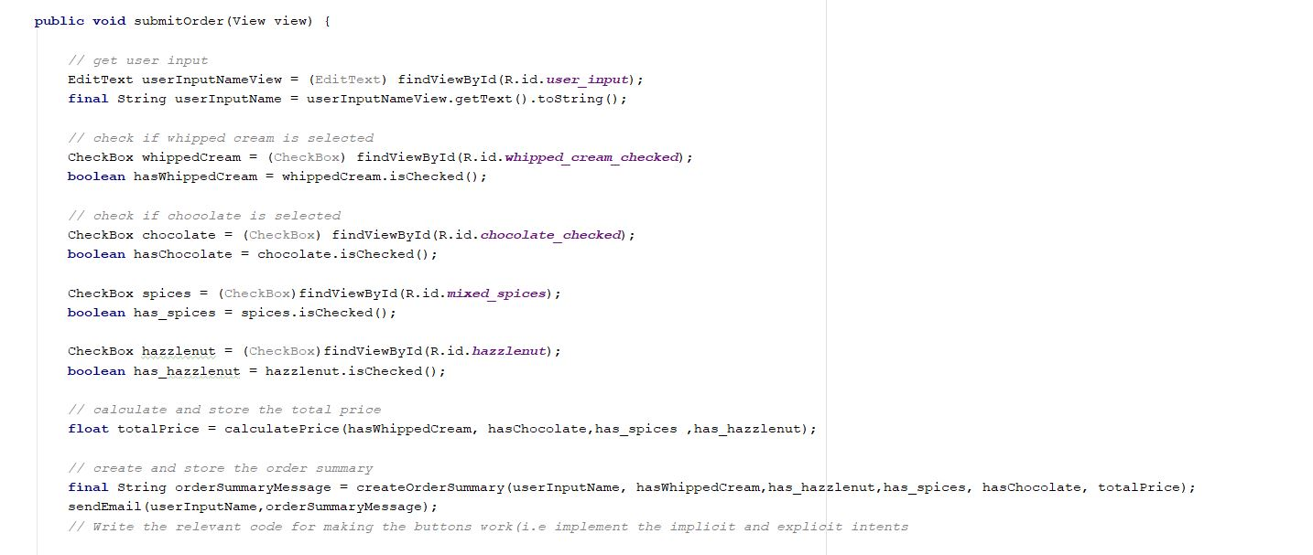

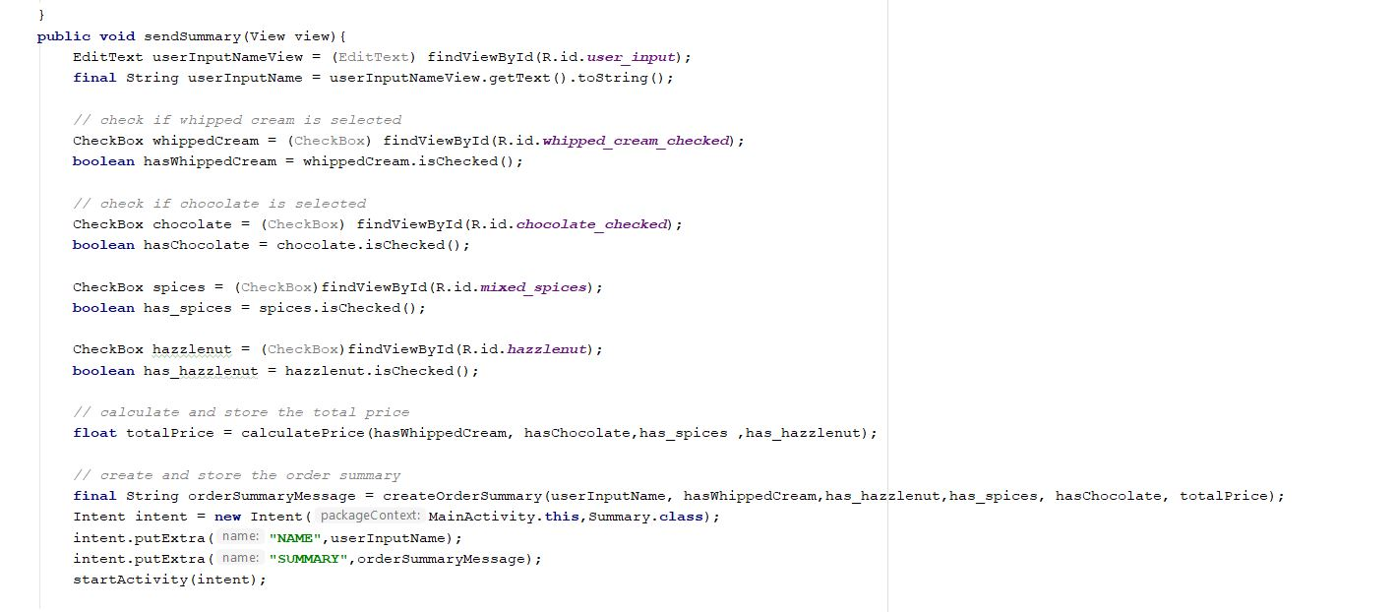

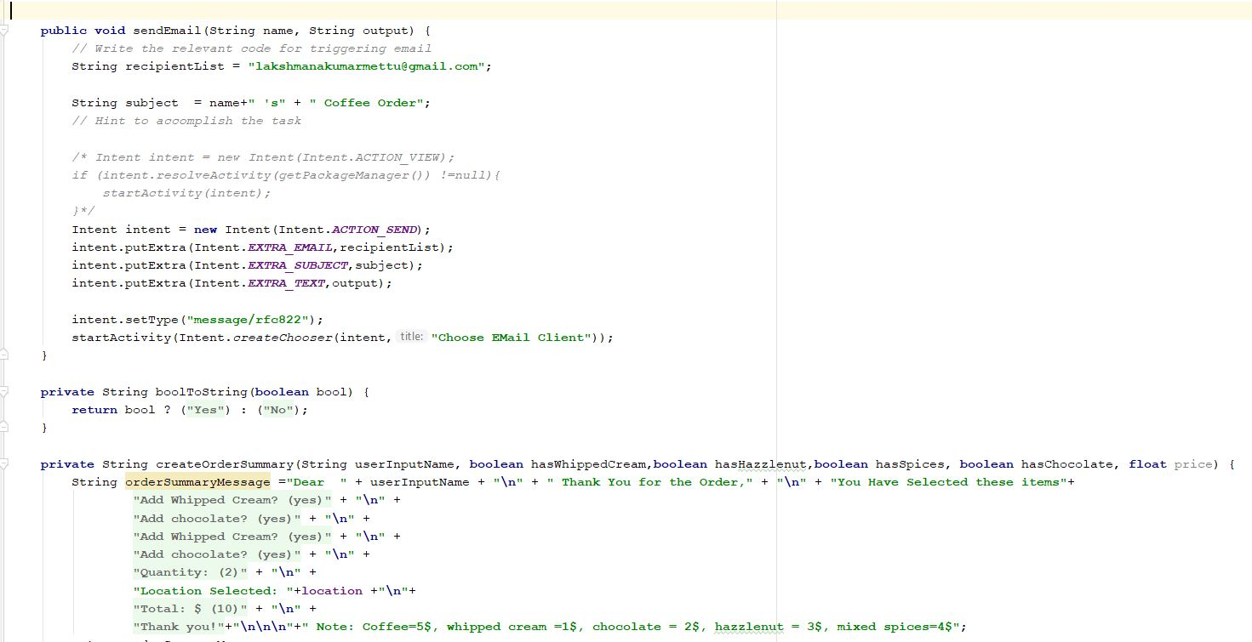

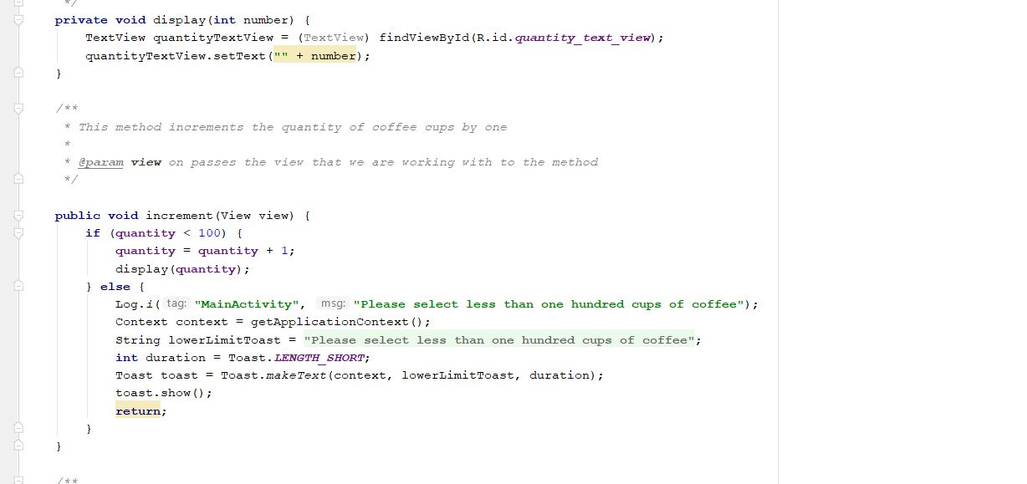

* The main activity has spinner to show the location, check boxes to select flavor, Buttons to get order and to show summary and increment and decrement buttons for number of items which are shown in above code snippets.
* When user completes the order, it will redirect to order page and has the mail approvals to send mail about order details.
* Corresponding code snippets shown below.

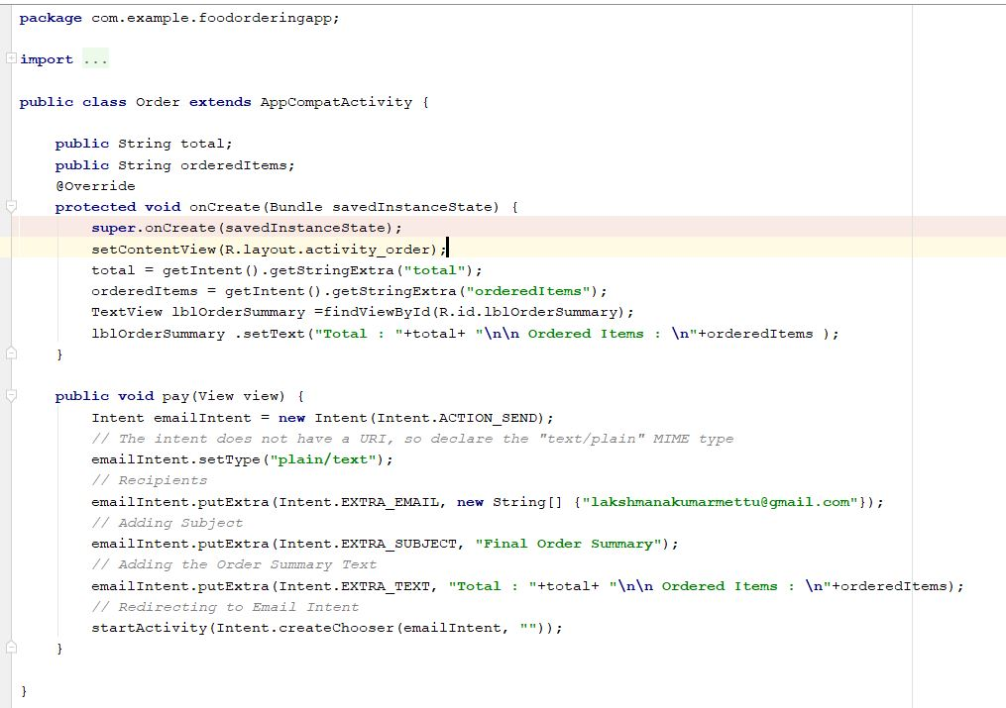

**Output:**

* I created an emulator in my laptop, build and run successfully.
* Corresponding outputs are given below.

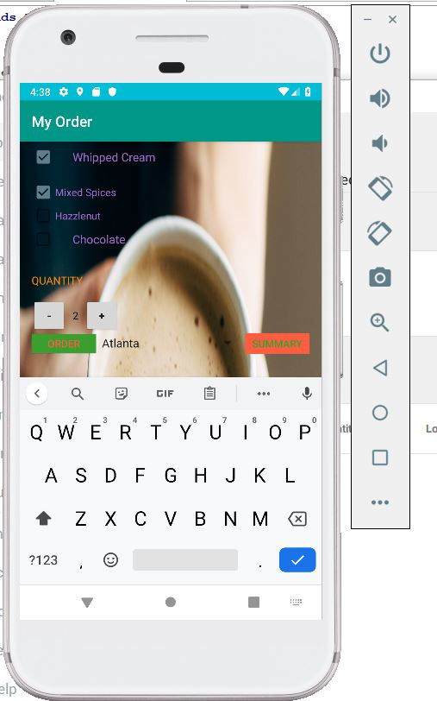

* Summary Page which is showing the order details and get button to place the order.

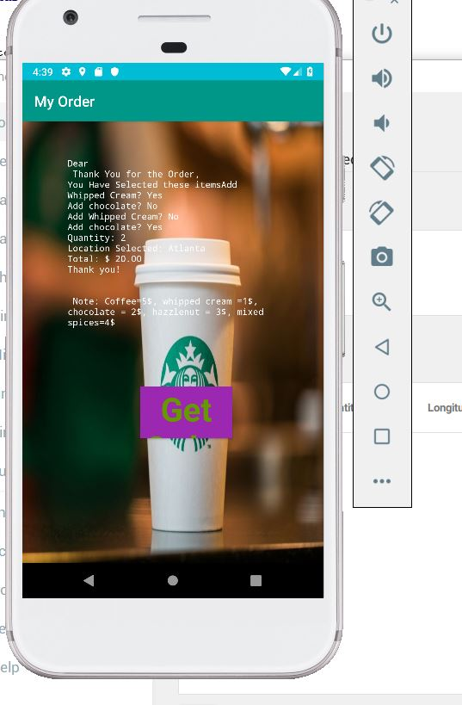

* When you click on order button it will redirect to mail.

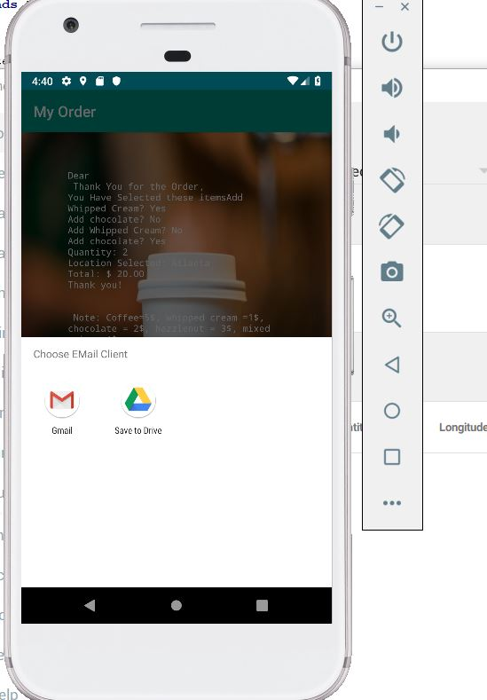

* Different type of buttons and spinner shown below.

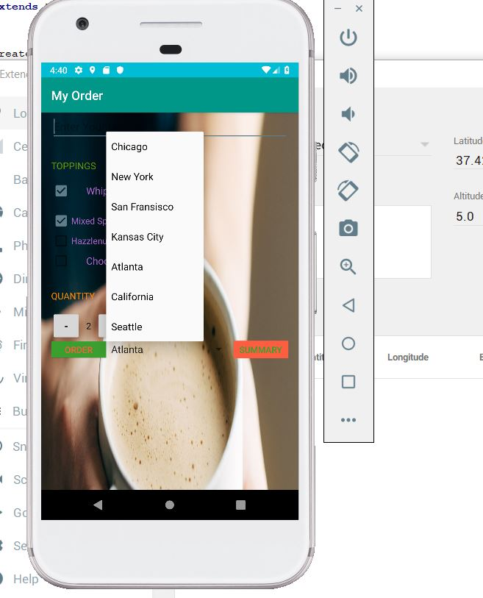

* When you give mail-id then order knock you through mail.

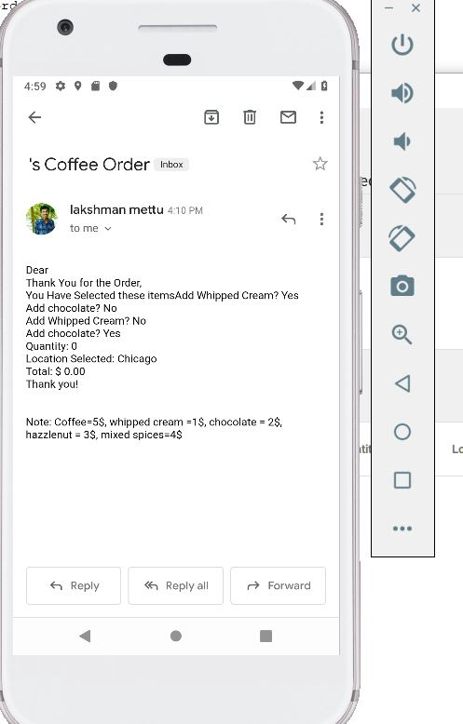

**Conclusion:**

* Hence learnt about how to create simple any food ordering app using android and linking with the mail to get alerts.