**Name: Lakshmana Kumar Mettu**

**Class ID:11**

**Introduction:**

* Implementation of user authentication web application.
* Developing an android application using social logins like Gmail, Facebook etc.

**Programming elements:**

* HTML5
* CSS
* Bootstrap
* Java Script
* Java

**Platforms Required:**

* Jet brains web storm
* Android Studio

**Connections and API's:**

* MongoDB
* Facebook oauth
* Google oauth

**Task-1:**

**Objective:**

* The main objective of task-1 is to develop mean stack web application.
* User should Register
* User can login into home page using registered details
* User should Save their data
* login status when they are moving to other pages
* Output screen changing depending on the moving pages
* Logout session by user
* Corresponding Code snippets for this task are given below

**Approaches and Workflow:**

* The main component for this task is server.js where user implement url connection to mongo DB which is shown below.

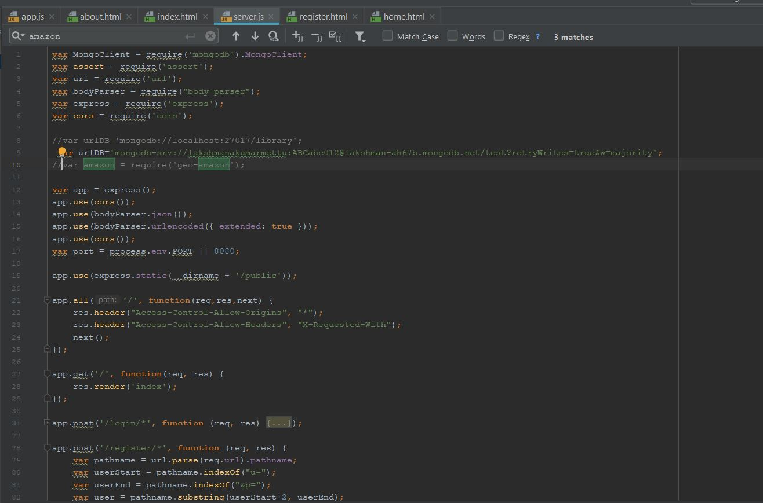

* Here DB name is library and have created collection as lab-2.
* After establishing the connection user can register their details and for each case pop-up will be shown.
* And update and delete functionalities are implemented for database shown in code snippet

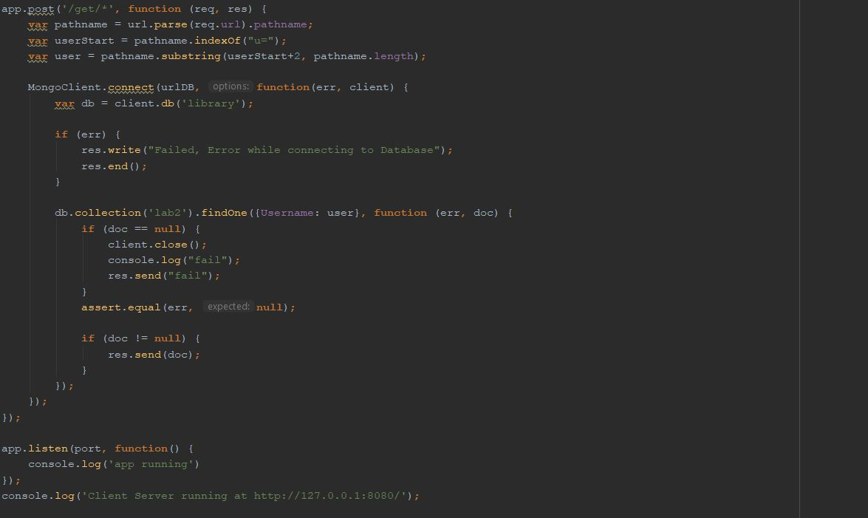

* User will redirect to local host and register and login into pages using saved details.

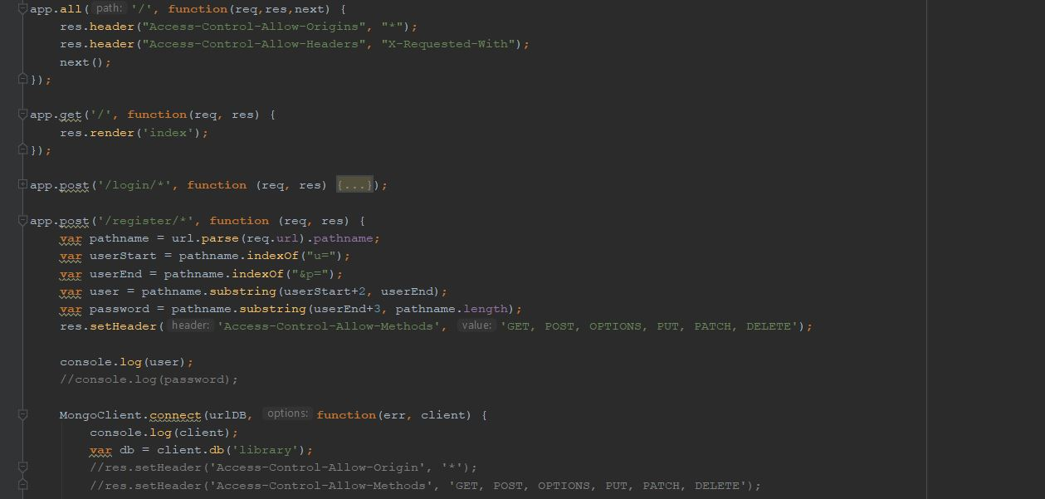

* Now app.js having functions for login, register and displaying pop-up messages depending on the user status.

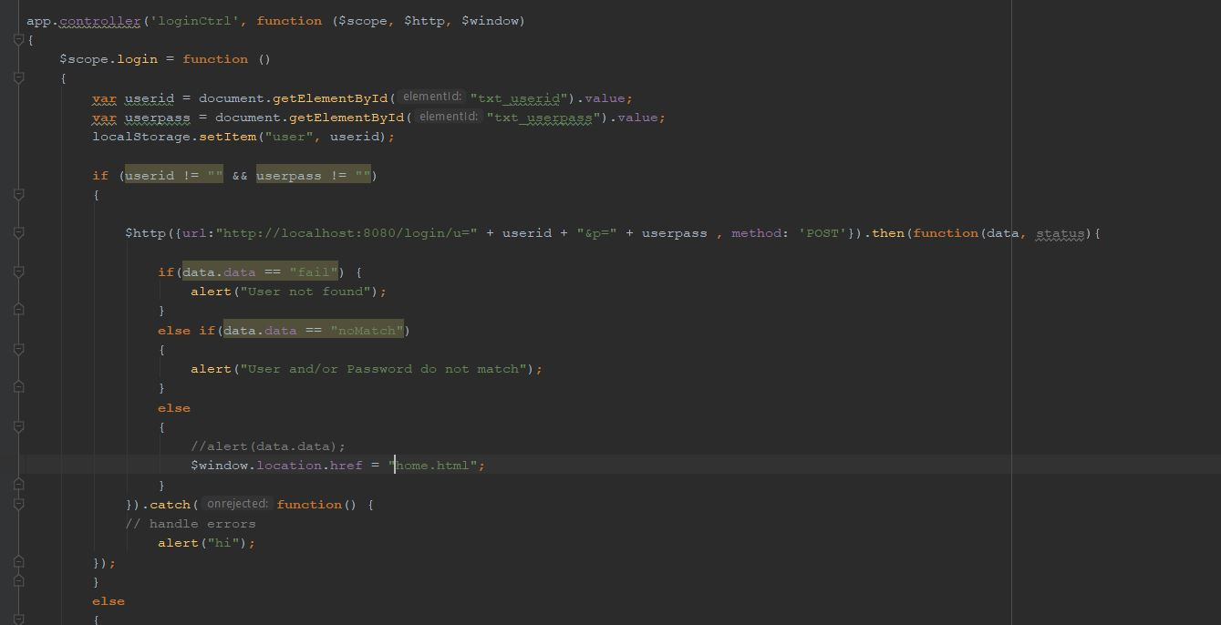

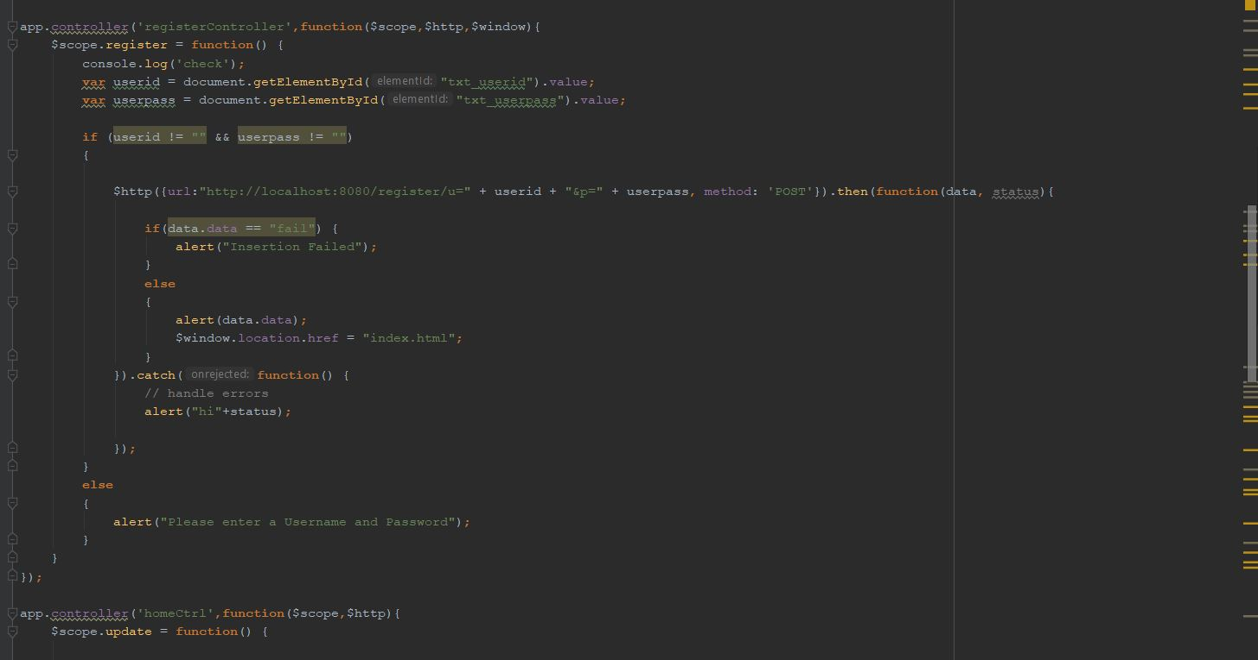

* It has functions for updating the dish details shown below.

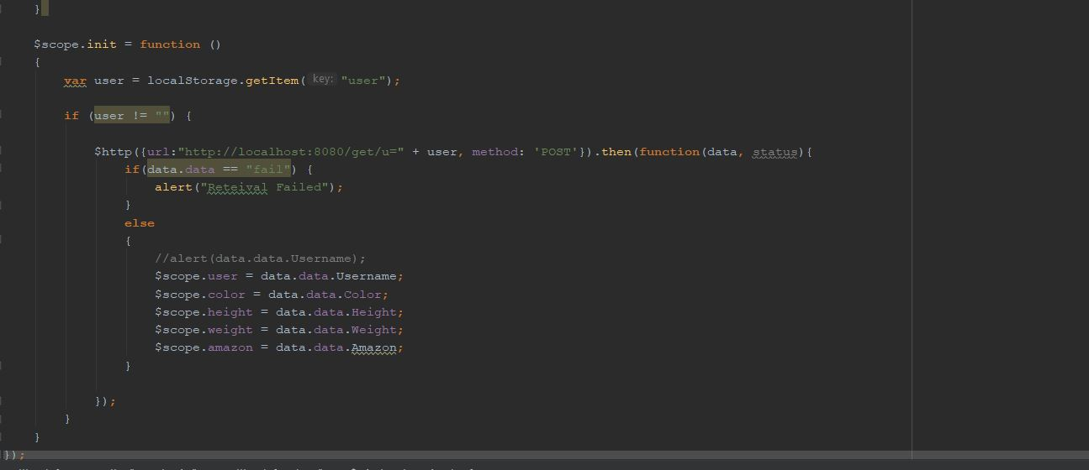

* Moving onto register page where user register their details user name and password.

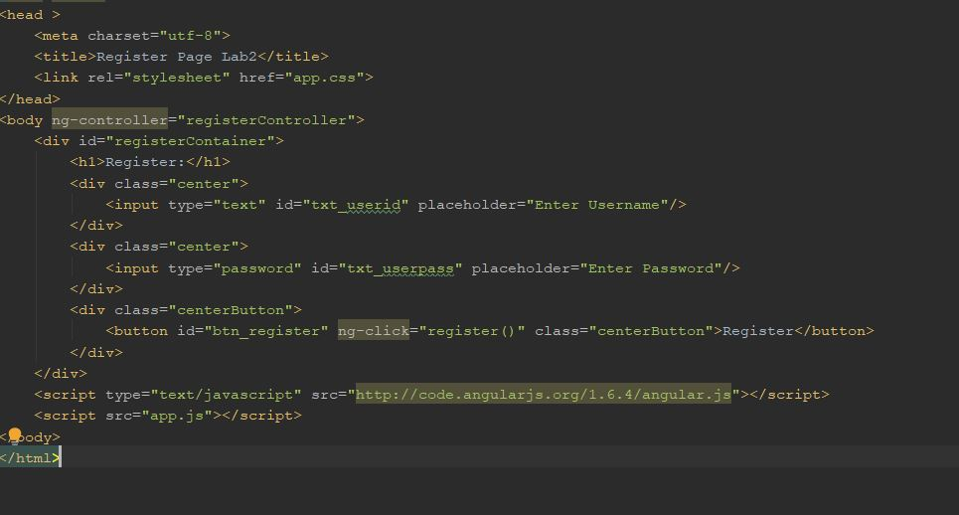

* User can login with registered details using login page given below.

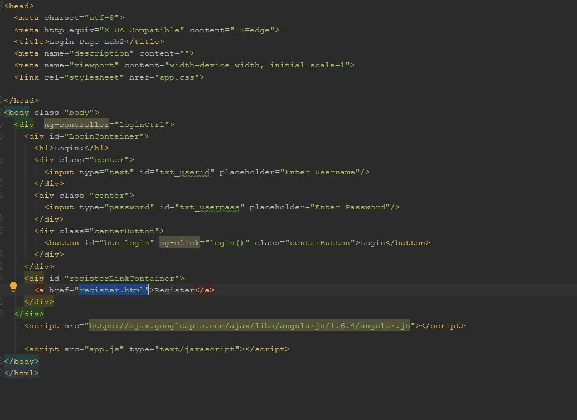

* Home page having item details shown below.

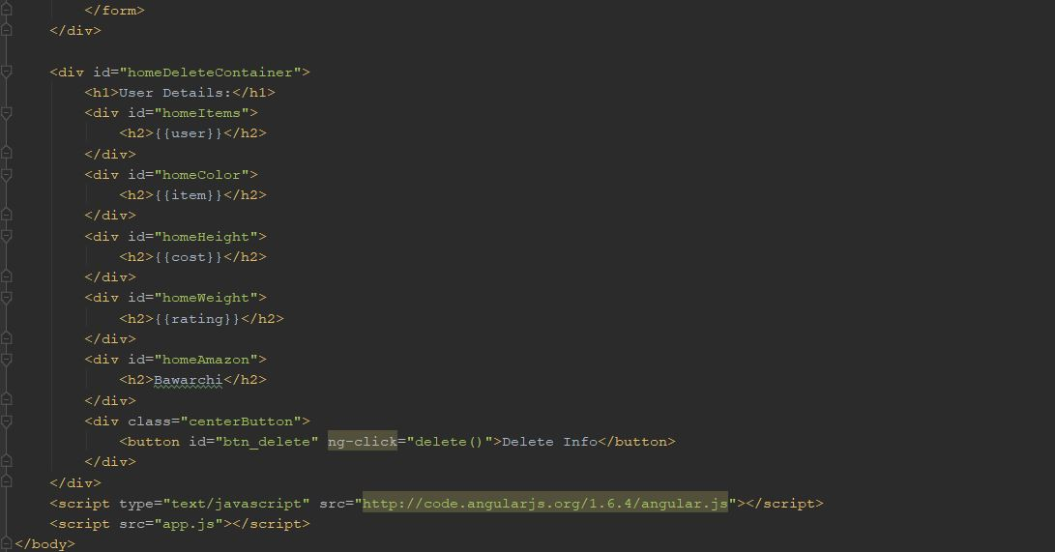

* Finally profile page is also implemented with user details.

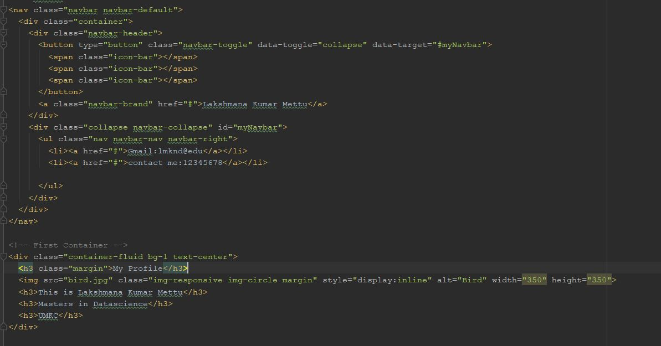

**Output:**

* Connecting to server shown below.



* Register page

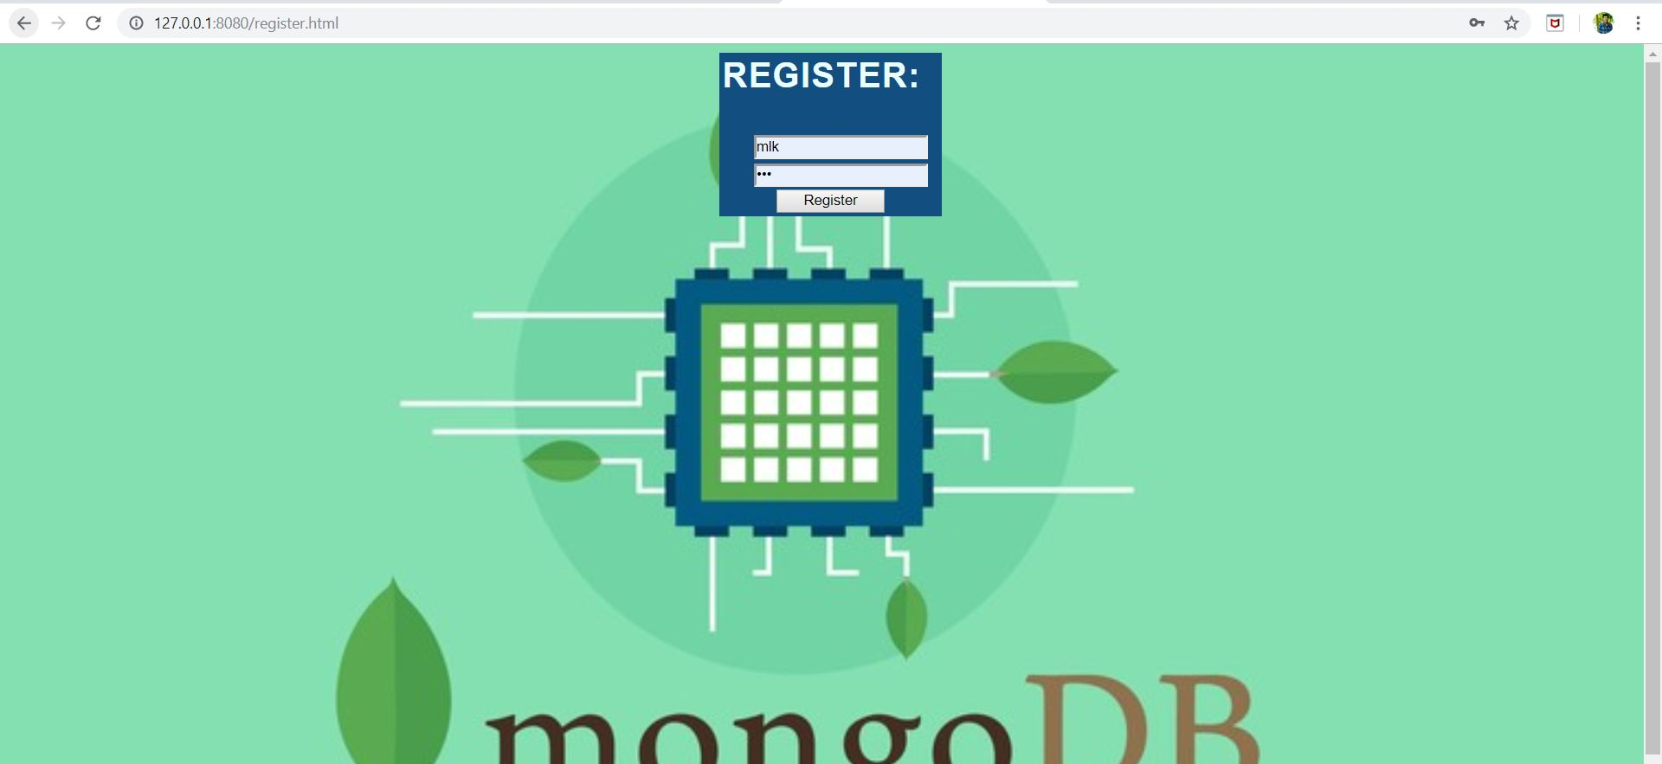

* Login page

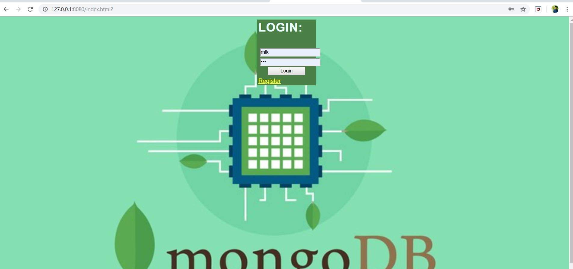

* when user login with saved details they will re-direct to home page shown below.

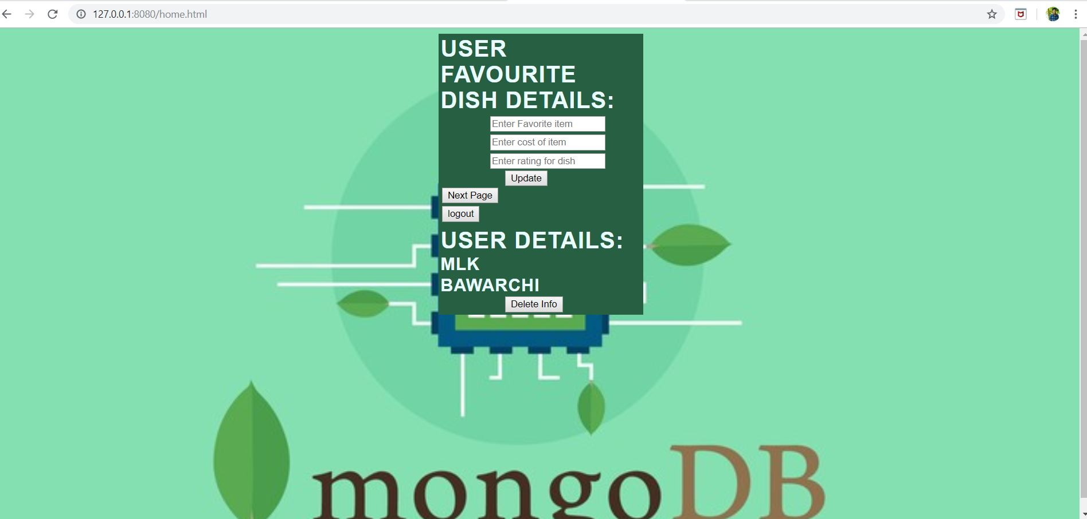

* Details inserting and updating in home page

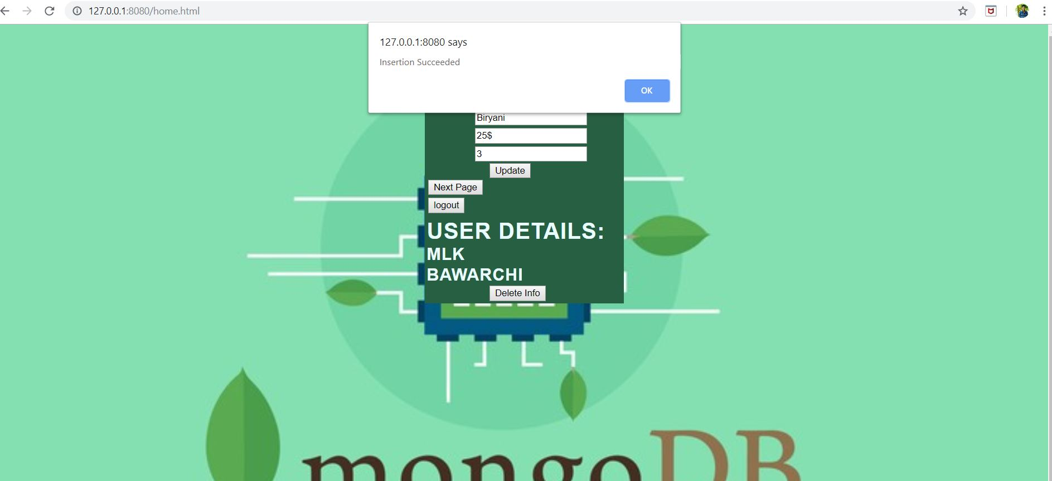

* When user click on next page, redirects to profile page.

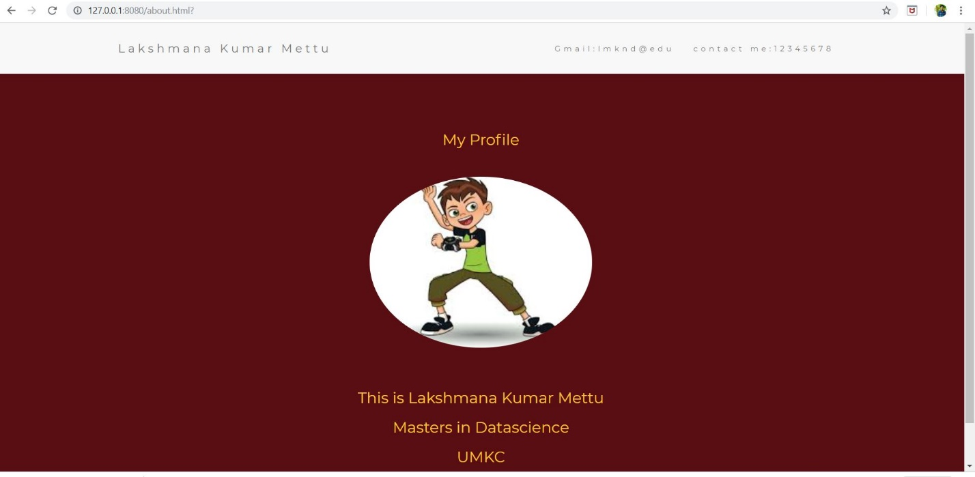

* Details deletion in database

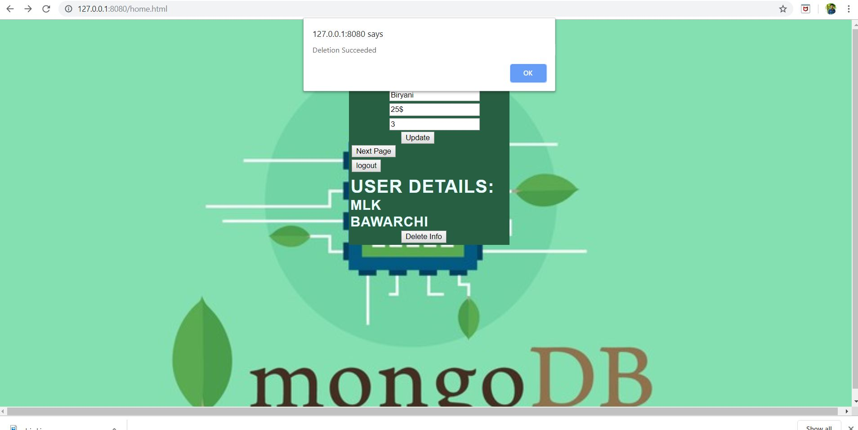

* when user click on logout button, it will redirect to login page given here.

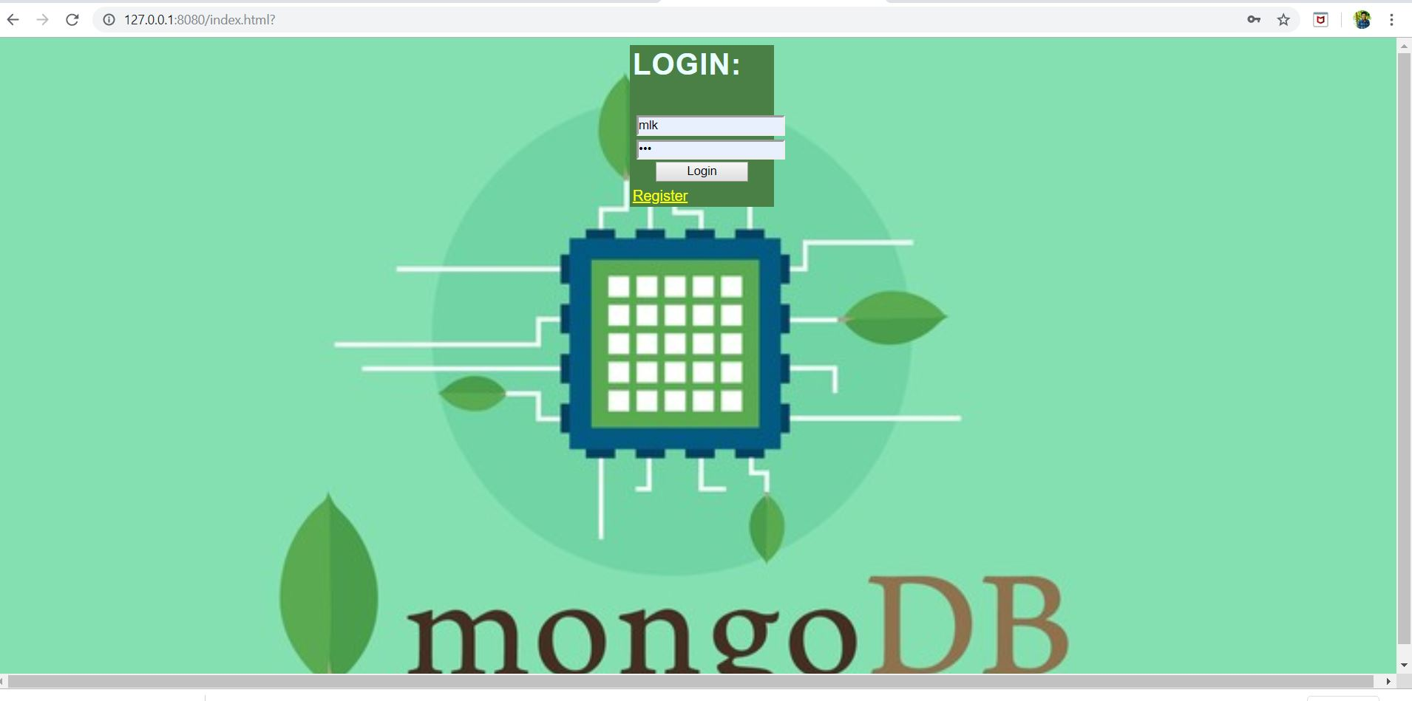

* Showing updated details in database

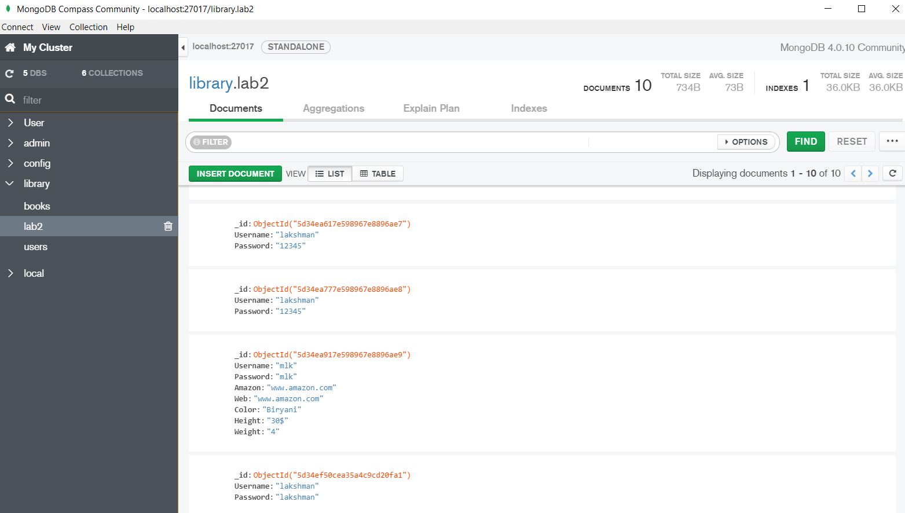

* Screenshot to show details are deleted in database

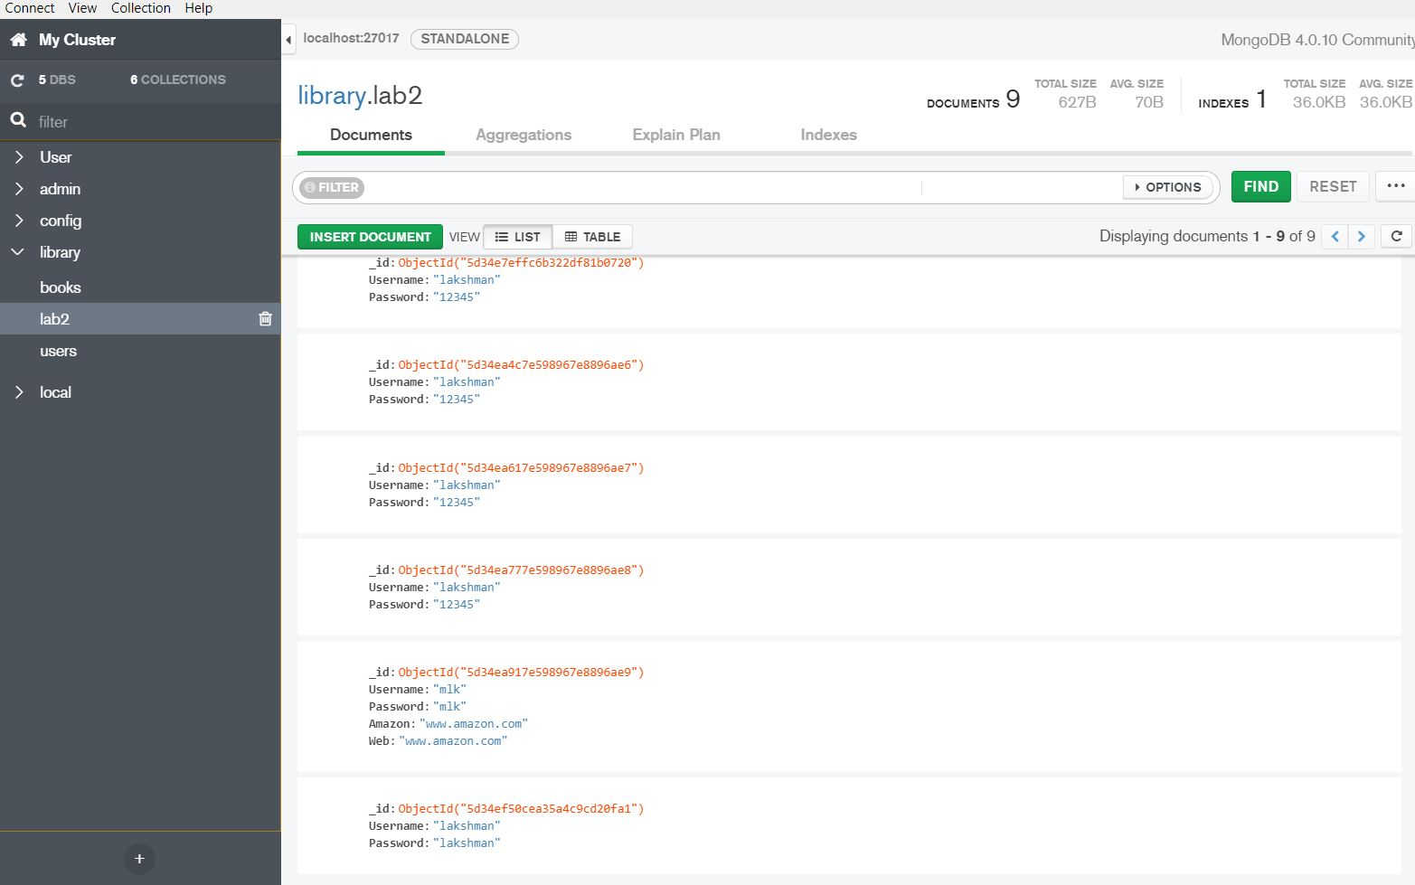

**Task-2:**

**Objective:**

* To design an android application
* It has normal login and signup
* It also has social login like Facebook, Gmail etc.
* It should display the user details like DOB, mail, location etc. in the welcome page.
* It has logout button

**Approaches and Workflow:**

* Coming to the code part it has two activities.

1. MainActivity.java
2. HomeActivity.java

* Main activity has normal login button, user login with their given username and password.
* It also has social logins Gmail and Facebook oauth.
* Using Json parser Facebook details are validated
* And by googleAPI oauth class Gmail credentials are validated.
* If user enters wrong username or password It shows wrong credentials.
* The corresponding code snippets are shown below.

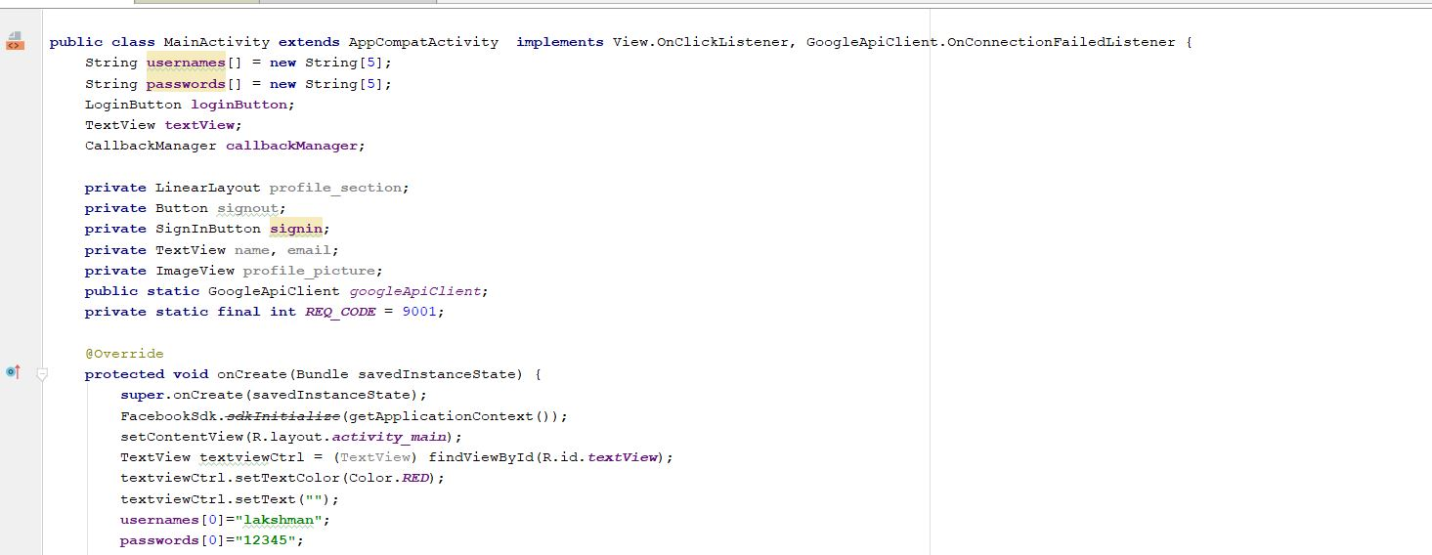

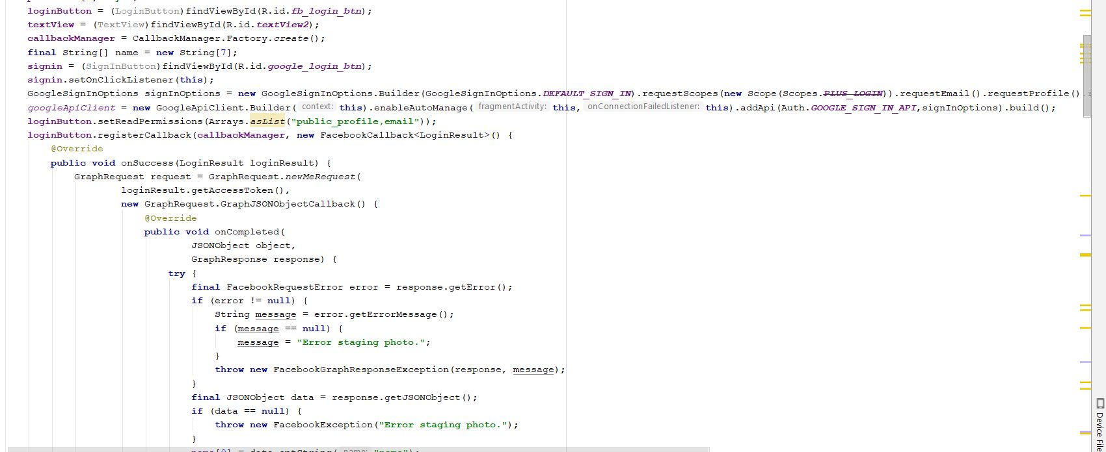

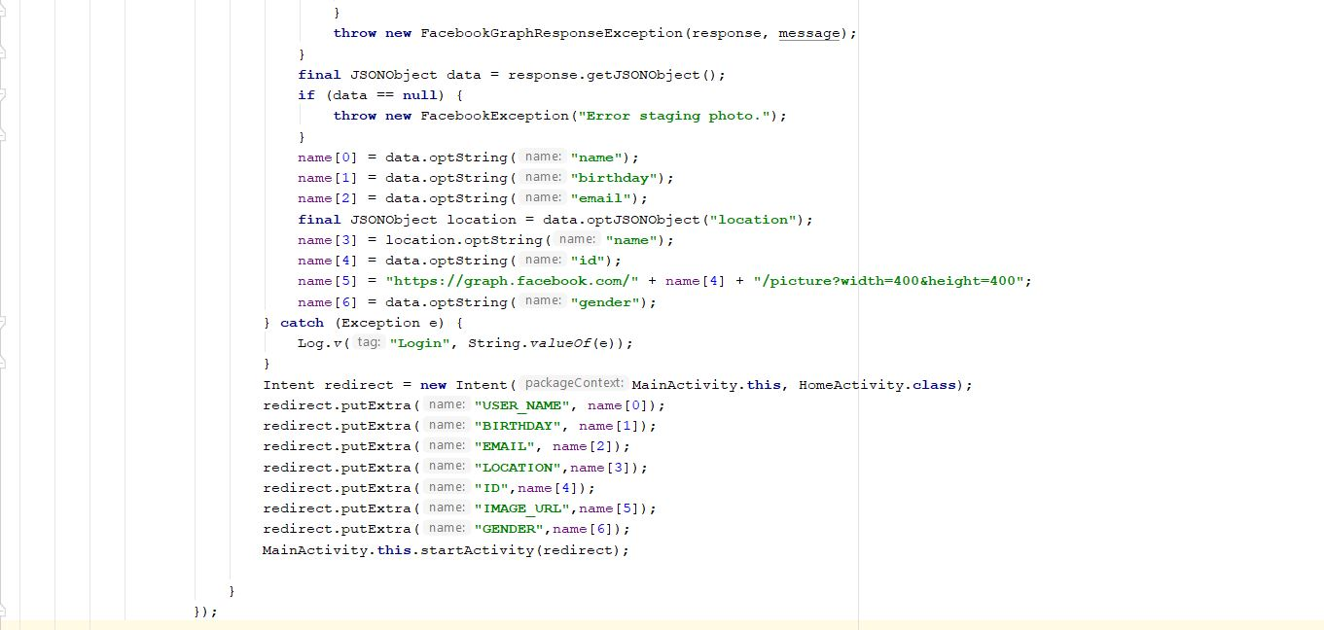

* Validating the credentials

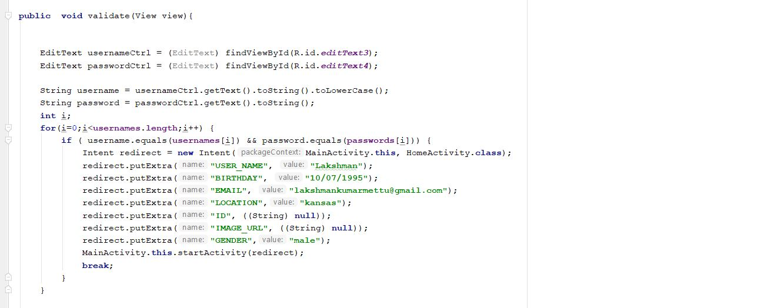

* Gmail login implementation

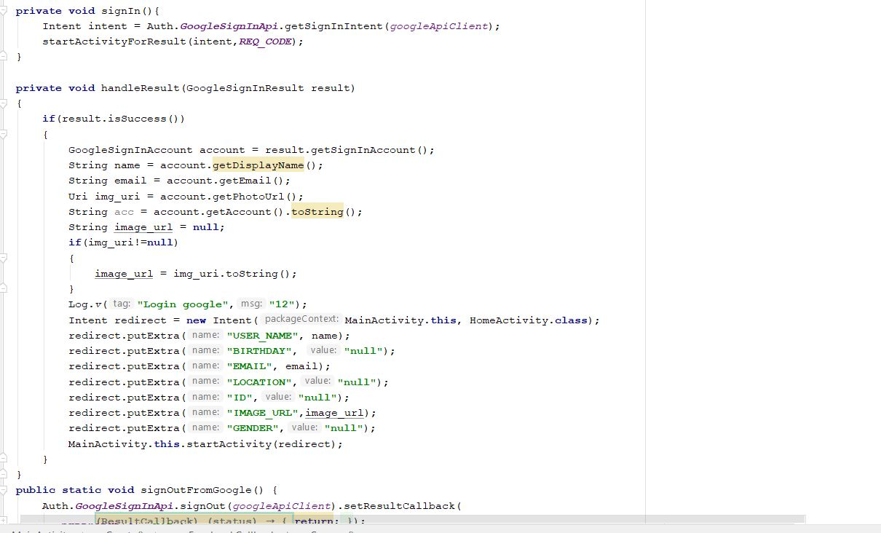

* Coming to the Home activity, where user details are implemented.
* It also containing logout button
* code snippet for home activity is given below

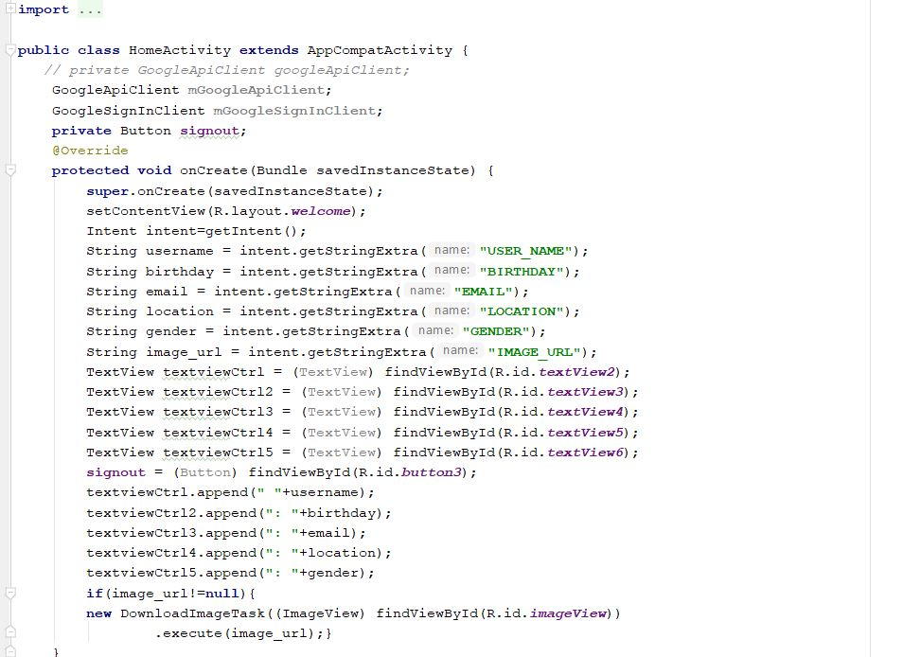

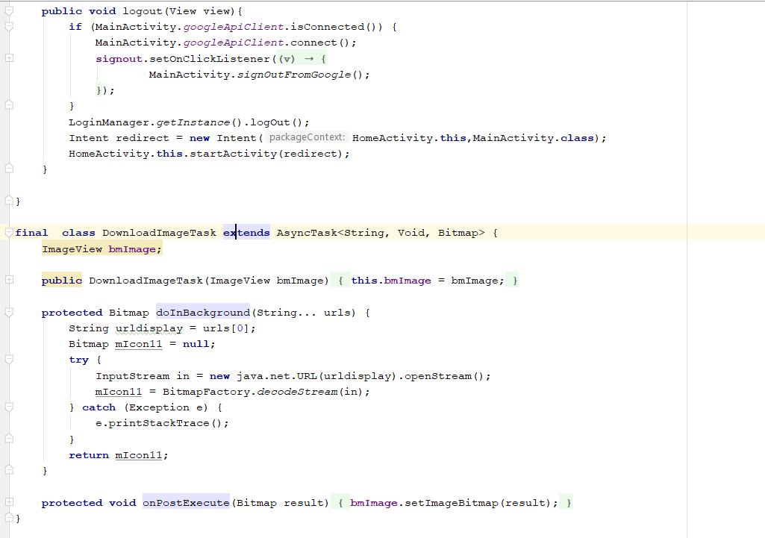

* Google-oauth class shown below.

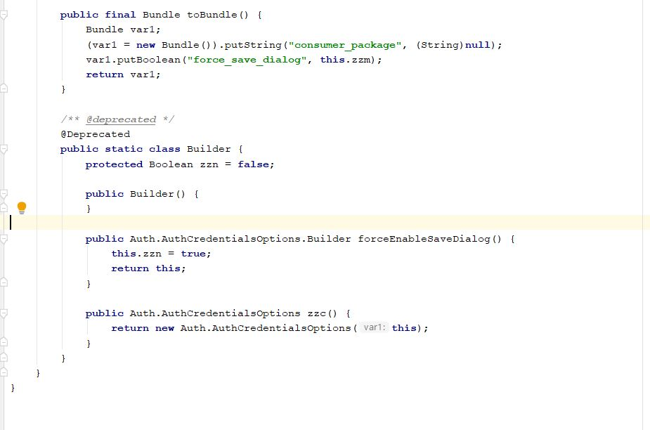

**Output:**

* Main activity having login, sign up and social logins Facebook and Gmail.

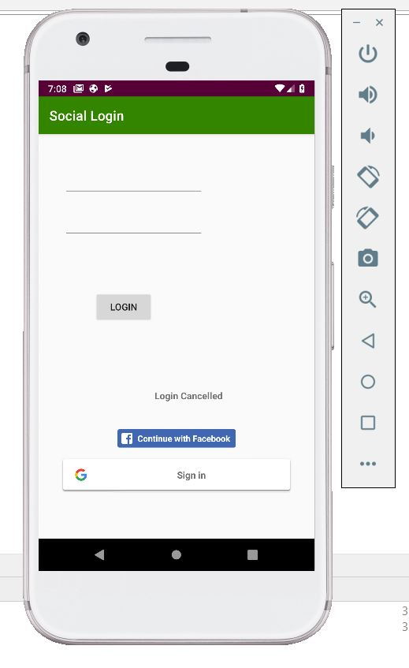

* Normal login

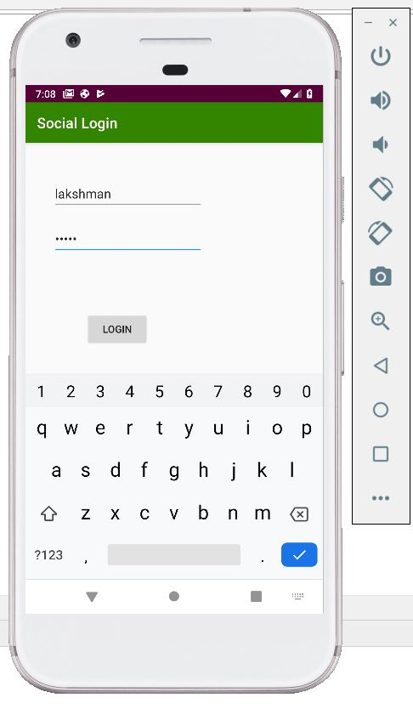

* Welcome screen showing the user details

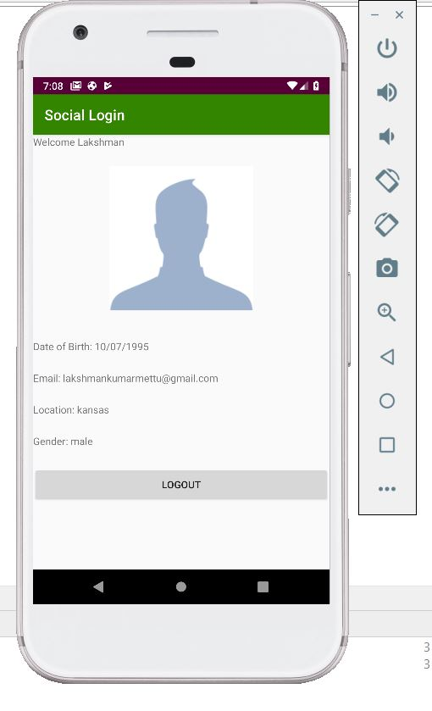

* Gmail login

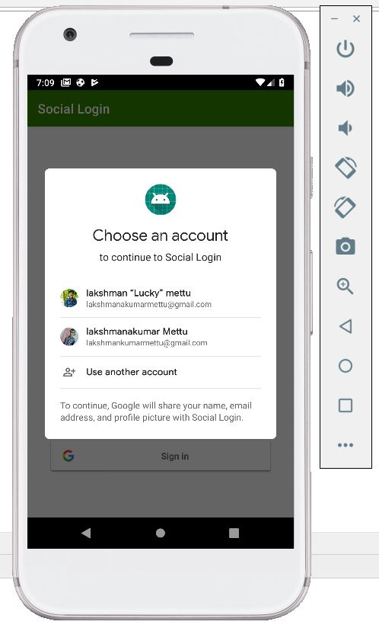

* Redirecting to welcome screen with gmail login

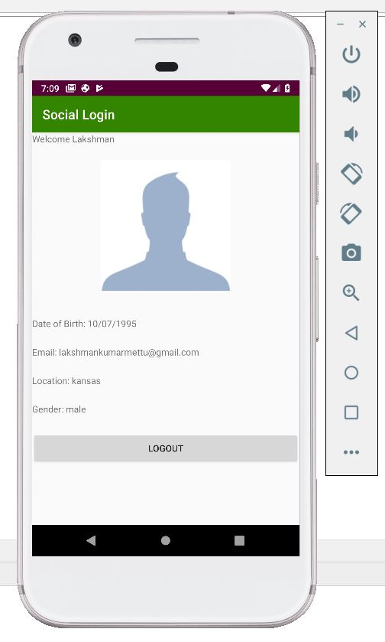

* Facebook login
* Since password attempts are exceeded so it is showing error message otherwise it redirects to welcome page.

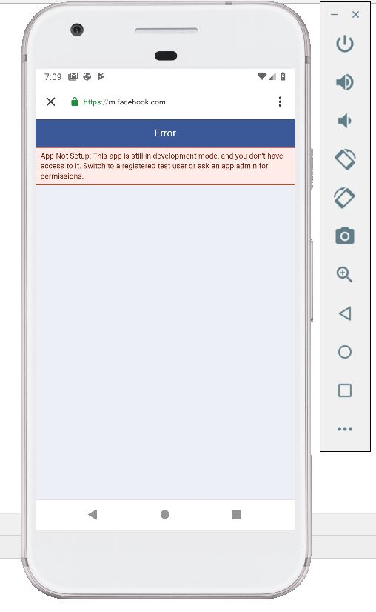

**Conclusion:**

* Hence Mean stack application as per the requirements has been completed
* Also, Implementation of android application using social login and signup with normal details has accomplished
* Learnt real time database usage in web as well as in android.