Vector Database as a Service (VectorDBaaS)
Programme Overview — parent page
AI for Tech | Unstructured Data Workstream | Working-group draft
Field | Value
Document | VectorDBaaS — Programme Overview (parent page)
Status | Working-group draft, intended as first-read orientation page
Audience | Architects, platform leads, governance stakeholders, senior reviewers, working-group members
Position | Parent page — sits above the v2.1 reference design and the control-plane vs data-plane sub-page
Authoritative reference | VectorDBaaS Reference Design and Roadmap v2.1 — this page is an orientation summary, not a backing paper
1. What VectorDBaaS is
VectorDBaaS is a proposed enterprise service for governed, reusable vector capability across the bank's data platforms. It provides a common way to onboard, embed, store, govern, and retrieve vector-encoded representations of unstructured and semi-structured data — supporting retrieval-augmented generation, agentic workflows, semantic search, knowledge services, and Fabric-published semantic and vector-derived products.
The service is proposed as the recommended target enterprise pattern. It moves the bank from fragmented, use-case-led vector solutions toward a shared, governed capability with consistent contracts, embedding-model governance, lineage, and runtime controls.
2. Why a service
Vector capability has rapidly become foundational to AI use cases. Without a shared service, each use case provisions its own vector store, brings its own embedding model, defines its own metadata, and applies inconsistent governance. For a regulated bank this creates four problems: cost duplication; non-comparable retrieval across use cases; weak controls around residency, classification, and lineage; and stranded collections that cannot be migrated when the underlying model is refreshed.
A shared service solves these by providing the common substrate — embedding-model governance, contracts, lineage, observability, and runtime enforcement — once, so that AI use cases reuse a governed capability rather than rebuilding it.
3. Proposed shape — hub-and-spoke
The recommended target shape is hub-and-spoke. One central control plane, owned by AI for Tech, holds the registry, contracts, embedding-model governance, lineage, and orchestration. Federated data planes — deployed within each data platform such as CIB, WPB, and other group platforms — hold the vector engines, run query and retrieval workloads, and enforce runtime policy locally. Consumers reach the service through an access layer that supports two equally-governed exposure surfaces.
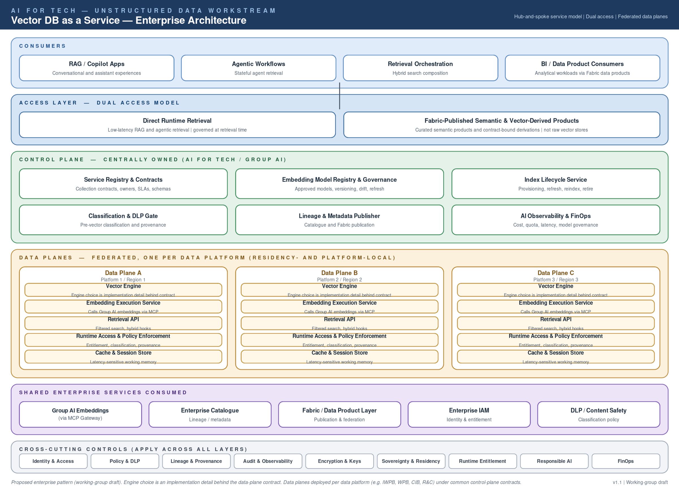
Figure 1 — Recommended target shape: central control plane, federated data planes, dual access. Full diagram and detail in v2.1.
4. The dual access model
VectorDBaaS supports two consumption patterns from the same governed collections:
- Direct runtime retrieval — for low-latency RAG, agentic retrieval, and semantic search workloads. Consumers reach the service via service principals, with entitlement and classification enforced at every call.
- Fabric-published semantic and vector-derived products — for analytical and BI consumption. What is published to Fabric is curated semantic products, governed semantic views, or contract-bound vector-derived products — not raw vector collections.
Both paths are governed by the same control plane. There is no Fabric path that bypasses classification, lineage, or embedding-model governance — Fabric publication is an exposure decision, not a governance shortcut.
5. Governance position
Embedding-model governance is proposed as the keystone of the service. A single registry of approved embedding models — with policy, lifecycle, residency constraints, and refresh orchestration — is what allows the service to remain coherent over time. Use cases consume approved models through a governed access layer (MCP); they do not select or version models independently. This is what prevents embedding-model proliferation, drift, and stranded collections.
Other first-class governance concerns built into the service: classification and DLP at ingest; lineage publication to the enterprise catalogue; residency and sovereignty enforcement at the data plane; retrieval-quality baselines and benchmark-set monitoring; and FinOps signals supporting per-tenant chargeback.
6. Operating model — ownership boundaries
Clear ownership is essential for a shared service in a regulated bank. The proposed accountabilities are:
Accountability | Owner (proposed)
Service design, control plane, contracts, registry, lineage, observability, FinOps framework | AI for Tech
Approved embedding models — selection, lifecycle, refresh, sanctioning | Group AI
Data plane operation within each platform — vector engine, runtime, residency enforcement, scale | Each data platform (e.g. CIB, WPB)
Use-case onboarding, business-relevant benchmark sets, acceptance criteria for retrieval quality | Tenant
Fabric publication of semantic and vector-derived products under data-product contracts | AI for Tech (publishing) + Data Product Access Layer (governance)
Service boundary
VectorDBaaS standardises and governs vector capability across the bank. It does not own all retrieval logic, all semantic reasoning, all knowledge-graph behaviour, or all use-case-specific ranking — those remain peer-service or tenant responsibilities.
7. In and out of scope
In scope | Out of scope
Vector storage, indexing, and retrieval as a managed service | General-purpose unstructured-data ingestion and ETL
Embedding-model governance and refresh orchestration | Embedding-model selection by individual use cases
Collection contracts, classification, residency, and lineage | Source-system data quality and master-data definitions
Runtime access and policy enforcement | Use-case-specific retrieval logic, ranking, and prompt orchestration
Fabric publication of semantic and vector-derived products | Raw collection exposure to Fabric or BI consumers
Retrieval-quality framework, monitoring, and baselines | Definition of business-relevant benchmark sets (tenant-owned)
8. Adoption approach
Adoption is staged across five phases — foundation, reference data plane, multi-tenant and governance hardening, federation across data planes, Fabric publication of semantic products, and steady state. No specific timeline is committed at this stage; phases are sequenced by exit criteria, not calendar dates, and progression depends on platform readiness, dependency alignment, working-group endorsement, funding approval, and tenant prioritisation.
POCs identified per phase are candidate validation areas, not committed deliveries. They represent where the service is expected to be validated against prioritised candidates from the capability gap assessment, subject to use-case prioritisation.
9. Document family — what to read
This parent page is a first-read orientation summary. The detailed positions and design rationale live in the documents below.
Document | Type | Read it for
VectorDBaaS — Programme Overview (this page) | Parent / overview | First-read orientation; what the service is, why it exists, the proposed shape, and how the document family fits together.
VectorDBaaS Reference Design and Roadmap v2.1 | Backing paper (authoritative) | Full architectural detail: 18 sections covering reference architecture alignment, service architecture, capability surface, tenancy, embedding governance, dual access, operating model, contracts, observability and FinOps, adoption roadmap, risks, decisions, and open questions.
VectorDBaaS — Control Plane vs Data Plane Responsibilities | Sub-page (companion) | A single-table view of which responsibilities sit on the control plane and which sit on the federated data planes, with positioning paragraphs.
Architecture diagram (PNG / SVG) | Visual | The hub-and-spoke shape: consumers, dual access, control plane components, federated data planes, shared services, cross-cutting controls.
10. Decisions sought from the working group
- Endorse VectorDBaaS as the proposed enterprise pattern for vector capability.
- Confirm the recommended hub-and-spoke shape — central control plane and per-platform data planes.
- Agree the dual-access model — direct runtime retrieval and Fabric-published semantic / vector-derived products under common governance.
- Confirm the proposed AI for Tech accountability for the control plane, and the Group AI accountability for embedding-model provision.
- Confirm the ownership and accountability boundaries set out in the operating model, including the service boundary against peer services.
- Endorse the phased adoption roadmap as the basis for funding, resourcing, and dependency conversations — noting that no specific timeline is committed at this stage.

