Initial Reference Architecture for Unstructured Data

1. Purpose
This document provides the initial draft reference architecture for the Unstructured Data for AI workstream.
Its purpose is to define a platform-agnostic, enterprise-level architecture view for how heterogeneous unstructured and semi-structured content can be onboarded, prepared, processed, integrated with shared AI services, persisted, and exposed for retrieval, analytics, and downstream business use.
This is an initial logical reference architecture intended to establish the baseline architectural direction for the workstream and support further refinement, stakeholder alignment, and gap assessment.

2. Scope
The A1 architecture is intended to support a broad range of source types, including internal documents and knowledge content, workflow and case content, communication and collaboration content, audio and transcripts, external and third-party content, and enterprise file and repository sources.
It is designed to support downstream patterns including retrieval and search, RAG and assistant experiences, stateful agent workflows, knowledge graph construction, structured downstream data products, enterprise application integration, and analytics use cases.
It is intentionally platform-agnostic and does not assume a single cloud, product, or implementation topology.

3. Architecture Intent
The architecture addresses a common enterprise problem: unstructured data is already being used in multiple ways across AI use cases, but current delivery patterns are fragmented, use-case led, and not yet aligned to a shared architecture model.
The A1 reference architecture therefore provides a common lifecycle model for unstructured content, a shared capability view across ingestion, preparation, processing, storage, and retrieval, and a clear place for security, governance, lineage, and policy controls.
This architecture should be read as a logical enterprise capability model rather than a detailed deployment diagram or project-specific implementation.

4. Key Architecture Principles
Source-agnostic by design — The architecture must support a broad range of source domains without assuming a single dominant source pattern.
Modality-aware processing — Documents, audio, chat, email, tickets, and external content require different preparation paths and should not be forced through a single generic processing flow.
Canonical content before downstream AI use — Content should be normalised, enriched, classified, and governed before it is indexed, embedded, graphed, or exposed for retrieval.
Shared controls across the full lifecycle — Security, policy, lineage, DLP, encryption, and observability must apply across ingestion, processing, persistence, and retrieval.
Multiple persistence models with clear roles — Raw, processed, metadata, analytical, vector, graph, and session-state persistence each serve distinct purposes and should be treated separately.
Governed AI and tool interaction — AI runtimes should access tools, services, and models through governed integration patterns rather than unmanaged direct calls.
Support deterministic and agentic execution — The platform must support both deterministic workflows and stateful agent execution, with agentic patterns used where complexity justifies them.
Retrieval is a governed capability — Retrieval must apply entitlement, policy, provenance, and ranking controls rather than acting as a purely technical search function.
Federated deployment is expected — The logical architecture does not imply a single physical platform. Capabilities may be deployed in hybrid, multi-cloud, regional, or on-prem patterns depending on policy and operational needs.

5. Layered Architecture Overview

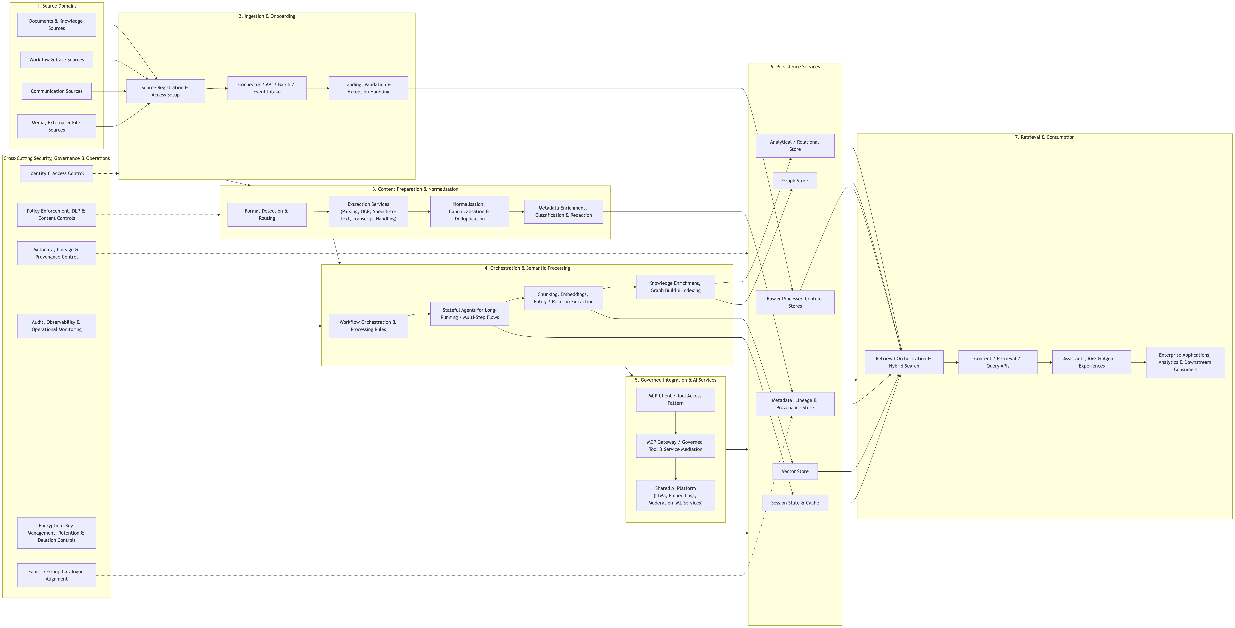
- 1. Source Domains
- 2. Ingestion & Onboarding
- 3. Content Preparation & Normalisation
- 4. Orchestration & Semantic Processing
- 5. Governed Integration & AI Services
- 6. Persistence Services
- 7. Retrieval & Consumption
- 8. Cross-Cutting Security, Governance & Operations

6. Layer-by-Layer Description

6.1 Source Domains
This layer represents the domains in which content originates. It includes broad source classes rather than individual products so that the architecture remains stable even as implementation technologies change. Typical domains include internal knowledge and document sources, operational workflow and case sources, communication and collaboration sources, media and interaction sources, external and third-party content sources, and enterprise storage and repository sources.

6.2 Ingestion & Onboarding
This layer provides the controlled path by which source content enters the platform. It includes source registration and ownership setup, access configuration, connector, API, batch, event, stream, or crawler-based intake, landing and raw intake handling, validation, quarantine and exception handling, and policy-aware routing based on source and content profile.

6.3 Content Preparation & Normalisation
This layer transforms heterogeneous source artefacts into a canonical, governed content form. Depending on content type, this may include format detection and modality routing, document parsing and OCR, speech-to-text and transcript handling, thread and conversation normalisation, cleaning and canonicalisation, metadata extraction and enrichment, classification, provenance capture, redaction, and sensitive-data handling.

6.4 Orchestration & Semantic Processing
This layer coordinates how content is processed once it has been normalised. It supports deterministic workflow orchestration, processing rules, replay and retry, controlled human intervention, and optional AI-enabled or semantic processing paths. Stateful agents are included here as a specialised execution pattern for long-running workflows, multi-step reasoning, and governed tool use.

6.5 Governed Integration & AI Services
This layer supports controlled interaction between orchestration/runtime services and shared AI or enterprise tooling. It includes MCP-based tool access patterns, governed mediation of service and tool calls, context, authorisation, and trace propagation, and access to shared AI platform services such as LLMs, embeddings, moderation, and ML models.

6.6 Persistence Services
This layer stores the outputs of the platform according to purpose. It includes raw content stores, processed artefact stores, metadata, lineage and provenance stores, analytical or relational stores, vector stores, graph stores, and session state and cache.

6.7 Retrieval & Consumption
This layer makes processed and governed content usable. It supports retrieval orchestration, hybrid search, policy and entitlement filtering, content and retrieval APIs, assistants and RAG experiences, enterprise application integration, and downstream analytics and data consumption.

6.8 Cross-Cutting Security, Governance & Operations
This is the control plane that applies across all layers. It includes identity and access control, policy enforcement and DLP, metadata, lineage, provenance and catalogue alignment, audit and observability, encryption and key management, retention and deletion controls, external source trust and legal/usage controls, and residency and sovereignty controls.

7. End-to-End Flow Summary
- Content originates in one or more enterprise or external source domains.
- It is onboarded into the platform through controlled ingestion and intake patterns.
- It is prepared and normalised according to modality and content type.
- It is processed through deterministic workflows and, where needed, stateful agent patterns and semantic services.
- It interacts with AI services and tools through governed integration mechanisms.
- It is stored in role-specific persistence services.
- It is exposed through retrieval and API layers for assistants, applications, analytics, and downstream consumers.
- Security, governance, lineage, and operational controls apply throughout the lifecycle.

8. Positioning of MCP and Stateful Agents

8.1 MCP
MCP is positioned as part of the governed integration layer. Its role is to provide controlled access from AI runtimes to tools and services, consistent handling of context and authorisation, and traceability and governed mediation. It should not be interpreted as the integration pattern for all ingestion or enterprise data movement.

8.2 Stateful Agents
Stateful agents are positioned as part of the orchestration and execution model. They are intended for long-running workflows, multi-step reasoning, governed tool usage, and scenarios where execution state must persist. They are not assumed to be the default processing path for all content types.

9. Mapping to Current Use Cases

Codifying the Bank
Provides strong patterns for stateful orchestration, MCP-based integration, graph and vector use together, and workflow-led knowledge processing.

Voice / Audio Use Cases
Provide strong patterns for audio ingestion, speech-to-text and transcript handling, sensitive-content controls, and structured downstream serving.

Knowledge Management / Managed Content Patterns
Provide strong patterns for managed content retrieval, metadata/content separation, caching/session behaviour, and governed AI interaction.
The A1 architecture generalises these patterns into a shared enterprise capability model while avoiding direct coupling to any single project design.

10. Current Assumptions and Constraints
- The platform must support heterogeneous source types.
- Metadata and lineage capabilities may initially be local to the platform, with strategic alignment to broader fabric and catalogue services over time.
- Processing and storage may be federated across cloud and on-prem environments.
- Some content may require restricted routing and cannot use all shared AI services.
- Not all use cases will need graph, vector, and agentic processing simultaneously.
- This initial version is a draft logical reference architecture, not a final target-state deployment design.

11. What This Initial Version Is Intended to Support
- Capability alignment across use cases
- Initial reference architecture review
- Structured gap assessment
- Identification of shared enterprise patterns
- Clearer separation of shared services from use-case-specific workflows
- Future refinement into a more detailed architect view and modality-specific swimlane diagrams

12. Summary
The A1 architecture provides the first shared enterprise view of how unstructured data can be onboarded, processed, governed, stored, and consumed across a broad range of AI use cases. Its value is in establishing a common architecture language across heterogeneous sources, modality-aware preparation, orchestration and semantic processing, governed AI integration, role-specific persistence, retrieval and downstream consumption, and strong security and governance controls. This initial version provides the architectural baseline needed to move from fragmented, use-case-led delivery patterns toward a more consistent and reusable model.

Appendix A. A1 Diagram
The A1 diagram provides the initial logical reference architecture for how heterogeneous unstructured and semi-structured content is onboarded from multiple source domains, prepared and normalised into a canonical governed content form, processed through deterministic and AI-enabled workflows, integrated with shared AI and tool services in a governed way, persisted across role-specific storage services, and exposed for retrieval, analytics, and downstream business use.
This version should be read as a logical enterprise capability view rather than a product-specific or deployment-specific architecture.

Appendix B. Policy and Routing Rules Examples
Policy and routing rules provide the decision logic that determines how different content types are handled across the platform. These rules allow the platform to route content differently based on source, modality, sensitivity, trust level, residency constraints, and intended use.
Rule Category | Example Trigger | Routing / Policy Action | Purpose
Sensitivity | Content classified as highly restricted | Route to restricted processing path; block shared embedding or external model use | Protect sensitive content
Source trust | Content from external web or social source | Apply provenance tagging, moderation, and optional human review | Prevent untrusted content from being treated as authoritative
Modality | Audio or call recording detected | Route through speech-to-text, segmentation, redaction, then downstream processing | Ensure correct modality-specific preparation
Document type | Scanned PDF or image-based document | Route through OCR and structure extraction before normalisation | Make non-born-digital content usable
Communication content | Email or chat thread | Route through thread or attachment normalisation and PII checks | Preserve conversation context and apply controls
Jurisdiction / residency | Source subject to regional processing restrictions | Keep content and derived outputs in approved environment | Enforce residency and sovereignty requirements
Use-case intent | Analytics-only use case | Route to structured transformation and analytical store; skip vector or graph if not needed | Avoid unnecessary processing
Knowledge enrichment need | Relationship-rich business knowledge detected | Route extracted entities and relations to graph build | Support explicit knowledge modelling
Semantic retrieval need | Search or RAG use case | Route to chunking, embeddings, and retrieval indexing | Support semantic retrieval
Low confidence / high risk | Extraction confidence below threshold or source risk high | Route to exception queue or human review | Improve quality and reduce automated risk
A policy document, a Jira ticket, a customer call transcript, and an external social media post should not all follow the same path. Policy and routing rules ensure each content type is processed, controlled, stored, and exposed in the right way.

Appendix C. Open Questions / Next Refinements
- Metadata and lineage integration: how should local metadata and lineage services align with broader fabric and group catalogue services over time?
- Federated deployment model: which capabilities are expected to be centralised, and which are expected to be cloud-local, region-local, or on-prem?
- Restricted-content processing paths: what are the approved processing paths for highly restricted content, especially for audio, transcripts, email, and case-based records?
- MCP scope and operating model: which use cases require MCP-based governed tool interaction, and where should simpler integration patterns remain sufficient?
- Stateful agent usage criteria: what criteria should be used to decide when stateful agent execution is justified versus deterministic orchestration?
- Graph versus vector decision model: what rules should govern when graph, vector, or both are used for a given use case?
- External content controls: what trust, licensing, legal, and moderation standards are required before external/public content can be used in enterprise AI scenarios?
- Retrieval-time governance model: what standard entitlement, policy, provenance, and ranking controls should apply consistently across retrieval use cases?
- Shared service boundaries: which capabilities should become shared enterprise services and which should remain use-case-local patterns?

Appendix D. Assumptions and Decisions Log

Assumptions
ID | Assumption
A1 | The platform must support heterogeneous unstructured and semi-structured source types, not only document repositories.
A2 | Different modalities require different preparation and control paths before downstream AI use.
A3 | Not all use cases require graph, vector, and stateful agent processing simultaneously.
A4 | Some content types will require restricted processing paths and may not be allowed to use all shared AI services.
A5 | Metadata and lineage capabilities may initially exist locally within the platform before broader catalogue and fabric alignment is complete.
A6 | The logical reference architecture may be implemented in federated or hybrid deployment patterns across cloud and on-prem environments.
A7 | External and third-party content requires additional provenance, legal, and trust controls compared with internal enterprise sources.

Initial decisions
ID | Decision
D1 | A1 is positioned as a logical enterprise reference architecture, not an implementation or deployment diagram.
D2 | The architecture is structured as a left-to-right lifecycle from source to retrieval and consumption.
D3 | A dedicated ingestion and onboarding layer is retained as a core architectural capability.
D4 | Content preparation and normalisation are treated as a shared platform capability and a critical control point.
D5 | Stateful agents are positioned as a specialised execution pattern, not the default runtime model for all workloads.
D6 | MCP is positioned as a governed interaction pattern for AI-to-tool and service access, not the primary mechanism for all data integration.
D7 | Persistence is separated by role, including raw, processed, metadata, analytical, vector, graph, and session-state stores.
D8 | Retrieval is treated as a governed capability with entitlement, policy, provenance, and ranking controls.
D9 | Cross-cutting security, governance, lineage, and operational controls apply across the entire lifecycle.
This assumptions and decisions log is intended to capture the design position of the initial A1 architecture and provide a basis for future refinement as the workstream matures.

