git init ,git status and git add . commands

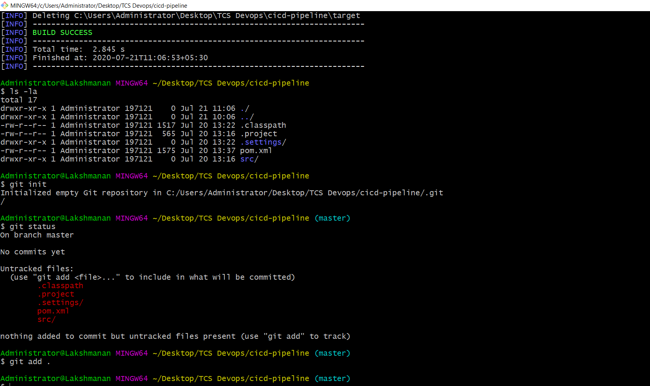
git commit and git status

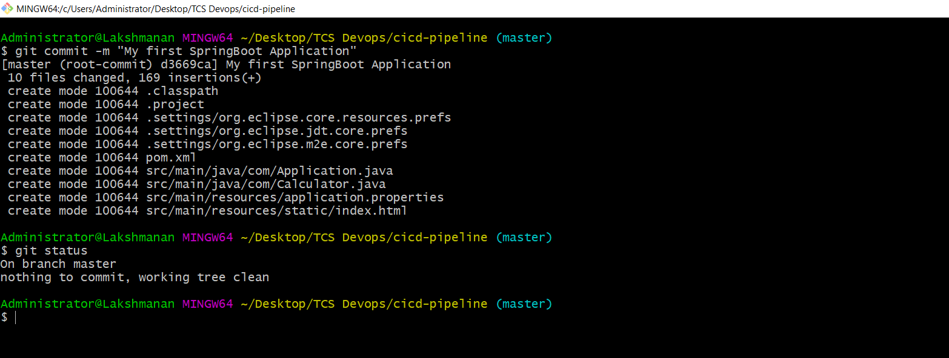

git remote add origin and git push

https://github.com/lakshmanandevops/devopsBootcamp.git

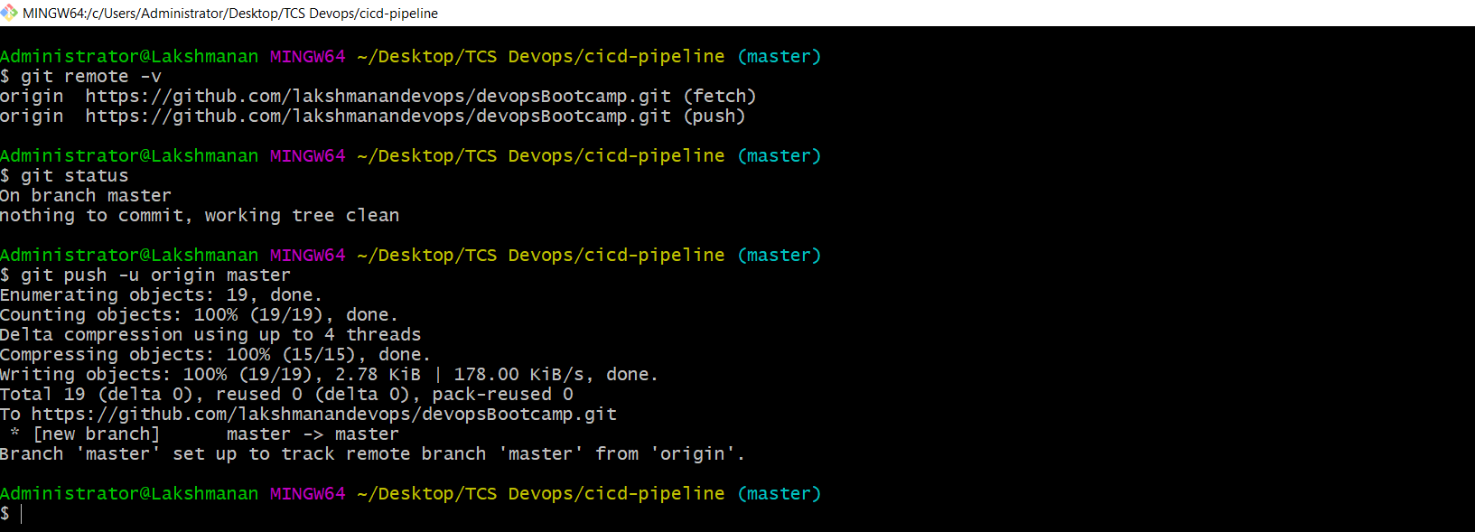
GitHub Repository Updated

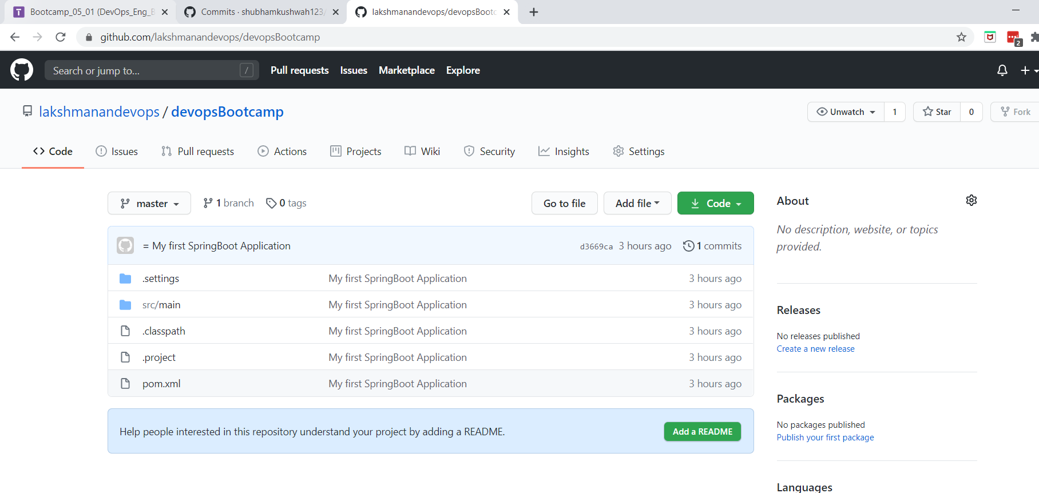

Adding a README file in remote repository

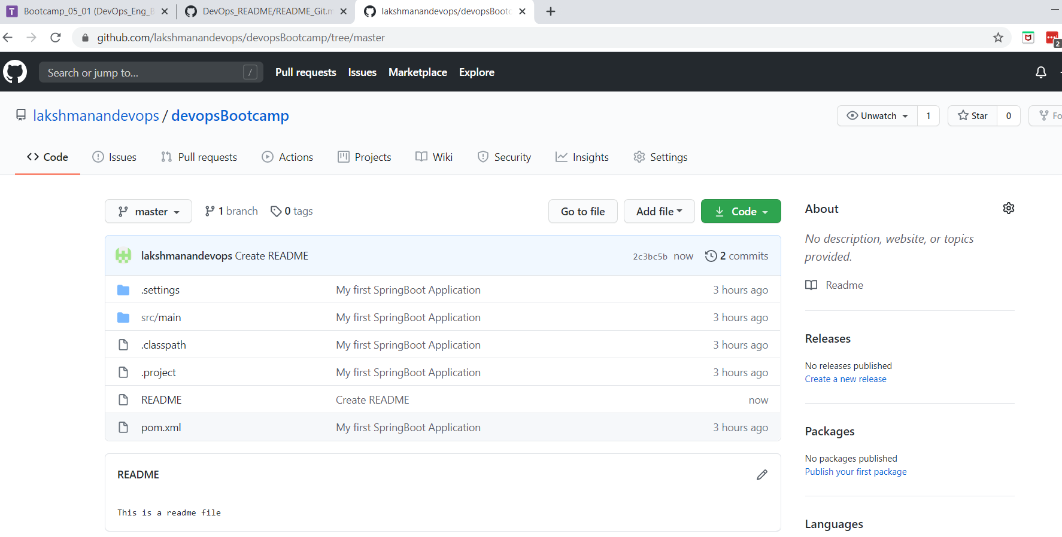
pull the changes into local repository using git pull command

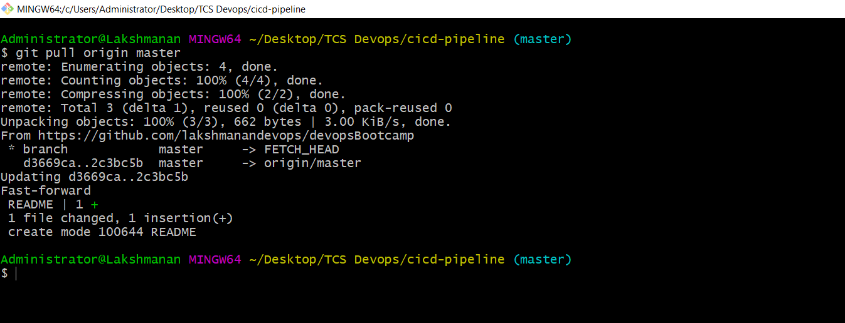

git branch creation and listing all branches

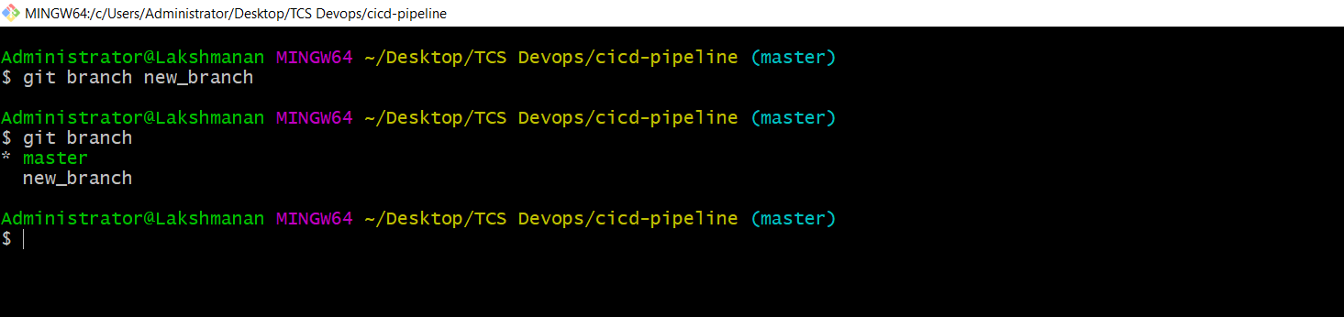
switching to new_branch using git checkout

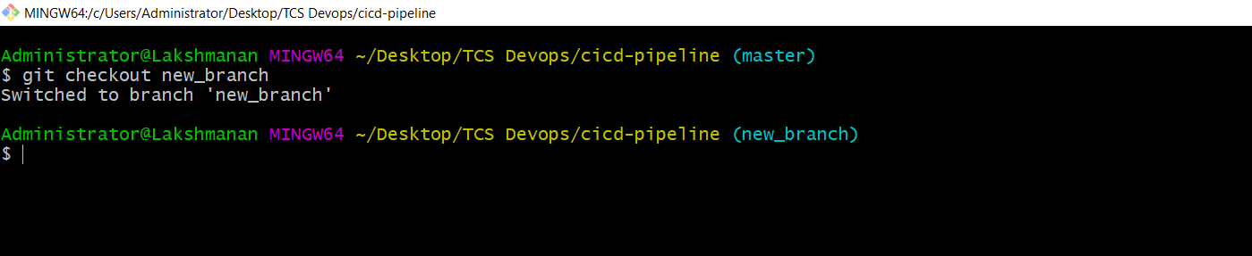
changes made (modified README file) in new_branch and commited

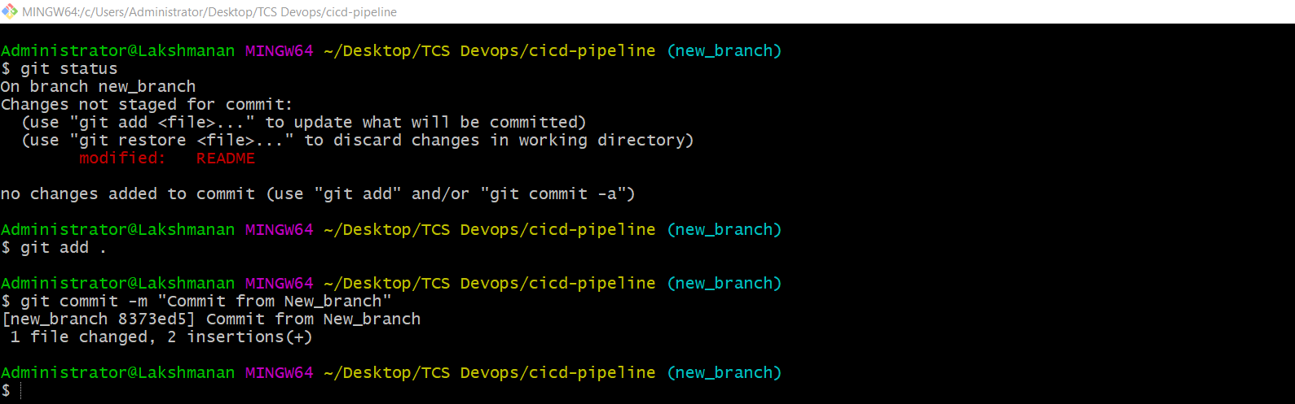

switch to master branch and merge new_branch to master branch sing git merge command

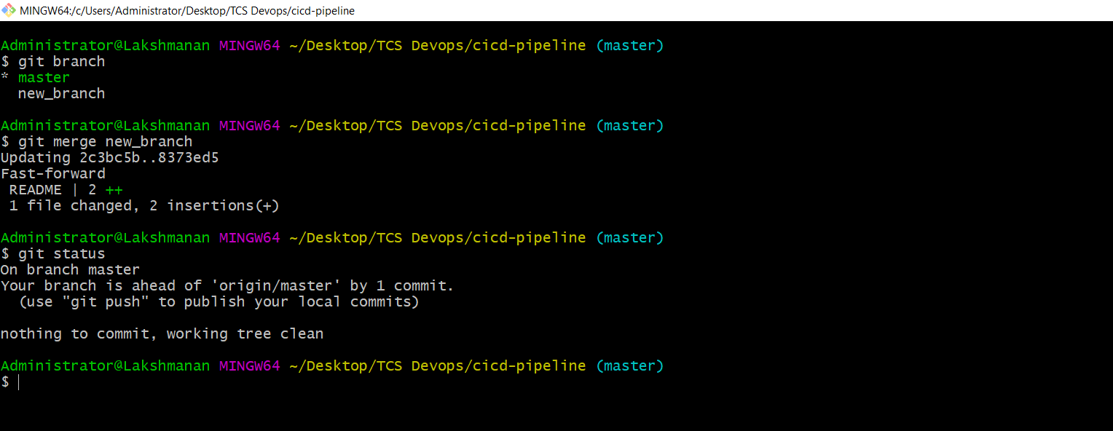

delete the new_branch as the changes are already merged to master by git branch -d

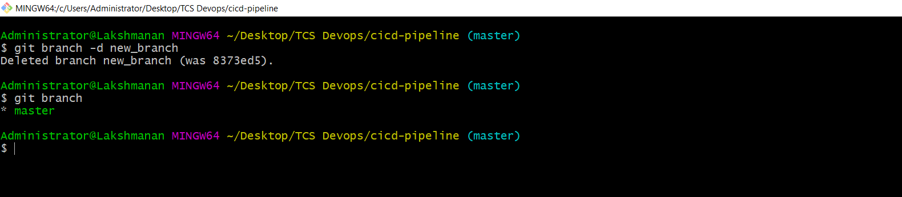
git clone to clone the remote repository to local

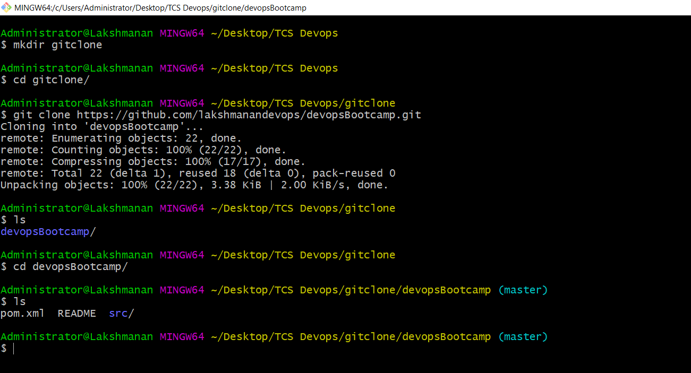

git log

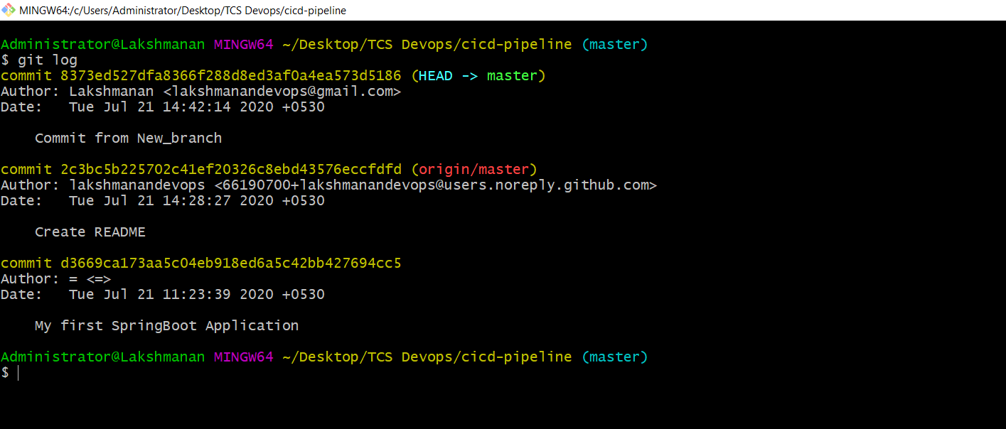

git stash and git stash list

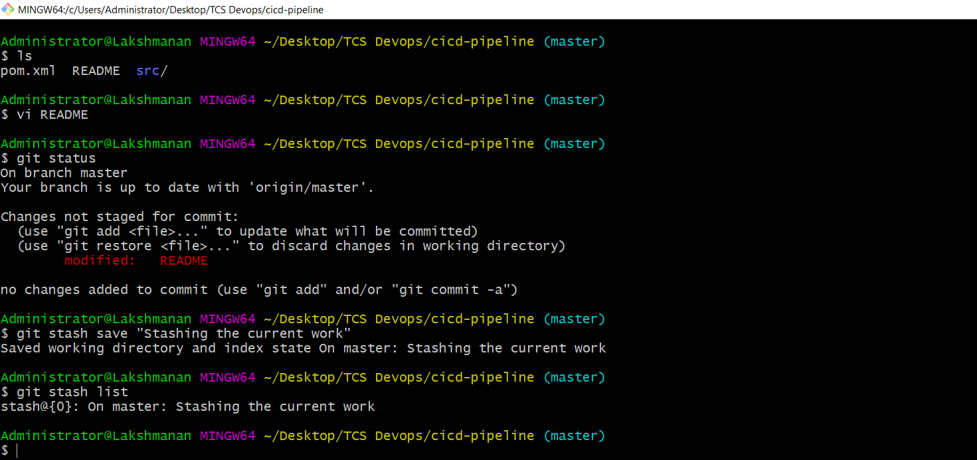

git stash -u and git stash apply

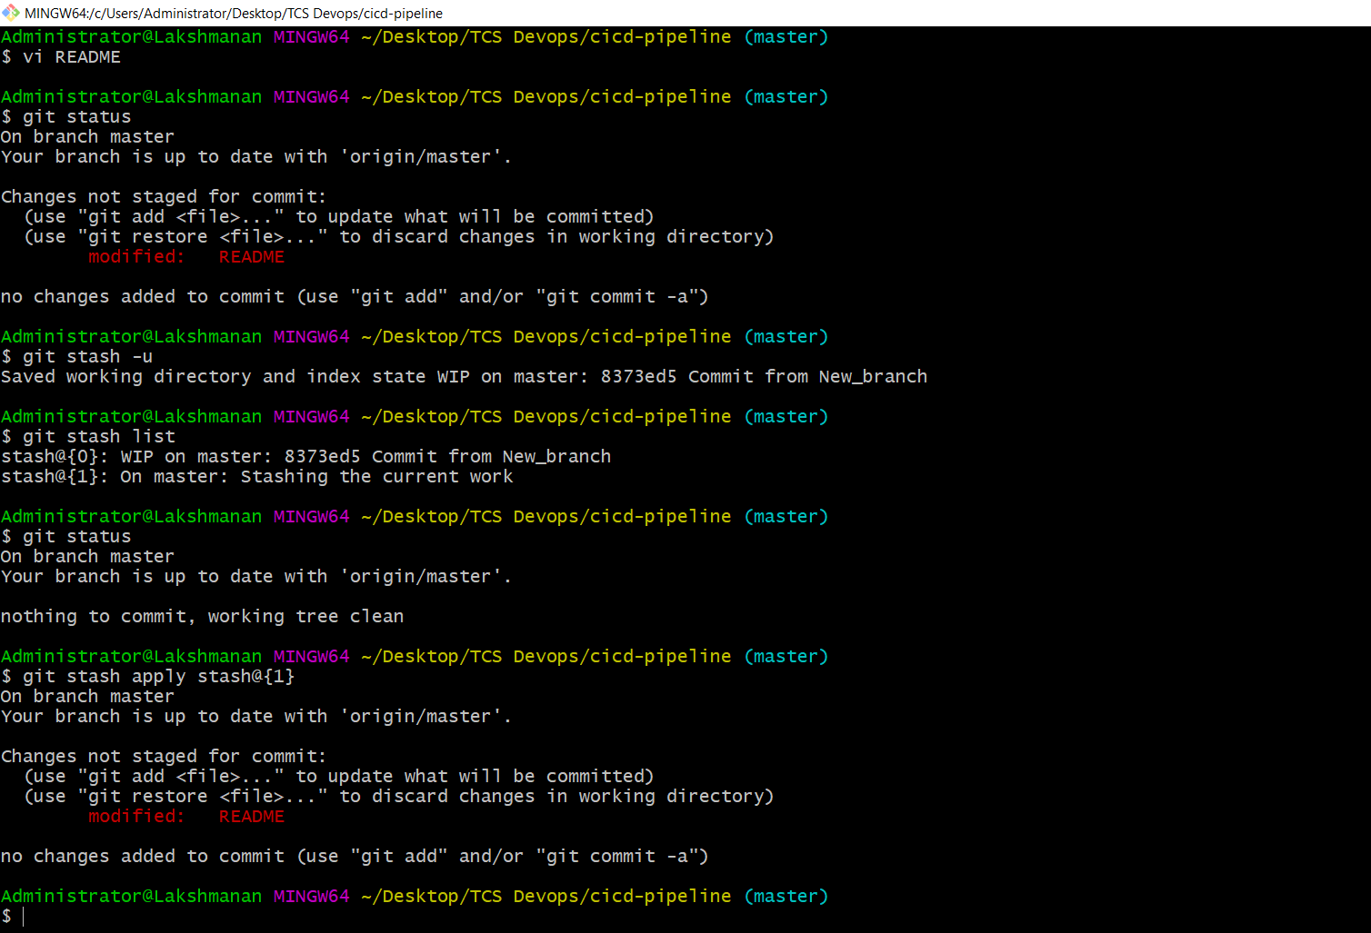

git revert

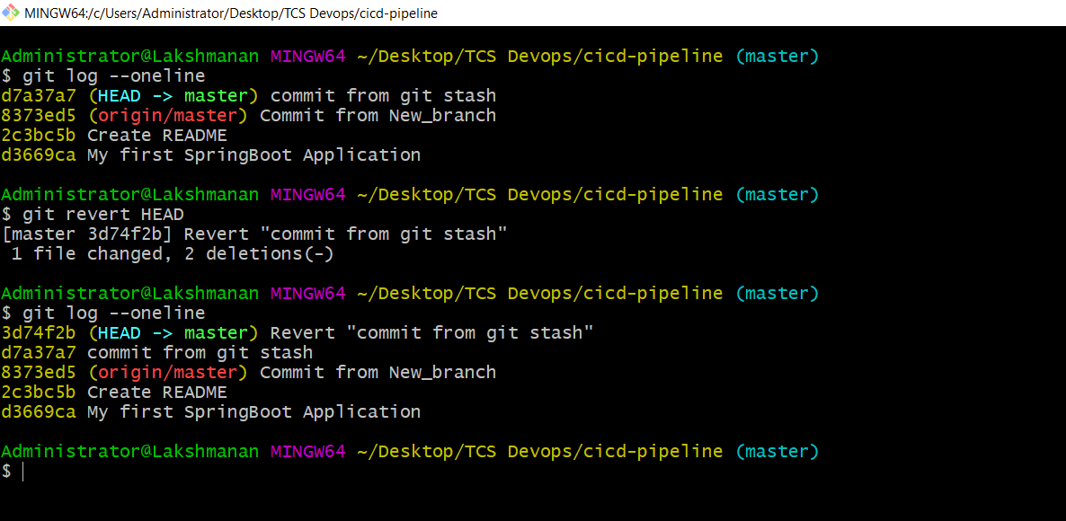

git rebase

