War-test Github repo is pulled to Fresco and generated war file

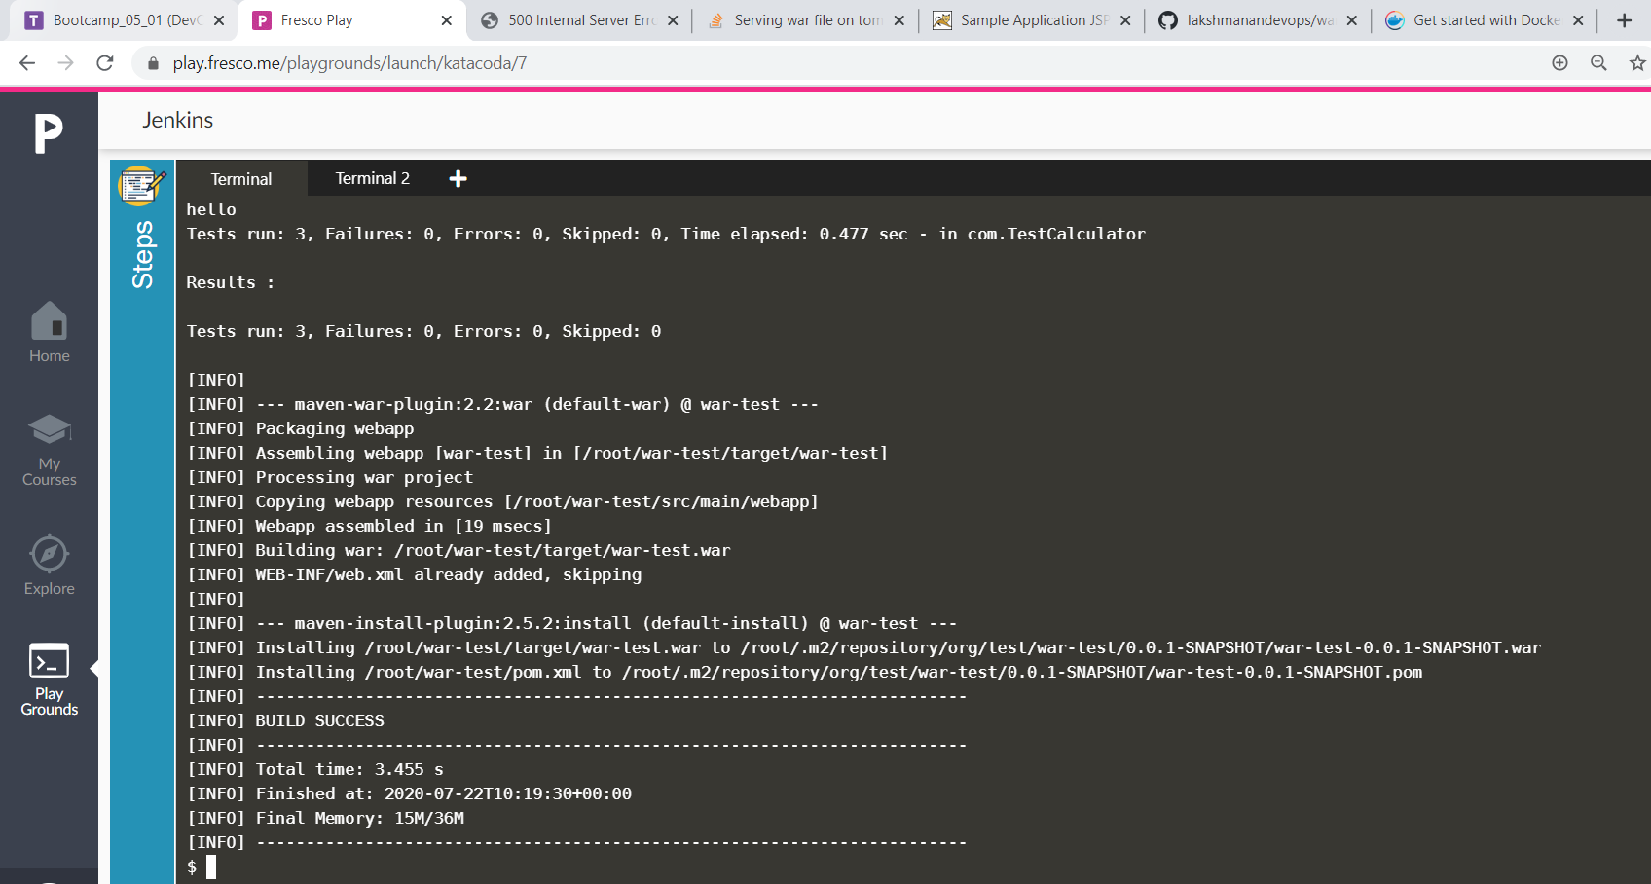

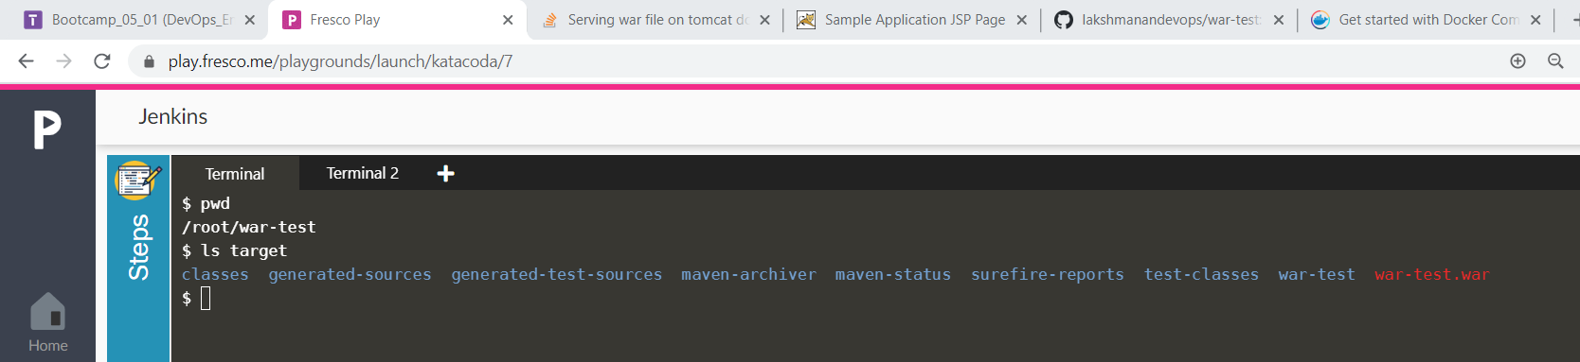

Created a Dockerfile to run the war app in tomcat and also created a docker-compose file to start tomcat and mysql containers together

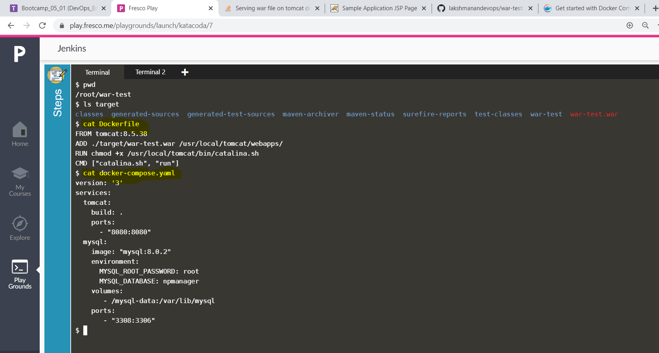
executed docker-compose up command and we can see tomcat and mysql containers created
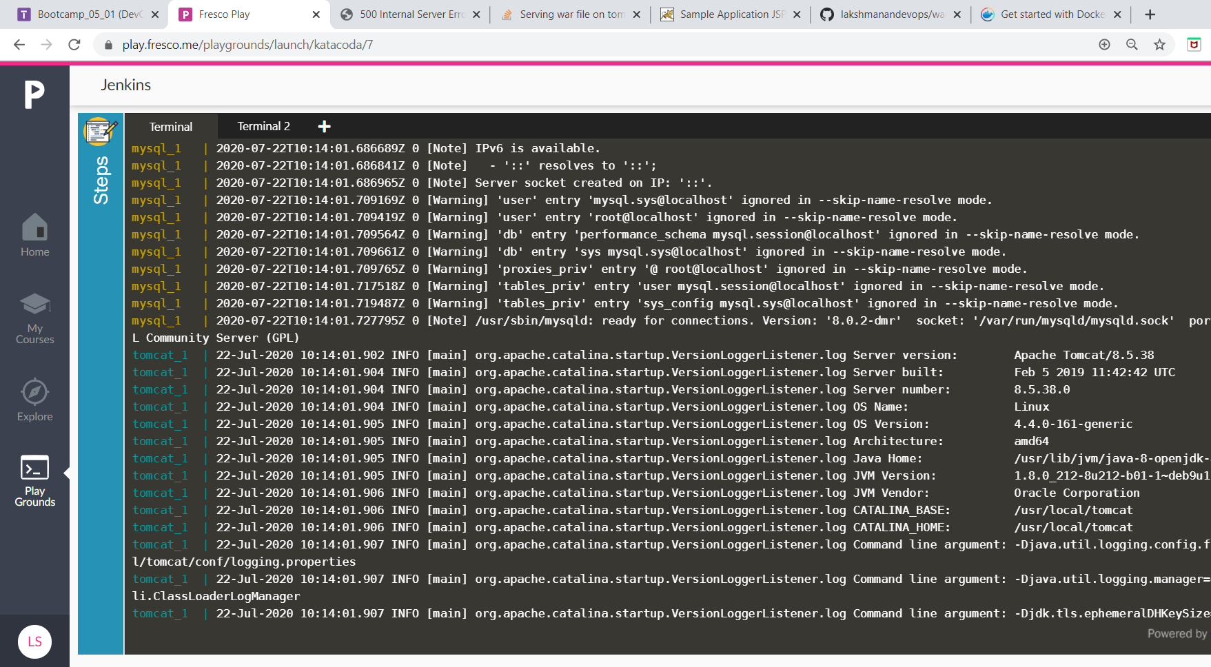
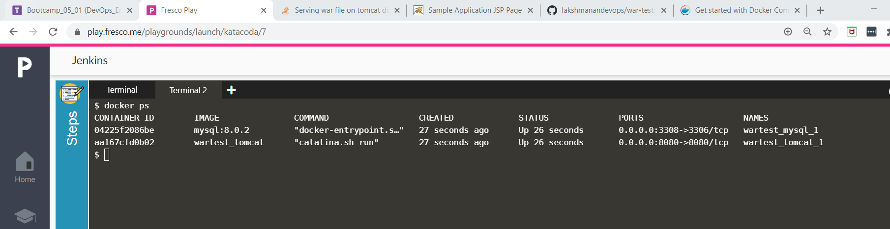
verifying the war-test application homepage

