Created the Wartest_pipeline job with below pipeline script

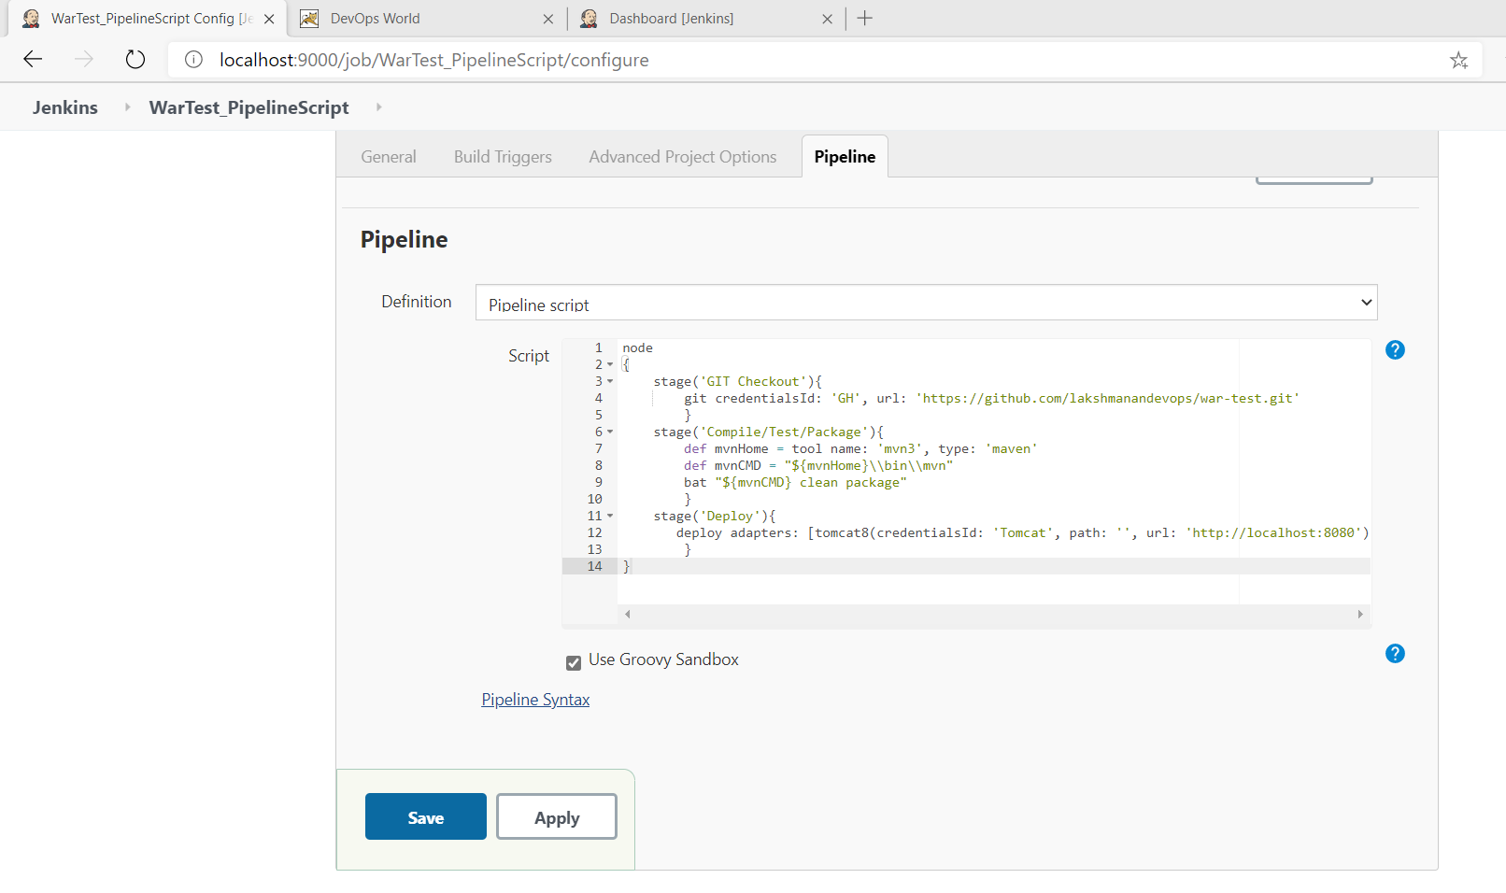
Job completed and war deployed to local tomcat

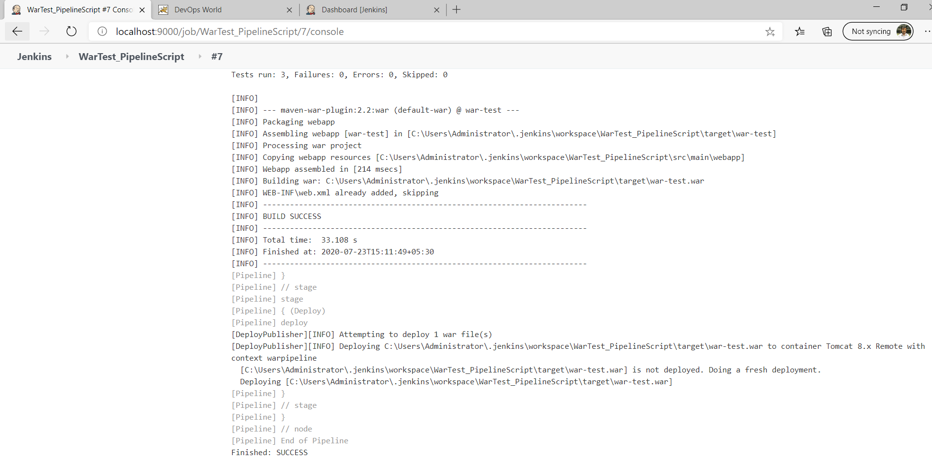

Tomcat server

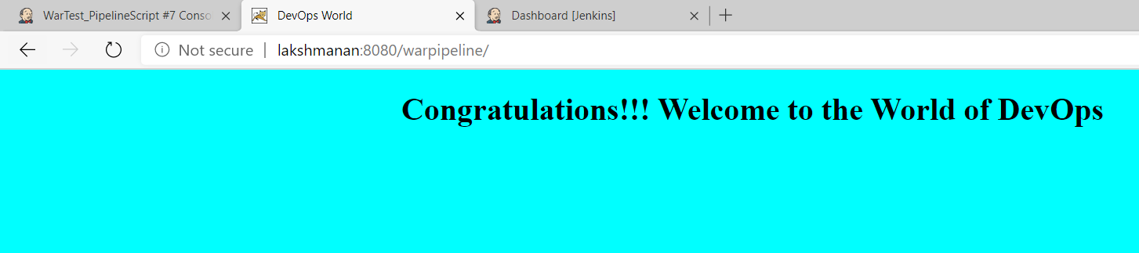

Jenkinsfile also pushed to remote repo https://github.com/lakshmanandevops/war-test/tree/master

