Springboot project is created with Pipeline script where maven and docker are used in run time

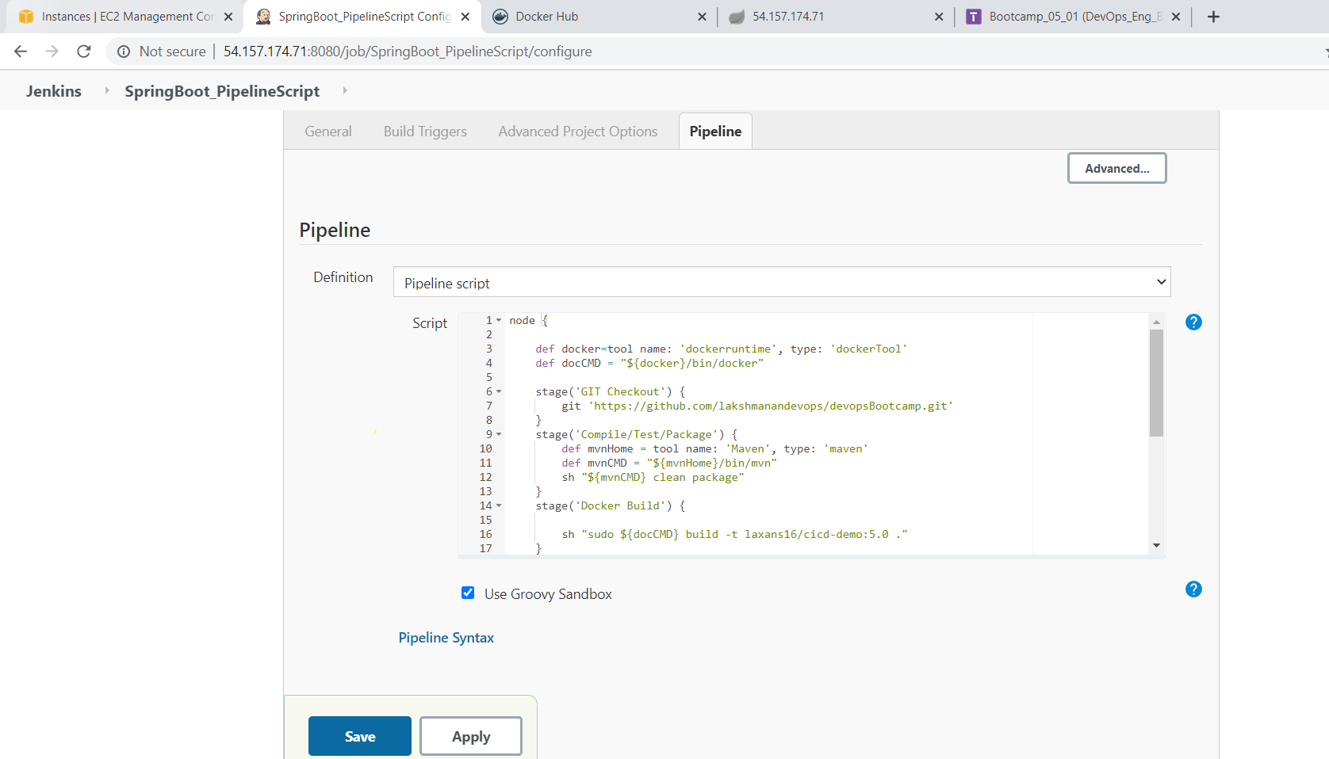
Build completed successfully

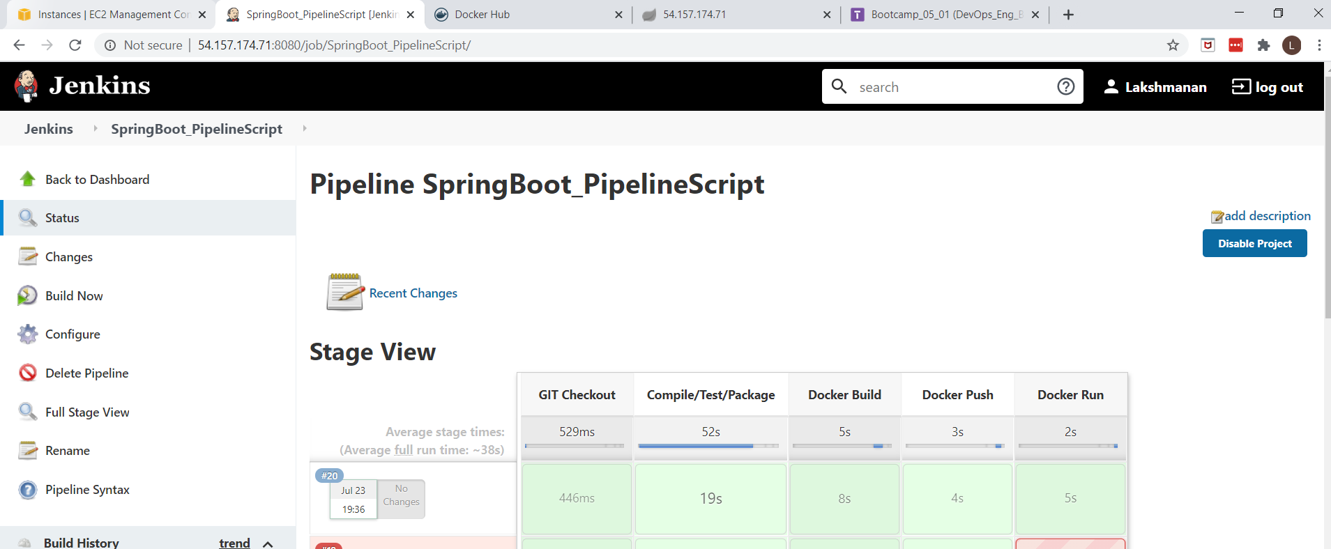

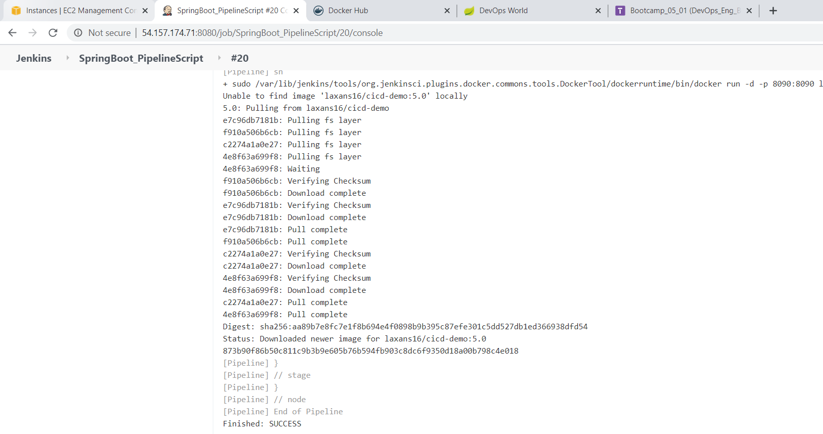
Image pushed to Docker Hub and application also running by pulling the Docker Hub image

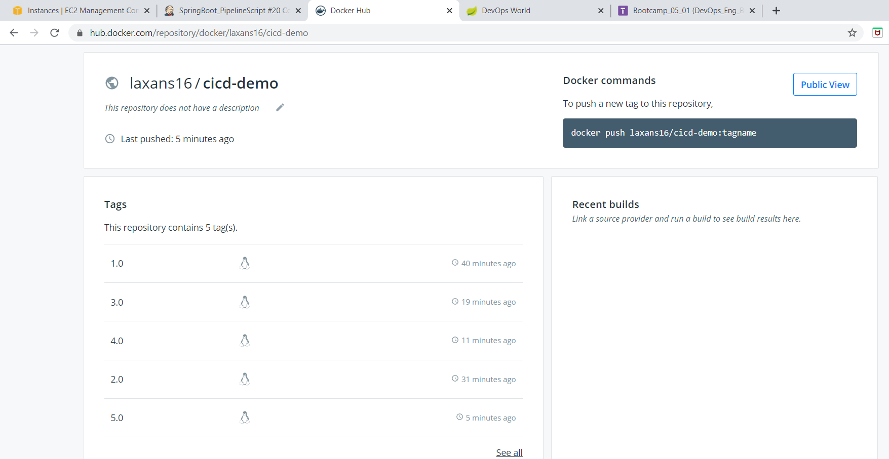

Accessing the application

http://54.157.174.71:8090/

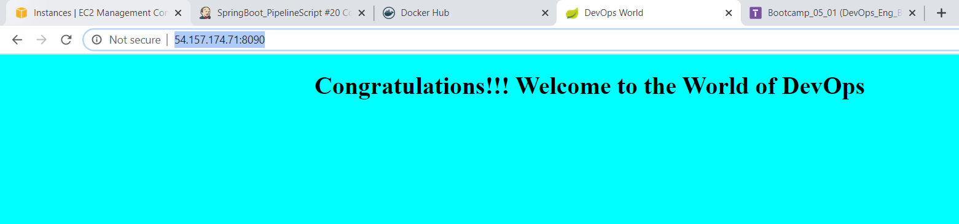

Created Jenkinsfile and pushed changes to GitHub Repo

