Dockerfile is created in Local Repo and pushed to Remote repo
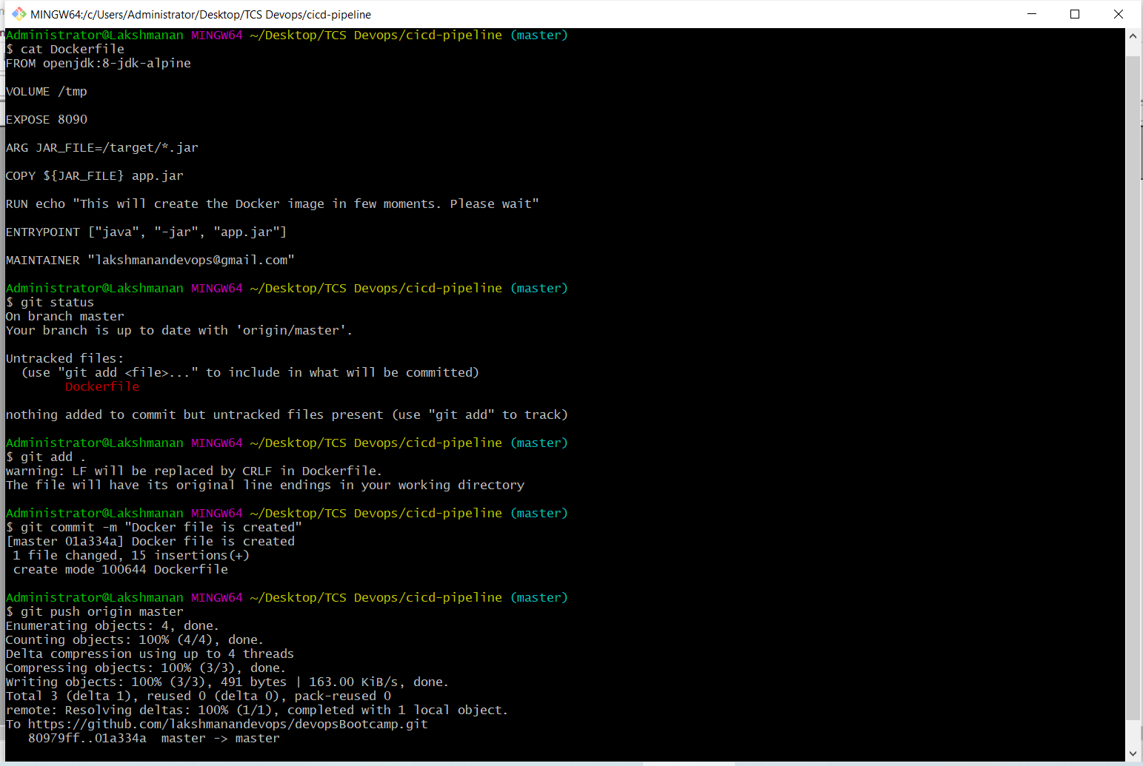
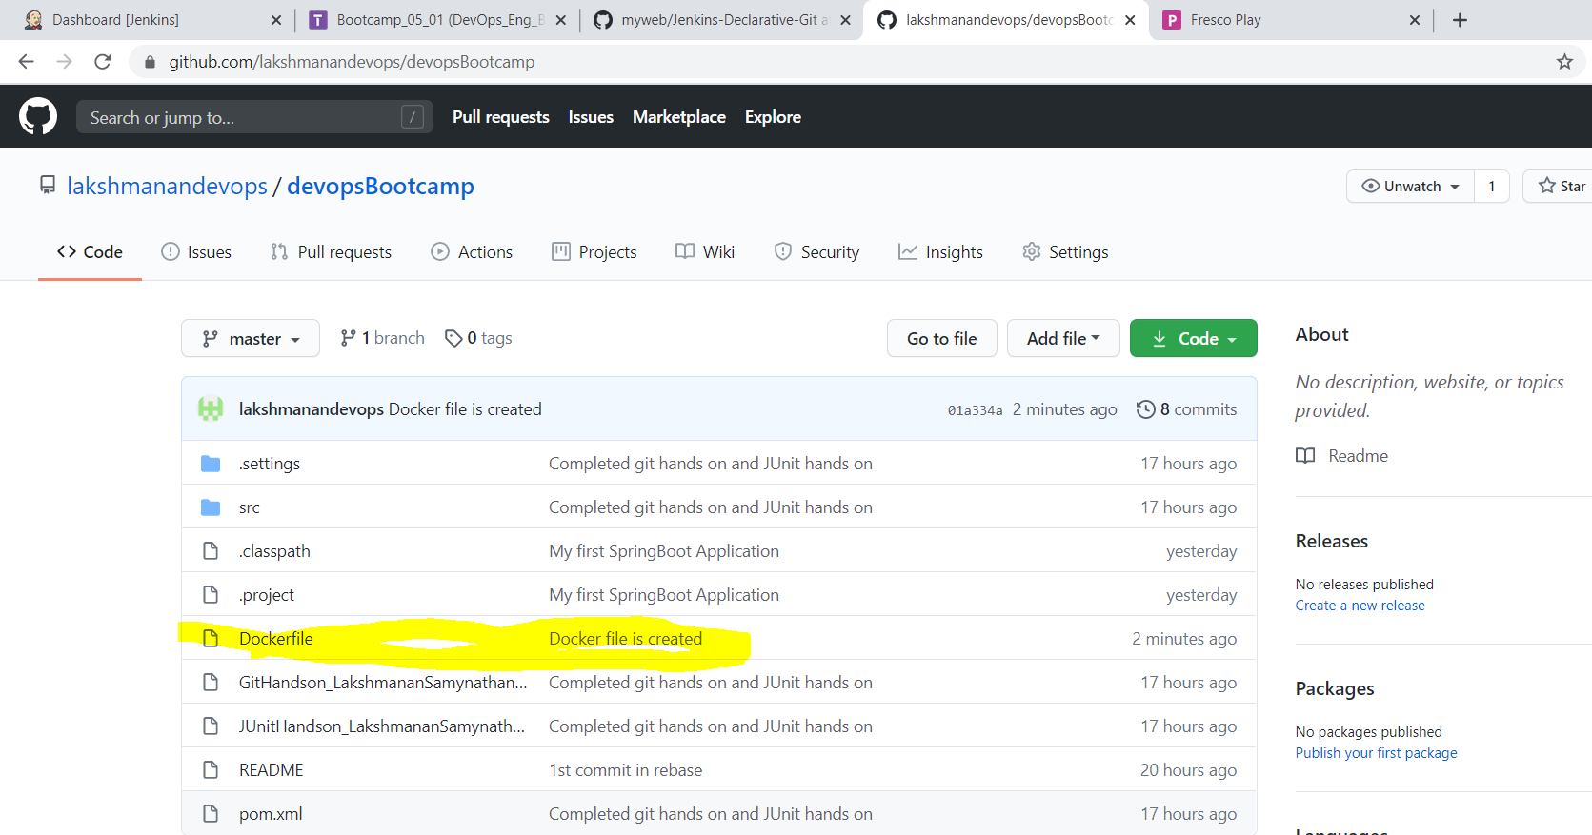

Clone the GitHub repo in Fresco Playground to perform the following actions

1.Build Using Maven
2.Create a Docker Image using Dockerfile and jar file
3.Push the Docker Image to DokcerHub
4.Pull the Image from DockerHub and run as a containter

Build using Maven

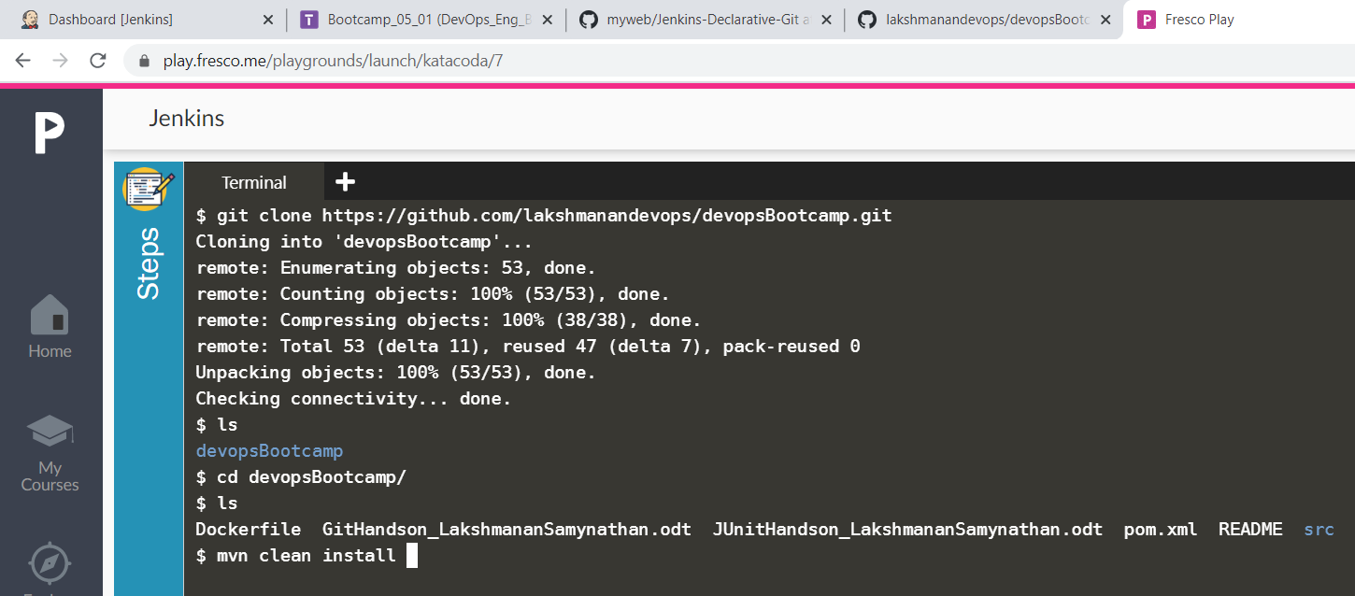
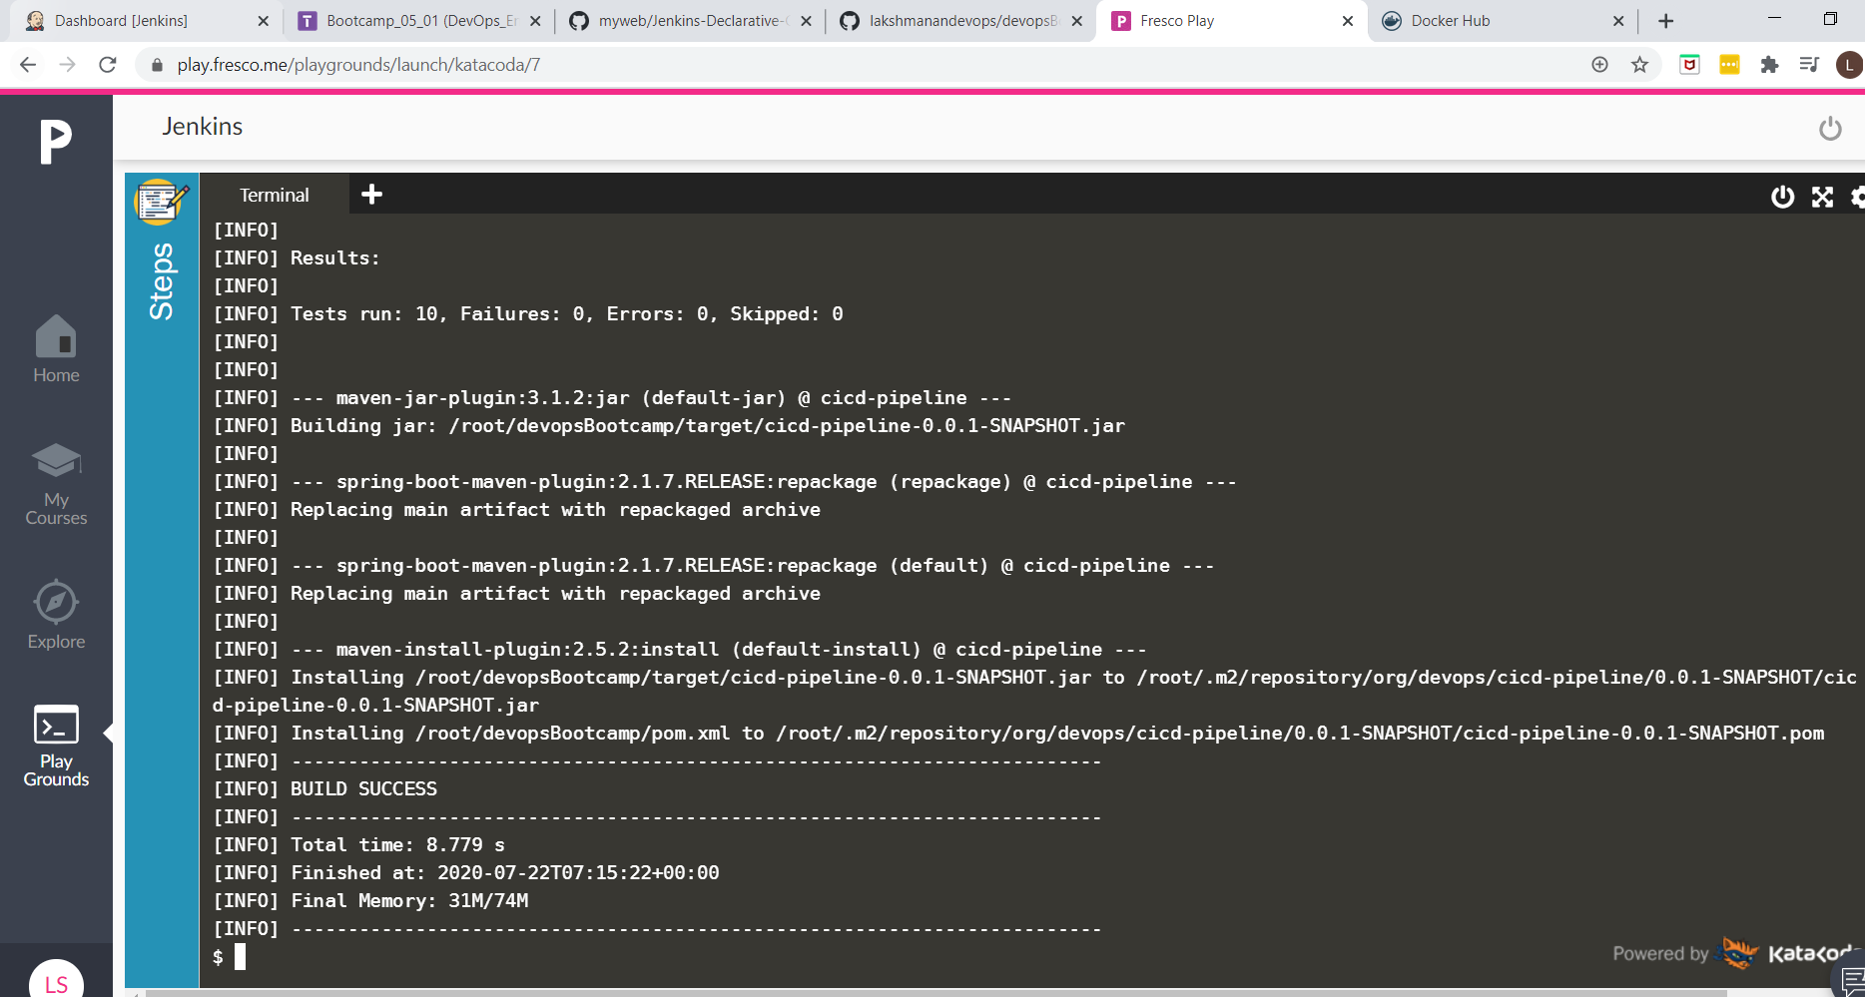

Create Docker image
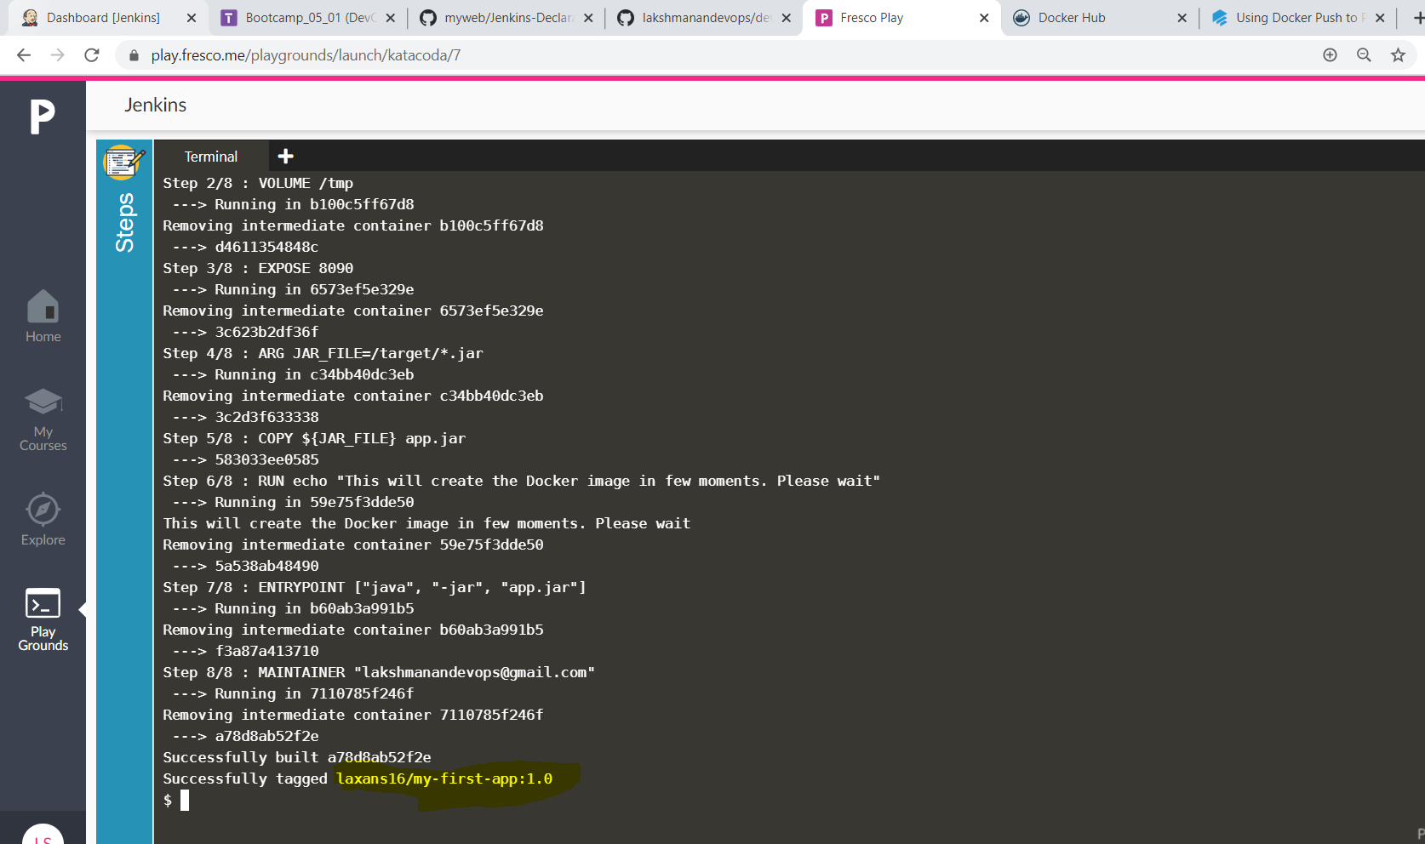
Connect to docker hub and push the docker image to DockerHub
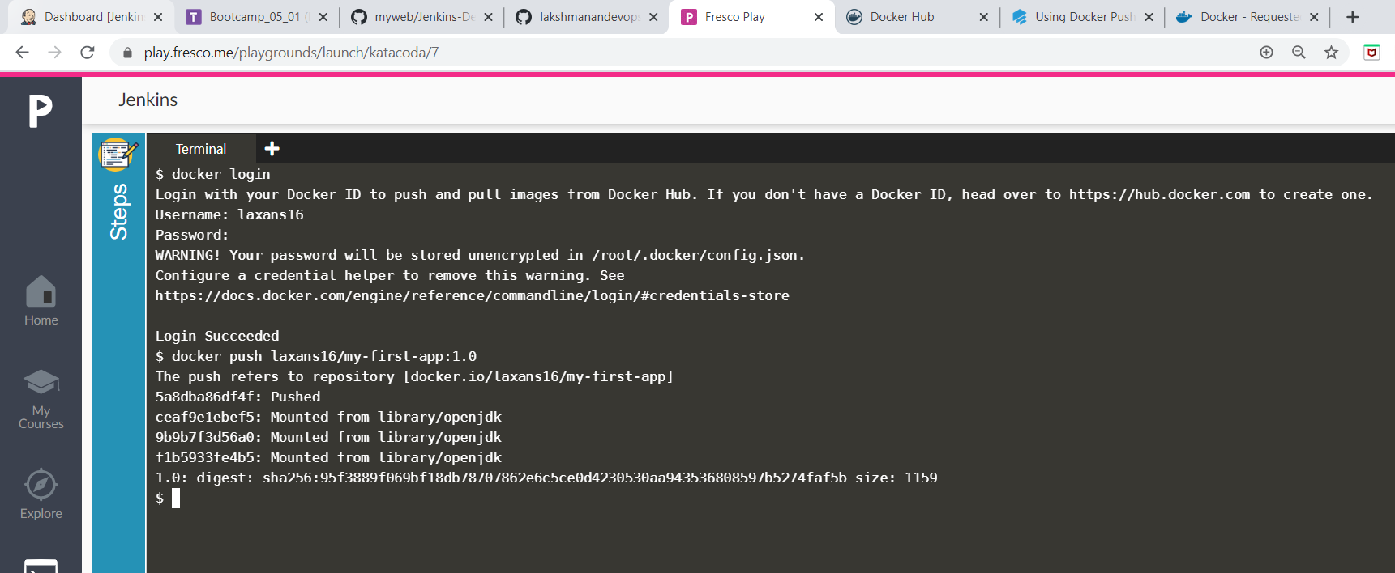
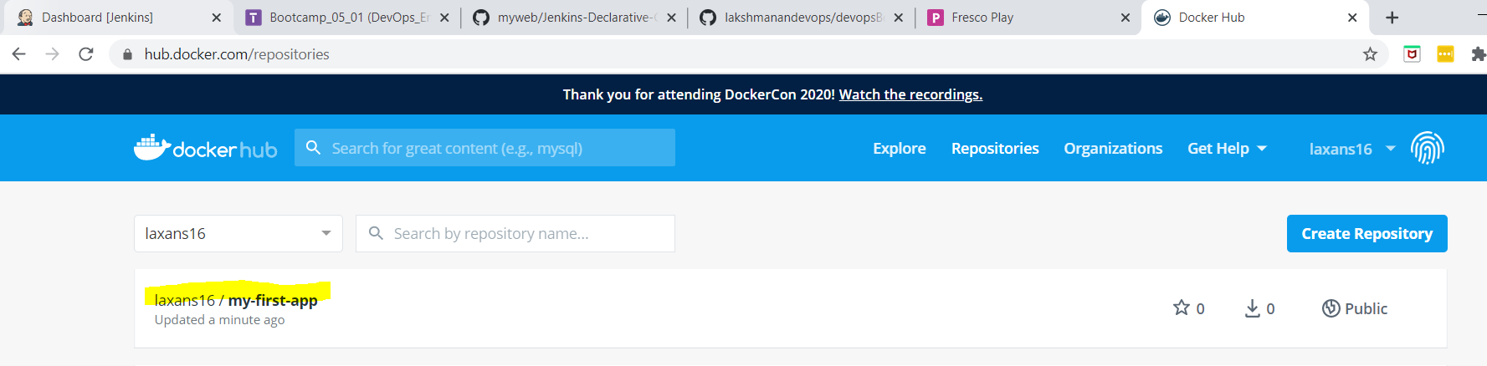

Pull the image from docker hub and run as a container

