Spring Boot Project with 2 Services

Calculator Service with TWO methods

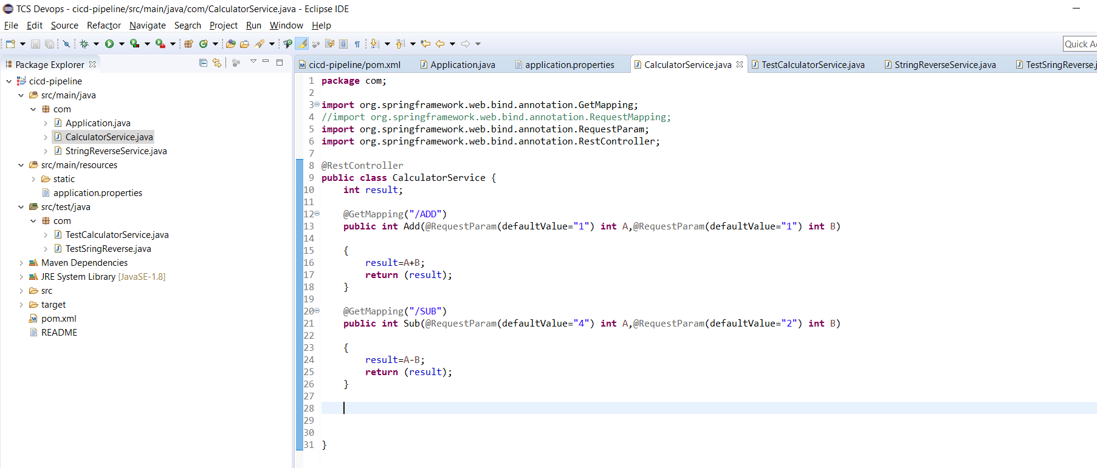
ADD Method With default value

http://localhost:8090/ADD

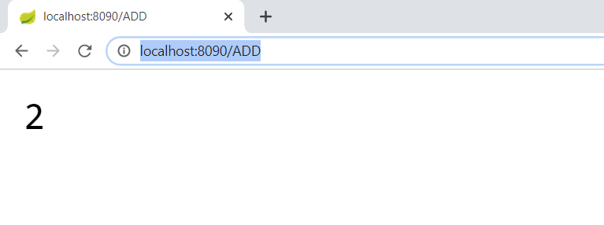
ADD method when parameters passed

http://localhost:8090/ADD?A=25&B=35

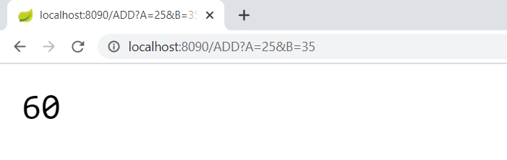
SUB Method With default value

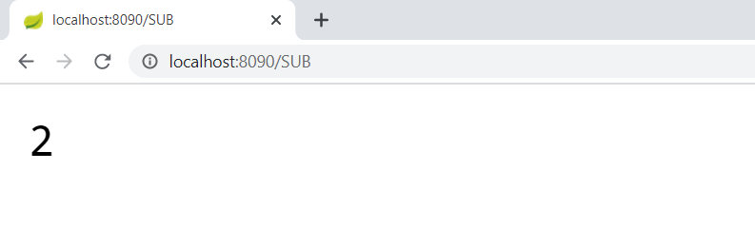
SUB Method when parameters passed

http://localhost:8090/SUB?A=25&B=35

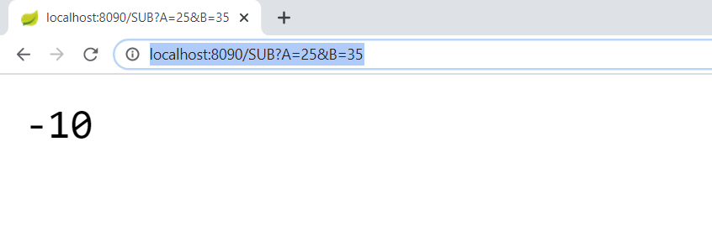
JUnit Test Cases for ADD/SUB Methods (Total 6 TCs).

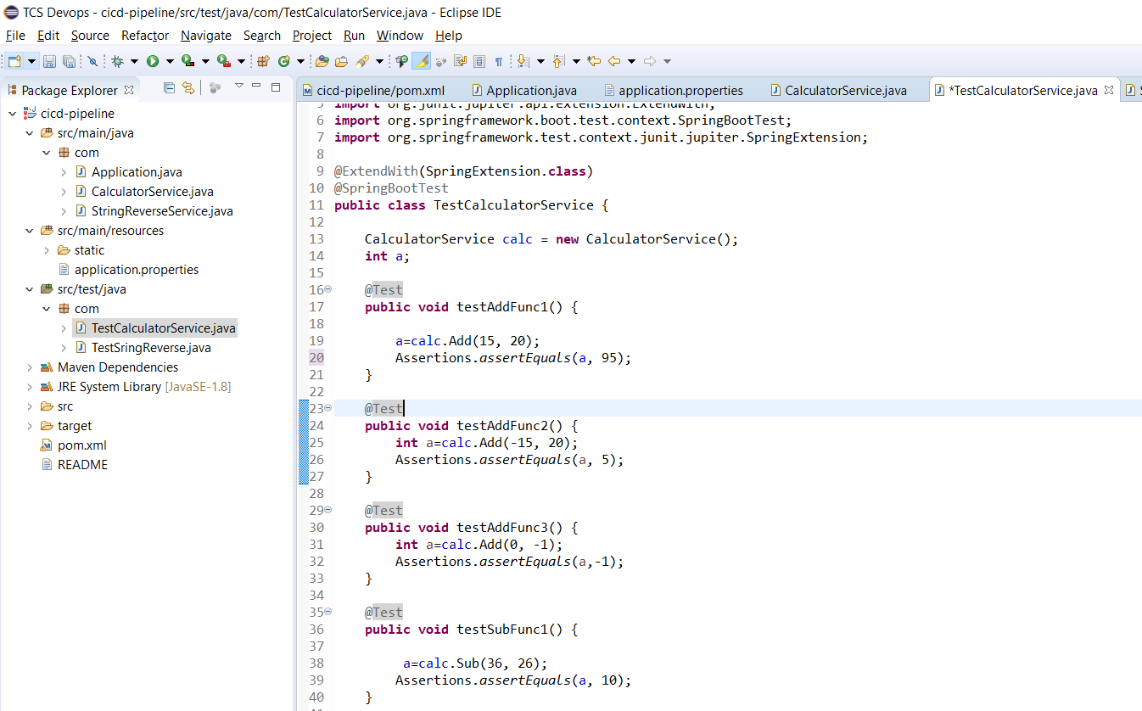

String Reverse Service With one Method

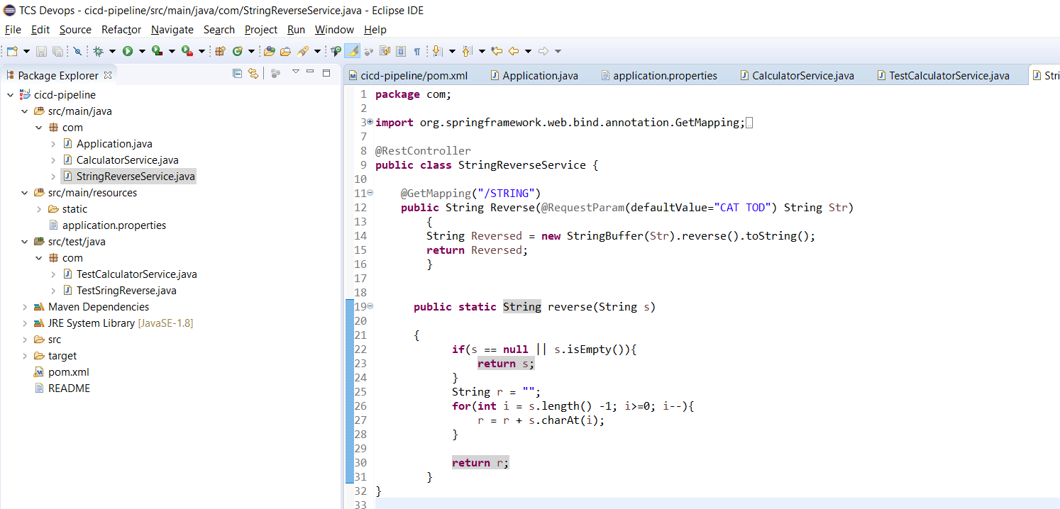
STRING method with default value

http://localhost:8090/STRING

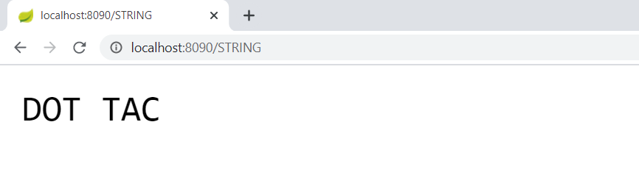
STRING Method with parameter passed

http://localhost:8090/STRING?Str=DEMO

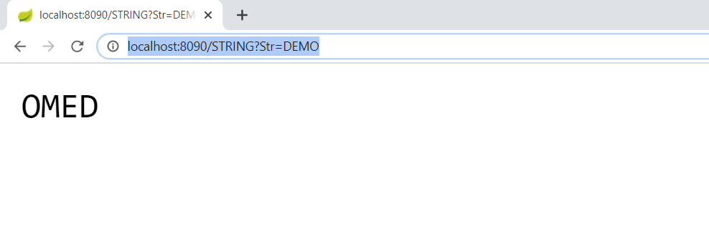
JUnit Test Cases for STRING Method (Total 4 TCs).

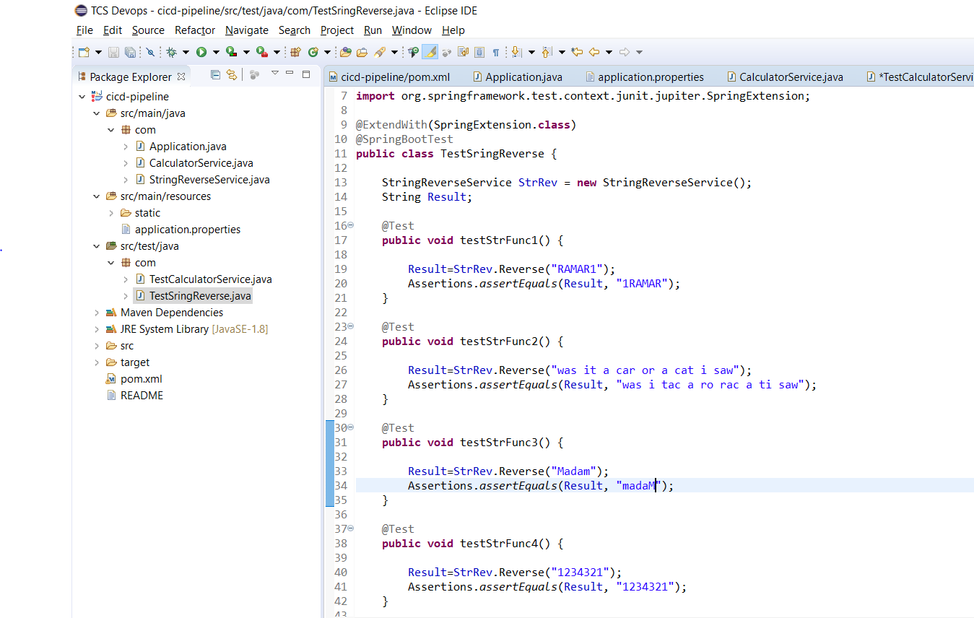

Maven build failed with negative TCs failed

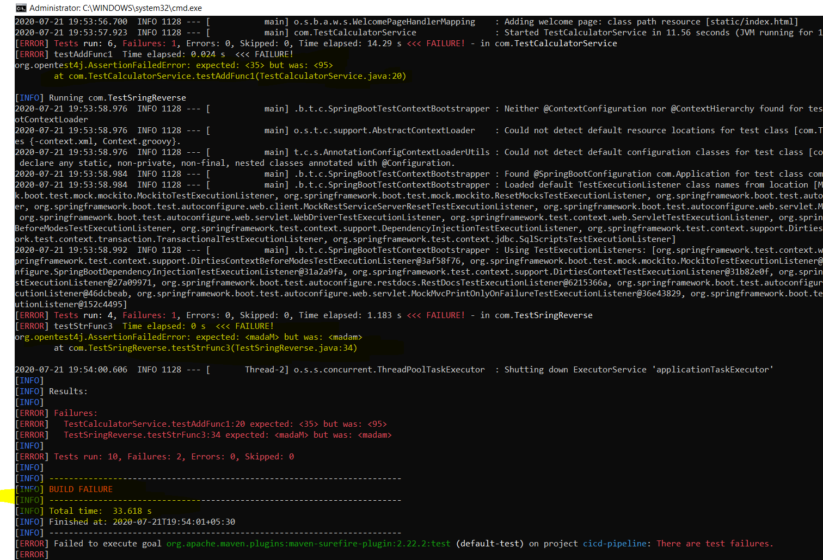

Build passed after correcting the inputs

