Study of Tools Available For Digital Identity Management, Digital Identity Consolidation and Post-Life Digital Asset Management

INTRODUCTION:
In this digital age, if a user wants to access a web application or an on-line service all of them request the users fill a sign-up form which also lets the users to choose username/password. Later if the user wants to access the account then the user is authenticated based on the username and shared secret he knows (password). With the ever increase in number of cyber applications from e-mails to e-banking, train ticket booking to flight ticket booking it has become a cumbersome task for the users to keep track of all the usernames and passwords for each of them. Month after month the no of accounts maintained by an individual grows exponentially. As a part of this study, the unified tools and methods available to solve this issue are analyzed. The single sign-on (SSO) access control model and the SSO tools are discussed. For instance, openID project, use of frequently used IDs such as gmail/facebook accounts for authentication to multiple services (few web applications are already doing this) are discussed.
Another interesting and potential problem in this digital era is what happens to the on-line accounts and digital assets after a person is deceased. If a person dies, his accounts go idle. His e-mails go unanswered and bidders on his eBay items don't know why they can't get an answer from the seller. Web site domains that he has purchased, some of which are now worth hundreds of thousands of dollars will expire. It's a scenario that's becoming more likely as we spend more of our lives online. And it's raising more questions about what happens to our online lives after we log off for the final time.
In this project we will study and analyze about the available tools and initiatives taken to avoid the above mentioned problems and propose the need for a unified, centralized and a strong authentication solution which integrates all the on-line accounts of the user, so that it becomes easy for the user to signup/login for multiple new on-line services. As the integration unifies all the on-line presence that makes it one-stop shop for the hackers to invade someone’s digital life build over years in seconds. That mandates the need for a strong, classifiable, customizable, multi-factor authentication system. If all the assets are consolidated at one place, the assets shall be easily classified and would be easy for the family members to access to if a person is deceased. Nominees shall easily be setup for each digital entity. Death verification and claiming assets will be a one step process. This papers also discusses the idea of integrating post-death process of the physical assets, bank accounts, bank lockers and insurance and linking them (as all of them provide an online account set-up as well) with the digital assets through the above discussed one-stop authentication portal to make the after-death handling process less cumbersome and to make sure everything is handled properly.
DIGITAL IDENTITY MANAGEMENT:
Time and time again, we are warned of the importance of having strong, secure online passwords. Phishing scams in the form of legitimate looking e-mails and websites try to trick the users to enter sensitive login information to a bank site, e-mail host or social network. This turns really bad when a scammer is able to compromise your account, but the result can be many times worse if the user uses that same password for a number of online accounts.
Likewise, when crackers break servers for various web services and expose the user information to others, then the entire system is broken.
That’s why it’s more important to use strong, secure and unique passwords for each of the online accounts. All though it sounds great in theory, but the main reason we often reuse the same password or passphrase is because trying to remember 50 different logins, each with various alphanumeric strings, is just not realistic.
Fortunately, there are some great tools and services available to not only to keep the passwords secure, but to also make them accessible and usable from multiple computers or web browsers.

DIGITAL IDENTITY MANGEMENT TOOLS:
We will look at few tools available for digital identity management. These tools can be used to store account details safely and use them effectively to login to different accounts.

- 1Password
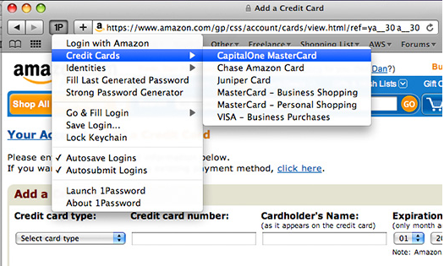
Fig.1. Application of 1password tool browser extension
This tool provides a great way to create and fill-in passwords across the web. The application has plugins for all the major web browsers such as Safari, Firefox and Chrome, and a user can also pull up the passwords from the application itself. The tool works as shown below:
When the user is on a website and creates a new account, 1Password will prompt to save that account to its database. In the future, rather than having to type it in manually or rely on the browser’s built-in manager, the user can just use 1Password to automatically fill in your username and password data.
1Password includes a fantastic password generator that lets the user to create robust passwords of a chosen length. Password can be generated for an account and then automatically saved.
1Password saves all of the user’s passwords and login information into its own secure database that is stored on the user’s computer locally, but 1Password really shines with its ability to sync with Dropbox. Dropbox is a free service that lets the user to keep a cloud copy of anything within the Dropbox folder on the user’s desktop. That folder is then accessible across computers and devices. Any change to that folder is synced across every connected computer. 1Password can use Dropbox to store its secure database, which means that if the user uses multiple Macs or want to have constant syncing on the iPhone, iPad or Android, he can get that done automatically.
1Password can even store other form information like credit cards, address information, server logins for your website, software serial numbers other personal information on the password protected application given. The data are encrypted and stored in the file system. It gives authentication not just for the online accounts but also for the accounts in various other soft wares, ftp accounts, outlook mail accounts etc.

- LastPass
LastPass is a very popular cross-platform password manager that stores all of its data in the cloud. It works on Windows and Mac and in every major web browser. Like 1Password, LastPass can automatically save your logins, help you generate safe and secure passwords and automatically fill in the passwords when the user visits a site.
The difference is that instead of storing its database on your computer or in Dropbox, it’s all stored on LastPass’s servers. LastPass claims that it has a really robust set of security around their customers’ data and if its center is compromised, the users’ data still can’t be accessed.
LastPass is free to use but for $12 a year, one can gain access to LastPass’s many mobile apps (including iPhone, BlackBerry and Android) and gain access to priority support. That also means the advertisements can be skipped.

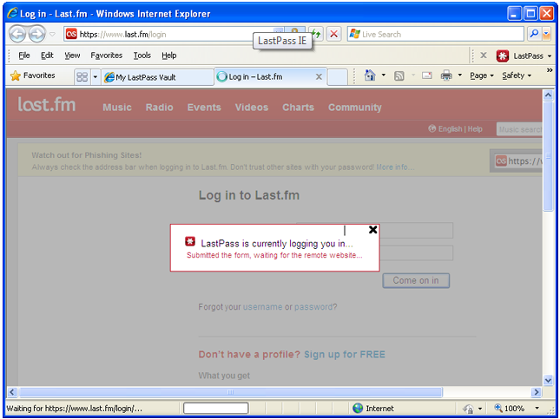
Fig.2. Application of Lastpasss browser extension
- KeePass and KeePassX

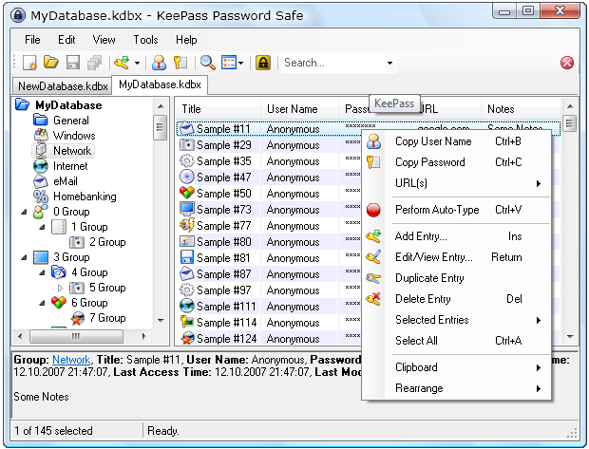
Fig.3. Application of Keepass password safe application
KeePass and KeePassX (which is KeePass but for Mac or Linux) is a free, open-source password manager. It works very much like 1Password, in that the database is stored on your local computer. Like 1Password, the user can use Dropbox to keep KeePass synced across machines and profiles.
KeePass can run off a USB drive, which makes it a great choice for users who frequently work on different machines but don’t want to leave any of their personal data on those machines.
KeePass isn’t as user-friendly as LastPass or 1Password, but it has got a dedicated userbase who love it because it can be extended and used in a variety of ways and it is free.

- RoboForm
RoboForm is very similar to 1Password, but it’s just for Windows users. It works with Internet Explorer, Firefox, Google Chrome and with Safari and Opera via a bookmarklet.

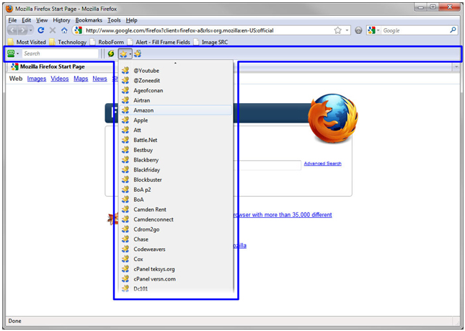
Fig.4. Application of RoboForm browser extension

RoboForm also has mobile apps for Android, iPhone, BlackBerry and Symbian. Like KeePass, the user can even run it from a USB drive, which is great for users who want a way to keep their passwords with them and use RoboForm on various computers they use, but don’t want to have to install a program on each of those computers.
The users can also use RoboForm with Dropbox, which makes using it across machines that much easier.
- Firefox Sync
Formerly known as Mozilla Weave, Firefox Sync is a Firefox plugin. Firefox Sync is a pretty cool concept and it takes a slightly different approach to password management and syncing from the other tools in this list.
Firefox Sync securely syncs and protects passwords, bookmarks and browser tabs (one can choose to sync all or few or none of these items). When the user logins to another computer with Firefox on it, he/she can just login to Sync and have access to their existing data and even pull up tabs that are open on their computer. When the user logs out, all of that information disappears.
Sync also has iPhone and Android apps so the user can bring the tabs over to those mobile devices. The upcoming Firefox Mobile for MeeGo and Android will let the users to access their passwords securely and remotely as well.
By being built into the browser, Sync is a great way for Firefox users to keep track of their passwords. Because it is part of Firefox, Firefox Sync is really designed for people who use Firefox as their primary web browser.
- Passpack

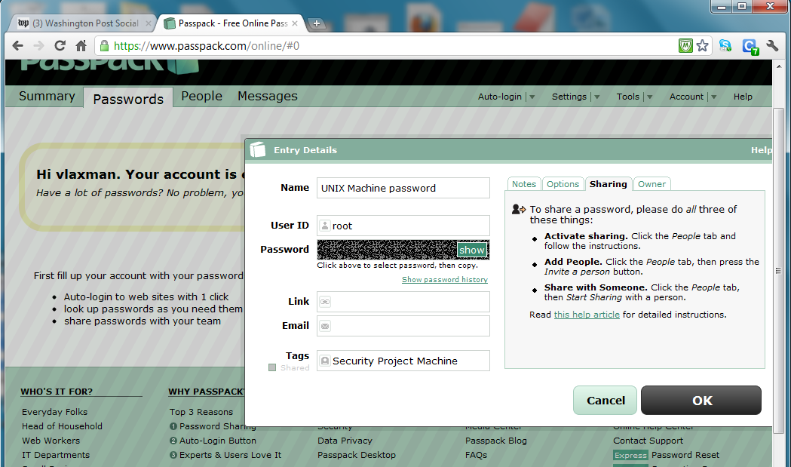
Fig.5. Application of passpack password sharing web application
Passpack lets the user to supply all project passwords to their client in a single, secure deliverable directly from within their account. It makes the password sharing look professional and elegant. There's no need to sign up for Passpack in order to retrieve passwords.
For the tech-savvy clients, or other professionals one often works with, the user can set up real-time sharing for passwords and online accounts. Everyone will be able to use their ‘Passpack It!’ login button to access shared accounts. All updates are automatically synchronized. It's hassle free, private and real-time. The authentication details can be shared with individual users or to entire groups.

DIGITAL IDENTITY CONSOLIDATION:
Most web users struggle to remember the multiple username and password combinations required sign-in to each of their favorite websites, and the password recovery process can be tedious. But using the same password at each of your favorite websites poses a security risk. The tools discussed above lets the user to store and manage the authentication details associated with many accounts. But the tools we are going to look at in this section let the user and various service providers to use a centralized system for authentication purpose. These tools let the users to consolidate all their identities using a single master password or a string authentication using multiple-factors such as smart-cards, face-recognition, fingerprints etc. If any service provider wants to authenticate a user, he relies on the centralized / distributed authentication facilitator node.
Most websites ask for an extended, repetitive amount of information in order to use their application. Also, centralized account management reduces the cost of maintaining separate systems and provides a comprehensive way to add, modify and delete accounts.

DIGITAL IDENTITY CONSOLIDATION TOOLS:
- OpenID
OpenID is an open standard that describes how users can be authenticated in a decentralized manner, eliminating the need for services to provide their own ad hoc systems and allowing users to consolidate their digital identities. Users may create accounts with their preferred OpenID identity providers, and then use those accounts as the basis for signing on to any website which accepts OpenID authentication. The OpenID standard provides a framework for the communication that must take place between the identity provider and the OpenID acceptor. An extension to the standard (the OpenID Attribute Exchange) facilitates the transfer of user attributes, such as name and gender, from the OpenID identity provider to the relying party.
The OpenID protocol does not rely on a central authority to authenticate a user's identity. Moreover, neither services nor the OpenID standard mandates a specific means by which to authenticate users, allowing for approaches ranging from the common (such as passwords) to the novel (such as smart cards or biometrics).
The term OpenID may also refer to an identifier as specified in the OpenID standard, these identifiers take the form of a unique URI, and are managed by some 'OpenID provider' that handles authentication.
OpenID authentication is now used and provided by several large websites. Providers include AOL, BBC, Google, IBM, MySpace, Orange, PayPal, VeriSign, LiveJournal, and Yahoo!. The following figure shows a website where the openID is used for authentication.
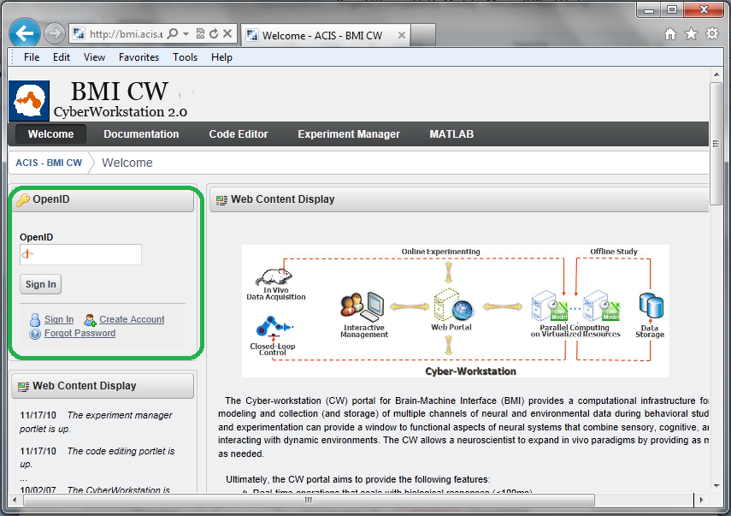
Fig.6. OpenID in use

AUTHENTICATION USING MOST COMMONLY USED SERVICES SUCH AS GOOGLE / FACEBOOK:
As we have seen above the most commonly used web services such as google and facebook are widely used by many web applications for authentication. Google provides a set of APIs to achieve federated login for google account users.
Third-party web sites and applications can now let visitors sign in using their Google user accounts. Federated Login, based on the OpenID standard, frees users from having to set up separate login accounts for different web sites--and frees web site developers from the task of implementing login authentication measures. OpenID achieves this goal by providing a framework in which users can establish an account with an OpenID provider, such as Google, and use that account to sign into any web site that accepts OpenIDs.
Google supports the OpenID 2.0 protocol, providing authentication support as an OpenID provider. On request from a third-party site, Google authenticates users who are signing in with an existing Google account, and returns to the third-party site an identifier that the site can use to recognize the user. This identifier is consistent, enabling the third-party site to recognize the user across multiple sessions. Google also supports the following extensions:
OpenID Attribute Exchange 1.0 allows web developers to access, with the user's approval, certain user information stored with Google, including user name and email address.
OpenID User Interface 1.0 supports alternative user experiences for the authentication process. The default experience requires the web application to redirect users away from the application site to Google's authentication pages. This extension allows web developers to open Google authentication in a popup window and includes favicon support for a smoother experience.
OpenID+OAuth Hybrid protocol lets web developers combine an OpenID request with an OAuth authentication request. This extension is useful for web developers who use both OpenID and OAuth, particularly in that it simplifies the process for users by requesting their approval once instead of twice.
PAPE (Provider Authentication Policy Extension) allows web developers to request other modifications to the flow, such as asking that Google re-prompt the user for their password.
Interaction sequence
OpenID login authentication for web applications involves a sequence of interactions between your web application, Google's login authentication service, and the end user. The diagram and sequence below describe the process as recommended by Google.
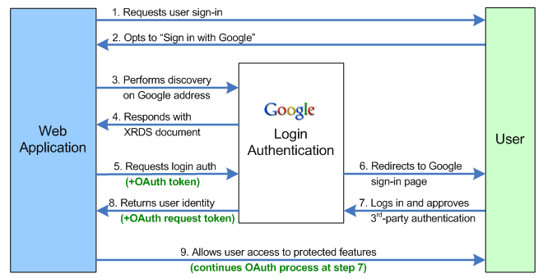
Fig.7. Google Single Sign-On Protocol
EXAMPLE:
Some of the web applications, for instance a Silicon Valley based recruitment web service www.interviewstreet.com, doesn’t have any sign-up form. It just uses the facebook/google log-in credentials for authentication.
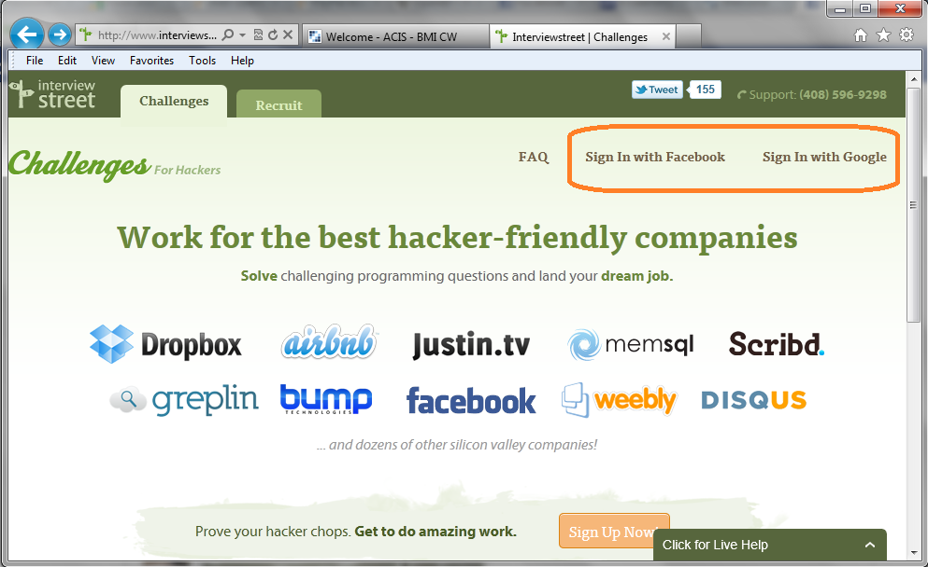
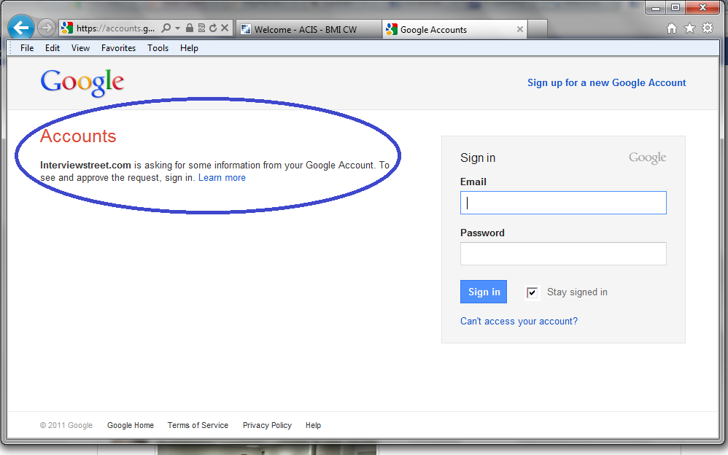
Fig.8 & 9. Google Single Sign-On In action

SINGLE SIGN-ON (SSO):
Organizations for the most part have recently started using a central authentication source for internal applications and web-based portals. This single source of authentication, when configured properly, provides strong security in the sense that users no longer keep passwords for different systems on sticky notes on monitors or under their keyboards. In addition, management and auditing of users becomes simplified with this central store.
As more web services are being hosted by external service providers, the sticky note problem has reoccurred for these outside applications. Users are now forced to remember passwords for HR benefits, travel agencies, expense processing, etc. Management of users becomes a complex problem for the help desk and custom built code for each external service provider can become difficult to administer and maintain.
In addition, there are problems for the external service provider as well. Every user in an organization will need to be set up for the service provider’s application, causing a duplicate set of data. Instead, if the organization can control this user data, it would save the service provider time by not needing to set up and terminate user access on a daily basis. Furthermore, one central source would allow the data to be more accurate and up-to-date.
Single sign-on (SSO) is a property of access control of multiple related, but independent software systems. With this property a user logs in once and gains access to all systems without being prompted to log in again at each of them. Single sign-off is the reverse property whereby a single action of signing out terminates access to multiple software systems.
As different applications and resources support different authentication mechanisms, single sign-on has to internally translate to and store different credentials compared to what is used for initial authentication.
Benefits include:
- Reduces phishing success, because users are not trained to enter password everywhere without thinking.
- Reducing password fatigue from different user name and password combinations
- Reducing time spent re-entering passwords for the same identity
- Can support conventional authentication such as Windows credentials (i.e., username/password)
- Reducing IT costs due to lower number of IT help desk calls about passwords
- Security on all levels of entry/exit/access to systems without the inconvenience of re-prompting users
- Centralized reporting for compliance adherence.
SSO uses centralized authentication servers that all other applications and systems utilize for authentication purposes, and combines this with techniques to ensure that users do not actively have to enter their credentials more than once.
SSO users need not remember so many passwords to login to different systems or applications.
Example: In our university, we use the gator link id and password as single sign-on credentials and use it across to access different campus services such as wi-fi, sakai, etc

SINGLE SIGN-ON TOOLS:
There are many single sign-on tools available in the market. They can be classified into the following categories.
- Kerberos based
Initial sign-on prompts the user for credentials, and gets a Kerberos ticket-granting ticket (TGT).
Additional software applications requiring authentication, such as email clients, wikis, revision control systems, etc., use the ticket-granting ticket to acquire service tickets, proving the user's identity to the mailserver / wiki server / etc. without prompting the user to re-enter credentials.
Windows environment - Windows login fetches TGT. Active Directory-aware applications fetch service tickets, so user is not prompted to re-authenticate.
UNIX/Linux environment - Login via Kerberos PAM modules fetches TGT. Kerberized client applications such as Evolution, Firefox, and SVN use service tickets, so user is not prompted to re-authenticate.
- Smart card based
Initial sign on prompts the user for the smart card. Additional software applications also use the smart card, without prompting the user to re-enter credentials. Smart card-based single sign-on can either use certificates or passwords stored on the smart card.
- OTP Token
Also referred to as one-time password token. Two-factor authentication with OTP tokens follows industry best practices for authenticating users. This OTP token method is more secure and effective at prohibiting unauthorized access than other authentication methods.
- Integrated Windows Authentication
Integrated Windows Authentication is a term associated with Microsoft products and refers to the SPNEGO, Kerberos, and NTLMSSP authentication protocols with respect to SSPI functionality introduced with Microsoft Windows 2000 and included with later Windows NT-based operating systems. The term is used more commonly for the automatically authenticated connections between Microsoft Internet Information Services and Internet Explorer. Cross-platform Active Directory integration vendors have extended the Integrated Windows Authentication paradigm to UNIX, Linux and Mac systems.
Let us look at few tools available in the market which is used to facilitate SSO.

- IMPRIVATA
Imprivata OneSign® Single Sign-On simplifies the login and logout process for users. No more having to remember multiple passwords that change frequently across the different applications. A swipe of an ID badge or finger and users are logged into their desktop and applications—without having to remember or type a single username or password. It has built-in support for multiple strong authentication methods including finger print biometrics, phone-based authentication, USB tokens, active and passive proximity cards, one time password etc. The following figure shows the list of authentication choices.
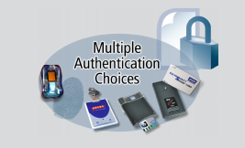
Fig.10. Multi-Factor authentication choices given by imprivata
It also supports single sign on feature on single and virtual environments. This also contains a utility to let the users manage their own passwords. The following figure illustrates how to login to a web account using imprivata onesign tool without typing any username and password.
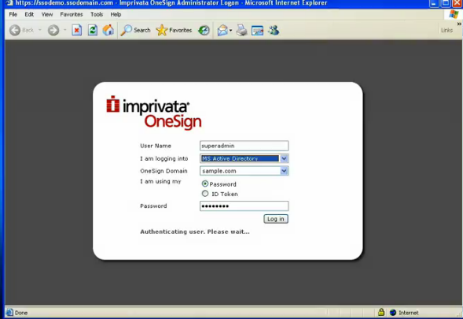
Fig.11. Imprivata onesign-on web application
- SafeTok – All Factor Security System
SafeTok provides a low cost, easily deployed solution protecting data on hard drives and portable storage devices, access to computers and websites, file sending and working with others. This all-factor security system enables users to combine protection by password, security device and fingerprints.
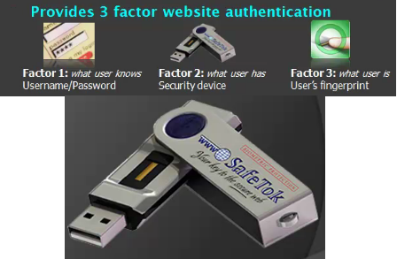
Fig.12. Multi-Factor authentication choices offered by SafeTok
It also helps the user to get around the password management hassle. It also supports features such as secure file sending, Computer access protection (protected multi factor log-in to user accounts), secure website access etc.
- Digital Persona
This is also similar to the tools we have seen above in this category. DigitalPersona is the powerful, modular suite of security applications that is easy to use, scalable and simple to deploy and manage on all endpoints either via the Cloud or Active Directory. The features supported by this product are
- Full disk encryption
- Fingerprint and strong authentication
- Single Sign-On (SSO) and password management
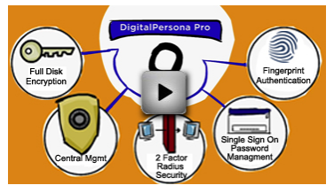
Fig.13. Security features offered by digital persona
This product also has cloud based security for cheaper rates.

POST-LIFE DIGITAL ASSET MANAGEMENT:
Digital assets are electronic data that the user has cretaed, accumulated and built that have meaning and value him/her. E-mail accounts and photo sharing accounts are built up over years and as a whole they document a part of the one’s life.
As life has become more electronic and convenient we accumulate more and more of these Digital Assets. In many cases we might not even know what we have. This following list is by no means exhaustive but it helps us to think of all the many different Digital Assets in someone's life:

Examples of Digital Assets
Email accounts – Ex: Gmail, Yahoo, AOL, Hotmail, private email addresses, corporate email addresses
Photo sharing – Ex: Flickr, Shutterfly, Kodak online, Picasa, Snapfish, Photobucket, Smugmug
Video sharing – Ex: You Tube, Vimeo, Veoh, Metacafe, Seesmic, 12seconds
Social networking – Ex: Facebook, Myspace, Bebo, Friendster, Orkut
Professional networking – Ex: LinkedIN, Plaxo
Domain services - Ex: GoDaddy
Online backup - Ex: Carbonite, Mozy, Box.net
Financials – Ex: Paypal, INGdirect, , eTrade, Schwab, Mint.com, Scotttrade,
Online merchants – Ex: Ebay, Amazon, Google Checkout, Yahoo Store
Media – Ex: iTunes Store, rhapsody
Personal identity - Ex: Typepad, Wordpress, Twitter, Blogger, Blogspot, Friendfeed
Online Entertainment – Ex: Party Poker, Netflix, Blockbuster Online,
Computer information – Ex: Computer Login, Routers/Home Networking

POST-LIFE DIGITAL ASSET MANAGEMENT TOOLS:
There are so many tools available in the market to manage digital assets. In this section we are going to look at few popular tools which are available in market. The tools we are going to look at are
- Legacylocker
Legacy Locker is easy to use and understand. First, the user can create an account and fill out the profile with the basic information (address, phone numbers, etc). Next, enter verifiers, the people who the user completely trusts to handle information in the unfortunate event of your passing. The next step is to identify all online assets, entering the Website, username, and password for each asset. As the assets are entered, beneficiaries to each of them can be assigned, the people to whom the user wishes to pass on his/her sensitive information. In addition to online assets, one can also create Legacy Letters, notes which get electronically delivered to friends, loved ones, or colleagues. Think of Legacy Locker similar to a safety deposit box, it's a secure place to store important assets - only online.
Once the Legacy Locker is set up, the user can always come back and add, edit, or remove assets. It's easy to update, and the user can do it from any Internet-connected computer, anywhere in the world. This way, when the passwords get changed, or new accounts are created, they can be protected with Legacy Locker within few minutes.
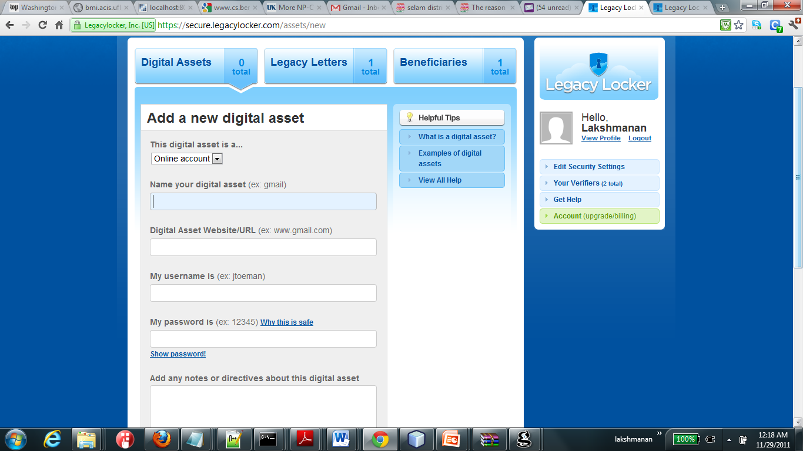
Fig.14. LegacyLocker’s digital asset management interface
The final part on how Legacy Locker works is just as straightforward. When a Legacy Locker customer passes away, one of their verifiers must visit the website to report the death. At this point, the service uses a safe combination of human oversight with secure technology to ensure the user's assets are properly dispersed. Emails to beneficiaries are sent with secure, embedded links that contain the assets or Legacy Letters. It's never fun to think about our own mortality, but we very much hope that Legacy Locker provides a valuable service to help ease the transition when a loved one passes away.

Death Verification process:
They have a multiple stage verification process, with direct human oversight at each step along the way. When a name is submitted to LegacyLocker as someone who has passed away, they immediately begin a verification process that includes at least two independent verifiers (as designated by the Legacy Locker account holder).
After both of the verifiers have confirmed that the account holder is deceased, we also require a certified copy of the individual's death certificate. Once that is received, they begin the process of alerting any beneficiaries of assets bequeathed to them. The beneficiaries also need to confirm their identity, and then receive the information designated for them from the Legacy Locker account holder. This may sound like a lot of work, but digital assets require the same trust and care as one’s life insurance, property, jewelry, cars, or other valuables.

Once verified about passing away or incapacitation, Legacy Locker will automatically distribute the digital asset information to the beneficiaries. Each beneficiary will receive an email containing a secure link to view the information. When they click on that link, they will be taken to a special Web page that displays the digital asset contents you have designated for them.

Security:
Like any other tools we have discussed, this team also claims that every last piece of data in the Legacy Locker is encrypted at all times. This goes for profile information, assets, beneficiaries—everything. Never is anything stored in plain text.
This team uses 256-bit encryption based on multiple 512-bit hash keys on all information being passed through 256-bit encrypted secure socket layers (SSL), which is encrypted over a thousand times before being stored in our maximum security databases in its encrypted format.

Additional features:
Along with the features discussed above, they also give a nice feature called ‘Legacy Letters’. A Legacy Letter is a farewell message to someone you care about. Legacy Letters are a convenient way to store a message for someone and have it automatically emailed to them in the unfortunate event of your passing. There is no limit what you can say and you can always go back and edit your message.

- Entrustet
Entrustet was also created to protect the digital assets in 2010. As we discussed in previous sections, any online content is an asset and files on computer are considered assets as well, one can have two types of digital assets. Economical ones, such as domain registrations with sites like GoDaddy.com and sentimental ones such as your online family photo albums at sites like Flickr or Photo Bucket.
Entrustet’s main offering is their Account Guardian service. Here the user can create an account and name a digital executor. The digital executor is the person responsible for receiving all the information about the user's digital assets once he/she pass on. It allows 2 executors per account. One can also name up to 10 heirs. Heirs are the people the user wants to give his/her digital content to. They will receive this information in the form of the user names and passwords for each of the sites specified that they are to receive.
After naming executors and heirs, the user can then proceed to enter the information about digital assets. There’s no limit to the amount of digital assets can be added. Entrustet has about 60 pre-set and if one that the user subscribe to is not present then theuser can easily add it. The user can also set the parameters that the executor will follow for each account.
The Account Guardian Service doscissed so far is free. But Entrustet does offer one paid service. They call it their Incinerator Service. For $20 per year, per account, user can set up services that should he die, they will be automatically deleted without anyone knowing they ever existed.
As with the legacylocker, along with online content the user can also upload documents to Entrustet account. For $1 per document Entrustet will keep the files and forward them as you wished if you die. But legacylocker offers this service for free.

Security:
Do I really trust a company with the user names and passwords to all my content? As all other companies discussed about describe, Entrustet too describes themselves as being about as safe as an online bank. They use verifying SSL, MaCafee Hacker Safe and perhaps most importantly do not keep their decryption keys in the same location as your information.

Death verification:
It’s important that the user has told someone about the Entrustet account, and the company recommends to be absolutely safe that you actually name the service in your written will with instructions for the executor. After the incident, the executor would need to provide Entrustet with a copy of your death certificate. They use this to double verify that you have indeed died by contacting the local records office in the user's area.
Once the company has verified the death, executor receives an e-mail containing a user name and password which allows him/her to log into the user's account and begin the process of honoring the user's wishes, contacting heirs, forwarding account information, deleting accounts etc.
Heirs receive, in the form of an e-mail, notification that they’ve been named as an heir to a portion of digital content. They then head to the Entrustet web site, register and gain access to the user names and passwords left for them. Entrustet also provides them instructions for completing whatever task you asked of them, be it transfer, deletion etc.
In addition to their paid Incinerator Service, they also allow lawyers to advertise on their site. If you don’t have a will and wish to make one, they’ll hook you up with a lawyer who can assist you with the process.
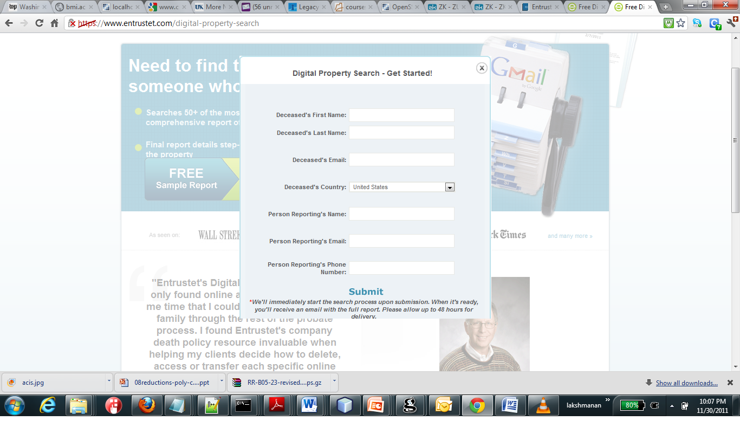
Fig.15. Entrustet’s digital property search interface
- Foreeveralive
This is also similar to the tools we discussed above in the lines of post-life digital asset management. The following figure given at their site explains the concept very well. They make an interesting claim about the data storage. They claim that their customer’s encrypted data is never stored on only one server in one country. They are duplicating and storing their customer’s vital encrypted data in the most secure data centers in various parts of the world. Among them Swiss Fort Knox an old War bunker deep inside the Swiss Alps behind a three and a half ton door that could withstand a nuclear attack.
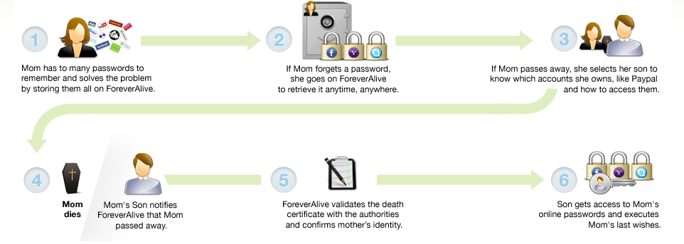
Fig.15. Foreverlive’s digital asset management lifecycle
Verification of death:
Like the other services discussed above, foreverlive too follows a multi-layered process. They contact the verifiers and also verify the death certificate. They also verify the identity of the beneficiaries.

PRACTICAL DIFFICULTIES IN USING THESE SERVICES:
It is hard to establish trustworthiness by these companies which provide these services & tools and convince the people that their data is safe. Many of these tools are from start-ups and the future of these companies is uncertain. If such services are given away by government or from a very well reputed company or if a single service becomes hit and used by masses then that might establish some trust. Even then some people may not be willing to keep their data at the hands of the government.
Many people would not feel comfortable in sharing their mail password, on-line banking password etc. with a third party, even with the government. If something goes wrong it would destroy one’s digital life build over years. All the tools discussed above claim that user’s data in their hand is safe & secure. All of them have a concept of a master password which they claim that is not known to them and the data is usable and even the company themselves can’t decrypt the data. It will be more concrete if they get the security of their system, secrecy and privacy of the user data if formally verified with the use of strong mathematical modeling by a standards committee / certification agency. May be that would convince people.
Another problem I could think of is, all though user assigns a nominee to his/her digital assets, since none of these tools did not involve lawyer/attorney/ notaries, it is not very clear that the nominees chosen and percentage allocated to each nominee is done with the full consent of the user. This might become an important point and anyone can legally break the digital will (created by the user using these tools) in court. So it is necessary for these tools to refine their process and include attorney / lawyer in the process of creating digital will.

CONCLUSION:
As we have seen, there are exists a set of interesting tools to make our on-line life lot easier than ever. Strong passwords can be used to different accounts without remembering them, authentication details can be reused to make sure the user is not added with yet an another userid and password. There are powerful tools which make post life digital asset management possible. But there is still a lot of scope for unification. If there exists a tool which unifies all the aspects about digital identity then it will make the people’s life even easier. If a single tool can be used to access many accounts, to deal with many account credentials, manage digital assets and also makes the authentication customizable then such a tool becomes a hotspot for the hackers. Since there is only one entity to be safe guarded, it can be treated with most care and power to make it unbreakable. If the digital entities are consolidated we can even go one step forward and integrate post-life real world asset management and digital asset management. If a person is dead then all his family would need to do is to report the event at this one stop shop. It can verify the event more rigorously and handle entities such as bank lockers, insurance, cancelling bank accounts, phone number, SSN, e-mail, social networks and all other digital assets promptly and properly.

REFERENCES:
- http://openid.net/
- http://cogprints.org/6695/1/2-41-48.pdf
- http://online.wsj.com/article/SB120587753685946459.html
- http://en.wikipedia.org/wiki/Single_sign-on
- http://legacylocker.com/
- http://blogs.wsj.com/digits/2009/03/10/now-that-im-dead-whos-going-to-update-my-facebook-status/
- http://techbiometric.com/articles/how-online-biometric-authentication-system-works/
- http://www.ex-sight.com/webaccess.htm
- http://www.sersc.org/journals/IJUNESST/vol2_no3/2.pdf
- http://en.wikipedia.org/wiki/Two-factor_authentication
- https://www.safetok.com/
- http://www.digitalpersona.com/
- http://www.entrustet.com/
- http://mashable.com/2010/10/08/password-management-tools/
- http://passpack.com/en/home/
- https://agilebits.com/
- https://lastpass.com/index.php
- http://www.keepassx.org/
- http://keepass.info/
- http://www.roboform.com/
- http://www.mozilla.org/en-US/mobile/sync/
- https://www.foreveralive.com/
- http://www.southindianbank.com/UserFiles/claim_policyforms_for_website.pdf
- http://articles.cnn.com/2009-05-18/tech/death.online_1_online-multiple-e-mail-addresses-account-information-and-passwords?_s=PM:TECH
- http://www.bbb.org/wisconsin/business-reviews/information-technology-services/entrustet-in-madison-wi-1000002096/
- http://www.estateplanninglawyerreviews.com/entrustet-launches-digital-property-reports-for-recently-deceased/
- http://www.techlicious.com/how-to/what-happens-to-your-online-accounts-when-you-die/
- http://www.popularmechanics.com/technology/how-to/tips/what-happens-to-your-online-data-when-you-die
- http://lifehacker.com/5407691/what-happens-to-your-online-accounts-when-you-die
- http://weprobateflorida.com/what-happens-to-online-accounts-after-you-die/
- http://h3sean.com/what-happens-to-your-online-accounts-when-you-die/
- http://code.google.com/apis/accounts/docs/OpenID.html
- http://www.idmanagement.gov/documents/ICAM_OpenID20Profile.pdf
- http://www.whitehouse.gov/sites/default/files/omb/memoranda/fy04/m04-04.pdf
- http://cogprints.org/6695/1/2-41-48.pdf
- http://www.geardiary.com/2010/04/02/entrustet-caring-for-your-digital-assets-when-youre-gone/

