GIT
Git is a free & open source, distributed version control system designed to handle everything from small to very large projects with speed and efficiency.
Every Git clone is a full-fledged repository with complete history and full revision tracking capabilities, not dependent on network access or a central server. Branching and merging are fast and easy to do.

Local Commands
git config Get and set repository or global options
git init Create an empty git repository or reinitialize an existing one
git add Add file contents to the index
git status Show the working tree status
git commit Record changes to the repository
git log Show commit history
git show Show information on any object
git tag Create, list, delete or verify tags

Remote Commands
git clone Clone a repository into a new directory
git remote Manage set of tracked repositories
git pull Fetch from and merge with another repository or a local branch
git fetch Download objects and refs from another repository
git push Update remote refs along with associated objects

Branch Commands
git checkout Checkout a branch or paths to the working tree
git branch List, create, or delete branches
git merge Join two or more development histories together
git rebase Forward-port local commits to the updated upstream head

The instructions with the rambling

Setting up a dummy initial project
Find yourself a comfortable directory and run these few commands to initiate a dummy client-side repository and its corresponding dummy remote:
mkdir test; cd $_
mkdir initial_project

# Creating a dummy repo
cd initial_project
git init
echo foo > file.txt
git add .
git commit -a -m "initial commit"
echo bar >> file.txt
git commit -a -m "modification"

# Setting up what's gonna be the central repo for our initial app
git remote add origin git@server.com/~/repo.git

git push origin master (push ur source code to server)
(or)
git push origin master:refs/heads/karthimaster

//(master-->local branch name;karthimaster-->remote branch name) //

git config branch.master.remote origin
git config branch.master.merge refs/heads/master
(The last 2 config commands configure your master branch to automatically track remote master )

To create New branch in local machine
git branch myproject
To create New branch in remote machine
git push origin HEAD:projectbranch
To Delete branch in Local machine
git branch -d myproject

To get the sourcecode (project) from remote machine to other machine
in ur local machine
cd /home/karthi/
mkdir newproject
git init
git add *
git remote add origin git@server.com/~/repo.git
git pull origin master
(or)
git pull origin master:refs/heads/karthimaster (that project branch)
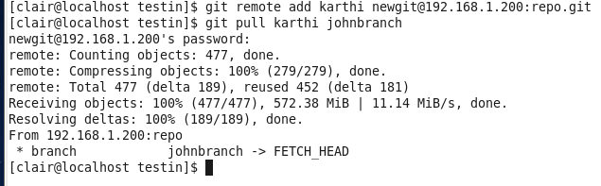
so, you got the sourcecode (project)
if u made some changes means again push into the server
edit files (after ur modification)
git add *

git commit -am “some changes in myproject @1pm”
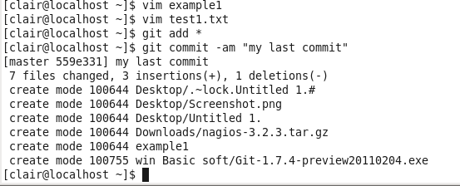
git checkout master (to change the branch)
after all modification over onceagain push to the server

git push origin master:refs/heads/karthimaster
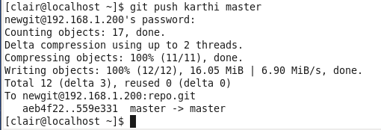
To check remote changes in local machine
git fetch origin karthimaster
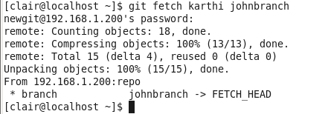
There is no change in remote machine means it just send
Already up-todate message only
To check git log
git log
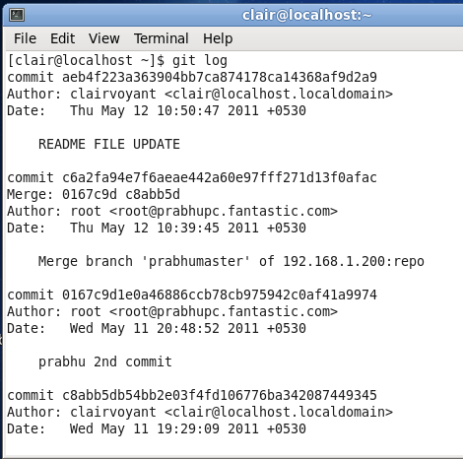

Referance:
http://www.kernel.org/pub/software/scm/git/docs/user-manual.html
http://www.kernel.org/pub/software/scm/git/docs/gittutorial.html
http://git-scm.com/

