LAKSHMANARAO TANNIRU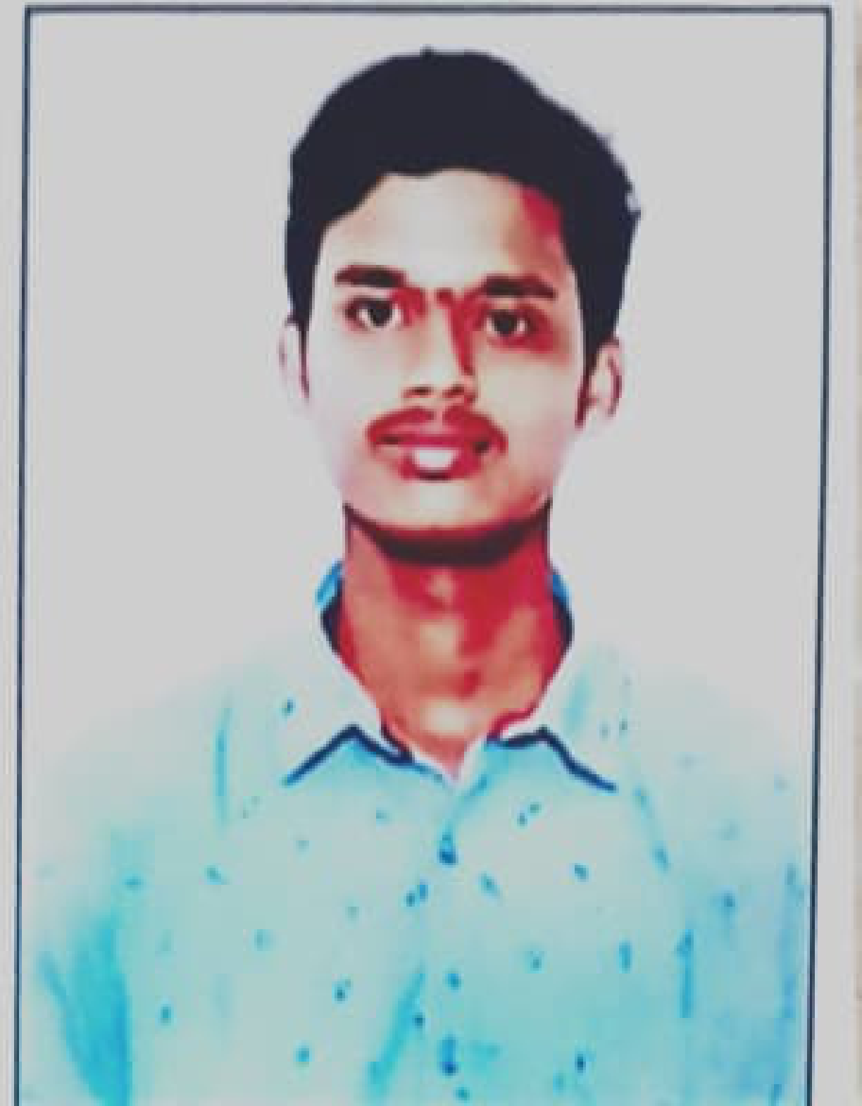
B.Tech Student | Aspiring Software Developer
Phone: +91 6300903856
Email: lakshmanaraotanniru@gmail.com
Location: Pathuru, Eluru District, Andhra Pradesh

Career Objective
Motivated B.Tech student with a strong foundation in C, Java, Python, and Full Stack Development. Seeking an internship or entry-level opportunity to apply my technical skills, gain practical experience, and grow as a software developer.

Education
• B.Tech, SASI Institute of Technology and Engineering, Tadepalligudem (2024–Present)
Completed 2nd Year | CGPA: 7.6/10
• Intermediate (MPC), NRI Junior College, Eluru
• SSC, Manasa English Medium High School

Technical Skills
Programming: C, Java, Python
Web: HTML, CSS, JavaScript, Full Stack Development (FSD-I)
Cloud & Tools: AWS Cloud, Oracle Cloud Foundations, Git (Basic), VS Code

Internship
Java Development Intern – Cognifyz Technologies
July 2025 – August 2025
• Gained practical experience in Java programming.
• Developed Java applications using object-oriented programming concepts.
• Improved debugging and problem-solving skills.
• Successfully completed the internship.

Certifications
- AWS Certified Cloud Practitioner
- Oracle Certified Foundations Associate
- Oracle Certificate of Recognition
- Free Python Course with Certificate (3 Weeks)
- FORGE INSPIRA25 Robotics Workshop – Certificate of Participation
- Java Development Internship Completion Certificate

Strengths
Quick Learner • Problem Solving • Teamwork • Time Management • Adaptability • Positive Attitude

Languages
English
Telugu

