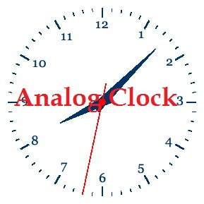
CS491-COMPUTER GRAPHICS & VISUALISATION LAB
ANALOG & DIGITAL CLOCK

A PROJECT REPORT

Submitted by

REG. NUMBER NAME

BL.EN.U4CSE09075 K. Lakshman Madhav
BL.EN.U4CSE09037 D. Nagarjuna

In partial fulfillment for the award of the degree
Of

BACHELOR OF TECHNOLOGY

IN

COMPUTER SCIENCE ENGINEERING



AMRITA SCHOOL OF ENGINEERING, BANGALORE

AMRITA VISHWA VIDYAPEETHAM

BANGALORE 560 035

November – 2012
Examiner 1 Examiner 2

………………… ………………...

