Chapter 1
INTRODUCTION

1. INTRODUCTION

1.1 Privacy Preserving Data Publishing
Detailed person-specific data in its original form often contains sensitive information about individuals, and publishing such data immediately violates individual privacy. The current practice primarily relies on policies and guidelines to restrict the types of publishable data and on agreements on the use and storage of sensitive data. The limitation of this approach is that it either distorts data excessively or requires a trust level that is impractically high in many data-sharing scenarios.

For example, contracts and agreements cannot guarantee that sensitive data will not be carelessly misplaced and end up in the wrong hands. A task of the utmost importance is to develop methods and tools for publishing data in a more hostile environment, so that the published data remains practically useful while individual privacy is preserved. This undertaking is called privacy-preserving data publishing (PPDP). In the past few years, research communities have responded to this challenge and proposed many approaches. While the research field is still rapidly developing, it is a good time to discuss the assumptions and desirable properties for PPDP, clarify the differences and requirements that distinguish PPDP from other related problems, and systematically summarize and evaluate different approaches to PPDP.

1.2 Phases of Privacy-Preserving Data Publishing
A typical scenario for data collection and publishing is described in Figure 1.2. In the data collection phase, the data publisher collects data from record owners (e.g., Alice and Bob). In the data publishing phase, the data publisher releases the collected data to a data miner or to the public, called the data recipient, who will then conduct data mining on the published data. In this survey, data mining has a broad sense, not necessarily restricted to pattern mining or model building. For example, a hospital collects data from patients and publishes the patient records to an external medical center. In this example, the hospital is the data publisher, patients are record owners, and the ACM Computing Surveys medical center is the data recipient. The data mining conducted at the medical center could be anything from a simple count of the number of men with diabetes to a sophisticated cluster analysis. There are two models of data publishers. In the untrusted model, the data publisher is not trusted and may attempt to identify sensitive information from record owners. Various cryptographic solutions; anonymous communications; and statistical methods were proposed to collect records anonymously from their owners without revealing the owners’ identity. In the trusted model, the data publisher is trustworthy and record owners are willing to provide their personal information to the data publisher; however, the trust is not transitive to the data recipient. In this ,we assume the trusted model of data publishers and consider privacy issues in the data publishing phase.

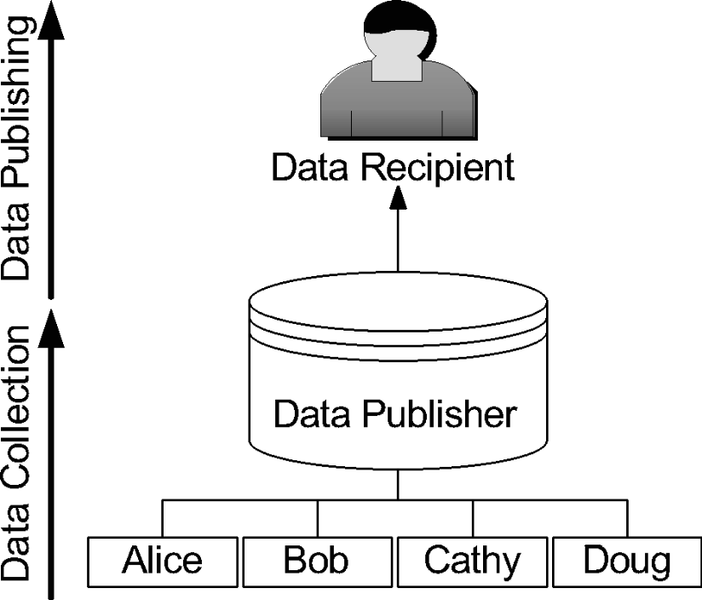
Figure 1.2 Data collection and Data Publishing.

1.3 Privacy Models
We can broadly classify privacy models into two categories based on their attack principles. The first category considers that a privacy threat occurs when an attacker is able to link a record owner to a record in a published data table, to a sensitive attribute in a published data table, or to the published data table itself. We call these record linkage, attribute linkage, and table linkage, respectively.
- Record linkage: attacker aims at linking a row to a person
- Attribute linkage: attacker wants to link (sensitive) attribute to person
- Table linkage: attacker wants to know whether data of a specific person is present in a table
The second category aims at achieving the uninformative principle: The published table should provide the attacker with little additional information beyond the background knowledge. If the attacker has a large variation between the prior and posterior beliefs, we call it the probabilistic attack.

1.4 Purpose & Objective
Privacy Preserving publishing of microdata has been studied extensively in recent years. Microdata contains records each of which contains information about an individual entity, such as a person, a household, or an organization. Several microdata anonymization techniques have been proposed. The most popular ones are generalization for k-anonymity and bucketization for l-diversity . In both approaches, attributes are partitioned into three categories: 1) some attributes are identifiers that can uniquely identify an individual, such as Name or Social Security Number; 2) some attributes are Quasi Identifiers (QI), which the adversary may already know (possibly from other publicly available databases) and which, when taken together, can potentially identify an individual, e.g., Birthdate, Sex, and Zipcode; 3) some attributes are Sensitive Attributes (SAs), which are unknown to the adversary and are considered sensitive, such as Disease and Salary.

We intend to develop a new anonymization tool defined from a technique called "Slicing" for privacy preserving publication, which is applicable to any monotonic anonymization principle. Slicing subsumes traditional generalization as a special case. It produces an anonymized relation that achieves the same privacy guarantee (as conventional generalization), but permits a much more accurate reconstruction of the original data distribution. Furthermore, Slicing offers a simple and rigorous solution to anonymized marginal publication, which was previously a difficult issue with conventional generalization. SLICING APPROACH utilizes existing algorithms of simple generalization to perform Slicing. It would be interesting to study whether it is possible to obtain better Slicing directly, without resorting to simple generalization. Previously only static microdata is considered for Slicing, but now we have extended it to real time dynamic data as well as support for republication with adhered changes from Slicing.

Slicing overcomes the limitations of generalization and bucketization and preserves better utility while protecting against privacy threats. We illustrate how to use slicing to prevent attribute disclosure and membership disclosure. Our experiments show that slicing preserves better data utility than generalization and is more effective than bucketization in workloads involving the sensitive attribute.

The general methodology proposed by this work is that: before anonymizing the data, one can analyze the data characteristics and use these characteristics in data anonymization.

The rationale is that one can design better data anonymization techniques when we know the data better. Attribute correlations can be used for privacy attacks and slicing succeds in maintaining a balance tp prevent such attacks yet mainitaing data utility.

1.5 Anonymization Techniques
There are mainly three types of anonymization techniques
- Generalization
- Bucketization
- Slicing
In both generalization and bucketization, one first removes identifiers from the data and then partitions tuples into buckets. The two techniques differ in the next step. Generalization transforms the QI-values in each bucket into “less specific but semantically consistent” values so that tuples in the same bucket cannot be distinguished by their QI values. In bucketization, one separates the SAs from the QIs by randomly permuting the SA values in each bucket. The anonymized data consists of a set of buckets with permuted sensitive attribute values.

1.6 Generalization
A common way for k-anonymisation is achieved by generalisation — an attribute value is generalised according to its attribute domain hierarchy. For example, date of birth D/M/Y is replaced by M/Y. All attribute domains are in hierarchical structures. Domains with fewer values are more general than domains with more values for an attribute. The most general domain contains only one value. For example, date of birth in D/M/Y is a lower level domain, and date of birth in Y is a higher level domain. The most general level of date of birth domain contains value unknown ‘*’. Numerical attributes are in a hierarchical structure too. That is {value, interval, *}. Intervals can be determined by users or a machine learning algorithm, say, a discretisation method. As illustrated in Figure 1, 10 year interval level in birth domain is more general than year level.

For example, Table 1.6.1 shows a simplified medical data set. It does not contain personal identification attributes, such as name, address, and medical care card number. However, the unique combinations of gender, age and postcode still reveal sensitive information of individuals. For instance, the first record is unique in these three attributes, and the patient is potentially identifiable. As a result, depression condition of the patient may be revealed by the unique combination.
 | Quasi identifier |  |  | Other attributes | Sensitive attributes
 | Gender | Age | Postcode |  | Diagnosis
1 | male | 25 | 4350 | … … … | Depression
2 | male | 22 | 4352 | … … … | Flu
3 | male | 28 | 4353 | … … … | Flu
4 | female | 34 | 4352 | … … … | Depression
5 | female | 38 | 4350 | … … … | alcohol addiction
6 | Male | 42 | 4351 | … … … | alcohol addiction
7 | male | 42 | 4350 | … … … | alcohol addiction
8 | male | 45 | 4351 | … … … | alcohol addiction
9 | male | 45 | 4350 | … … … | alcohol addiction
Table 1.6.1 Raw Medical Data Set

To avoid privacy breaching, Table 1.6.1 can be modified to Table 1.6.2. In Table 1.6.2, age is grouped into intervals, and postcodes are clustered into large areas. Symbol ‘*’ denotes any digit. A record in the quasi-identifier is identical to at least 3 other records, and therefore, no individual is identifiable.

 | Quasi identifier |  |  | Other attributes | Sensitive attributes
 | Gender | Age | Postcode |  | Diagnosis
1 | Male | 20-29 | 435* | … … … | Depression
2 | Male | 20-29 | 435* | … … … | Flu
3 | Male | 20-29 | 435* | … … … | Flu
4 | Female | 30-39 | 435* | … … … | Depression
5 | Female | 30-39 | 435* | … … … | alcohol addiction
6 | Female | 30-39 | 435* | … … … | alcohol addiction
7 | Male | 40-49 | 435* | … … … | alcohol addiction
8 | Male | 40-49 | 435* | … … … | alcohol addiction
9 | Male | 40-49 | 435* | … … … | alcohol addiction
Table 1.6.2 Generalized Data Set

Generalization may reveal sensitive information under the following two types of attacks. Homogeneity attack to a k-anonymity table: Bob and Tom are two hostile neighbours. Bob knows that Tom goes to hospital recently and tries to find out the disease Tom suffers. Bob finds the 4-anonymous table as in Table 1.6.2. He knows that Tom is 42 years’ old and lives in the suburb with postcode 4350. Tom must be record 2, 10, 11, or 12. All four patients are alcohol addiction sufferers. Bob knows for sure that Tom suffers alcohol addiction. Therefore, homogeneous values in the sensitive attribute of a k-anonymous group leak private information.
Background knowledge attack to a k-anonymity table: Bob and Alice are friends and Bob does not want Alice to know his medical condition. Alice knows Bob goes to hospital, but does not know what the medical problem is. She finds the 4-anonymous table containing Bob’s record. Bob is 25 years old and lives in suburb with postcode 4352. Bob’s record must be record 1, 2, 3 or 4. Based on the table, Alice does not know whether Bob suffers depression or flu. However, she knows Bob did not have a flu for a long time. So, Alice knows nearly for sure that Bob suffers depression. Therefore, k-anonymity does not protect individuals from a background knowledge attack.

1.7 Bucketization
In bucketization, we partition the tuples in table into buckets, and then to separate the sensitive attribute from the non-sensitive ones by randomly permuting the sensitive attribute values within each bucket. The sanitized data then consists of the buckets with permuted sensitive values. we use bucketization as the method of constructing the published data from the original table T, although all our results hold for full-domain generalization as well. We now specify our notion of bucketization more formally. Partitition the tuples into buckets (i.e., horizontally partition the table T according to some scheme), and within each bucket, we apply an independent random permutation to the column containing S-values. The resulting set of buckets, denoted by B, is then published.

While bucketization has better data utility than generalization, it has several limitations. First, bucketization does not prevent membership disclosure. Because bucketization publishes the QI values in their original forms, an adversary can find out whether an individual has a record in the published data or not. As shown in, 87 percent of the individuals in the United States can be uniquely identified using only three attributes (Birthdate, Sex, and Zipcode). A microdata (e.g., census data) usually contains many other attributes besides those three attributes. This means that the membership information of most individuals can be inferred from the bucketized table.

Second, bucketization requires a clear separation between QIs and SAs. However, in many data sets, it is unclear which attributes are QIs and which are SAs. Third, by separating the sensitive attribute from the QI attributes, bucketization breaks the attribute correlations between the QIs and the SAs.
Table 1.7 shows the bucketization where sensitive attributes are separated and randomly shuffled.

 | Quasi identifier |  |  | Other attributes | Sensitive attributes
 | Gender | Age | Postcode |  | Diagnosis
1 | Male | 25 | 4350 | … … … | Flu
2 | Male | 22 | 4352 | … … … | Depression
3 | Male | 28 | 4353 | … … … | Depression
4 | Female | 34 | 4352 | … … … | Alcohol addiction
5 | Female | 38 | 4350 | … … … | Flu
6 | female | 35 | 4350 | … … … | alcohol addiction
7 | male | 42 | 4351 | … … … | Flu
8 | male | 45 | 4351 | … … … | Depression
9 | male | 45 | 4350 | … … … | alcohol addiction
Table 1.7 Bucketized Data set

1.8 Slicing
To overcome the problems with existing techniques, we introduce a novel data anonymization technique called slicing. Slicing partitions the data set both vertically and horizontally. Vertical partitioning is done by grouping attributes into columns based on the correlations among the attributes. Each column contains a subset of attributes that are highly correlated. Horizontal partitioning is done by grouping tuples into buckets. Finally, within each bucket, values in each column are randomly permutated (or sorted) to break the linking between different columns. The basic idea of slicing is to break the association cross columns, but to preserve the association within each column. This reduces the dimensionality of the data and preserves better utility than generalization and bucketization.
Slicing preserves utility because it groups highly correlated attributes together, and preserves the correlations between such attributes. Slicing protects privacy because it breaks the associations between uncorrelated attributes, which are infrequent and thus identifying. Note that when the data set contains QIs and one SA, bucketization has to break their correlation; slicing, on the other hand, can group some QI attributes with the SA, preserving attribute correlations with the sensitive attribute.

The key intuition that slicing provides privacy protection is that the slicing process ensures that for any tuple, there are generally multiple matching buckets. Slicing first partitions attributes into columns. Each column contains a subset of attributes. Slicing also partition tuples into buckets. Each bucket contains a subset of tuples. This horizontally partitions the table. Within each bucket, values in each column are randomly permutated to break the linking between different columns.
Table 1.8 shows how the correlated attributes are grouped together and how the associations cross columns are broken and associations within column are preserved.

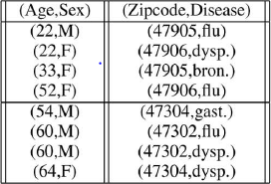
Table 1.8 Sliced Data Set

