Chapter 6
TESTING

6. TESTING

6.1 Introduction
Software Testing is the process of executing a program or system with the intent of finding errors. It also involves any activity aimed at evaluating an attribute or capability of a program or system and determining that it meets its required results. Any errors created within the system development life cycle can lead to many faults within the software, which will eventually lead to failure of the software. Software bugs will almost always exist in any software module with moderate size: not because programmers are careless or irresponsible, but because the complexity of software is generally intractable the more faults or defects that are detected and corrected the more reliable the system will be. Since the project includes mainly software components the testing is done mainly for the software components. However, basic hardware testing is done as well.

6.2 Hardware Testing
The hardware used here is an android mobile phone with a speaker and a mic integrated with the system.
- Testing the component: The component required for the application is tested.

6.3 Software Testing
Software testing is a process used to assess the quality or computer software. Software testing is an empirical technical investigation conducted to provide stakeholders with information about the quality of the product or service under the test, with respect to the context in which it is intended to operate. This includes, but is not limited to, the process of executing a program or application with the intent of finding software bugs. As computers and software are used in critical applications, the outcome of a bug can be severe. Bugs can cause huge losses.
Software testing involves an activity aimed at evaluating an attribute or capability of a program or system and determining that it meets its required results. Once the source code has been generated, software must be tested to uncover as many errors as possible before delivery to the customer.

The software faults occur through the following processes: A programmer makes an error (mistake), which results in a defect (fault, bug) in the software source code. If this defective code is executed then in certain situations the system will produce wrong results, causing failure. But note that not all defects will result in failures.

For example, defects in dead code will not result in failures. A defect can turn into a failure when the environment is changed. Examples of these changes in environment include software being used in a new hardware platform, alteration in source data or interaction with different software.

There are many approaches to software testing. Reviews, walk through or inspection are considered as static testing, whereas actually running the program within a given set of test cases in a given deployment stage is referred to as dynamic testing.
Software testing is used in association with
- Verification
- Validation
Verification checks if the result agrees with the specification and ensures the product is designed to deliver all functionality to the customer. Validation ensures that functionality, as defined in requirements, is the intended behavior of the product. Validation typically involves actual testing and takes place after verifications are completed.

6.4 Testing Methods
Software testing methods are traditionally divided into Black box testing and White box testing. The two approaches are used to describe the point of view that an engineer takes when designing test cases.
- Black box testing treats the software as a black-box without any understanding of the internal behavior. The black-box approach is a testing method in which test data are derived from the specified functional requirements without regard to the final program structure. Only the functionality of the software module is of concern. Black-box testing also mainly refers to functional testing, a testing method emphasized on executing the functions and examination of their input and output data. Thus, the tester inputs the data and only sees the output from the test object. This level of testing usually requires thorough test cases to be provided to the tester who then can simply verify that for a given input, the output value is the same as expected value specified in the test case. Black box testing methods include: equivalence partitioning, traceability matrix, boundary value analysis, all-pairs testing, fuzz testing, model based testing etc.
- White box testing, is when the tester has access to the internal data structures, code, algorithms. Software is viewed as a white-box, or glass-box in white-box testing, as the structure and flow of the software under test are visible to the tester. White box testing methods includes creating tests to satisfy some code coverage criteria. For example, the test designer can create tests to cause all statements in the program to be executed at least once. Other examples of white box testing are mutation testing and fault injection methods.

6.5 Testing Process
A common practice of software testing is performed by an independent group of testers after the functionality is developed before it is shipped to the customer. This practice often results in the testing phase being used as project buffer to compensate for project delays,, thereby compromising the time devoted to testing. Another practice is to start software testing at the same moment the project starts and it is a continuous process until the project finishes.

Testing can be done in the following levels:
- Unit testing tests the minimal software components or module.
- Integration testing exposes defects in the interfaces and interaction between integrated components.
- System testing tests are completely integrated systems to verify that it meets its requirements.

6.5.1 Unit Testing
In computer programming, unit testing is a procedure used to validate that individual units of source code are working properly. Unit testing extensively makes use of white box testing techniques to ensure complete coverage and maximum error detection. Unit testing deals with testing a unit as a whole. A unit is the smallest testable part of an application. This would test the interaction of many functions but confine the test within one unit. While in object oriented programming, the smallest unit is a method, which may belong to a base/super class, abstract class or derived/ child class. The exact scope of a unit is left to interpretation.

6.5.2 Integration Testing
Integration testing is the phase of software testing in which individual software modules are combined and tested as a group. It follows unit testing and precedes system testing.

Integration testing takes as its input modules that have been unit tested, groups them in larger aggregates , applies tests defined in an integration test plan to those aggregates, and delivers as its output the integration system ready for system testing .
The purpose of integration testing is to verify functional, performance and reliability requirements placed on major design items. These “design items”, i.e. groups of units, are exercised through their interfaces using black box testing , success and error cases being simulated via appropriate parameters and data inputs. Simulated usage of shared data areas and inter-process communication is tested and individuals subsystem are exercised through their input interface. Test cases are constructed to test that all components within assemblages interact correctly, for example across procedure calls or process activations, and this is done after testing individual modules, that is unit testing.

6.5.3 System Testing
System testing of software and hardware is testing conducted on a complete, integrated system to evaluate the system compliance with its specified requirements. System testing falls within scope of black box testing and as such, should require no knowledge of the inner design if the code or logic.

As a rule, system testing takes, as its input, all of the “integrated” software components that have successfully passed integration testing and also software system itself integrated with an applicable hardware system(s). The purpose of the integration testing is to detect any inconsistencies between the software units that are integrated together or between any of the assemblages and the hardware. System testing is more limiting type of testing; it seeks to detect defects both within the “inter-assemblages".

6.6 Test Cases
A test case in software engineering is a set of conditions or variables under which a tester will determine whether an application or software system is working correctly or not.

6.6.1 Testing Module 1
The first module is testing for Registration.
- Functionality Tested : Testing the validation of registration form

- Test Execution Procedure : Fill the form with credentials.

- Test Results Checking Method : A message will be displayed when incorrect input is given

S l: No: | Condition to be tested | Expected Result | Result
1 | E mail Id | If doesn’t contain ‘@’ or ‘.com’ gives a message: Invalid Email Id | Pass
2 | Contact number | Should contain 10 integers only | Pass
3 | All fields should be filled | Prompts an alert when any field is empty | Pass
4 | User Id & Username must be unique | Checks in database and If already exists, displays a message: Try another User Id | Pass
Table 6.6.1 Test Case for Registration

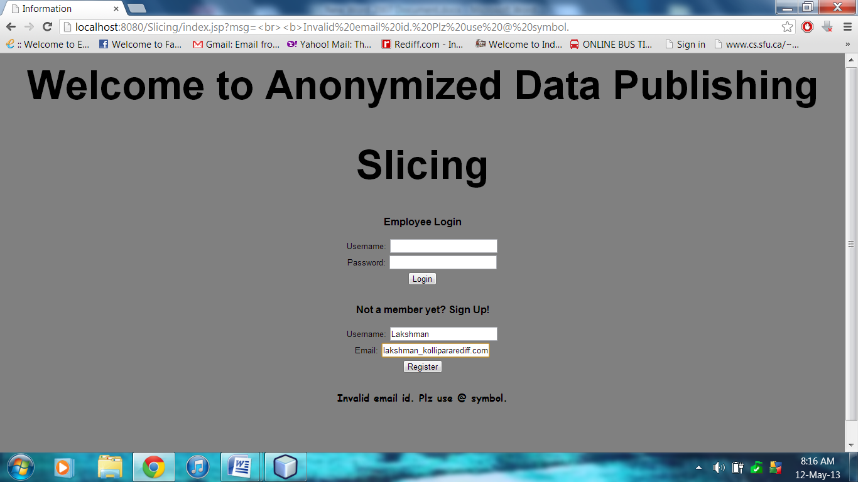
Figure 6.6.1.1 Result of Testing for Registration(Email Id)

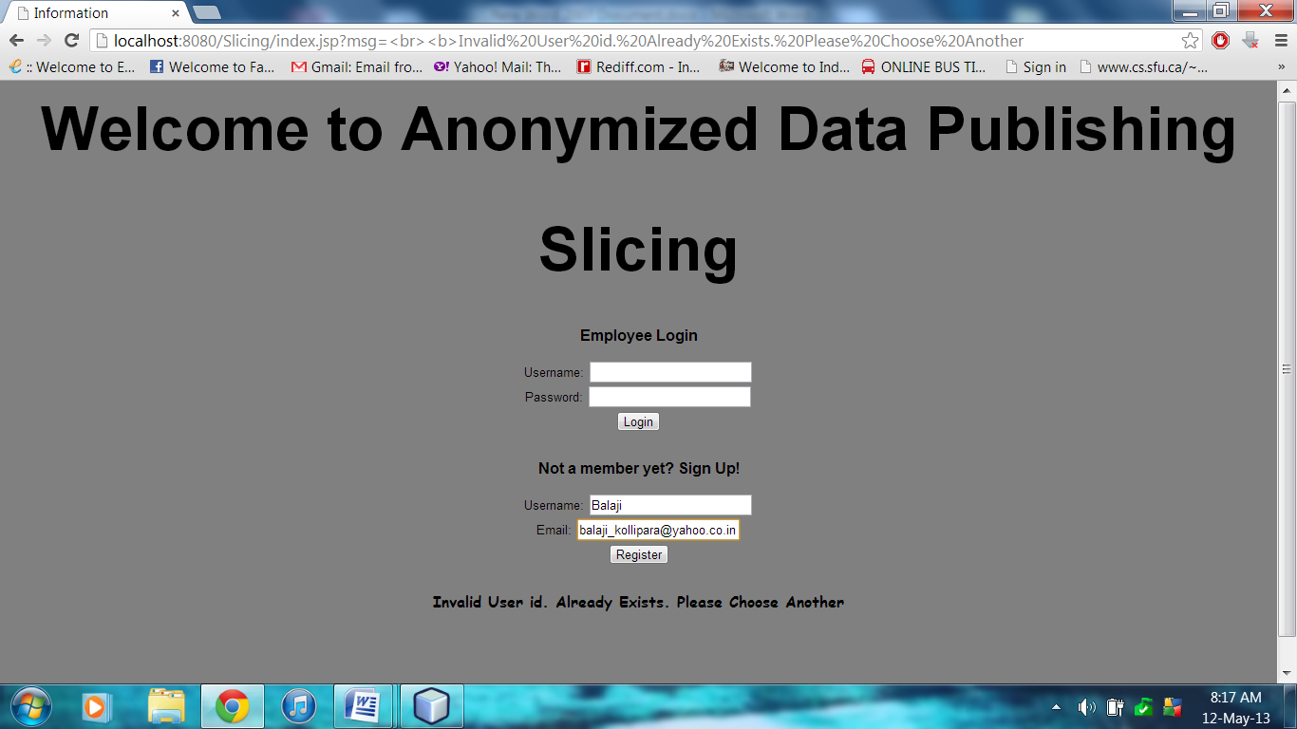Figure 6.6.1.2 Result of Testing for Registration(Unique User Id)

6.6.2 Testing Module 2
The Second module is testing for Validation of user
1. Functionality Tested : The user is validated by admin or not

2. Test Execution Procedure : The admin must make the status of user as ‘yes’

3. Test Results Checking Method : User can’t login unless admin validates the employee by making status =’yes’.

Sl: No: | Condition to be tested | Expected Result | Result
1 | Admin validated employee | User can login | Pass
2 | Admin didn’t validate the employee | User can’t login.  A message will be displayed: Admin yet to validate | Pass
Table 6.6.2 Test Case for Admin Validation
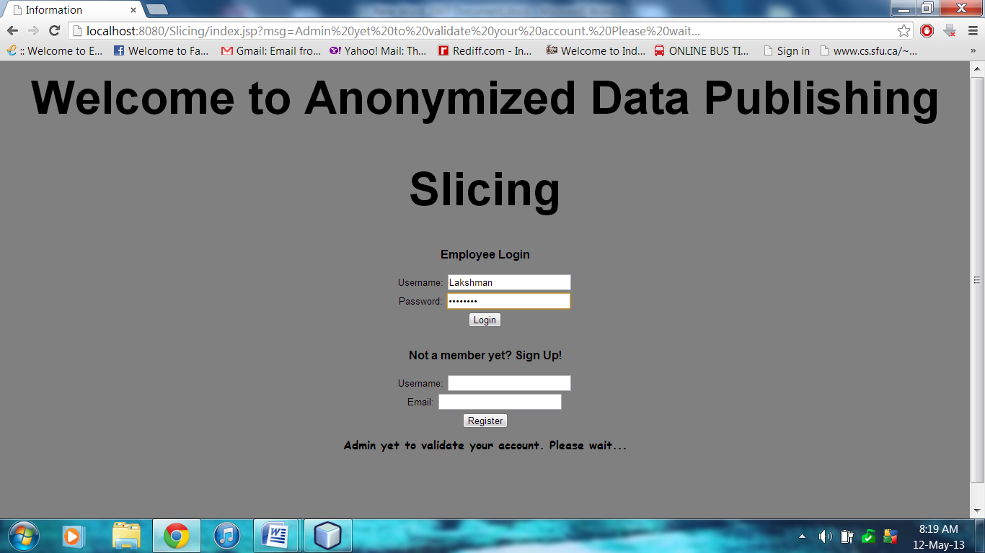
Figure 6.6.2.1 Result of Testing for Admin validation

