Project Over view

Signature recognization using Convolutional Neural Networks
In the process we follow below steps to interact with model.

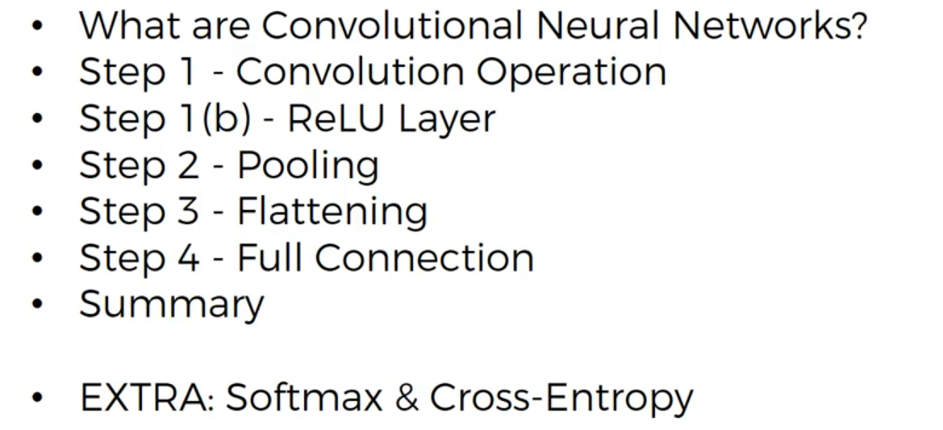

What are convolutional neural networks?

A convolution neural network is an ANN on which we use convolution trick to add some convolutional layers because to preserve spatial structure in images and therefore to be able to classify some images.

For input image it considers as image of black and white it will contain(matrix) only ‘0’ and ‘1’ then we will have a feature detector matrix(probabaly 3*3 matrix)
[Alex Net uses 7*7 matrix ]
The famous feature detector is feature detector or Kernel or some times it is called Filter.

In The input image we have to consider 3*3(filter) and it will be multiplied(not matrices but just variable multiplication) with feature detector which is shown in below and we have to add how many matched up in the stride(the size of feature detector in input image)

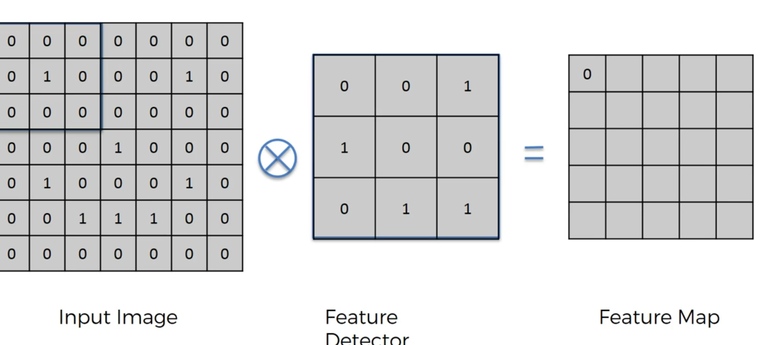

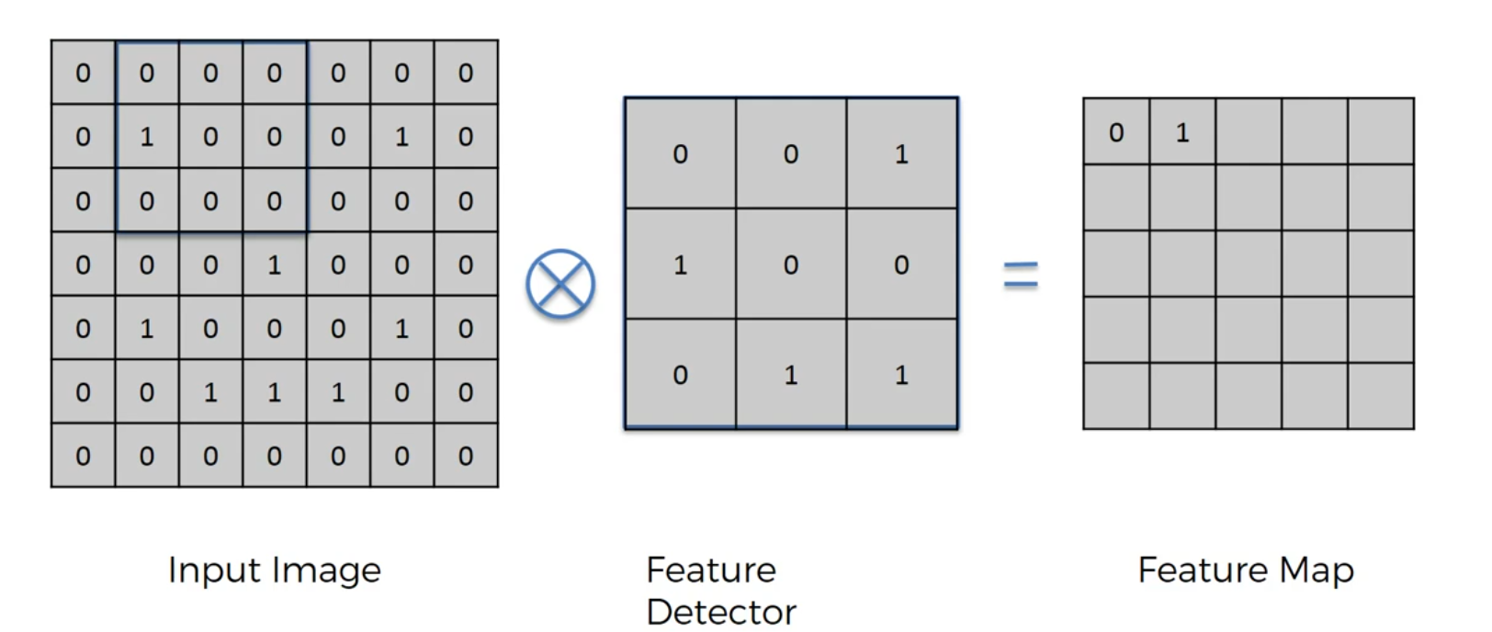
Final after doing for all strides
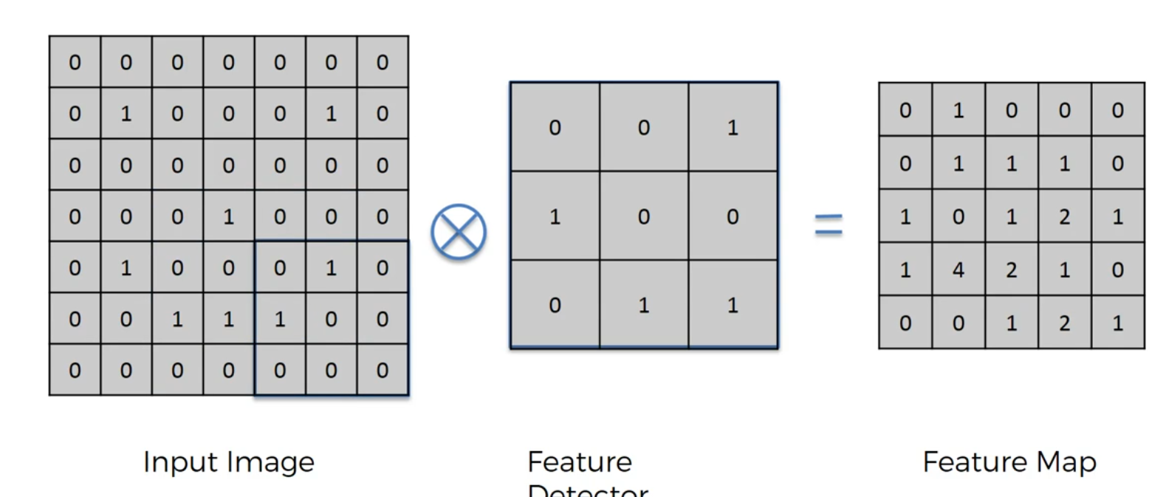

Feature map is some times called convolved feature or activation Map.
The purpose of generating Feature map is to reduce the size of image and processing of image will be faster.

Generally image will be 256 * 256 pixel size so feature map generation.

Are we loosing information while applying Feature Detector?
Some information will be loosing because we are reducing the size of image but image contains some integral parts. So the highest number in the feature map is when that pattern matches up

We create many feature Maps because we use different filters. We look for certain features and basically the network decides through its training it decides which feature is important.

Step 1(b) RELU- Rectified Linear Unit (we don’t use sigmoid function here)
The reason why we apply rectifier is to increase non-linearity in our image or network
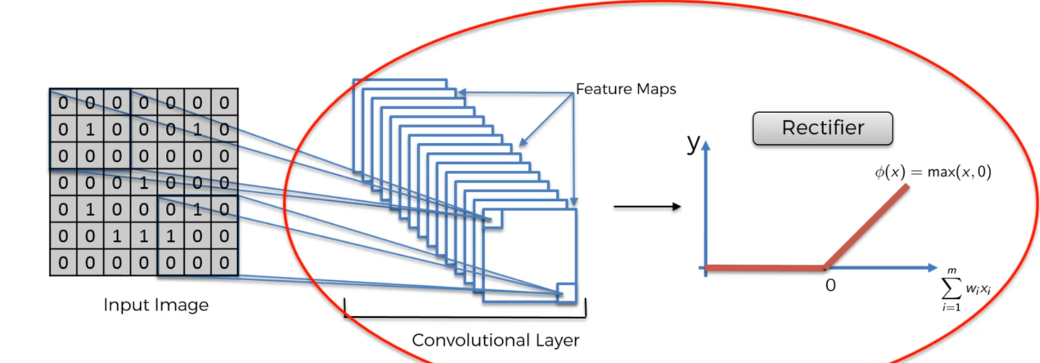
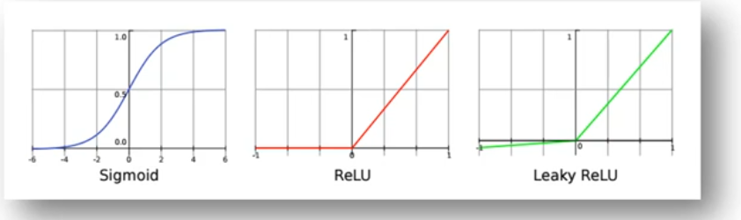

Step 2 Max Pooling
What is pooling and why do we need it?

We have to make sure that our neural network has a property called spatial invariance means it doesn’t care when the features are bit tilted or bit different.So if the feature is bit distorted our neural network has some flexibility to discover that feature and this what pooling is about.

There are different types of pooling are there Max Pooling,Mean Pooling, Sum pooling etc.,

We have to consider Feature Map in this example we will apply Max Pooling so here we will take 2*2 stride in feature map (the size is not fixed we can take how much we want) but overlapping of strides is not allowed and we have to consider max value in the stride then we will get Pooled feature Map(matrix)

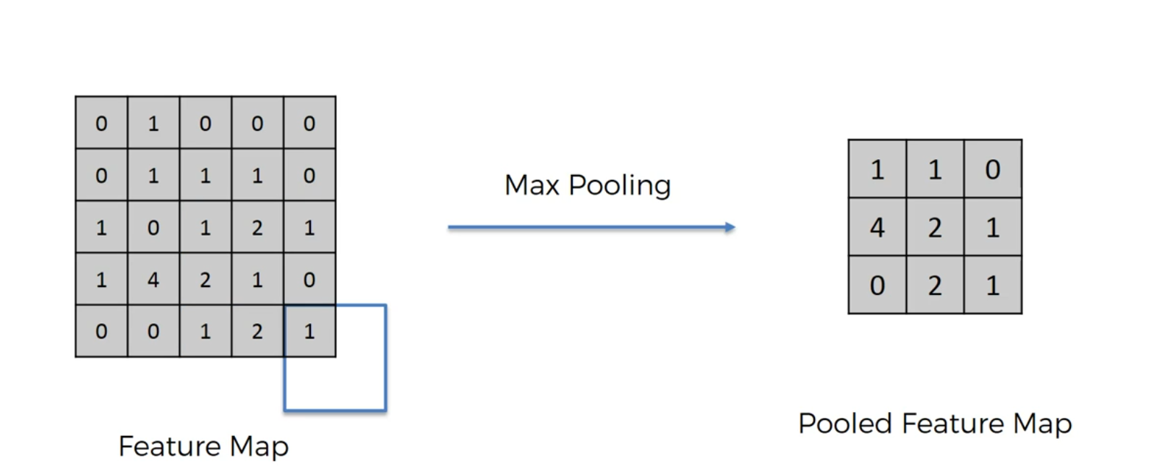

With the help of pooling we are reducing the size by 75% so that we process only important part of the image and another benefit of pooling is we are reducing the number of parameters it helps in reducing the outfitting of model.

Step 3 Flattening
In this technique Pooled Feature Map will be transformed into single column as shown below.

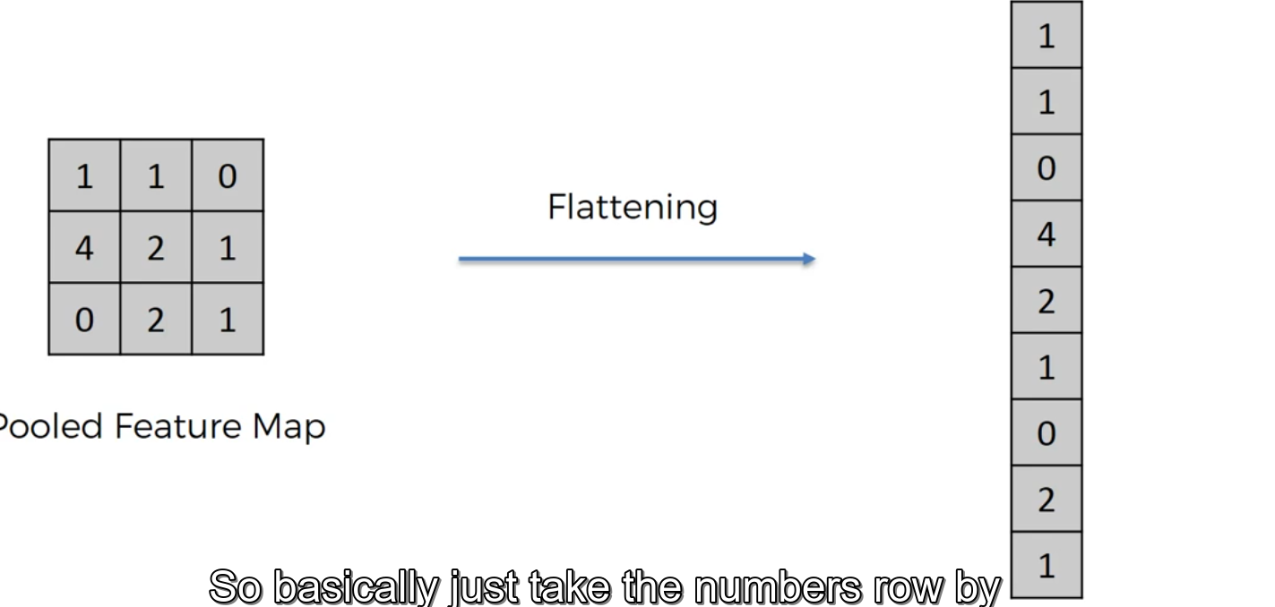

Because we have to input these numbers into artificial neural network.

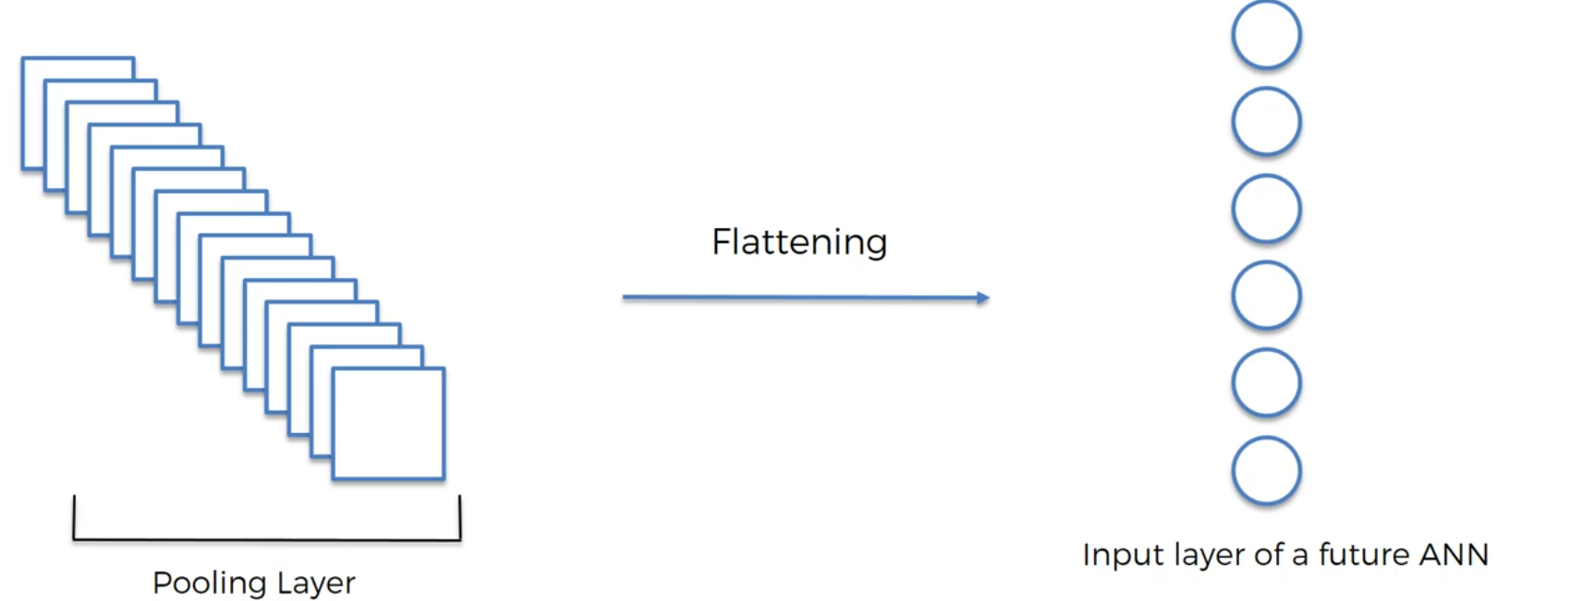

Step 4 Full Connection
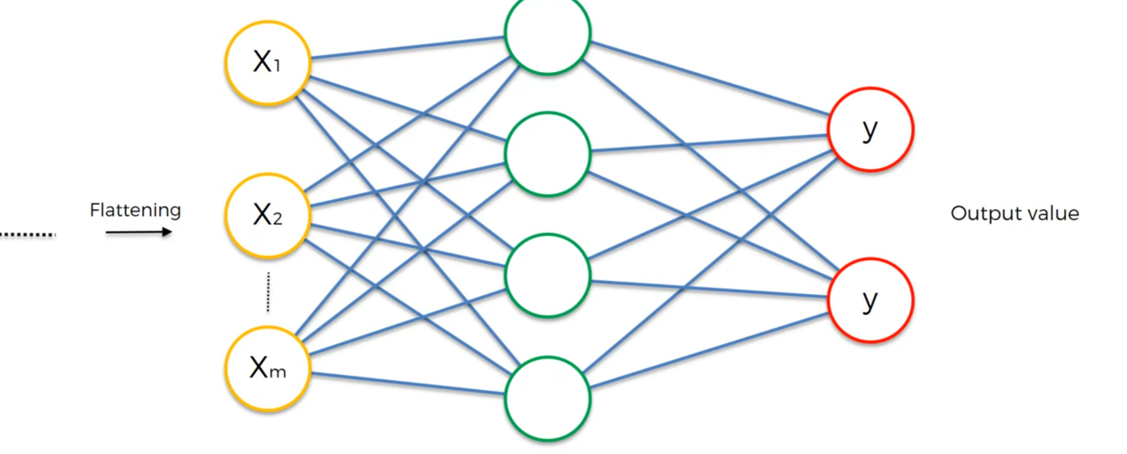
In convolution neural networks we use fully connected layers where as in ANN it is not mandatory to full connected.

If an error occurs after passing to ANN then error is calculated and we will adjust the feature detector according to that because we are not looking for that feature to be occur here. There a lot of gradient descent of back propagation occurs to adjust the feature detector and weight are also adjusted.

What if we have two output Neurons?
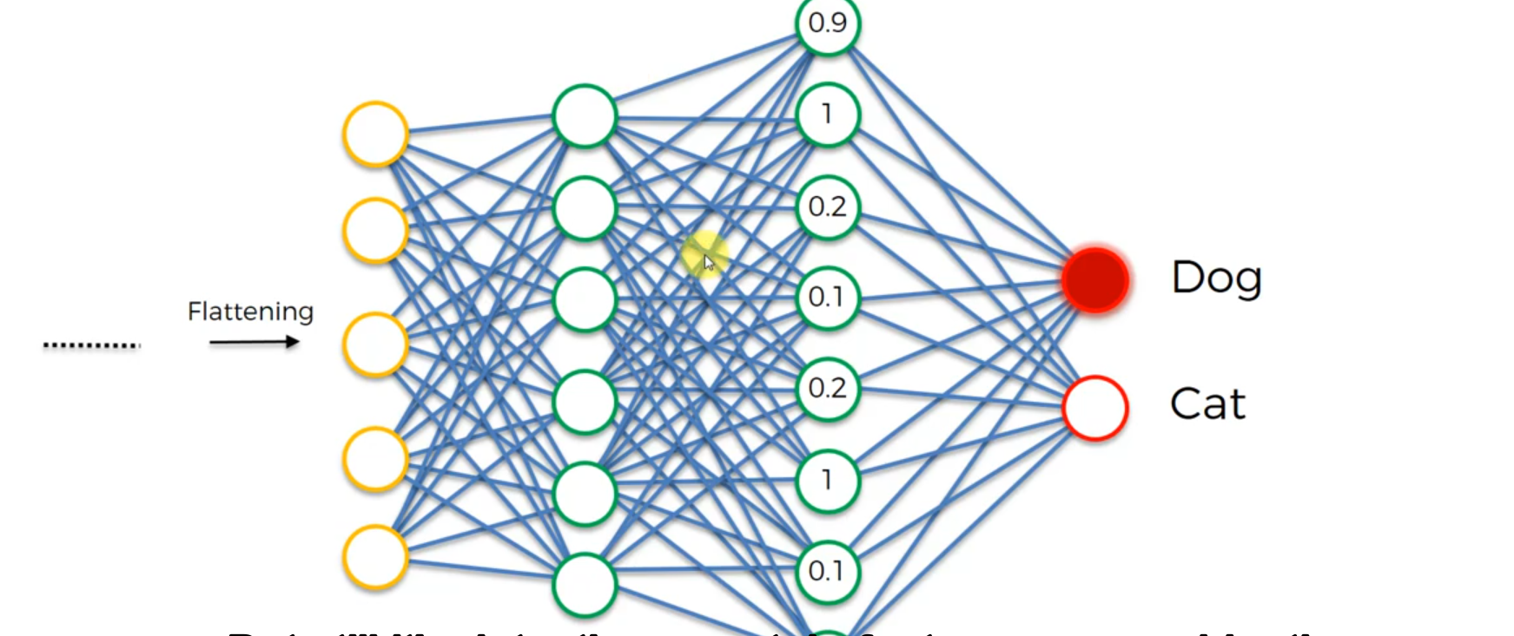

Here the hidden layer beside the output layer gets some numbers between 0 and 1

The hidden layer consists of features of dog and cat like eye brow length,eyes length,floppy ears etc., when ever the value comes like eyes length then the neuron that matches will trigger it is a dog or cat.
So maximum probability features matches to particular one(dog or cat) will be detected.

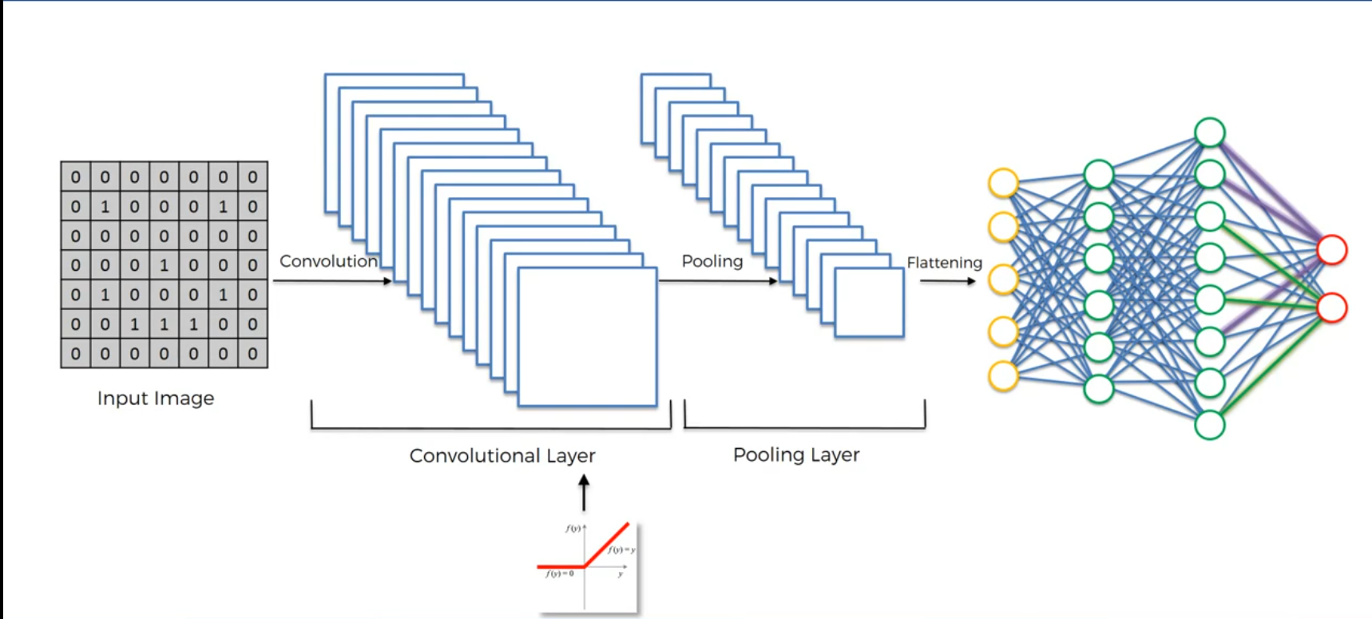

SoftMax
Why don’t we take each pixel as huge single dimensional vector and pass it through as Input to ANN?

Because if we take each pixel as input we will get only information of that pixel we don’t get how the pixel is spatially connected to another pixel. So basically we don’t get spatial structure of the pixel

Use AlexNet Structure and GoogleNet Structure for the model
Alex net consists of 5 convolution layers and 3 fully connected layers

Without padding formula N x N) * (F x F) = (N-F+1)x(N-F+1) for N x N input image and F x F feature detector.
But we use padding in the padding we add 0’s across the image

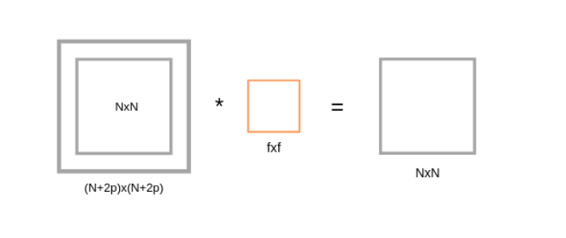
If we apply filter F x F in (N+2p) x (N+2p) input matrix with padding, then we will get output matrix dimension (N+2p-F+1) x (N+2p-F+1). As we know that after applying padding we will get the same dimension as original input dimension (N x N). Hence we have,
(N+2p-F+1)x(N+2p-F+1) equivalent to NxN
N+2p-F+1 = N ---(2)
p = (F-1)/2 ---(3)

