Lakshman Kumar. Prathi
Third Year B.Tech Student Email : lakshmankumarprathi@gmail.com
Computer Science and Engineering Mobile: +917997739310
Aditya Engineering College, Surampalem

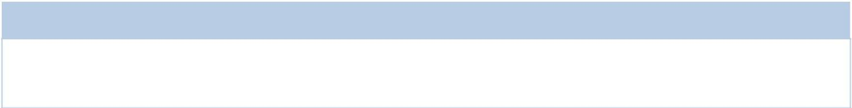
Career Objective

To pursue a challenging career in a progressive environment where learning, innovation, and creativity are encouraged, where my skills are increased to their maximum potential to contribute to the success and growth of the organization.

Education

Degree | Branch | Year of Pass | College/School | CGPA
B.Tech | CSE | 2020-present | Aditya Engineering College, Surampalem | 8.05
DIPLOMA | CME | 2020 | A.A.N.M & V.V.R.S.R polytechnic, Gudlavaleru | 9.2
CLASS – X | - | 2017 | Z.P.H.S, Arthamuru | 8.7

Technical Skill Set

Skills | Details
Languages | C , CPP, Java
Web Technologies | HTML,CSS
Operating Systems | Windows and Linux variants.

Projects

Project Title Hospital Management
Technologies | HTML, CSS,
Synopsis | It display the avaliability of dotcors.

Certifications

- Certification of Full Stack by APSSDC.

Workshops and Conferences

- Attended the workshop on Python by APSSDC

- Attended the workshop on MIT App invent organized by APSSDC.

Extra-Curricular Activities

- Bagged 1st Prize in District Level Kabaddi Competition.

- Bagged 2nd Prize in General Quiz on Techfest-2k18 at A.A.N.M & V.V.R.S.R polytechnic, Gudlavaleru.

- Finalist in Code-A-Thon event organized of Technical Hub, Aditya Engineering College.

Personal Information

Personal Information
Full Name | Lakshman Kumar. Prathi
Father Name | Mr. Nancharaiah
Permanent Address | 1-25 A, Manimeswaram(V), Bantumilli(M),Krishna(D), Andhra Pradesh, 521369
Languages Known | Telugu & English (Read & Write)

Declaraion: I hereby declare that the above information is true to best of my knowledge.

Place: Manimeswaram
Signature
[Lakshman Kumar]

