

A Course End Project Report on
Quiz Application

A9513 – PYTHON PROGRAMING LAB
Submitted by
LAKSH MEHTA
25881A0592
NALAM ANANYA
25881A0571
Course Facilitator
Ms S Madhavi
Assistant Professor

Department of Computer Science and Engineering Vardhaman College of Engineering, Hyderabad



Autonomous Institute, Affiliated to JNTUH,
Approved by AICTE, Accredited by NAAC with A++ Grade Kacharam, Shamshabad, Hyderabad- 501 218, Telangana, India.

DEPARTMENT OF COMPUTER SCIENCE AND ENGINEERING

This is to certify that the Course End Project titled “Quiz Application” is carried out by LAKSH MEHTA and NALAM ANANYA with Roll Numbers 25881A0592 and 25881A0571 towards A9513 – PYTHON PROGRAMING Laboratory course in partial fulfilment of the requirements for the award of degree of Bachelor of Technology in Computer Science and Engineering during the Academic year 2025-26.

Signature of the Course Faculty Ms S Madhavi
Assistant Professor, CSE
Signature of the HOD Dr . Y.Vijayalata HOD, CSE

Contents
- Introduction 3
- Literature Review 3
- Objectives 3
- Methodology 3
  - Architectural Diagram 3
  - Hardware and Software Requirements 3
  - Working Principle 3
  - Software Implementation 3
- Results and Discussion 3
- Mapping POs, PSOs and SDGs 3
  - Program Outcomes (POs) Mapping 3
  - Program Specific Outcomes (PSOs) Mapping 3
  - Sustainable Development Goals (SDGs) Mapping 3
- Conclusion 3
Bibliography 3

Abstract

The Quiz Application, branded QuizVerse – Brain Arena, is a desktop quiz game developed in Python using the Tkinter library for the graphical user interface. Players choose a topic, a difficulty level (Easy, Medium or Hard), the number of questions and one of four game modes – Classic, Blitz, Survival and Streak Rush – and then answer timed multiple-choice questions. Every correct answer earns experience points (XP) based on the difficulty, the remaining time and the current answer streak, while the 50/50 and Skip lifelines add strategic depth. At the end of each run the application shows the score, accuracy, best combo and a question-by-question breakdown with explanations.

The question bank is not hard-coded. It is read from an Excel workbook (quizverse_questions.xlsx) by a lightweight parser that uses only the Python standard library, so topics and questions can be added without touching the source code. Player progress – XP, level, quizzes played, accuracy, topic mastery, achievements and the last twenty runs – is stored in a JSON profile file and shown on the home screen, achievement vault and statistics screen. The modular design separates data loading, game logic and screen drawing, which makes the application easy to extend and suitable as a revision tool for any subject.

Keywords: Python, Tkinter, Quiz Application, Gamification, XP and Levels, Game Modes, Excel Question Bank, JSON Profile, Desktop GUI, E-Learning.

Introduction

Quizzes are one of the most widely used techniques for revising a subject and for checking understanding. Frequent low-stakes testing forces learners to retrieve information from memory, and research on test-enhanced learning has shown that this improves long-term retention more than simply re-reading notes. With the growth of digital learning, quiz tools have moved from paper to screens, where answers can be evaluated instantly and feedback can be given the moment a response is submitted.
However, a plain list of questions quickly becomes monotonous. Gamification – the use of game design elements such as points, levels, streaks, badges and time pressure in a non-game context – is a popular way to keep learners motivated and engaged. A well-designed quiz game rewards accuracy and speed, encourages regular practice and lets the player see progress over time.
This project presents QuizVerse – Brain Arena, a desktop quiz application built with Python and Tkinter. The player picks a topic, a difficulty, the number of questions and a game mode, and each run is scored with XP that grows with difficulty, speed and combo length. Four game modes (Classic, Blitz, Survival and Streak Rush), two lifelines (50/50 and Skip), eight achievements, a levelling system and per-topic mastery bars turn a routine revision session into a small competitive game.
The application is intentionally lightweight. It relies only on the Python standard library, reads its questions from an Excel workbook through a built-in parser and stores progress in a local JSON file. This keeps installation trivial, makes the question bank easy for non-programmers to edit, and demonstrates core programming concepts – event-driven GUI programming, classes and objects, file handling, data structures, randomisation, timers and exception handling – in a single, complete project.

Literature Review

Quiz-based assessment has been studied extensively in educational research. Experiments on the testing effect report that taking practice tests improves later recall compared with repeated study, which motivates the use of frequent self-quizzing in revision tools. Online platforms such as Kahoot! and Quizizz have popularised live, game-like quizzes in classrooms by adding timers, leaderboards and instant feedback, while language-learning and flash-card applications use streaks and points to encourage daily practice.
Reviews of empirical gamification studies generally report positive effects on engagement and motivation, although the outcome depends strongly on the context and on how the game elements are designed. Common limitations of existing quiz tools are their dependence on an internet connection and user accounts, fixed question sets that are difficult to modify, and the absence of progress tracking in simple classroom or college-level mini-projects. Many beginner quiz programs also hard-code their questions inside the source code, so adding even one question means editing and re-running the program.
This project addresses these gaps by providing an offline, installation-free desktop quiz game. Questions and topics are loaded from an Excel workbook, so the content can be changed by anyone who can use a spreadsheet. The application combines multiple game modes, difficulty-based timers, XP and levels, achievements and a persistent player profile in a single Python program that depends only on the standard library. It therefore serves both as a practical revision tool and as a compact example of structured GUI application development for engineering students.

Objectives

To design and develop a Python-based desktop quiz application using Tkinter.
The primary objective is to build a functional, responsive and visually consistent quiz game in Python. The application provides a home dashboard, a run-setup screen, a timed question screen, a results screen, an achievement vault, a statistics screen and a profile dialog, all implemented as screens of a single QuizVerse class that is driven by Tkinter events.

To load questions from an Excel workbook and support multiple topics, difficulty levels and game modes.
A built-in parser reads the Topics and Questions sheets of quizverse_questions.xlsx using only the zipfile and xml.etree modules, so no external library is required. The player can choose Easy, Medium or Hard difficulty, 5 to 20 questions per run, and one of four modes – Classic, Blitz, Survival and Streak Rush – each of which changes the timer or the rules of the run.

To provide gamified feedback and persistent progress tracking.
The application awards XP using difficulty, speed and combo bonuses, converts XP into levels, unlocks eight achievements, shows a question-by-question breakdown with explanations, and stores the player profile and recent history in a JSON file so that statistics and topic mastery are available in the next session.

Methodology

Architectural Diagram

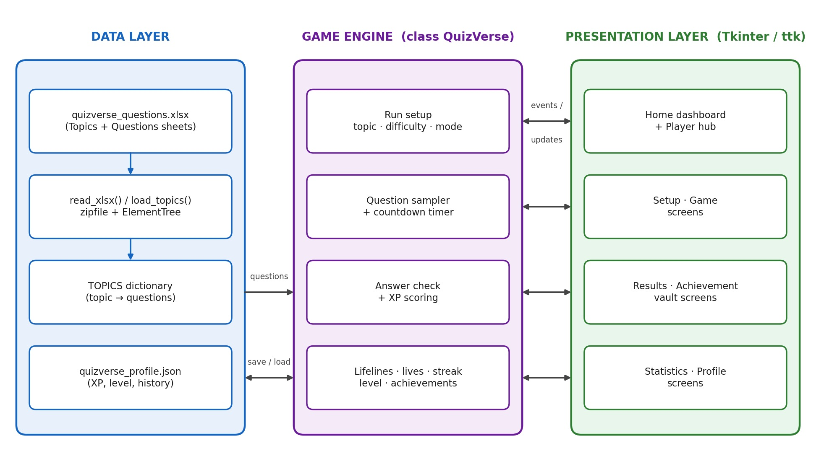
Figure 1: Architectural Diagram
The Presentation Layer is the Tkinter graphical interface implemented in the QuizVerse class. It contains seven screens: the home dashboard with topic cards, player hub and recent runs; the run-setup screen where the topic, difficulty, number of questions and game mode are chosen; the game screen with the progress bar, countdown timer, combo counter, four answer buttons and the Quit, 50/50 and Skip controls; the results screen; the achievement vault; the statistics screen; and the profile dialog. A dark colour theme defined by constants such as APP_BG, CARD, PURPLE and CYAN keeps every screen visually consistent.
The Game Engine forms the core of the application. It samples the requested number of questions at random from the selected topic, starts a one-second countdown for every question, evaluates the answer, updates the streak, lives and XP, and decides when the run ends. The XP for a correct answer is the sum of a base score (100 × difficulty multiplier), a speed bonus (3 points per remaining second), a combo bonus (25 points for every earlier consecutive correct answer) and, in Streak Rush mode, a fixed 40-point bonus. After the run the engine updates the profile, checks the achievement conditions and recalculates the level.
The Data Layer has two parts. The question bank is an Excel workbook whose Topics sheet lists the topic name, icon and colour and whose Questions sheet lists the topic, question, options A to D, the correct letter and an explanation. Because an .xlsx file is a ZIP archive of XML files, the functions read_xlsx() and load_topics() open it with zipfile, parse the XML with ElementTree and build the TOPICS dictionary used by the game. Player data – name, XP, level, quizzes played, accuracy, best streak, topics played, achievements and the last 20 runs – is saved to quizverse_profile.json after every run.
Together these layers form a modular and extensible framework. Because data loading, game logic and screen drawing are separated, new topics can be added by editing the spreadsheet, new modes or achievements by adding an entry to the MODES or ACHIEVEMENTS dictionaries, and new screens by adding one more method to the QuizVerse class, without disturbing the rest of the program.

Hardware and Software Requirements

Hardware:
    - Intel/AMD processor (dual-core or better)
    - Minimum 4 GB RAM
    - Display of at least 1000 × 680 pixels (default window 1180 × 760), keyboard and mouse

Software:
    - Python 3.8 or later (standard library only: tkinter, json, zipfile, xml.etree.ElementTree)
    - Question bank file quizverse_questions.xlsx (editable in Microsoft Excel or LibreOffice Calc)
    - Any code editor or IDE (IDLE, VS Code or PyCharm)

Working Principle

The working principle of QuizVerse is an event-driven game loop built on Tkinter. When the program starts, main() creates the root window, loads the question bank from the Excel workbook into the global TOPICS dictionary and then creates the QuizVerse object, which reads the saved profile from the JSON file and displays the home screen. If the workbook is missing or contains no valid questions, an error message is shown and the program exits cleanly. Rows with a missing question, fewer than two options or an invalid answer letter are skipped while loading.
From the home screen the player selects a topic and opens the setup screen to choose the difficulty, the number of questions and the game mode. Pressing ENTER ARENA samples the questions and starts the run. For every question the application displays the text and four options and starts a countdown whose length depends on the difficulty (30, 20 or 12 seconds, reduced by 5 seconds in Blitz mode with a minimum of 6 seconds). The chosen option turns green or red, the correct option is always revealed, the streak and XP are updated and the next question loads after a short delay. When all questions are finished – or the lives run out in Survival mode – the profile is updated and saved and the results screen is shown.

Example problem: a Medium-difficulty Classic run of four questions. The base score is 100 × 1.5 = 150 XP per correct answer, the speed bonus is 3 XP per remaining second and the combo bonus is 25 XP for every earlier consecutive correct answer.
Question | Result | Time left (s) | Base XP | Speed bonus | Combo bonus | XP earned
Q1 | Correct | 15 | 150 | 45 | 0 | 195
Q2 | Correct | 10 | 150 | 30 | 25 | 205
Q3 | Wrong | – | 0 | 0 | 0 | 0
Q4 | Correct | 18 | 150 | 54 | 0 | 204

Total XP = 195 + 205 + 0 + 204 = 604 XP, accuracy = 3 / 4 = 75 % and the best combo is 2. At 75 % accuracy the results screen shows the headline “YOU COOKED.” The 604 XP is added to the profile; because level 1 needs 1000 XP, no level-up occurs, and the First Run achievement is unlocked if this was the player’s first quiz.

Classic
Normal quiz with a relaxed run.
- Timer: 30 s (Easy), 20 s (Medium), 12 s (Hard).
- Rules: no lives; all selected questions are played.

Blitz
Fast questions and aggressive timers.
- Timer: 25 s (Easy), 15 s (Medium), 7 s (Hard).
- Rules: same scoring as Classic, but shorter timers reduce the speed bonus that can be earned.

Survival
Three lives. One mistake hurts.
- Each wrong answer, timeout or skip costs one life; the run ends when the lives reach zero.
- Finishing a Survival run unlocks the Survivor achievement.

Streak Rush
Build the longest combo possible.
- Every correct answer earns a 40 XP mode bonus on top of the normal score.
- Long streaks earn the combo bonus and the Combo 5 and Combo 10 achievements.

Software Implementation

The complete source code of the application (quizverse_ultimate.py, 781 lines) is given below.

1 | import json
2 | import os
3 | import random
4 | import time
5 | import zipfile
6 | import xml.etree.ElementTree as ET
7 | import tkinter as tk
8 | from tkinter import ttk, messagebox
9
10 | APP_BG = "#070b16"
11 | CARD = "#10182b"
12 | CARD2 = "#151f36"
13 | CARD3 = "#1b2742"
14 | TEXT = "#f4f7ff"
15 | MUTED = "#7f8ba8"
16 | PURPLE = "#8b5cf6"
17 | CYAN = "#22d3ee"
18 | GREEN = "#34d399"
19 | YELLOW = "#fbbf24"
20 | RED = "#fb7185"
21 | ORANGE = "#fb923c"
22
23 | BASE_DIR = os.path.dirname(os.path.abspath(__file__))
24 | DATA_FILE = os.path.join(BASE_DIR, "quizverse_profile.json")
25 | QUESTIONS_FILE = os.path.join(BASE_DIR, "quizverse_questions.xlsx")
26
27
28 | # ----------------------------------------------------------------------
29 | # Question bank loader — reads the .xlsx with the standard library only
30 | # (an .xlsx is just a zip of XML files), so no pip install is needed.
31 | # ----------------------------------------------------------------------
32 | _MAIN = "{http://schemas.openxmlformats.org/spreadsheetml/2006/main}"
33 | _REL = "{http://schemas.openxmlformats.org/officeDocument/2006/relationships}"
34 | _PKG = "{http://schemas.openxmlformats.org/package/2006/relationships}"
35
36
37 | def _col_index(ref):
38 | """'C5' -> 2 (zero-based column number)."""
39 | n = 0
40 | for ch in ref:
41 | if not ch.isalpha():
42 | break
43 | n = n * 26 + (ord(ch.upper()) - 64)
44 | return n - 1
45
46
47 | def read_xlsx(path):
48 | """Return {sheet_name: [[cell, cell, ...], ...]} with every cell as text."""
49 | sheets = {}
50 | with zipfile.ZipFile(path) as z:
51 | shared = []
52 | if "xl/sharedStrings.xml" in z.namelist():
53 | root = ET.fromstring(z.read("xl/sharedStrings.xml"))
54 | for si in root.iter(_MAIN + "si"):
55 | shared.append("".join(t.text or "" for t in si.iter(_MAIN + "t")))
56
57 | rels = {}
58 | rel_root = ET.fromstring(z.read("xl/_rels/workbook.xml.rels"))
59 | for r in rel_root.iter(_PKG + "Relationship"):
60 | target = r.get("Target").lstrip("/")
61 | rels[r.get("Id")] = target if target.startswith("xl/") else "xl/" + target
62
63 | wb_root = ET.fromstring(z.read("xl/workbook.xml"))
64 | for sh in wb_root.iter(_MAIN + "sheet"):
65 | part = rels[sh.get(_REL + "id")]
66 | rows = []
67 | for row in ET.fromstring(z.read(part)).iter(_MAIN + "row"):
68 | cells = []
69 | for c in row.iter(_MAIN + "c"):
70 | idx = _col_index(c.get("r"))
71 | while len(cells) <= idx:
72 | cells.append("")
73 | kind = c.get("t")
74 | if kind == "inlineStr":
75 | val = "".join(t.text or "" for t in c.iter(_MAIN + "t"))
76 | else:
77 | v = c.find(_MAIN + "v")
78 | val = (v.text or "") if v is not None else ""
79 | if kind == "s" and val != "":
80 | val = shared[int(val)]
81 | cells[idx] = val.strip()
82 | rows.append(cells)
83 | sheets[sh.get("name")] = rows
84 | return sheets
85
86
87 | def load_topics(path=QUESTIONS_FILE):
88 | """Build the TOPICS structure the game uses from the Excel file."""
89 | sheets = read_xlsx(path)
90 | if "Questions" not in sheets:
91 | raise ValueError("The workbook needs a sheet named 'Questions'.")
92
93 | meta = {}
94 | for row in sheets.get("Topics", [])[1:]:
95 | row = row + [""] * (3 - len(row))
96 | if row[0]:
97 | meta[row[0]] = (row[1] or "❓", row[2] or "#8b5cf6")
98
99 | topics = {name: {"icon": icon, "color": color, "questions": []}
100 | for name, (icon, color) in meta.items()}
101
102 | for row in sheets["Questions"][1:]:
103 | row = row + [""] * (8 - len(row))
104 | topic, question, a, b, c, d, letter, explanation = row[:8]
105 | options = [o for o in (a, b, c, d) if o]
106 | letter = letter.upper()
107 | if not (topic and question and len(options) >= 2 and letter in "ABCD" and letter):
108 | continue # skip blank / malformed rows
109 | correct = "ABCD".index(letter)
110 | if correct >= len(options):
111 | continue
112 | topics.setdefault(topic, {"icon": "❓", "color": "#8b5cf6", "questions": []})
113 | topics[topic]["questions"].append((question, options, correct, explanation))
114
115 | topics = {k: v for k, v in topics.items() if v["questions"]}
116 | if not topics:
117 | raise ValueError("No valid questions found in the workbook.")
118 | return topics
119
120
121 | # Filled in main() before the game starts
122 | TOPICS = {}
123
124 | DIFFICULTY = {
125 | "Easy": {"time": 30, "mult": 1.0},
126 | "Medium": {"time": 20, "mult": 1.5},
127 | "Hard": {"time": 12, "mult": 2.0}
128 | }
129
130 | MODES = {
131 | "Classic": ("🎯", "Normal quiz with a relaxed run"),
132 | "Blitz": ("⚡", "Fast questions and aggressive timers"),
133 | "Survival": ("☠", "Three lives. One mistake hurts."),
134 | "Streak Rush": ("🔥", "Build the longest combo possible")
135 | }
136
137 | ACHIEVEMENTS = {
138 | "First Run": ("🚀", "Complete your first quiz"),
139 | "Perfect": ("💎", "Get 100% in a quiz"),
140 | "Combo 5": ("🔥", "Reach a 5-question streak"),
141 | "Combo 10": ("🌋", "Reach a 10-question streak"),
142 | "Scholar": ("🧠", "Earn 2,000 total XP"),
143 | "Explorer": ("🗺", "Play 5 different topics"),
144 | "Speed Demon": ("⚡", "Finish a quiz with 90%+ accuracy"),
145 | "Survivor": ("☠", "Finish Survival mode")
146 | }
147
148 | class QuizVerse:
149 | def __init__(self, root):
150 | self.root = root
151 | self.root.title("QUIZVERSE — Brain Arena")
152 | self.root.geometry("1180x760")
153 | self.root.minsize(1000, 680)
154 | self.root.configure(bg=APP_BG)
155
156 | self.profile = self.load_profile()
157 | self.topic = "Python"
158 | self.difficulty = "Medium"
159 | self.mode = "Classic"
160 | self.count = 10
161 | self.questions = []
162 | self.answers = []
163 | self.current = 0
164 | self.streak = 0
165 | self.best_streak = 0
166 | self.correct = 0
167 | self.xp_run = 0
168 | self.lives = 3
169 | self.time_left = 20
170 | self.timer_id = None
171 | self.answer_locked = False
172 | self.session_topic_set = set()
173
174 | self.configure_styles()
175 | self.show_home()
176
177 | def load_profile(self):
178 | default = {
179 | "name": "",
180 | "xp": 0,
181 | "level": 1,
182 | "games": 0,
183 | "correct": 0,
184 | "questions": 0,
185 | "best_streak": 0,
186 | "topics": [],
187 | "achievements": [],
188 | "history": []
189 | }
190 | try:
191 | if os.path.exists(DATA_FILE):
192 | with open(DATA_FILE, "r", encoding="utf-8") as f:
193 | data = json.load(f)
194 | default.update(data)
195 | except Exception:
196 | pass
197 | return default
198
199 | def save_profile(self):
200 | try:
201 | with open(DATA_FILE, "w", encoding="utf-8") as f:
202 | json.dump(self.profile, f, indent=2)
203 | except Exception:
204 | pass
205
206 | def configure_styles(self):
207 | style = ttk.Style()
208 | style.theme_use("clam")
209 | style.configure("Game.Horizontal.TProgressbar",
210 | troughcolor="#202a43", background=PURPLE,
211 | bordercolor="#202a43", lightcolor=PURPLE, darkcolor=PURPLE)
212
213 | def clear(self):
214 | if self.timer_id:
215 | self.root.after_cancel(self.timer_id)
216 | self.timer_id = None
217 | for w in self.root.winfo_children():
218 | w.destroy()
219
220 | def lbl(self, parent, text, size=12, color=TEXT, bold=False, **kwargs):
221 | return tk.Label(parent, text=text, font=("Segoe UI", size, "bold" if bold else "normal"),
222 | fg=color, bg=parent.cget("bg"), **kwargs)
223
224 | def btn(self, parent, text, command, bg=CARD3, fg=TEXT, size=10, **kwargs):
225 | return tk.Button(parent, text=text, command=command,
226 | font=("Segoe UI", size, "bold"), bg=bg, fg=fg,
227 | activebackground=bg, activeforeground=fg,
228 | bd=0, relief="flat", cursor="hand2",
229 | padx=15, pady=9, **kwargs)
230
231 | def level_info(self):
232 | level = self.profile["level"]
233 | current = self.profile["xp"]
234 | needed = level * 1000
235 | while current >= needed:
236 | current -= needed
237 | level += 1
238 | needed = level * 1000
239 | self.profile["level"] = level
240 | return level, current, needed
241
242 | def award_achievement(self, name):
243 | if name not in self.profile["achievements"]:
244 | self.profile["achievements"].append(name)
245 | return True
246 | return False
247
248 | def home_header(self, parent):
249 | top = tk.Frame(parent, bg=APP_BG)
250 | top.pack(fill="x", padx=36, pady=(24, 10))
251 | brand = tk.Frame(top, bg=APP_BG)
252 | brand.pack(side="left")
253 | self.lbl(brand, "QUIZ", 17, PURPLE, True).pack(side="left")
254 | self.lbl(brand, "VERSE", 17, CYAN, True).pack(side="left")
255 | self.lbl(top, f"LVL {self.profile['level']} ✦ {self.profile['xp']} XP",
256 | 10, "#b8c1da", True).pack(side="right", pady=5)
257 | return top
258
259 | def show_home(self):
260 | self.clear()
261 | self.root.configure(bg=APP_BG)
262 | self.home_header(self.root)
263
264 | hero = tk.Frame(self.root, bg=CARD)
265 | hero.pack(fill="x", padx=36, pady=(5, 16))
266
267 | left = tk.Frame(hero, bg=CARD)
268 | left.pack(side="left", fill="both", expand=True, padx=28, pady=24)
269 | self.lbl(left, f"Welcome back, {self.profile['name'] or 'Player'} 👋", 12, CYAN, True).pack(anchor="w")
270 | self.lbl(left, "ENTER THE BRAIN ARENA.", 28, TEXT, True).pack(anchor="w", pady=(5, 0))
271 | self.lbl(left, "Pick your battlefield. Build a combo. Earn XP. Master every topic.", 11, MUTED).pack(anchor="w", pady=(4, 15))
272 | self.btn(left, "🚀 START A NEW RUN", self.open_setup, PURPLE, size=11).pack(anchor="w")
273
274 | stats = tk.Frame(hero, bg=CARD2)
275 | stats.pack(side="right", padx=22, pady=22, fill="y")
276 | self.stat_box(stats, "LEVEL", str(self.profile["level"]), PURPLE)
277 | self.stat_box(stats, "QUIZZES", str(self.profile["games"]), CYAN)
278 | self.stat_box(stats, "BEST", str(self.profile["best_streak"]), YELLOW)
279 | self.stat_box(stats, "TOPICS", str(len(self.profile["topics"])), GREEN)
280
281 | body = tk.Frame(self.root, bg=APP_BG)
282 | body.pack(fill="both", expand=True, padx=36)
283
284 | left_col = tk.Frame(body, bg=APP_BG)
285 | left_col.pack(side="left", fill="both", expand=True, padx=(0, 10))
286 | right_col = tk.Frame(body, bg=APP_BG, width=280)
287 | right_col.pack(side="right", fill="y", padx=(10, 0))
288 | right_col.pack_propagate(False)
289
290 | self.lbl(left_col, "CHOOSE YOUR ARENA", 10, MUTED, True).pack(anchor="w", pady=(0, 8))
291 | grid = tk.Frame(left_col, bg=APP_BG)
292 | grid.pack(fill="both", expand=True)
293
294 | items = list(TOPICS.items())
295 | for i, (name, info) in enumerate(items):
296 | r, c = divmod(i, 3)
297 | card = tk.Frame(grid, bg=CARD, cursor="hand2", highlightthickness=1, highlightbackground="#202b45")
298 | card.grid(row=r, column=c, padx=(0, 8), pady=5, sticky="nsew")
299 | grid.grid_columnconfigure(c, weight=1)
300 | grid.grid_rowconfigure(r, weight=1)
301 | self.lbl(card, f"{info['icon']} {name}", 10, TEXT, True).pack(anchor="w", padx=13, pady=(11, 2))
302 | qcount = len(info["questions"])
303 | mastery = self.topic_mastery(name)
304 | self.lbl(card, f"{qcount} questions • {mastery}% mastered", 8, MUTED).pack(anchor="w", padx=13)
305 | bar = ttk.Progressbar(card, style="Game.Horizontal.TProgressbar", maximum=100, value=mastery)
306 | bar.pack(fill="x", padx=13, pady=(7, 11))
307 | card.bind("<Button-1>", lambda e, t=name: self.select_topic(t))
308 | for child in card.winfo_children():
309 | child.bind("<Button-1>", lambda e, t=name: self.select_topic(t))
310
311 | self.lbl(right_col, "PLAYER HUB", 10, MUTED, True).pack(anchor="w", pady=(0, 8))
312 | panel = tk.Frame(right_col, bg=CARD)
313 | panel.pack(fill="both", expand=True)
314
315 | self.lbl(panel, "⚡ QUICK ACTIONS", 9, PURPLE, True).pack(anchor="w", padx=18, pady=(18, 10))
316 | self.btn(panel, "🎲 Random Topic", self.random_topic, CARD2).pack(fill="x", padx=16, pady=4)
317 | self.btn(panel, "🏆 Achievements", self.show_achievements, CARD2).pack(fill="x", padx=16, pady=4)
318 | self.btn(panel, "📊 My Statistics", self.show_statistics, CARD2).pack(fill="x", padx=16, pady=4)
319 | self.btn(panel, "⚙ Profile", self.profile_dialog, CARD2).pack(fill="x", padx=16, pady=4)
320
321 | self.lbl(panel, "RECENT RUNS", 9, CYAN, True).pack(anchor="w", padx=18, pady=(20, 8))
322 | if not self.profile["history"]:
323 | self.lbl(panel, "No runs yet.\nYour first record starts here.", 9, MUTED, wraplength=220).pack(anchor="w", padx=18)
324 | else:
325 | for h in self.profile["history"][-4:][::-1]:
326 | self.lbl(panel, f"{h['topic']} • {h['score']}% • +{h['xp']} XP", 8, "#b5bfd7").pack(anchor="w", padx=18, pady=3)
327
328 | def stat_box(self, parent, title, value, color):
329 | f = tk.Frame(parent, bg=CARD2)
330 | f.pack(side="left", padx=10, pady=14)
331 | self.lbl(f, title, 7, MUTED, True).pack()
332 | self.lbl(f, value, 15, color, True).pack(pady=(2, 0))
333
334 | def topic_mastery(self, topic):
335 | played = [h for h in self.profile["history"] if h["topic"] == topic]
336 | if not played:
337 | return 0
338 | return min(100, round(sum(h["score"] for h in played) / len(played)))
339
340 | def select_topic(self, topic):
341 | self.topic = topic
342 | self.open_setup()
343
344 | def random_topic(self):
345 | self.topic = random.choice(list(TOPICS))
346 | self.open_setup()
347
348 | def open_setup(self):
349 | self.clear()
350 | self.lbl(self.root, "BUILD YOUR RUN", 27, TEXT, True).pack(anchor="w", padx=60, pady=(35, 3))
351 | self.lbl(self.root, "Everything here changes how the challenge feels.", 10, MUTED).pack(anchor="w", padx=60)
352
353 | main = tk.Frame(self.root, bg=APP_BG)
354 | main.pack(fill="both", expand=True, padx=60, pady=28)
355
356 | left = tk.Frame(main, bg=CARD)
357 | left.pack(side="left", fill="both", expand=True, padx=(0, 12), ipadx=10)
358
359 | self.lbl(left, "TOPIC", 9, MUTED, True).pack(anchor="w", padx=25, pady=(25, 10))
360 | self.setup_topic = tk.StringVar(value=self.topic)
361 | topic_box = ttk.Combobox(left, textvariable=self.setup_topic, values=list(TOPICS), state="readonly", font=("Segoe UI", 11))
362 | topic_box.pack(fill="x", padx=25, ipady=7)
363
364 | self.lbl(left, "DIFFICULTY", 9, MUTED, True).pack(anchor="w", padx=25, pady=(20, 10))
365 | self.setup_diff = tk.StringVar(value=self.difficulty)
366 | for d in DIFFICULTY:
367 | self.radio(left, d, self.setup_diff, d == self.difficulty).pack(fill="x", padx=25, pady=3)
368
369 | self.lbl(left, "QUESTIONS", 9, MUTED, True).pack(anchor="w", padx=25, pady=(20, 10))
370 | self.setup_count = tk.StringVar(value=str(self.count))
371 | count_box = ttk.Combobox(left, textvariable=self.setup_count, values=["5", "10", "15", "20"], state="readonly", font=("Segoe UI", 11))
372 | count_box.pack(fill="x", padx=25, ipady=7)
373
374 | right = tk.Frame(main, bg=CARD)
375 | right.pack(side="right", fill="both", expand=True, padx=(12, 0))
376 | self.lbl(right, "GAME MODE", 9, MUTED, True).pack(anchor="w", padx=25, pady=(25, 10))
377
378 | self.setup_mode = tk.StringVar(value=self.mode)
379 | for mode, (icon, desc) in MODES.items():
380 | f = tk.Frame(right, bg=CARD2, cursor="hand2")
381 | f.pack(fill="x", padx=25, pady=5)
382 | rb = tk.Radiobutton(f, text=f"{icon} {mode}", variable=self.setup_mode, value=mode,
383 | bg=CARD2, fg=TEXT, selectcolor=CARD3, activebackground=CARD2,
384 | activeforeground=TEXT, font=("Segoe UI", 10, "bold"), anchor="w")
385 | rb.pack(anchor="w", padx=12, pady=(9, 0))
386 | self.lbl(f, desc, 8, MUTED).pack(anchor="w", padx=37, pady=(0, 9))
387 | f.bind("<Button-1>", lambda e, m=mode: self.setup_mode.set(m))
388
389 | self.btn(self.root, "← Back", self.show_home, CARD3).pack(side="left", padx=60, pady=18)
390 | self.btn(self.root, "🔥 ENTER ARENA", self.launch_run, PURPLE, size=12).pack(side="right", padx=60, pady=18)
391
392 | def radio(self, parent, text, variable, selected):
393 | return tk.Radiobutton(parent, text=text, variable=variable, value=text,
394 | bg=CARD, fg=TEXT, selectcolor=CARD3, activebackground=CARD,
395 | activeforeground=TEXT, font=("Segoe UI", 10), anchor="w")
396
397 | def launch_run(self):
398 | self.topic = self.setup_topic.get()
399 | self.difficulty = self.setup_diff.get()
400 | self.mode = self.setup_mode.get()
401 | self.count = int(self.setup_count.get())
402 | self.profile["name"] = self.profile["name"] or "Player"
403
404 | bank = TOPICS[self.topic]["questions"]
405 | self.questions = random.sample(bank, min(self.count, len(bank)))
406 | self.answers = [None] * len(self.questions)
407 | self.current = 0
408 | self.streak = 0
409 | self.best_streak = 0
410 | self.correct = 0
411 | self.xp_run = 0
412 | self.lives = 3
413 | self.session_topic_set.add(self.topic)
414 | self.show_game()
415
416 | def show_game(self):
417 | self.clear()
418 | self.answer_locked = False
419
420 | top = tk.Frame(self.root, bg=CARD)
421 | top.pack(fill="x")
422 | self.lbl(top, f"{TOPICS[self.topic]['icon']} {self.topic.upper()}", 13, TEXT, True).pack(side="left", padx=30, pady=20)
423 | self.game_stats = self.lbl(top, "", 9, GREEN, True)
424 | self.game_stats.pack(side="right", padx=30)
425
426 | content = tk.Frame(self.root, bg=APP_BG)
427 | content.pack(fill="both", expand=True, padx=60, pady=25)
428
429 | self.question_no = self.lbl(content, "", 9, MUTED, True)
430 | self.question_no.pack(anchor="w")
431 | self.progress = ttk.Progressbar(content, style="Game.Horizontal.TProgressbar", maximum=len(self.questions))
432 | self.progress.pack(fill="x", pady=(6, 22))
433
434 | card = tk.Frame(content, bg=CARD)
435 | card.pack(fill="both", expand=True)
436
437 | top_line = tk.Frame(card, bg=CARD)
438 | top_line.pack(fill="x", padx=28, pady=(22, 0))
439 | self.mode_label = self.lbl(top_line, "", 8, PURPLE, True)
440 | self.mode_label.pack(side="left")
441 | self.timer_label = self.lbl(top_line, "", 12, YELLOW, True)
442 | self.timer_label.pack(side="right")
443
444 | self.streak_label = self.lbl(card, "", 11, ORANGE, True)
445 | self.streak_label.pack(anchor="center", pady=(15, 0))
446
447 | self.question = self.lbl(card, "", 21, TEXT, True, wraplength=850, justify="center")
448 | self.question.pack(fill="x", padx=50, pady=(12, 25))
449
450 | self.answers_frame = tk.Frame(card, bg=CARD)
451 | self.answers_frame.pack(fill="x", padx=50)
452
453 | self.answer_buttons = []
454 | for i in range(4):
455 | b = tk.Button(self.answers_frame, text="", font=("Segoe UI", 11, "bold"),
456 | bg=CARD2, fg=TEXT, activebackground=CARD3,
457 | activeforeground=TEXT, bd=0, relief="flat",
458 | cursor="hand2", anchor="w", padx=18, pady=13,
459 | command=lambda n=i: self.answer(n))
460 | b.pack(fill="x", pady=5)
461 | self.answer_buttons.append(b)
462
463 | bottom = tk.Frame(content, bg=APP_BG)
464 | bottom.pack(fill="x", pady=(16, 0))
465 | self.btn(bottom, "🏠 Quit", self.quit_run, CARD3, fg="#d5dced").pack(side="left")
466 | self.life_label = self.lbl(bottom, "", 9, RED, True)
467 | self.life_label.pack(side="left", padx=25)
468 | self.btn(bottom, "💡 50/50", self.use_fifty, CARD3, CYAN).pack(side="right", padx=5)
469 | self.btn(bottom, "⏭ Skip", self.skip_question, CARD3, MUTED).pack(side="right", padx=5)
470
471 | self.load_question()
472
473 | def load_question(self):
474 | self.answer_locked = False
475 | q = self.questions[self.current]
476 | self.selected_index = None
477 | self.question_no.config(text=f"QUESTION {self.current + 1} / {len(self.questions)}")
478 | self.progress["value"] = self.current + 1
479 | self.question.config(text=q[0])
480 | self.mode_label.config(text=f"{MODES[self.mode][0]} {self.mode.upper()} • {self.difficulty.upper()}")
481 | self.streak_label.config(text=f"🔥 {self.streak} COMBO")
482 | self.life_label.config(text=f"❤ {self.lives}" if self.mode == "Survival" else "")
483 | for i, b in enumerate(self.answer_buttons):
484 | b.config(text=f"{chr(65+i)} {q[1][i]}", state="normal", bg=CARD2, fg=TEXT)
485 | if self.mode == "Blitz":
486 | self.time_left = max(6, DIFFICULTY[self.difficulty]["time"] - 5)
487 | else:
488 | self.time_left = DIFFICULTY[self.difficulty]["time"]
489 | self.tick()
490
491 | def tick(self):
492 | self.timer_label.config(text=f"⏱ {self.time_left}s")
493 | if self.time_left <= 0:
494 | self.answer(None, timed_out=True)
495 | return
496 | self.time_left -= 1
497 | self.timer_id = self.root.after(1000, self.tick)
498
499 | def stop_timer(self):
500 | if self.timer_id:
501 | self.root.after_cancel(self.timer_id)
502 | self.timer_id = None
503
504 | def answer(self, index, timed_out=False):
505 | if self.answer_locked:
506 | return
507 | self.answer_locked = True
508 | self.stop_timer()
509
510 | q = self.questions[self.current]
511 | correct = q[2]
512 | self.answers[self.current] = index
513
514 | if index == correct:
515 | self.correct += 1
516 | self.streak += 1
517 | self.best_streak = max(self.best_streak, self.streak)
518 | base = int(100 * DIFFICULTY[self.difficulty]["mult"])
519 | speed_bonus = self.time_left * 3
520 | combo_bonus = max(0, self.streak - 1) * 25
521 | mode_bonus = 40 if self.mode == "Streak Rush" else 0
522 | gained = base + speed_bonus + combo_bonus + mode_bonus
523 | self.xp_run += gained
524 | self.answer_buttons[index].config(bg="#145c4b", fg=GREEN)
525 | else:
526 | self.streak = 0
527 | if index is not None:
528 | self.answer_buttons[index].config(bg="#65283a", fg=RED)
529 | if self.mode == "Survival":
530 | self.lives -= 1
531 | if self.lives <= 0:
532 | self.root.after(550, self.finish_run)
533 | return
534
535 | self.answer_buttons[correct].config(bg="#145c4b", fg=GREEN)
536 | self.game_stats.config(text=f"✦ +{self.xp_run} XP ✓ {self.correct}/{self.current + 1}")
537 | self.streak_label.config(text=f"🔥 {self.streak} COMBO")
538 | self.life_label.config(text=f"❤ {self.lives}" if self.mode == "Survival" else "")
539 | for b in self.answer_buttons:
540 | b.config(state="disabled")
541 | self.root.after(850, self.next_question)
542
543 | def next_question(self):
544 | if self.current < len(self.questions) - 1:
545 | self.current += 1
546 | self.load_question()
547 | else:
548 | self.finish_run()
549
550 | def skip_question(self):
551 | if self.answer_locked:
552 | return
553 | self.answer(None)
554
555 | def use_fifty(self):
556 | if self.answer_locked:
557 | return
558 | q = self.questions[self.current]
559 | wrong = [i for i in range(4) if i != q[2]]
560 | remove = random.sample(wrong, 2)
561 | for i in remove:
562 | self.answer_buttons[i].config(text="—", state="disabled", fg=MUTED)
563
564 | def quit_run(self):
565 | if messagebox.askyesno("Leave arena?", "Your current run will not be saved. Leave?"):
566 | self.show_home()
567
568 | def finish_run(self):
569 | self.stop_timer()
570 | total = len(self.questions)
571 | accuracy = round((self.correct / total) * 100)
572 | old_level = self.profile["level"]
573
574 | self.profile["xp"] += self.xp_run
575 | self.profile["games"] += 1
576 | self.profile["correct"] += self.correct
577 | self.profile["questions"] += total
578 | self.profile["best_streak"] = max(self.profile["best_streak"], self.best_streak)
579 | if self.topic not in self.profile["topics"]:
580 | self.profile["topics"].append(self.topic)
581
582 | unlocked = []
583 | if self.profile["games"] == 1 and self.award_achievement("First Run"):
584 | unlocked.append("🚀 First Run")
585 | if accuracy == 100 and self.award_achievement("Perfect"):
586 | unlocked.append("💎 Perfect")
587 | if self.best_streak >= 5 and self.award_achievement("Combo 5"):
588 | unlocked.append("🔥 Combo 5")
589 | if self.best_streak >= 10 and self.award_achievement("Combo 10"):
590 | unlocked.append("🌋 Combo 10")
591 | if self.profile["xp"] >= 2000 and self.award_achievement("Scholar"):
592 | unlocked.append("🧠 Scholar")
593 | if len(self.profile["topics"]) >= 5 and self.award_achievement("Explorer"):
594 | unlocked.append("🗺 Explorer")
595 | if accuracy >= 90 and self.award_achievement("Speed Demon"):
596 | unlocked.append("⚡ Speed Demon")
597 | if self.mode == "Survival" and self.award_achievement("Survivor"):
598 | unlocked.append("☠ Survivor")
599
600 | level, _, _ = self.level_info()
601 | level_up = level > old_level
602
603 | self.profile["history"].append({
604 | "topic": self.topic, "score": accuracy, "xp": self.xp_run,
605 | "mode": self.mode, "date": time.strftime("%Y-%m-%d")
606 | })
607 | self.profile["history"] = self.profile["history"][-20:]
608 | self.save_profile()
609
610 | self.show_results(accuracy, unlocked, level_up)
611
612 | def show_results(self, accuracy, unlocked, level_up):
613 | self.clear()
614 | if accuracy >= 90:
615 | headline = "ABSOLUTE BEAST. 🏆"
616 | sub = "That run was seriously clean."
617 | elif accuracy >= 75:
618 | headline = "YOU COOKED. 🔥"
619 | sub = "Strong run. Your brain is leveling up."
620 | elif accuracy >= 50:
621 | headline = "SOLID RUN. ⚡"
622 | sub = "You're building the foundation. Keep going."
623 | else:
624 | headline = "RUN COMPLETE. 💪"
625 | sub = "Now you know exactly what to improve."
626
627 | self.lbl(self.root, headline, 29, TEXT, True).pack(pady=(35, 3))
628 | self.lbl(self.root, sub, 11, MUTED).pack()
629
630 | card = tk.Frame(self.root, bg=CARD)
631 | card.pack(fill="x", padx=100, pady=24)
632 | results = [
633 | ("SCORE", f"{self.correct}/{len(self.questions)}", PURPLE),
634 | ("ACCURACY", f"{accuracy}%", CYAN),
635 | ("BEST COMBO", str(self.best_streak), ORANGE),
636 | ("XP", f"+{self.xp_run}", GREEN)
637 | ]
638 | for i, (title, val, col) in enumerate(results):
639 | card.grid_columnconfigure(i, weight=1)
640 | f = tk.Frame(card, bg=CARD)
641 | f.grid(row=0, column=i, sticky="nsew", padx=10, pady=24)
642 | self.lbl(f, title, 8, MUTED, True).pack()
643 | self.lbl(f, val, 22, col, True).pack(pady=4)
644
645 | if level_up:
646 | self.lbl(self.root, f"🎉 LEVEL UP! You are now LEVEL {self.profile['level']}", 13, YELLOW, True).pack(pady=(0, 8))
647
648 | if unlocked:
649 | self.lbl(self.root, "NEW ACHIEVEMENTS", 9, PURPLE, True).pack()
650 | self.lbl(self.root, " ".join(unlocked), 10, TEXT, True).pack(pady=5)
651
652 | self.lbl(self.root, "RUN BREAKDOWN", 9, MUTED, True).pack(anchor="w", padx=100, pady=(16, 7))
653 | review = tk.Frame(self.root, bg=CARD)
654 | review.pack(fill="both", expand=True, padx=100)
655
656 | txt = tk.Text(review, bg=CARD, fg=TEXT, font=("Segoe UI", 10), bd=0, padx=16, pady=12, wrap="word")
657 | sb = tk.Scrollbar(review, command=txt.yview)
658 | txt.configure(yscrollcommand=sb.set)
659 | sb.pack(side="right", fill="y")
660 | txt.pack(side="left", fill="both", expand=True)
661
662 | for i, (q, options, correct, explanation) in enumerate(self.questions):
663 | ans = self.answers[i]
664 | if ans == correct:
665 | txt.insert("end", f"✓ Q{i+1} {q}\n", "good")
666 | else:
667 | your = "Skipped" if ans is None else options[ans]
668 | txt.insert("end", f"✗ Q{i+1} Your answer: {your} | Correct: {options[correct]}\n", "bad")
669 | txt.insert("end", f" {explanation}\n\n", "muted")
670
671 | txt.tag_config("good", foreground=GREEN, font=("Segoe UI", 10, "bold"))
672 | txt.tag_config("bad", foreground=RED, font=("Segoe UI", 10, "bold"))
673 | txt.tag_config("muted", foreground=MUTED)
674 | txt.config(state="disabled")
675
676 | bottom = tk.Frame(self.root, bg=APP_BG)
677 | bottom.pack(pady=18)
678 | self.btn(bottom, "🏠 Home", self.show_home, CARD3).pack(side="left", padx=5)
679 | self.btn(bottom, "🔄 Play Again", self.replay, PURPLE).pack(side="left", padx=5)
680
681 | def replay(self):
682 | bank = TOPICS[self.topic]["questions"]
683 | self.questions = random.sample(bank, min(self.count, len(bank)))
684 | self.answers = [None] * len(self.questions)
685 | self.current = 0
686 | self.streak = 0
687 | self.best_streak = 0
688 | self.correct = 0
689 | self.xp_run = 0
690 | self.lives = 3
691 | self.show_game()
692
693 | def show_achievements(self):
694 | self.clear()
695 | self.lbl(self.root, "ACHIEVEMENT VAULT", 26, TEXT, True).pack(anchor="w", padx=55, pady=(35, 4))
696 | self.lbl(self.root, "Collect them all. Some are easy. Some are nasty.", 10, MUTED).pack(anchor="w", padx=55)
697 | grid = tk.Frame(self.root, bg=APP_BG)
698 | grid.pack(fill="both", expand=True, padx=55, pady=25)
699 | for i, (name, (icon, desc)) in enumerate(ACHIEVEMENTS.items()):
700 | r, c = divmod(i, 2)
701 | unlocked = name in self.profile["achievements"]
702 | card = tk.Frame(grid, bg=CARD2 if unlocked else CARD)
703 | card.grid(row=r, column=c, padx=8, pady=8, sticky="nsew")
704 | grid.grid_columnconfigure(c, weight=1)
705 | grid.grid_rowconfigure(r, weight=1)
706 | self.lbl(card, f"{icon} {name}", 13, YELLOW if unlocked else MUTED, True).pack(anchor="w", padx=18, pady=(16, 5))
707 | self.lbl(card, desc, 9, TEXT if unlocked else "#56617a").pack(anchor="w", padx=18)
708 | self.lbl(card, "UNLOCKED" if unlocked else "LOCKED", 7, GREEN if unlocked else "#56617a", True).pack(anchor="w", padx=18, pady=(10, 16))
709 | self.btn(self.root, "← Back", self.show_home, CARD3).pack(pady=18)
710
711 | def show_statistics(self):
712 | self.clear()
713 | self.lbl(self.root, "PLAYER STATISTICS", 26, TEXT, True).pack(anchor="w", padx=55, pady=(35, 4))
714 | self.lbl(self.root, "Your progress across every run.", 10, MUTED).pack(anchor="w", padx=55)
715 | panel = tk.Frame(self.root, bg=CARD)
716 | panel.pack(fill="x", padx=55, pady=25)
717
718 | total = self.profile["questions"]
719 | accuracy = round(self.profile["correct"] / total * 100) if total else 0
720 | stats = [
721 | ("TOTAL XP", self.profile["xp"], PURPLE),
722 | ("QUIZZES", self.profile["games"], CYAN),
723 | ("QUESTIONS", total, TEXT),
724 | ("GLOBAL ACCURACY", f"{accuracy}%", GREEN),
725 | ("BEST COMBO", self.profile["best_streak"], ORANGE),
726 | ("TOPICS PLAYED", len(self.profile["topics"]), YELLOW)
727 | ]
728 | for i, (a, b, col) in enumerate(stats):
729 | r, c = divmod(i, 3)
730 | f = tk.Frame(panel, bg=CARD)
731 | f.grid(row=r, column=c, padx=20, pady=18, sticky="w")
732 | self.lbl(f, a, 8, MUTED, True).pack(anchor="w")
733 | self.lbl(f, str(b), 20, col, True).pack(anchor="w")
734
735 | self.lbl(self.root, "TOPIC MASTERY", 10, PURPLE, True).pack(anchor="w", padx=55)
736 | mastery = tk.Frame(self.root, bg=CARD)
737 | mastery.pack(fill="x", padx=55, pady=10)
738 | for i, topic in enumerate(TOPICS):
739 | col = i % 2
740 | row = i // 2
741 | f = tk.Frame(mastery, bg=CARD)
742 | f.grid(row=row, column=col, padx=18, pady=8, sticky="ew")
743 | mastery.grid_columnconfigure(col, weight=1)
744 | self.lbl(f, f"{TOPICS[topic]['icon']} {topic}", 9, TEXT, True).pack(side="left")
745 | self.lbl(f, f"{self.topic_mastery(topic)}%", 9, GREEN, True).pack(side="right")
746 | self.btn(self.root, "← Back", self.show_home, CARD3).pack(pady=20)
747
748 | def profile_dialog(self):
749 | win = tk.Toplevel(self.root)
750 | win.title("Profile")
751 | win.geometry("390x230")
752 | win.configure(bg=CARD)
753 | win.resizable(False, False)
754 | self.lbl(win, "YOUR PROFILE", 17, TEXT, True).pack(pady=(25, 15))
755 | self.lbl(win, "Display name", 9, MUTED).pack()
756 | entry = tk.Entry(win, bg=CARD2, fg=TEXT, insertbackground=TEXT, bd=0, font=("Segoe UI", 11))
757 | entry.pack(fill="x", padx=45, pady=7, ipady=8)
758 | entry.insert(0, self.profile["name"])
759 | def save():
760 | name = entry.get().strip()
761 | if name:
762 | self.profile["name"] = name[:25]
763 | self.save_profile()
764 | win.destroy()
765 | self.show_home()
766 | self.btn(win, "SAVE PROFILE", save, PURPLE).pack(pady=15)
767
768 | def main():
769 | root = tk.Tk()
770 | try:
771 | TOPICS.update(load_topics())
772 | except Exception as e:
773 | messagebox.showerror("QuizVerse",
774 | f"Could not load questions from:\n{QUESTIONS_FILE}\n\n{e}")
775 | root.destroy()
776 | return
777 | QuizVerse(root)
778 | root.mainloop()
779
780 | if __name__ == "__main__":
781 | main()

Results and Discussion
The Quiz Application was executed as a normal Python program on a computer with Python 3 and Tkinter installed, and its behaviour was examined screen by screen. The screens of the application and the observed behaviour are described below. The screenshots of the running application are shown in Figures 2 to 4.

Application launch and home screen
On running quiz_app.py, a fixed-size window titled “Quiz Application” appears. The home screen shows the heading QUIZ APPLICATION, the sub-heading “Python Programming Quiz”, the number of questions (10), a name entry field, and the Start Quiz and Exit buttons.
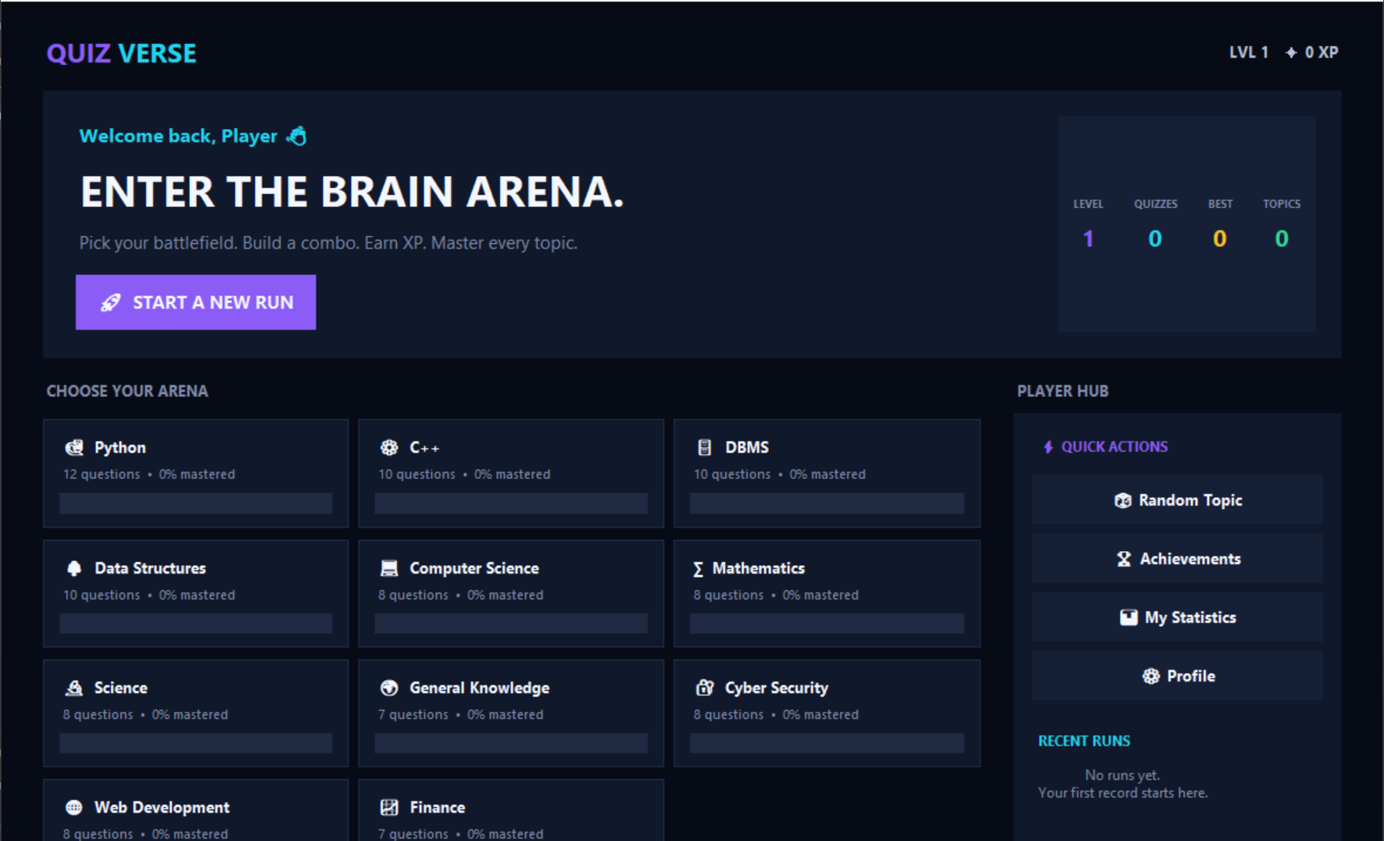
Figure 2: Quiz Application Home Screen

Question display, option selection and navigation
After a valid name is entered, the quiz screen is displayed. It shows the question counter, the progress bar, the question text and four radio-button options. Selecting an option and pressing Next stores the answer and displays the next question, while the counter and the progress bar advance. The Previous button is disabled on the first question, and going back to an earlier question shows the option selected earlier. On the last question the Next button changes to Submit.
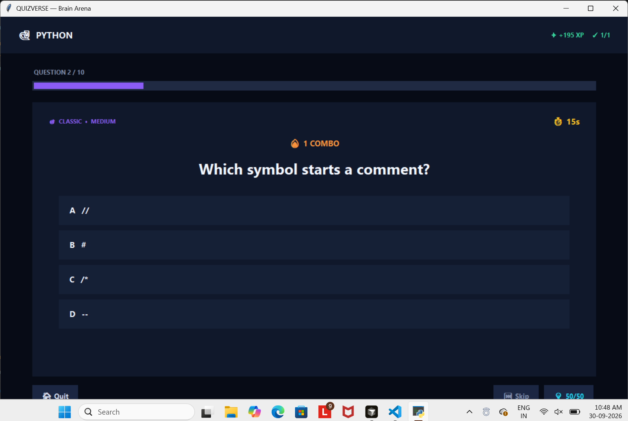
Figure 3: Question and Options Screen

Answer validation, score tracking and final result
When the quiz is submitted, the answers are compared with the stored correct options and the result screen is displayed. It shows the name of the user, the score in the form “Score: n / 10”, the percentage to one decimal place, the performance remark according to Table 1, and a scrollable answer review that marks each question as correct or incorrect and, for incorrect answers, shows the selected option and the correct option. The Restart Quiz button returns to the home screen with an empty name field and starts a new attempt in which the questions are shuffled again, and the Exit button closes the application.

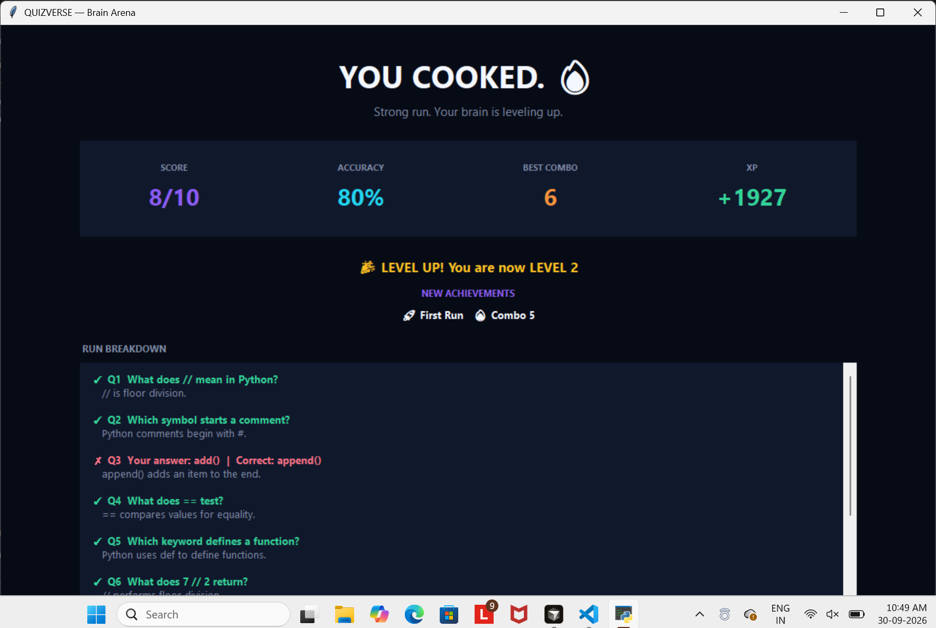

Functional testing
The functions of the application were checked with the test cases listed in Table 3, which also gives the expected behaviour of the application in each case.
Table 3: Functional Test Cases and Expected Behaviour

No. | Action / Input | Expected Behaviour
1 | Press Start Quiz with an empty name | Warning “Please enter your name.” is displayed; the start screen remains.
2 | Enter a name containing digits or symbols | Warning that the name should contain only letters and spaces; the start screen remains.
3 | Enter a name longer than 30 characters | Warning that the name should not exceed 30 characters.
4 | Enter a valid name and press Start Quiz | Quiz screen shows “Question 1 of 10”; the Previous button is disabled.
5 | Press Next without selecting an option | A message asks the user to select an option; the same question stays on the screen.
6 | Select an option and press Next | The answer is stored; the next question is shown and the counter and progress bar advance.
7 | Press Previous after answering a question | The earlier question is shown with the previously selected option restored.
8 | Reach the last question | The Next button is relabelled Submit.
9 | Answer 8 questions correctly and 2 incorrectly, then Submit | Result shows 8 / 10, 80.0% and “Excellent”; the review lists 8 correct and 2 incorrect questions.
10 | Press Restart Quiz | Start screen appears with an empty name field; a new attempt begins with the questions shuffled again.
11 | Press Exit | The application window closes.

Summary of Results
The application displays the questions one at a time, records the selected options, validates them against the stored answers, and reports the score, percentage, performance remark and a question-wise review at the end of the quiz. The input checks on the name field and on the selection of an option prevent an attempt from starting or continuing with missing data, and the restart function allows the quiz to be taken repeatedly.

Interpretation
Since the evaluation rule is a direct comparison with the stored answer, the score always follows exactly from the options selected, and the same answers always produce the same result. Presenting the correct answers only after submission keeps the quiz in the form of a test and uses the review for revision. The behaviour of the application also shows its limits: the question bank is small (ten questions), the questions are fixed in the source code, and a multiple-choice format can check the recognition of correct answers but not the ability to write an answer.

Achievement of Objectives
The project met its objectives. A Python-based application with a Tkinter interface was developed; an interactive multiple-choice environment with question counter, progress bar and navigation was provided; automated answer evaluation, score and percentage calculation were implemented; a performance remark and answer review were displayed; questions were organised in a list of dictionaries and shuffled for each attempt; and the code demonstrates the Python concepts listed in the objectives.

Implications
The application can be used by students for quick self-assessment of basic Python concepts and by instructors for a short objective test on a single computer. Because the code is compact and uses only the standard library, it can also be used as a starting point for learning GUI programming in Python and can be extended by adding questions or new features.

Mapping POs, PSOs and SDGs

Program Outcomes (POs) Mapping
Table 1: Mapping of Program Outcomes (POs) to Project Relevance
PO No. | Program Outcome | Relevance
PO1 | Engineering Knowledge | Applied programming fundamentals – classes, functions, dictionaries, lists, file handling and event-driven GUI concepts – to build a complete working application.
PO2 | Problem Analysis | Analysed the requirements of an engaging quiz tool and decomposed them into data loading, game logic, scoring, persistence and screen design.
PO3 | Design/Development of Solutions | Designed a layered, multi-screen application with four game modes, three difficulty levels, an XP and level system and a data-driven question bank.
PO4 | Conduct Investigations of Complex Problems | Tested the application with different topics, difficulties, modes and question counts, and handled invalid data and missing files through validation and exception handling.
PO5 | Engineering Tool Usage | Used Python, Tkinter/ttk, JSON, an Excel workbook and a self-written .xlsx parser built on zipfile and ElementTree.
PO8 | Individual and Collaborative Team work | Worked on coding, question-bank preparation and documentation as a team, and collaborated for reviews, improvements and testing.
PO9 | Communication | Presented results through clear screens, statistics and a question-by-question breakdown with explanations, and documented the design in this report.
PO11 | Life-Long Learning | Learned GUI programming, the Office Open XML file format and gamification concepts through self-study and hands-on coding.

Program Specific Outcomes (PSOs) Mapping
Table 2: Mapping of Program Specific Outcomes (PSOs) to Project Relevance
PSO No. | Program Specific Outcome | Relevance
PSO1 | Problem Solving and Software Development | Designed and implemented a complete multi-screen Python application of about 780 lines, using modular functions, classes and data structures to solve a real revision-tool problem.
PSO2 | Application Development using Modern Tools | Built a data-driven desktop application with Tkinter/ttk, JSON persistence and an Excel-based question bank without any external dependency.
PSO3 | Innovation and Career Readiness | Combined gamification (XP, levels, streaks, achievements) with an extensible architecture, showing product thinking that can grow into a full educational software product.

Sustainable Development Goals (SDGs) Mapping

Table 3: Mapping of Sustainable Development Goals (SDGs) to Project Relevance

SDG No. | Goal | Relevance
SDG 4 | Quality Education | The application provides an interactive, self-paced way to practise and revise any subject, with instant feedback and explanations that support quality education.
SDG 8 | Decent Work and Economic Growth | Builds programming, problem-solving and software-development skills that improve employability in IT and technology-driven industries.
SDG 9 | Industry, Innovation and Infrastructure | Promotes innovation in educational software by combining gamification, data-driven design and a modular, extensible architecture.

Conclusion

This project successfully implemented QuizVerse – Brain Arena, a gamified desktop quiz application in Python and Tkinter. The system loads its questions from an Excel workbook, lets the player choose the topic, difficulty, length and game mode, runs timed questions with 50/50 and Skip lifelines, and rewards the player with XP, levels and achievements. Player statistics and topic mastery are stored in a JSON profile, so progress continues across sessions. The project shows how data-driven design, event-driven programming and simple game mechanics can turn routine revision into an engaging activity.

For future enhancements, the application can be extended with a question editor inside the GUI, image and code-snippet questions, a usage limit for lifelines, online or LAN multiplayer with leaderboards, and sound effects. Additional features such as spaced-repetition scheduling of missed questions, import from CSV or Google Sheets, a web or mobile version and teacher dashboards with class-wide analytics would further increase its educational value.

Bibliography

Online Resources
- Python Software Foundation – tkinter: Python interface to Tcl/Tk. https://docs.python.org/3/library/tkinter.html
- Python Software Foundation – tkinter.ttk: Tk themed widgets. https://docs.python.org/3/library/tkinter.ttk.html
- Python Software Foundation – zipfile: Work with ZIP archives. https://docs.python.org/3/library/zipfile.html
- Python Software Foundation – xml.etree.ElementTree: The ElementTree XML API. https://docs.python.org/3/library/xml.etree.elementtree.html
- Python Software Foundation – json: JSON encoder and decoder. https://docs.python.org/3/library/json.html
- Ecma International – ECMA-376: Office Open XML file formats. https://ecma-international.org/publications-and-standards/standards/ecma-376/
- GeeksforGeeks – Python GUI – tkinter. https://www.geeksforgeeks.org/python-gui-tkinter/

Research article references
- Deterding, S., Dixon, D., Khaled, R., & Nacke, L. (2011). From game design elements to gamefulness: defining “gamification”. Proceedings of the 15th International Academic MindTrek Conference, 9–15.
- Hamari, J., Koivisto, J., & Sarsa, H. (2014). Does gamification work? A literature review of empirical studies on gamification. Proceedings of the 47th Hawaii International Conference on System Sciences, 3025–3034.
- Roediger, H. L., & Karpicke, J. D. (2006). Test-enhanced learning: Taking memory tests improves long-term retention. Psychological Science, 17(3), 249–255.
- Lutz, M. (2013). Learning Python (5th ed.). O’Reilly Media.

