MINI PROJECT REPORT
ON
PARKING MANAGEMENT SYSTEM
(Database Design and Management)

Submitted in partial fulfilment of the requirements
for the course / subject: Database Management System

Submitted by
Name: ______________________________
Roll No.: ___________________________
Class / Division: _____________________

Under the guidance of
Faculty Name: ________________________

Department of _________________________
College / Institute: ____________________
Academic Year: 2026–2027

Abstract
The Parking Management System is a database-oriented mini project designed to organize customer, vehicle, parking-slot, and parking-session information in a structured way. The system records vehicle entry and exit, associates each parking record with a vehicle and a parking slot, and supports the identification of currently available slots. The database design uses four core entities—Customer, Vehicle, Parking_Slot, and Parking_Record—with primary keys, foreign keys, and integrity constraints to maintain consistent data. Two supporting views, Parking_Details and Available_Slots, simplify common queries. This report presents the project overview, entity-relationship diagram, relational table schema, applications, future improvements, conclusion, references, and a sample execution snapshot.

1. Introduction
Parking facilities often need to track many vehicles, customers, spaces, and parking sessions. Manual registers can lead to duplicate entries, slow searches, inaccurate fee calculations, and difficulty identifying vacant spaces. A database-backed Parking Management System helps centralize this information and makes it easier to retrieve and update records.
The proposed database is named parking_management and is illustrated for MySQL 5.5. It stores customer contact details, vehicle identifiers, slot information, and parking-session timestamps. The schema is intended as a foundational academic model; a production deployment would also need transaction handling, user authentication, operational rules, and stronger validation of overlapping bookings.

Objectives
- Maintain customer and vehicle information in related tables.
- Track vehicle entry and exit times and store parking duration and fee.
- Identify available parking slots through a view or query.
- Use keys and constraints to reduce duplicate and inconsistent records.
- Provide a clear database structure that can be extended into a complete application.

2. ER Diagram
The Entity-Relationship (ER) diagram describes the entities, their attributes, and the relationships between them. Underlined attributes represent primary keys. Foreign-key attributes connect the related entities.
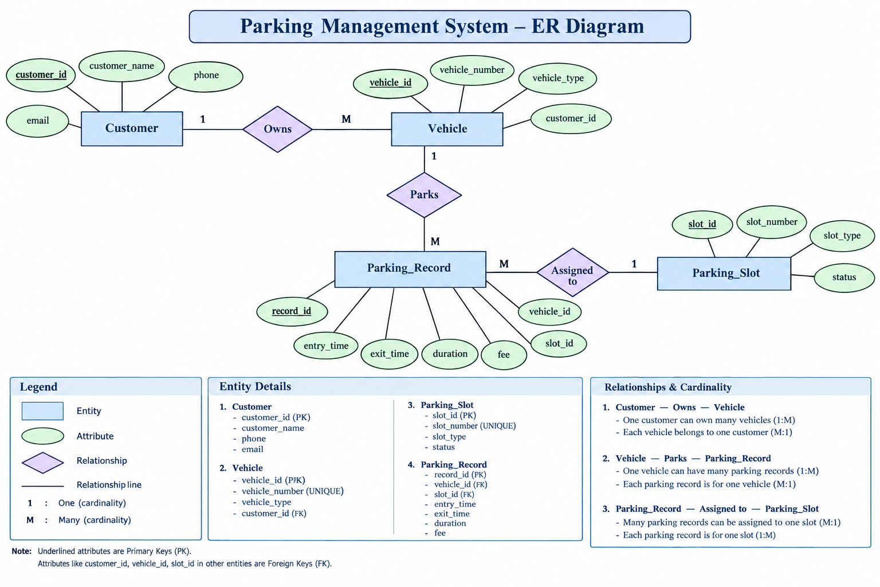
Figure 1. Entity-Relationship diagram of the Parking Management System.

Entities and relationships
- Customer — Vehicle (Owns): one customer can own many vehicles; each vehicle is associated with one customer (1:M).
- Vehicle — Parking_Record (Parks / Generates): one vehicle can have multiple parking records over time; each record refers to one vehicle (1:M).
- Parking_Slot — Parking_Record (Assigned to): one slot can appear in many parking records over time; each parking record refers to one slot (1:M from slot to records).

3. Table Schema
The schema translates the ER model into relational tables. PK means Primary Key, FK means Foreign Key, and NULL indicates that a value may be absent. NOT NULL requires a value.
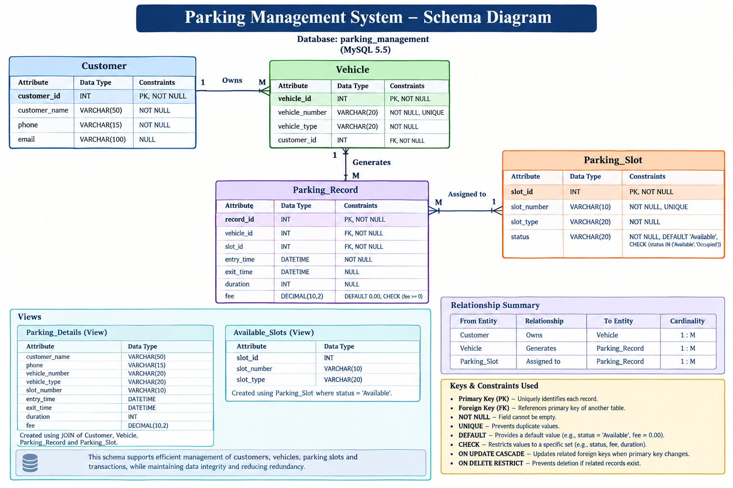
Figure 2. Database schema, including tables, relationships, views, and constraints.

3.1 Table definitions

Customer
Attribute | Data Type | Constraints
customer_id | INT | PK, NOT NULL
customer_name | VARCHAR(50) | NOT NULL
phone | VARCHAR(15) | NOT NULL
email | VARCHAR(100) | NULL

Vehicle
Attribute | Data Type | Constraints
vehicle_id | INT | PK, NOT NULL
vehicle_number | VARCHAR(20) | NOT NULL, UNIQUE
vehicle_type | VARCHAR(20) | NOT NULL
customer_id | INT | FK → Customer.customer_id, NOT NULL

Parking_Slot
Attribute | Data Type | Constraints
slot_id | INT | PK, NOT NULL
slot_number | VARCHAR(10) | NOT NULL, UNIQUE
slot_type | VARCHAR(20) | NOT NULL
status | VARCHAR(20) | NOT NULL, DEFAULT 'Available'; CHECK in Available/Occupied

Parking_Record
Attribute | Data Type | Constraints
record_id | INT | PK, NOT NULL
vehicle_id | INT | FK → Vehicle.vehicle_id, NOT NULL
slot_id | INT | FK → Parking_Slot.slot_id, NOT NULL
entry_time | DATETIME | NOT NULL
exit_time | DATETIME | NULL
duration | INT | NULL
fee | DECIMAL(10,2) | DEFAULT 0.00; CHECK fee >= 0

3.2 Views
Parking_Details (View): combines customer, vehicle, parking-record, and slot details using joins. Typical columns include customer_name, phone, vehicle_number, vehicle_type, slot_number, entry_time, exit_time, duration, and fee.
Available_Slots (View): lists slot_id, slot_number, and slot_type for rows where status = 'Available'. This helps an operator find vacant spaces quickly.

3.3 Keys and constraints
- PRIMARY KEY: uniquely identifies each row in a table.
- FOREIGN KEY: links a row to a valid row in another table.
- NOT NULL: prevents required fields from being left empty.
- UNIQUE: prevents duplicate values such as vehicle numbers and slot numbers.
- DEFAULT: supplies a value when one is not explicitly provided.
- CHECK: restricts values to an allowed range or set where supported by the database version.
- Referential actions: foreign-key update/delete rules should be selected to protect related records.
Implementation note: CHECK-constraint enforcement differs by MySQL version. Since this schema is labelled MySQL 5.5, validate the status and fee rules in application logic or triggers if the database engine does not enforce the specified CHECK constraints.

4. Application
The system can be used in places where vehicles enter and leave controlled parking areas, including:
- Shopping malls and commercial complexes.
- Colleges, universities, hospitals, and office campuses.
- Apartment complexes and residential societies.
- Public and private parking facilities.
- Small parking operators who need entry/exit history and fee records.

Benefits
- Faster retrieval of customer, vehicle, and parking details.
- Improved visibility of available parking spaces.
- Reduced duplication through unique constraints.
- Better record keeping for parking duration and fees.
- A normalized structure that can be expanded as requirements grow.

5. Future Improvements
- Develop a web or mobile interface for customers and parking staff.
- Add automatic fee calculation based on configurable hourly or daily rates.
- Integrate QR codes, RFID, number-plate recognition, or entry-gate sensors.
- Prevent simultaneous allocation of the same slot using transactions and concurrency controls.
- Add payment-gateway support and digital receipts.
- Create dashboards for occupancy, peak hours, revenue, and usage reports.
- Implement role-based access, audit logs, backups, and secure handling of personal data.
- Add reservations and notifications for upcoming or expiring parking sessions.

6. Conclusion
The Parking Management System provides a clear relational database model for managing customers, vehicles, parking spaces, and parking sessions. The ER diagram defines the entities and their relationships, while the schema specifies the attributes, data types, keys, and constraints. The two views make parking details and available slots easier to query. With a user interface, transaction-safe slot allocation, fee automation, and secure payment integration, the model can be extended into a more complete real-world parking solution.

7. References
- Oracle. MySQL 5.5 Reference Manual — SQL Statements, Data Types, and Constraints. https://dev.mysql.com/doc/
- Elmasri, R. and Navathe, S. B. Fundamentals of Database Systems. Pearson.
- Silberschatz, A., Korth, H. F., and Sudarshan, S. Database System Concepts. McGraw-Hill.
- Project diagrams supplied for this report: Parking Management System ER Diagram and Schema Diagram.

8. Snapshot of Execution
The following screenshots were captured from the MySQL command-line interface during execution of the Parking Management System queries. They show table structures, stored records, joins, aggregate functions, availability checks, revenue summaries, and an update operation.
Snapshot 1. Table structures and vehicle records (DESC and SELECT commands).
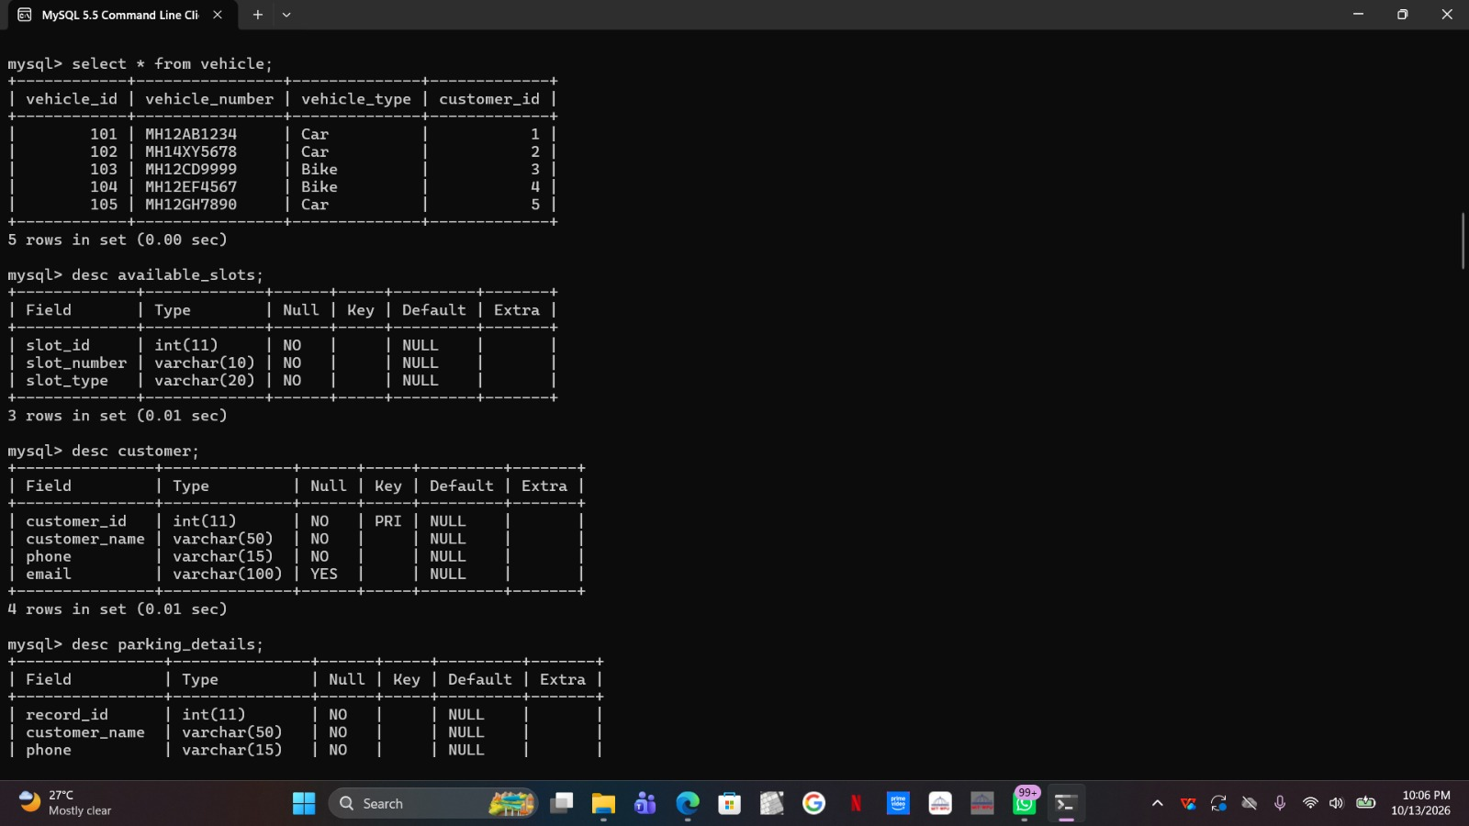

Snapshot 2. Displaying parking details, parking records, and parking-slot status.
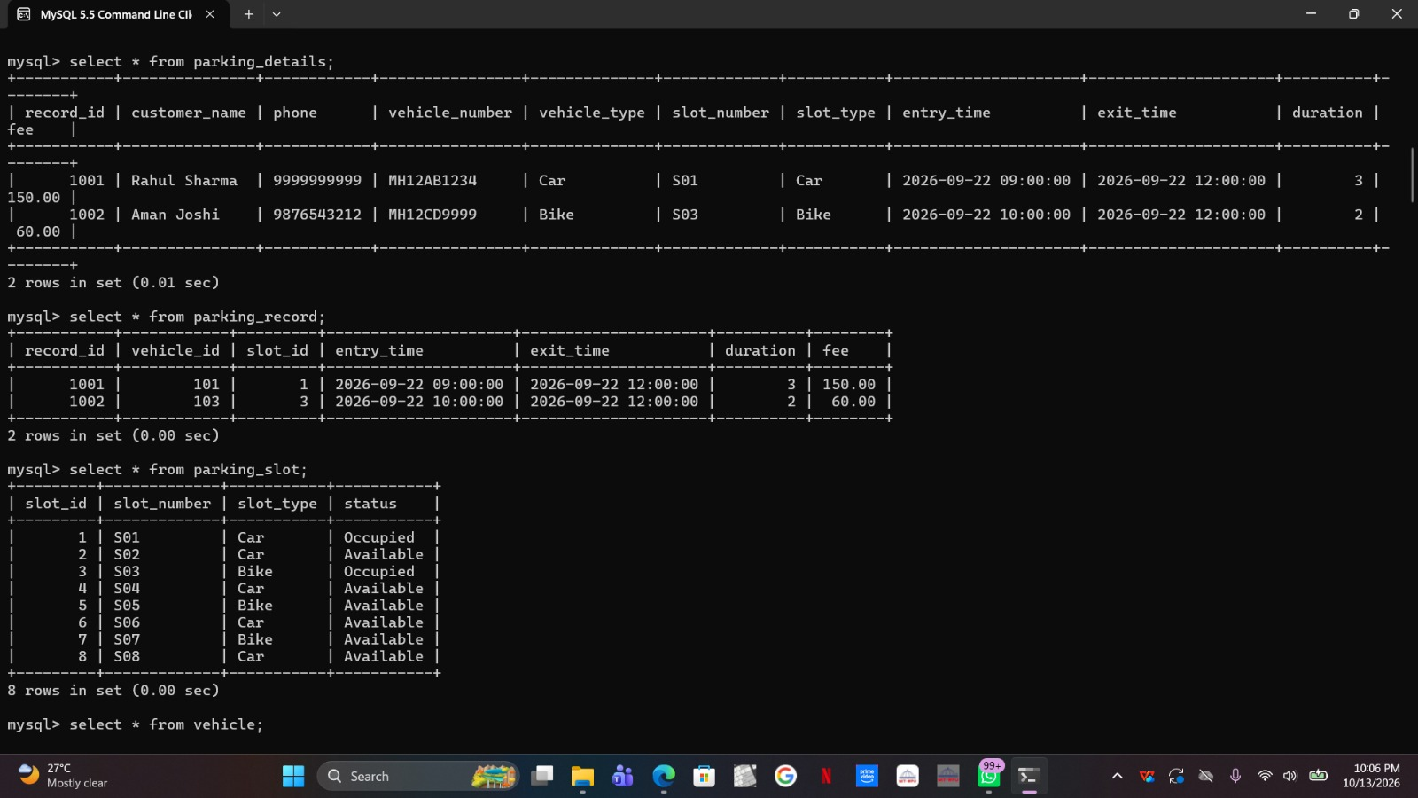

Snapshot 3. JOIN query showing customer, vehicle, slot, entry time, duration, and fee for records with fee above 50.
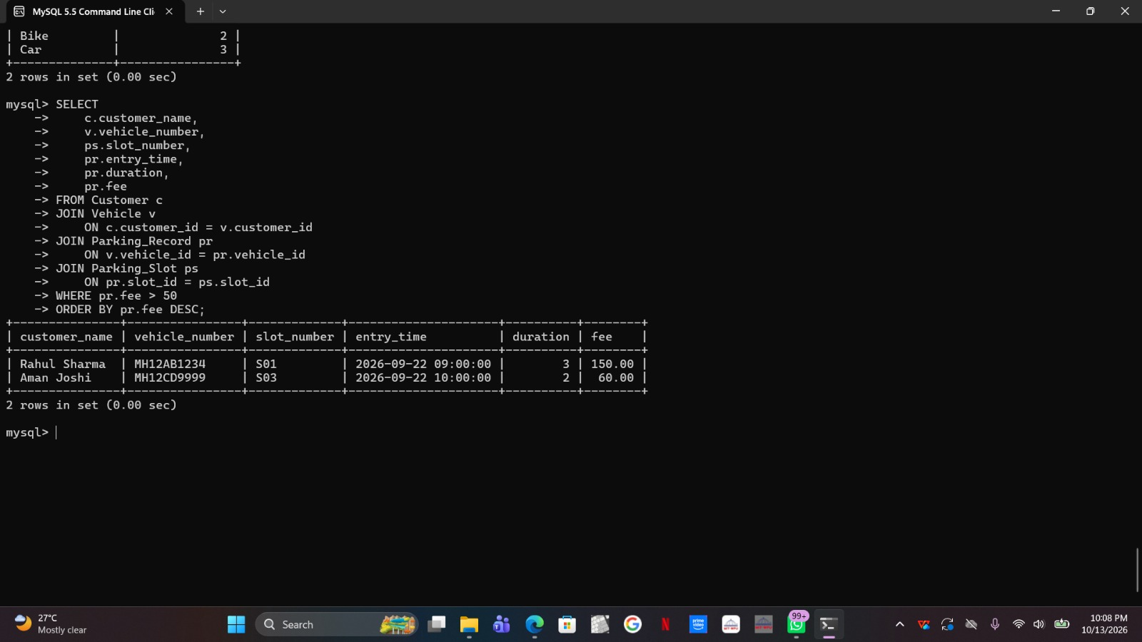

Snapshot 4. Aggregate queries: highest fee, slot counts by status, and vehicle counts by type.
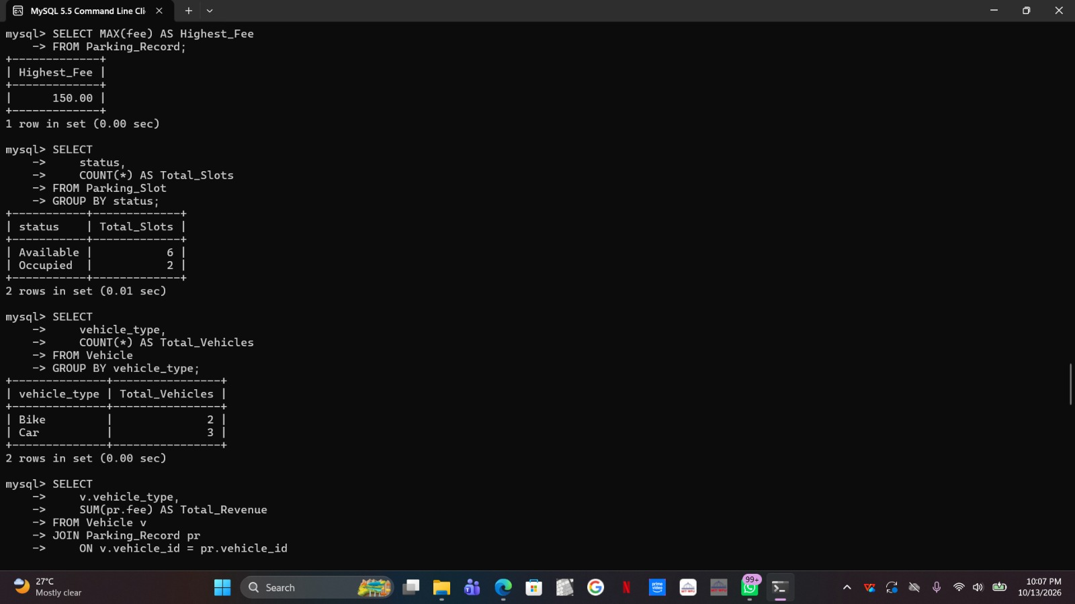

Snapshot 5. Available-slot view and HAVING query for vehicle types with more than one vehicle.
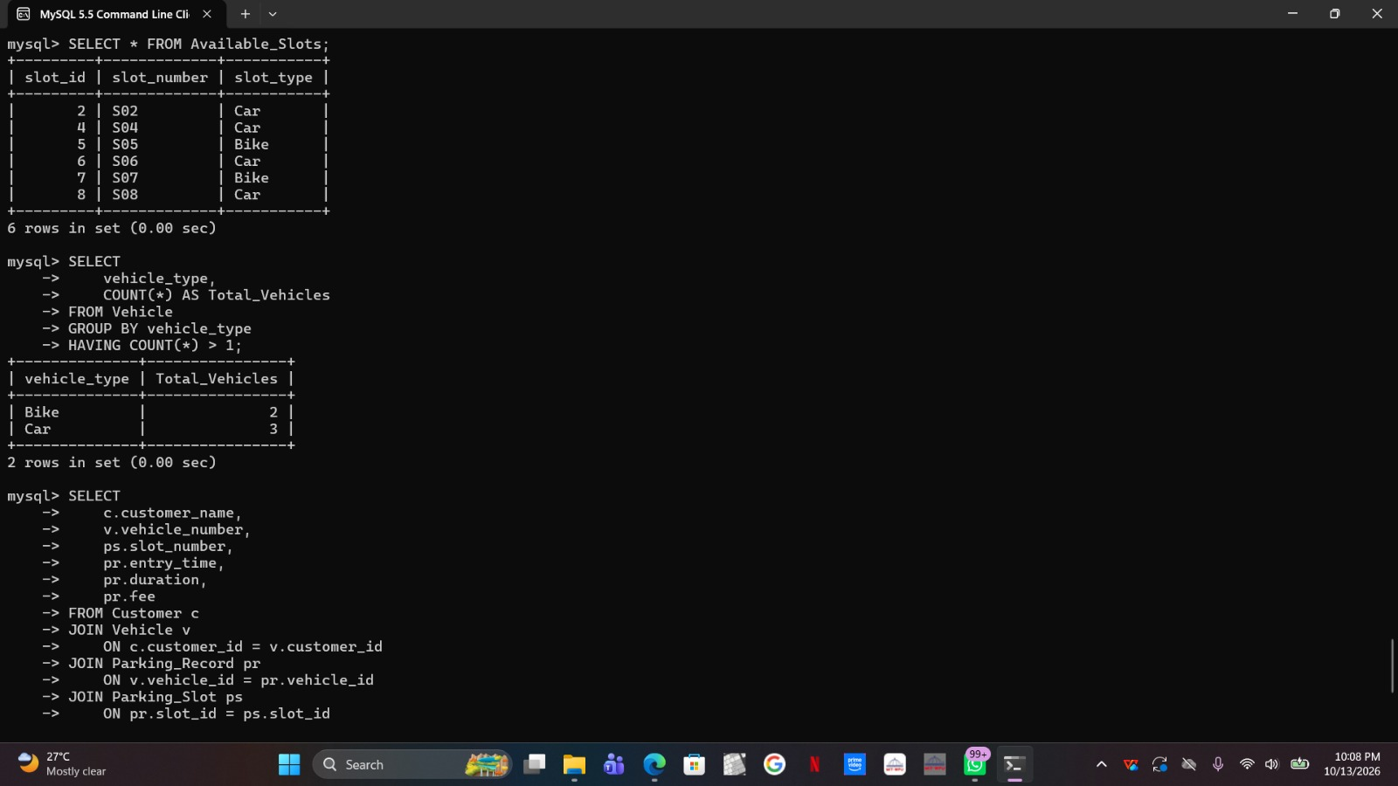

Snapshot 6. Revenue grouped by vehicle type, fee sorting, and parking-slot lookup.
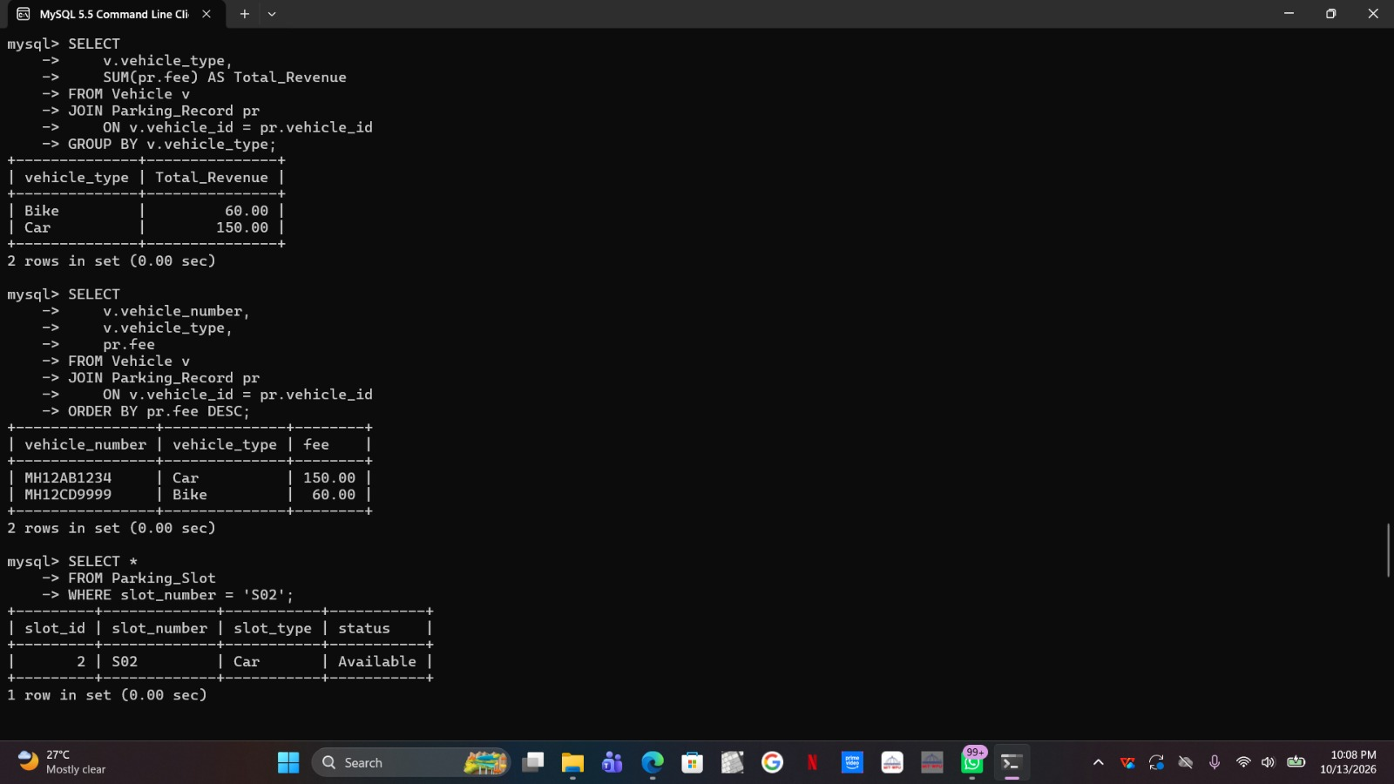

Snapshot 7. Updating slot S02 status and verifying the updated slot and parking details.
