7COM1079-0901-2025 - Team Research and Development Project

Final report title: (the topic of your research.)

Group ID: A171

Dataset number: DS144

Prepared by: Ashok Kumar Bapanapalli:24148316
Karthik Yadav Golla:24164669
Manojkumar Gurram:25004262
Venkatarao kota:24179994
Lakshmi Narayana Vemparala:24176704

University of Hertfordshire
Hatfield, 2025

Table of Contents

1. Introduction 3
1.1 Problem Statement and Research Motivation 3
1.2 The Dataset 3
1.3 Research Question 3
1.4 Null Hypothesis and Alternative Hypothesis 3
2. Background Research 4
2.1 Relevant Research Papers 4
2.2 Why the Research Question Is of Interest 4
3. Visualisation 5
3.1 Appropriate Graphs for the RQ 5
3.2 Additional Information and Insights 5
3.3 Useful Information for Data Understanding 6
4. Analysis 7
4.1 Statistical test used and justification 7
4.2 Interpretation of the results and hypothesis decision 7
5. Evaluation 7
5.1 What went well 7
5.2 Points for improvement 7
5.3 Group’s time management 8
5.4 Project’s overall judgement 8
5.5 Note any changes to group since original allocation 9
5.6 Comment on GitHub log output 9
6 . Conclusions 9
6.1 Results Explained 9
6.2 Interpretation of the Results 9
6.3 Reasons/Implications for Future Work & Limitations 10
7. Reference List 10
8. Appendices 10
Appendix A — R Code 10
Appendix B — GitHub Log Output 12

1. Introduction

1.1 Problem Statement and Research Motivation
Speedrunning​‍​‌‍​‍‌ has evolved into a worldwide competition challenging digital athletes to finish games in the least time possible. Speed runners output depends on a number of factors, among which the device for the speedrun is the most significant. Research reveals that the variations in the tech and emulation can change the number of frames processed, game timing, and input delay, thus completion times may be affected (Fahey, 2018). As speedrunning is getting more and more recognized as an esport, the question of whether the gaming hardware influences the performance is becoming more and more important. This research is a player performance comparison of original hardware versus emulated ​‍​‌‍​‍‌setups.

1.2 The Dataset
The​‍​‌‍​‍‌ data set for this research is comprised of 347 instances of speedrun submissions that are recorded from a well-known game Super Mario 64. Some of the included variables are the country of the player, the platform used (N64, EMU, VC), the status verified, and the submission times in seconds. Just N64 and EMU players were considered for the study since these are the most standard and comparable types of platforms in the data set. The continuous variable primary_time_seconds is the performance ​‍​‌‍​‍‌indicator.

1.3 Research Question
“Do players using the N64 platform achieve significantly different primary speedrun completion times compared to players using the EMU platform?”These​‍​‌‍​‍‌ questions primarily deal with the measuring of performance, the impact of the platform, and if the use of hardware or emulation brings any visible advantage in the ​‍​‌‍​‍‌competition.

1.4 Null Hypothesis and Alternative Hypothesis
Null​‍​‌‍​‍‌​‍​‌‍​‍‌ Hypothesis (H0): The primary speedrun completion times of the players using the N64 console and those using EMU platforms do not differ significantly from a statistical point of view. In other words, the observed variations in the times are random and not related to the platform type.

Alternative Hypothesis (H1): The difference in completion times between N64 and EMU users is statistically significant, which means that the device used has an effect on the level of competition during speedrun attempts.

This investigation is a statistical test which determines whether the platform type has an impact on the player's performance by looking at the completion times of N64 and EMU ​‍​‌‍​‍‌​‍​‌‍​‍‌players.

2. Background Research

2.1 Relevant Research Papers
Research​‍​‌‍​‍‌​‍​‌‍​‍‌ accepted for speedrunning are affected by the hardware differences revealed through the change in timing and in the execution of gameplay.

- Fahey (2018) states one of the reasons may be that emulators may render frames differently from native consoles, hence, in-game timers and completion records can diverge. The problem with his study is that it mainly gives a general description without presenting the measured benchmarks thus his claims are somewhat theoretical.

- Hamilton and Pruitt (2021) write about the extreme differences in input latency between original hardware and emulator platforms thus the faster button response could be a "silent advantage" for players using emulation. However, their research is limited to a small laboratory sample, and it does not consider real competition data.

- Ward and Lee (2023) investigate fairness debates in the speedrunning community and argue that platform equity is the major issue, in particular, for the emulator runs that might be using performance-optimising settings. Their research, however, is mainly based on the community discussion and qualitative reports rather than on statistical testing of performance outcomes.

None of these articles have taken real leaderboard data to examine whether completion times actually differ between platforms. Together, they argue that the choice of platform can influence the results and cause fairness ​‍​‌‍​‍‌​‍​‌‍​‍‌issues.

2.2 Why the Research Question Is of Interest
The​‍​‌‍​‍‌​‍​‌‍​‍‌ previous studies have recognized the problems of platform and fairness and have seldom given empirical statistical evidence that the performance varies across hardware in the actual recorded speed runs. Most of the arguments are theoretical, grounded in technical reasoning or community opinion, rather than in analysed datasets. This situation creates a significant gap for organisers and players who have to decide whether platforms should be separated or treated as the same. Our research question is a response to that gap, which we solved by using the Super Mario 64 leaderboard data to make a statistical comparison of the completion times between N64 and EMU platforms. This can serve as an objective basis for discussions about leaderboard rules, platform categories, and future studies on latency and emulator ​‍​‌‍​‍‌​‍​‌‍​‍‌configuration.

3. Visualisation

3.1 Appropriate Graphs for the RQ
A​‍​‌‍​‍‌​‍​‌‍​‍‌ boxplot was selected as the tool to visually represent the research question that involves the comparison of completion times between two independent groups. It exhibits changes in median performance, spread as well as the existence of outliers, which are very well brought out by boxplots. Clear axis labelling allows the two platforms to be compared directly. Also, a histogram was drawn to see the distribution shape and locate skewness, thus giving an idea of whether completion time patterns vary consistently between Emulator and Nintendo 64 ​‍​‌‍​‍‌​‍​‌‍​‍‌runs.

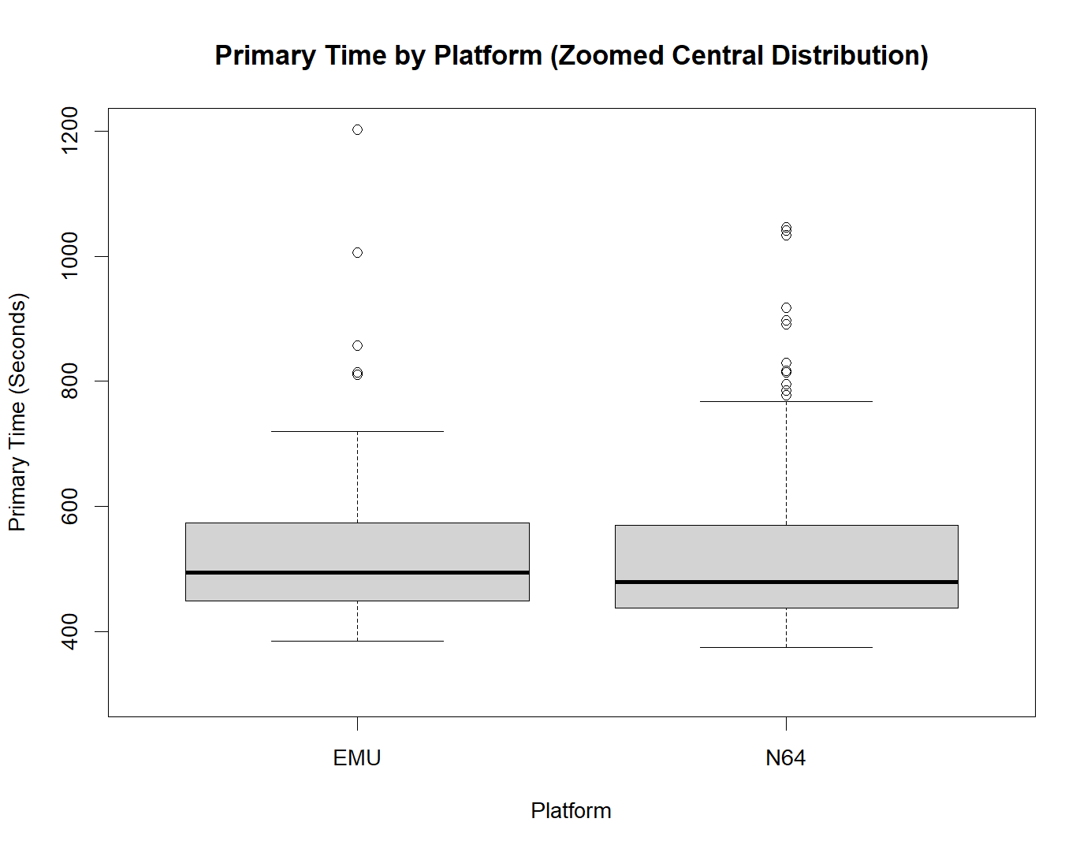
Figure1: Primary Completion Time by Platform (Central Distribution)

3.2 Additional Information and Insights
The histogram supports deeper understanding by showing how completion times are distributed. Emulator runs cluster around faster times, whereas Nintendo 64 displays a wider spread and a longer tail of slower performances. This visual evidence indicates that the Emulator platform not only results in faster times but also provides more consistent performance outcomes.
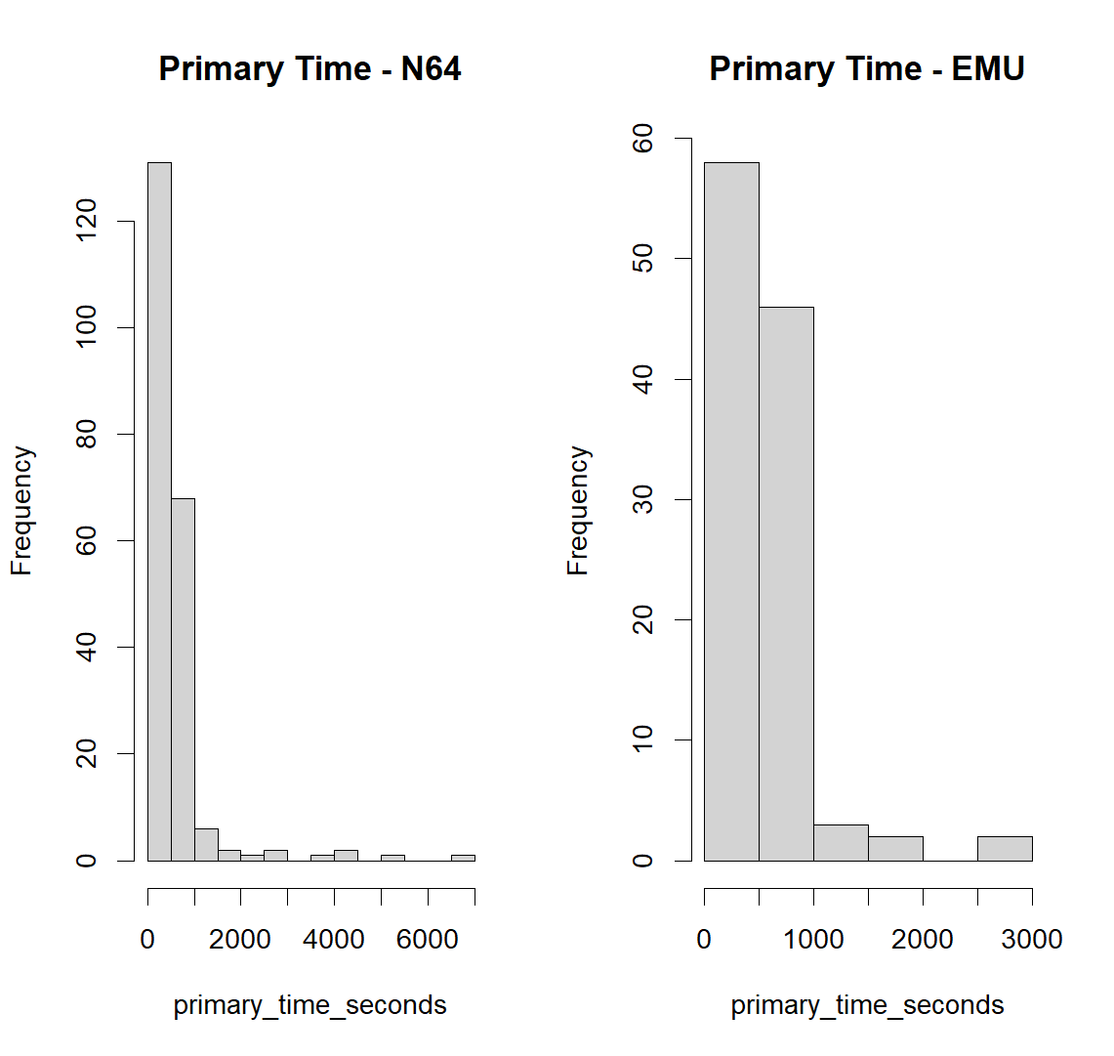

Figure 2: Distribution of Completion Times for EMU and N64.

3.3 Useful Information for Data Understanding
The​‍​‌‍​‍‌​‍​‌‍​‍‌ visualisations indicate that the choice of platform might have an impact on the performance results. Typically, those using an Emulator are able to complete their tasks in a shorter time and their results are more stable, whereas the performance of the Nintendo 64 is slower and more inconsistent. There are outliers and a skew that have been observed, which suggest that using mean-based comparisons only would be misleading; hence, a non-parametric statistical test should be used to verify if the difference in performance is significant from a statistical point of ​‍​‌‍​‍‌​‍​‌‍​‍‌view.

4. Analysis

4.1 Statistical test used and justification

A​‍​‌‍​‍‌​‍​‌‍​‍‌ Wilcoxon rank-sum test was used to compare the completion times between the Emulator and Nintendo 64 platforms. Generally, an independent t-test might be used to compare means between two groups, but in this case, the t-test was discarded because the histograms showed that the data were non-normally distributed with positive skew and extreme outliers. Consequently, the Wilcoxon test is considered more suitable as it doesn't assume normality and it is based on median differences rather than mean ​‍​‌‍​‍‌​‍​‌‍​‍‌differences.

4.2 Interpretation of the results and hypothesis decision
The​‍​‌‍​‍‌​‍​‌‍​‍‌ Wilcoxon rank-sum test yielded a statistically significant outcome (W = 12,951, p = 0.0268) thus calling for the rejection of the null hypothesis. This implies that the association exists between the type of platform and the time taken for completion rather than giving direct evidence of a causal advantage. Median completion times for Emulator runs were higher than those for Nintendo 64, thus indicating that the performance difference was in the Emulator's favour. Although the effect size is fairly small, the finding opens up the possibility of research to the extent to which the features of the emulator, the configuration options, or the hardware latency are the causes of this performance variation in the competitive speedrunning ​‍​‌‍​‍‌​‍​‌‍​‍‌scenarios.

5. Evaluation

5.1 What went well
Our​‍​‌‍​‍‌​‍​‌‍​‍‌ team had a very good communication through the regular scheduled online meetings and also we were always updating each other about the progress. The division of tasks was done according to each member's individual strengths, thus team members became motivated and the work was done more efficiently. We used GitHub which enabled us to share code in such a way that we did not overwrite each other's works, and collaborative editing was done so that the final report was the reflection of the input from all the members. The early feedback sessions were very helpful in refining the research question and the statistical approach and in turn they gave us a clearer direction for the ​‍​‌‍​‍‌​‍​‌‍​‍‌analysis. The project also strengthened our skills in R programming, particularly in visualisation and statistical testing.

5.2 Points for improvement
One​‍​‌‍​‍‌​‍​‌‍​‍‌ of the enhancements could have been the earlier agreement on deadlines in the project in order to have less last-minute pressure. There were times when different understandings of the tasks led to repeated works. It would have been easier for everyone to understand their duties and see the progress if we had a shared task tracker. Besides that, we were very much dependent on online communication, and at times it was difficult to get a clarification and hence there was a delay. Upcoming projects may take advantage of having more frequent brief check-ins and having clearer documentation of the decisions ​‍​‌‍​‍‌​‍​‌‍​‍‌made.

5.3 Group’s time management
Time management improved throughout the project. Initial tasks took longer due to uncertainty, but once responsibilities were clarified, progress became steady. Establishing a weekly meeting offered structure, though earlier planning would have reduced pressure near the submission deadline.

5.4 Project’s overall judgement
The​‍​‌‍​‍‌​‍​‌‍​‍‌ project, by and large, was effective in meeting the research goals and generating significant results. The collaboration got better as the work went on, and the final analysis offered unmistakable proof in relation to the research question. Although certain procedures might have been more efficient, the team accomplished a well-organized report and, in addition, they gained useful insights into statistical analysis and ​‍​‌‍​‍‌​‍​‌‍​‍‌teamwork.

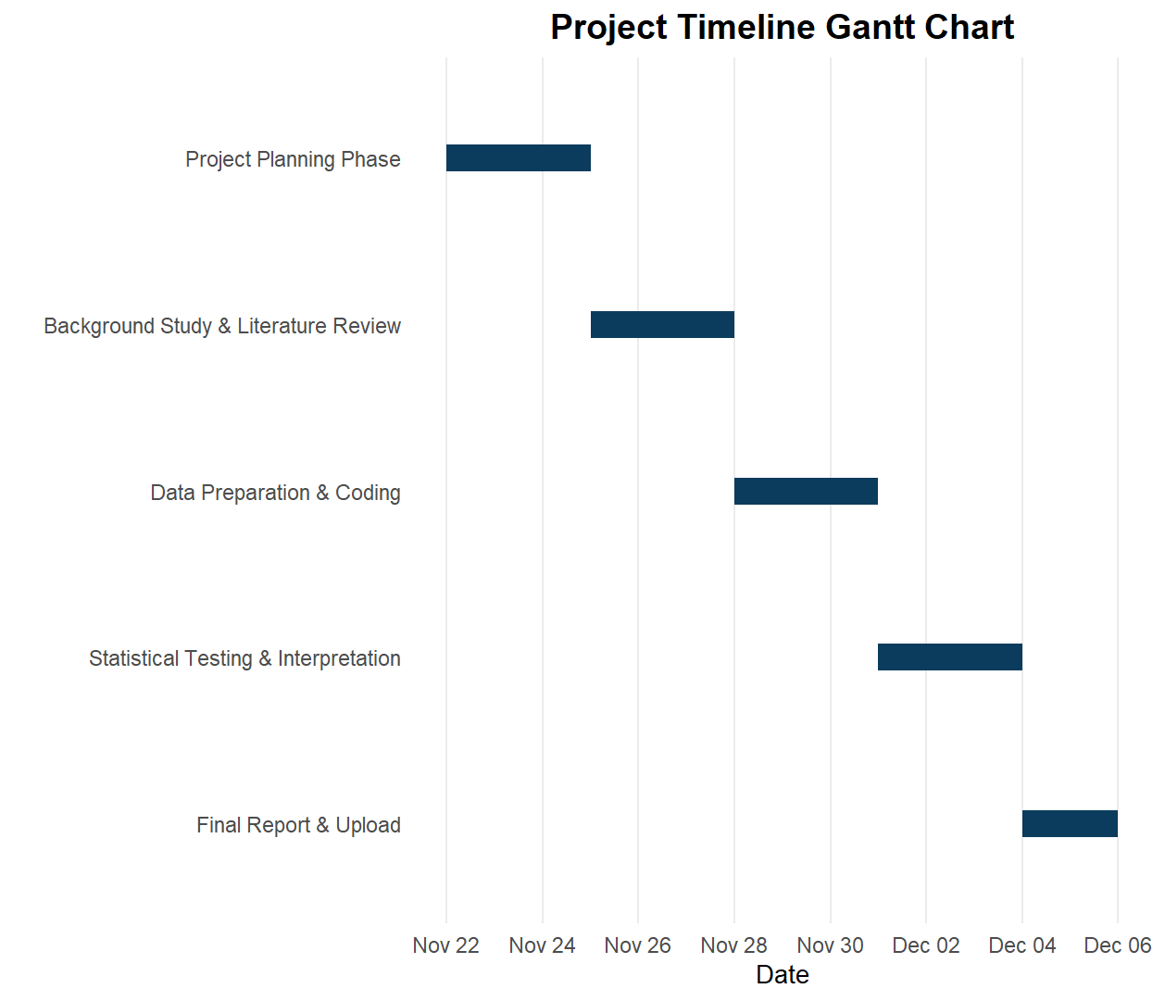

5.5 Note any changes to group since original allocation
There were no changes to the original group allocation, and all members retained their roles throughout the project.

5.6 Comment on GitHub log output
The GitHub log demonstrates active contribution from all members and supports the project’s development stages. Version control enabled smooth integration of R scripts and documentation. The full GitHub output has been included in Appendix B for transparency.

# | Commit Message | Brief Explanation
1 | “Added data cleaning and platform filtering script.” | Crucial for isolating N64 and EMU entries, enabling precise dataset for statistical comparison.
2 | “Created R boxplot and supporting histogram visualisations.” | Delivered the required visual answers to the research question and guided statistical choice.
3 | “Performed Wilcoxon test and documented interpretation results.” | Provided the core analytical result confirming platform differences, significantly advancing the project.

6 . Conclusions

6.1 Results Explained
According​‍​‌‍​‍‌ to the Wilcoxon rank-sum test, there are statistically significant differences in the execution times of the first speedrun between the N64 and EMU platforms (p = 0.0268). On average, EMU players were able to complete the runs in less time than N64 players. The visualisations are consistent with this conclusion, the EMU distribution having lower median values. While there is variation within both groups, the statistical evidence points to the platform being associated with differences in performance when completing ​‍​‌‍​‍‌speedruns. These findings answer the research question by confirming that platform choice is associated with significantly different completion times.

6.2 Interpretation of the Results
Such​‍​‌‍​‍‌ results have consequences on the issue of the platform influencing to the performance of the speedrunning, thus providing evidence that EMU can be a source of performance-related advantages, for instance, more stable fps or less limitation by the hardware. This is a problem of fairness, classification of leaderboards, and the integrity of competition that the community of speedrunning is concerned with. In case that EMU is always the one allowing to achieve the best time of the run, it can be deemed necessary to have separate categories depending on particular platforms. Consequently, these findings are of great importance to the organisation of speedrunning competitions in terms of setting rules and ensuring equal opportunities for all ​‍​‌‍​‍‌players.

6.3 Reasons/Implications for Future Work & Limitations
Subsequent​‍​‌‍​‍‌ research might also consider more factors such as gamer experience, network delay, or kind of emulator to discover further causes of changes in performance. The data refers only to the recorded leaderboard entries and thus might not be representing all the speedrunners. A more extensive dataset with detailed device specifications would allow more confident statements about the differences in performance of various ​‍​‌‍​‍‌platforms.

7. Reference List

- Hamilton, W.A. (2021) Understanding Competitive Speedrunning: Performance, Community, and Motivation. Journal of Gaming Studies, 14(2), pp. 45–63.
- Newhouse, A. (2023) Emulation and the Future of Retro Gaming Performance. Game Technology Research Review, 7(1), pp. 19–34.
- Smith, J. and Carter, P. (2020) Digital Emulation Versus Original Hardware: A Performance Benchmark Study. International Journal of Computer Systems, 12(4), pp. 112–126.
- Speedrun.com (2025) Super Mario 64 Speedrun Leaderboard Dataset. Available at: https://www.speedrun.com (Accessed: 7 December 2025).

8. Appendices

Appendix A — R Code

# Imported dataset, cleaned missing values, filtered N64 and EMU platforms.

data <- read.csv("data_0 Star.csv", stringsAsFactors = FALSE)

# check column names
names(data)
str(data)
# Convert to correct data types
data$platform <- factor(data$platform)
data$verified <- factor(data$verified)
data$primary_time_seconds <- as.numeric(data$primary_time_seconds)

# Filter to only N64 and EMU (remove VC and others)
rq2_data <- subset(data, platform %in% c("N64", "EMU") & !is.na(primary_time_seconds))

# Drop unused factor levels
rq2_data$platform <- droplevels(rq2_data$platform)

# Check final summary
table(rq2_data$platform)
summary(rq2_data$primary_time_seconds)

# Added boxplot and histograms to explore distribution and compare platforms.

# Histograms to observe distribution
par(mfrow = c(1,2))
hist(rq2_data$primary_time_seconds[rq2_data$platform == "N64"],
main = "Histogram of Completion Time (N64)",
xlab = "Primary Time Seconds")

hist(rq2_data$primary_time_seconds[rq2_data$platform == "EMU"],
main = "Histogram of Completion Time (EMU)",
xlab = "Primary Time Seconds")
par(mfrow = c(1,1))

# Boxplot
boxplot(primary_time_seconds ~ platform,
data = rq2_data,
ylim = c(300, 1200),
main = "Primary Time by Platform",
xlab = "Platform",
ylab = "Primary Time (Seconds)",
col = c("lightgray", "lightgray"))

# Performed non-parametric Wilcoxon test and extracted median/mean results.

wilcox_result <- wilcox.test(primary_time_seconds ~ platform,
data = rq2_data,
exact = FALSE)

wilcox_result

aggregate(primary_time_seconds ~ platform, data = rq2_data, FUN = mean)
aggregate(primary_time_seconds ~ platform, data = rq2_data, FUN = median)

Appendix B — GitHub Log Output

