SG Airlines End-to-End Data Engineering Case Study
Project Documentation
Name : Parasaram R N V Rajyalakshmi
Date : 10/09/2026
Technology stack: Azure Blob Storage | Azure Data Factory | Power BI
Project Overview
1. Data Pipeline Implementation
The complete data pipeline was implemented using Microsoft Azure services, primarily Azure Blob Storage and Azure Data Factory.
The overall flow of the pipeline is:
- Source Excel File
- Azure Blob Storage – Raw Layer
- Azure Data Factory
- Mapping Data Flow
- Cleaning , Transformation , Validation
- Azure Blob Storage – Clean Layer
- clean_flights.csv
- Power BI
The original airline Excel workbook was uploaded to the raw container in Azure Blob Storage. Azure Data Factory was then configured to access the source file using a Blob Storage linked service.
An Excel dataset named Raw_Flights was created in Azure Data Factory and configured to read the flights worksheet.
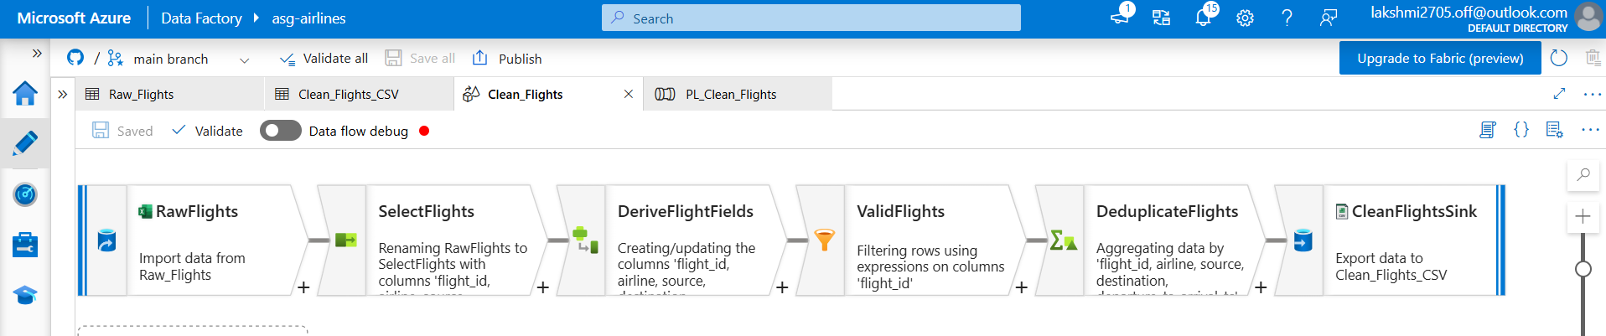
Data Cleaning and Transformation

Ingestion
The raw source file was stored in Azure Blob Storage. The flight data was ingested using the Raw_Flights Excel dataset.
The schema was imported from the source file before transformation to ensure that the required columns were correctly identified.
Transformation
Several transformations were performed inside the Azure Data Factory Mapping Data Flow.
Text columns such as flight_id, airline, source, and destination were standardized by trimming unnecessary spaces and converting values to uppercase. Ex: upper(trim(flight_id))
The original departure and arrival fields were converted into proper timestamp values.Similarly, the arrival timestamp was converted using the same timestamp format.
The following new fields were created:
- departure_ts
- arrival_ts
- duration_minutes
Flight Duration Calculation
Flight duration was calculated using the difference between the arrival timestamp and departure timestamp.
( toLong( toTimestamp(arrival_time,
"yyyy-MM-dd'T'HH:mm:ss.SSS'Z'")) –
toLong( toTimestamp(departure_time,
"yyyy-MM-dd'T'HH:mm:ss.SSS'Z'"))) / 60000

The timestamp difference is calculated in milliseconds and divided by 60000 to obtain the duration in minutes.
Validation
A validation step named ValidFlights was included in the Mapping Data Flow.
Records without a valid flight_id were filtered before loading them into the clean dataset.
!isNull(flight_id)
Timestamp conversion also ensured that departure and arrival values could be interpreted consistently before duration calculations were performed.

Duplicate Handling
Duplicate records were handled using an Aggregate transformation named:
DeduplicateFlights
Records were grouped using:
- flight_id
- airline
- source
- destination
- departure_ts
- arrival_ts
The calculated duration_minutes value was retained for the resulting record.
Aggregation
The transformed dataset was designed to support aggregations required for reporting, including:
- Average flight duration
- Number of flights by airline
- Number of flights by route
- Distinct routes
- Duration anomaly counts
These aggregations were primarily performed in Power BI using the cleaned analytical dataset.
Standardization
Text columns were standardized using:
trim()
upper()
This reduces inconsistencies caused by unnecessary spaces and differences in uppercase/lowercase formatting.
Missing Values
Records without a usable flight_id were filtered from the valid-flight stream.
Missing or unknown airline values were not artificially assigned to an existing airline because doing so could introduce inaccurate information.

Timestamp Standardization
Departure and arrival strings were converted into timestamp data types using an explicit timestamp pattern.
yyyy-MM-dd'T'HH:mm:ss.SSS'Z'
Duplicate Records
Potential duplicate flight records were grouped using the relevant identifying flight fields.
Duration Cleaning
The original duration column was not relied upon for analytics.
Instead:
duration_minutes = arrival timestamp - departure timestamp was calculated.
Error Handling and Logging
Azure Data Factory's built-in pipeline monitoring and execution status were used to validate successful pipeline execution.
Before execution, the pipeline was validated in Azure Data Factory.
The final pipeline: PL_Clean_Flights was executed successfully.
ADF monitoring can be used to identify failed pipeline activities, transformation errors, and execution issues. The pipeline execution status provides visibility into whether the data flow completed successfully.
For a larger production implementation, additional monitoring mechanisms such as Azure Monitor alerts and automated failure notifications could be added.

2. Dataset Documentation
Dataset Structure
The source flight dataset contains operational flight information.
The main fields are:
Field | Description
flight_id | Flight identifier
airline | Airline operating the flight
source | Departure location
destination | Arrival location
departure_time | Original flight departure timestamp
arrival_time | Original flight arrival timestamp
duration | Duration field available in the source

The source dataset contains intentional quality issues such as inconsistent values, missing information, timestamp issues, malformed identifiers, and overnight flights. These are exactly the kinds of preprocessing and transformation areas requested in the case study.
After transformation, the cleaned dataset contains additional analytical fields:
- departure_ts
- arrival_ts
- duration_minutes
In Power BI, two additional analytical fields were created:
- Route
- Duration Anomaly

3. PII Protection and Privacy
The source workbook contains passenger information that includes Personally Identifiable Information (PII). To protect this sensitive information, a separate Azure Data Factory Mapping Data Flow named Protect_Passenger_PII was implemented.
The passengers worksheet was ingested from the raw Azure Blob Storage layer using the PII_protection dataset. The passenger data was then passed through a Derived Column transformation named MaskPII, where sensitive attributes were masked before being written to the clean layer.
The following protection rules were implemented:
Passenger Field | Protection Applied
first_name | Replaced with REDACTED
last_name | Replaced with REDACTED
email | Replaced with REDACTED
phone | Replaced with XXXXXXXXXX
aadhaar_id | Replaced with XXXXXXXXXXXX
date_of_birth | Replaced with REDACTED
passenger_id | Retained
age | Retained
gender | Retained

After masking, the records pass through the SelectProtectedFields transformation and are written to the clean Azure Blob Storage layer using the Protected_Passengers_CSV sink dataset. The PII protection flow is:
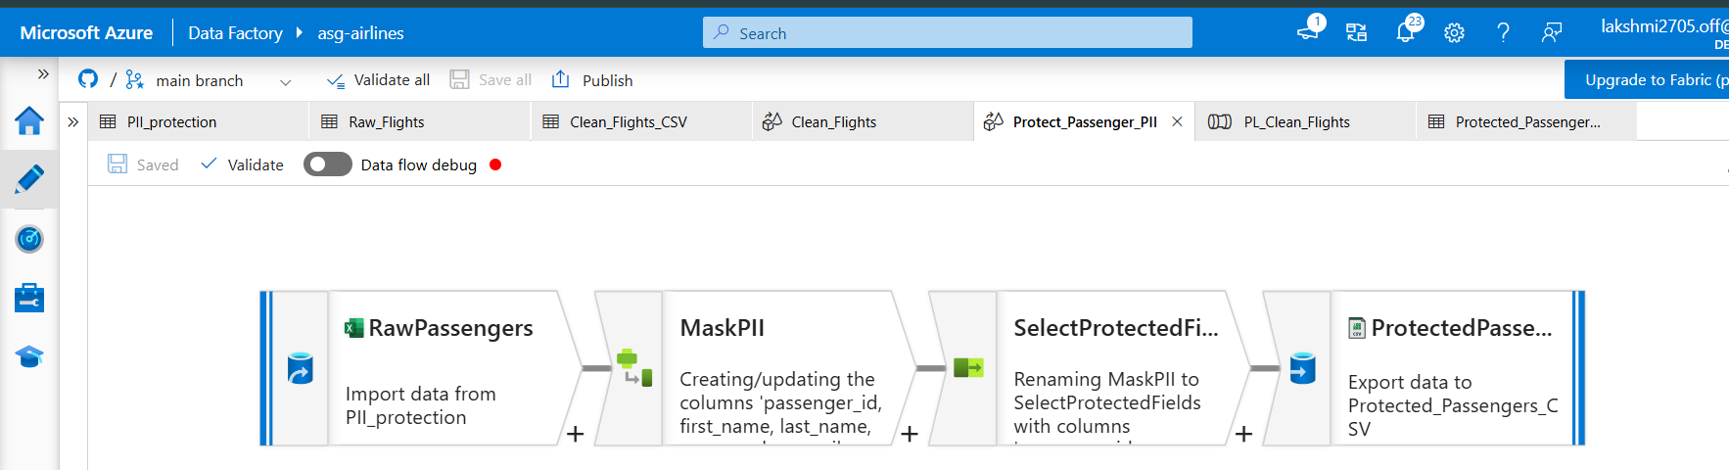
4. Dashboard and Reporting
Power BI Report
The cleaned dataset: clean_flights.csv was imported into Power BI Desktop.
An interactive dashboard named:
ASG Airlines – Flight Operations Analytics Dashboard
was created to analyze airline operational data.
KPI Cards
The dashboard contains the following KPI cards:
Total Flights
Shows the total number of flight records available in the cleaned dataset.
Average Flight Duration
Shows the average value of: duration_minutes across flight records.
Distinct Routes
Shows the number of unique source-to-destination routes.
Flights by Airline
A clustered column chart was created to show: Airline vs Count of Flights
This visualization helps compare operational flight volumes across airlines.
Route-wise Traffic
A clustered bar chart was created using: Route vs Count of Flights
This helps identify routes with the highest flight traffic.
Average Flight Duration by Airline
A column chart was created using: Airline vs Average duration_minutes
This allows comparison of average flight duration across airlines.
Duration Anomaly Analysis
Because scheduled and actual departure/arrival timestamps were not available separately, confirmed delays could not be calculated reliably.
Therefore, a duration-based anomaly metric was introduced.
The following Power BI calculated column was created:
Duration Anomaly =
IF(
clean_flights[duration_minutes] > 240,
"Long Duration",
"Normal"
)
Flights with durations exceeding 240 minutes are classified as: Long Duration
All remaining flights are classified as: Normal
A donut chart displays the distribution of normal and long-duration flights.
This is treated as an analytical anomaly indicator rather than a confirmed delay metric.
Interactive Filtering
An Airline slicer was added to the dashboard.
The slicer allows users to select individual airlines and dynamically update the dashboard visuals and KPI cards.
This makes the dashboard interactive and suitable for operational exploration.
The case study specifically requests KPI cards, filters/slicers, meaningful visualizations, and operational insights, so these dashboard elements directly address that requirement.
These visualizations make the cleaned flight data easier to interpret for operational decision-making.

