What is Naive Bayes algorithm?

It is a classification technique based on [Bayes’ Theorem](https://en.wikipedia.org/wiki/Bayes%27_theorem) with an assumption of independence among predictors. In simple terms, a Naive Bayes classifier assumes that the presence of a particular feature in a class is unrelated to the presence of any other feature. For example, a fruit may be considered to be an apple if it is red, round, and about 3 inches in diameter. Even if these features depend on each other or upon the existence of the other features, all of these properties independently contribute to the probability that this fruit is an apple and that is why it is known as ‘Naive’.

Naive Bayes model is easy to build and particularly useful for very large data sets. Along with simplicity, Naive Bayes is known to outperform even highly sophisticated classification methods.

Bayes theorem provides a way of calculating posterior probability P(c|x) from P(c), P(x) and P(x|c). Look at the equation below:

[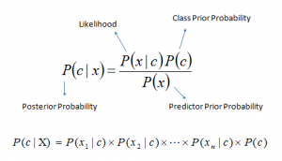](https://www.analyticsvidhya.com/wp-content/uploads/2015/09/Bayes_rule-300x172.png)Above,

* *P*(*c|x*) is the posterior probability of *class* (c, *target*) given *predictor* (x, *attributes*).
* *P*(*c*) is the prior probability of *class*.
* *P*(*x|c*) is the likelihood which is the probability of *predictor* given *class*.
* *P*(*x*) is the prior probability of *predictor*.

How Naive Bayes algorithm works?

Let’s understand it using an example. Below I have a training data set of weather and corresponding target variable ‘Play’ (suggesting possibilities of playing). Now, we need to classify whether players will play or not based on weather condition. Let’s follow the below steps to perform it.

Step 1: Convert the data set into a frequency table

Step 2: Create Likelihood table by finding the probabilities like Overcast probability = 0.29 and probability of playing is 0.64.

[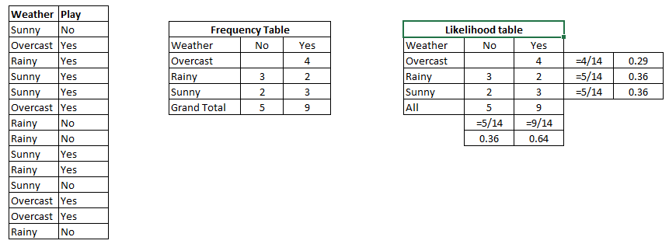](https://www.analyticsvidhya.com/wp-content/uploads/2015/08/Bayes_41.png)

Step 3: Now, use Naive Bayesian equation to calculate the posterior probability for each class. The class with the highest posterior probability is the outcome of prediction.

**Problem:**Players will play if weather is sunny. Is this statement is correct?

We can solve it using above discussed method of posterior probability.

P(Yes | Sunny) = P( Sunny | Yes) * P(Yes) / P (Sunny)

Here we have P (Sunny |Yes) = 3/9 = 0.33, P(Sunny) = 5/14 = 0.36, P( Yes)= 9/14 = 0.64

Now, P (Yes | Sunny) = 0.33 * 0.64 / 0.36 = 0.60, which has higher probability.

Naive Bayes uses a similar method to predict the probability of different class based on various attributes. This algorithm is mostly used in text classification and with problems having multiple classes.

What are the Pros and Cons of Naive Bayes?

***Pros:***

* It is easy and fast to predict class of test data set. It also perform well in multi class prediction
* When assumption of independence holds, a Naive Bayes classifier performs better compare to other models like logistic regression and you need less training data.
* It perform well in case of categorical input variables compared to numerical variable(s). For numerical variable, normal distribution is assumed (bell curve, which is a strong assumption).

***Cons:***

* If categorical variable has a category (in test data set), which was not observed in training data set, then model will assign a 0 (zero) probability and will be unable to make a prediction. This is often known as “Zero Frequency”. To solve this, we can use the smoothing technique. One of the simplest smoothing techniques is called Laplace estimation.
* On the other side naive Bayes is also known as a bad estimator, so the probability outputs from predict_proba are not to be taken too seriously.
* Another limitation of Naive Bayes is the assumption of independent predictors. In real life, it is almost impossible that we get a set of predictors which are completely independent.

4 Applications of Naive Bayes Algorithms

* **Real time Prediction:**Naive Bayes is an eager learning classifier and it is sure fast. Thus, it could be used for making predictions in real time.
* **Multi class Prediction:**This algorithm is also well known for multi class prediction feature. Here we can predict the probability of multiple classes of target variable.
* **Text classification/ Spam Filtering/ Sentiment Analysis:** Naive Bayes classifiers mostly used in text classification (due to better result in multi class problems and independence rule) have higher success rate as compared to other algorithms. As a result, it is widely used in Spam filtering (identify spam e-mail) and Sentiment Analysis (in social media analysis, to identify positive and negative customer sentiments)
* **Recommendation System:**Naive Bayes Classifier and [Collaborative Filtering](https://en.wikipedia.org/wiki/Collaborative_filtering) together builds a Recommendation System that uses machine learning and data mining techniques to filter unseen information and predict whether a user would like a given resource or not

How to build a basic model using Naive Bayes in Python?

Again, scikit learn (python library) will help here to build a Naive Bayes model in Python. There are three types of Naive Bayes model under scikit learn library:

* [**Gaussian:**](http://scikit-learn.org/stable/modules/naive_bayes.html)It is used in classification and it assumes that features follow a normal distribution.
* [**Multinomial**](http://scikit-learn.org/stable/modules/naive_bayes.html)**:**It is used for discrete counts. For example, let’s say,  we have a text classification problem. Here we can consider bernoulli trials which is one step further and instead of “word occurring in the document”, we have “count how often word occurs in the document”, you can think of it as “number of times outcome number x_i is observed over the n trials”.
* [**Bernoulli**](http://scikit-learn.org/stable/modules/naive_bayes.html)**:**The binomial model is useful if your feature vectors are binary (i.e. zeros and ones). One application would be text classification with ‘bag of words’ model where the 1s & 0s are “word occurs in the document” and “word does not occur in the document” respectively.

Based on your data set, you can choose any of above discussed model. Below is the example of Gaussian model.