Fraudulent_Claim_Detection
Authors: Lakshimi Sagar SP, Karthik R L, Anish Khosla
Date: 08th April 2025
Summary
This document includes the overall approach, covering details about the problem statement, methodology, techniques, visualisations, insights, and actionable outcomes.
Model Comparison
- Logistic Regression Model Matrix
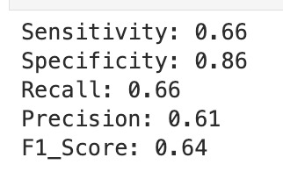
- Random Forest Model Matrix
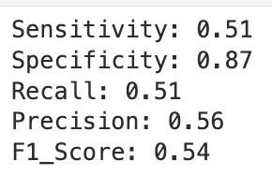
Important Results
- The Logistic Regression model performed better than the Radom Forest model.
- Model selection methods helped in selecting the better model.
- Shorter tenures often correlate with higher fraud risk.
- Policy Deductible, Policy Annual Premium, Umbrella Limit: Certain coverage or cost thresholds seem to attract more fraud.
- Total Claim Amount, Vehicle Claim, Injury Claim, Property Claim: Fraudsters frequently inflate or bundle extra costs into claims.
- Some age groups appear to file suspiciously high or frequent claims.

Recommendations
Shorter tenures often correlate with higher fraud risk. Hence, the longer tenure should be preferred and have extra vigilance during shorter tenure claims.
Policy Deductible, Policy Annual Premium, Umbrella Limit: Certain coverage or cost thresholds seem to attract more fraud. Hence these should be taken into consideration while setting the claims.

