**1. student grading**

import java.util.Scanner;

public class StudentGradingSystem {

public static char calculateGrade(double average) {

if (average >= 90) {

return 'A';

} else if (average >= 80) {

return 'B';

} else if (average >= 70) {

return 'C';

} else if (average >= 60) {

return 'D';

} else {

return 'F';

}

}

public static void main(String[] args) {

Scanner scanner = new Scanner(System.in);

System.out.print("Enter the average score: ");

double averageScore = scanner.nextDouble();

char grade = calculateGrade(averageScore);

System.out.println("The grade is: " + grade);

scanner.close();

}

}

Output:-

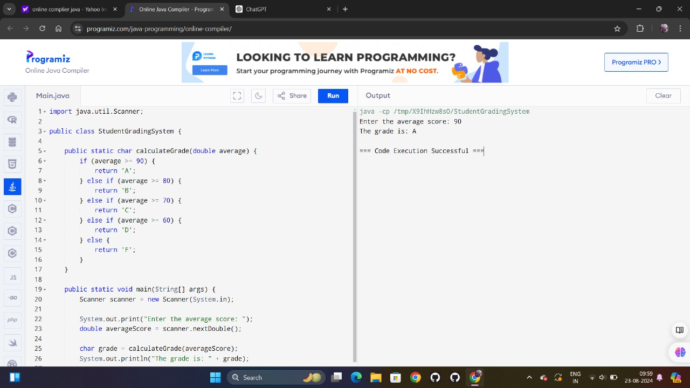

**2.numberguessinggame**

import java.util.Random;

import java.util.Scanner;

public class NumberGuessingGame {

public static void main(String[] args) {

Scanner scanner = new Scanner(System.in);

Random random = new Random();

int numberToGuess = random.nextInt(100) + 1; // Random number between 1 and 100

int numberOfTries = 0;

int guess;

boolean hasGuessedCorrectly = false;

System.out.println("Welcome to the Number Guessing Game!");

System.out.println("I have selected a number between 1 and 100.");

System.out.println("Can you guess what it is?");

while (!hasGuessedCorrectly) {

System.out.print("Enter your guess: ");

guess = scanner.nextInt();

numberOfTries++;

if (guess < numberToGuess) {

System.out.println("Too low! Try again.");

} else if (guess > numberToGuess) {

System.out.println("Too high! Try again.");

} else {

hasGuessedCorrectly = true;

System.out.println("Congratulations! You've guessed the number.");

System.out.println("It took you " + numberOfTries + " tries.");

}

}

scanner.close();

}

}

Output:-

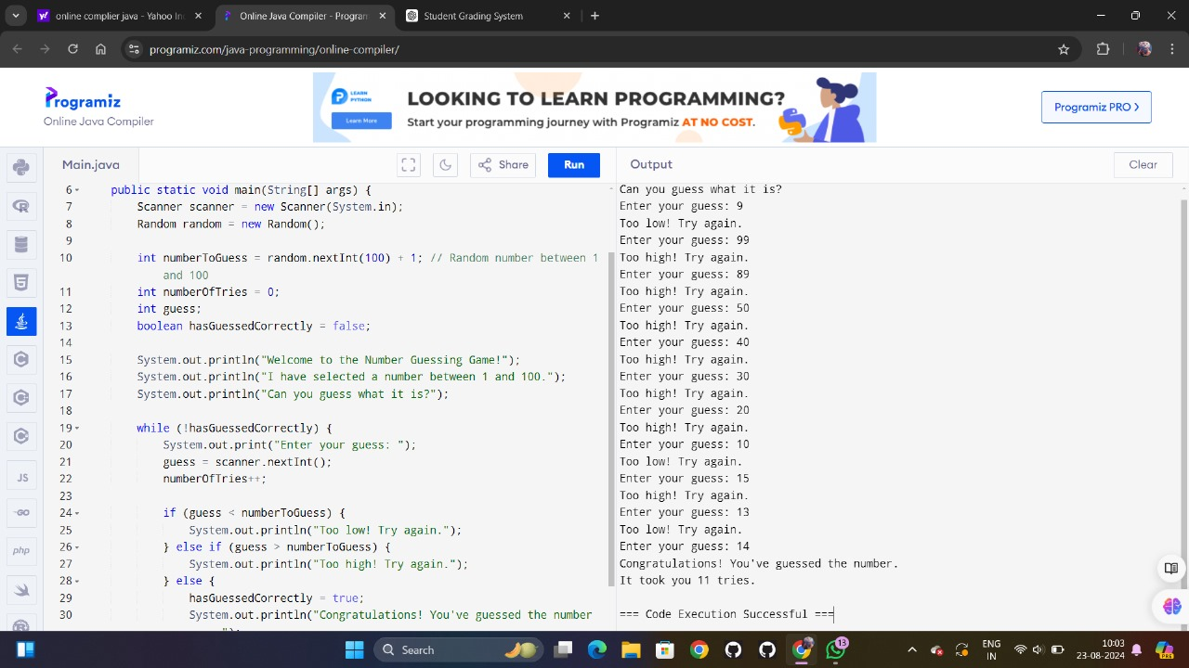

**3.multiplication table**

import java.util.Scanner;

public class MultiplicationTable {

public static void main(String[] args) {

Scanner scanner = new Scanner(System.in);

System.out.print("Enter the number for which you want the multiplication table: ");

int number = scanner.nextInt();

System.out.println("Multiplication Table for " + number + ":");

for (int i = 1; i <= 10; i++) {

System.out.println(number + " x " + i + " = " + (number * i));

}

scanner.close();

}

}

Output:-

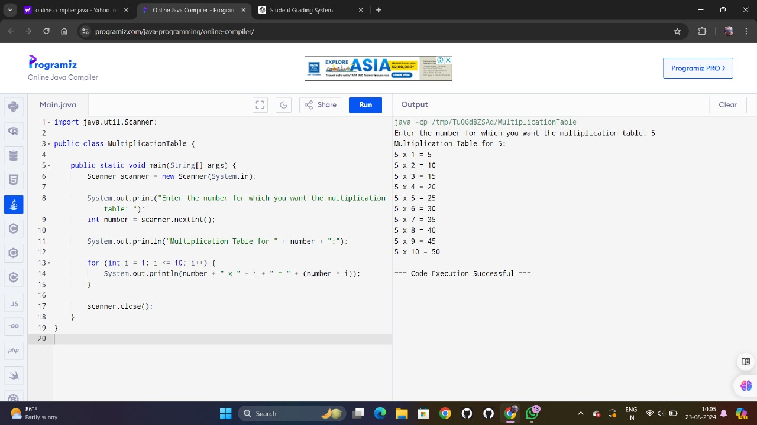

**4.odd or even**

import java.util.Scanner;

public class EvenOrOdd {

public static void main(String[] args) {

Scanner scanner = new Scanner(System.in);

System.out.print("Enter a number: ");

int number = scanner.nextInt();

if (number % 2 == 0) {

System.out.println(number + " is even.");

} else {

System.out.println(number + " is odd.");

}

scanner.close();

}

}

Output:-

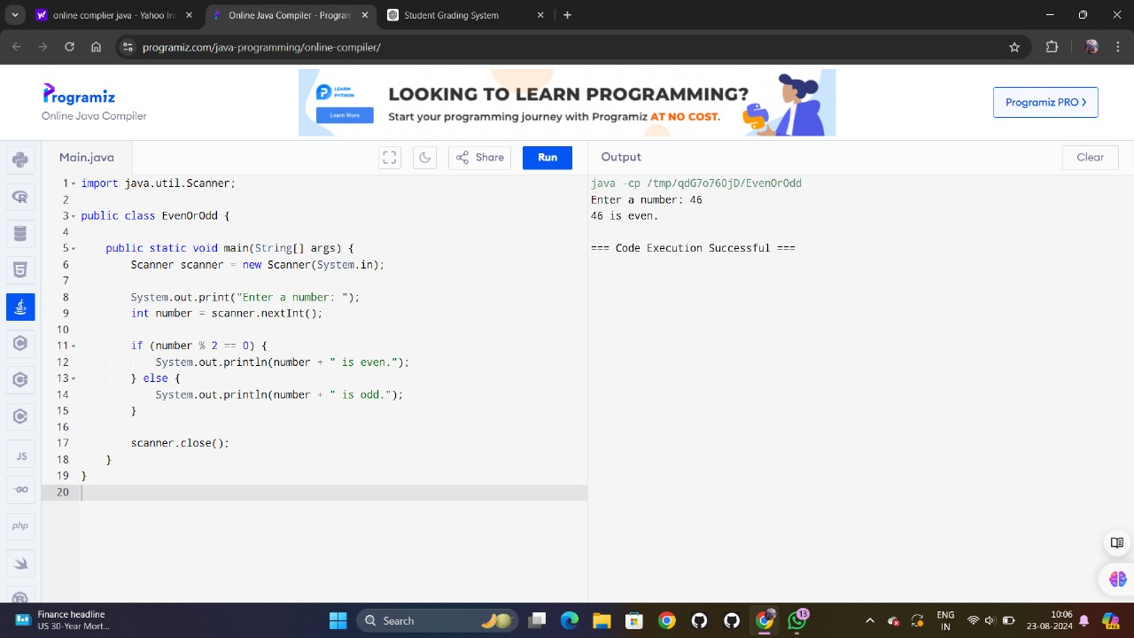

**5.atm stimulator**

import java.util.Scanner;

public class ATMSimulation {

public static void main(String[] args) {

Scanner scanner = new Scanner(System.in);

int balance = 1000; // Initial balance

int choice;

System.out.println("Welcome to the ATM!");

do {

System.out.println("\nATM Menu:");

System.out.println("1. Check Balance");

System.out.println("2. Deposit Money");

System.out.println("3. Withdraw Money");

System.out.println("4. Exit");

System.out.print("Enter your choice: ");

choice = scanner.nextInt();

switch (choice) {

case 1:

System.out.println("Your current balance is: $" + balance);

break;

case 2:

System.out.print("Enter the amount to deposit: $");

int depositAmount = scanner.nextInt();

if (depositAmount > 0) {

balance += depositAmount;

System.out.println("You've successfully deposited $" + depositAmount);

System.out.println("Your new balance is: $" + balance);

} else {

System.out.println("Invalid deposit amount.");

}

break;

case 3:

System.out.print("Enter the amount to withdraw: $");

int withdrawAmount = scanner.nextInt();

if (withdrawAmount > 0 && withdrawAmount <= balance) {

balance -= withdrawAmount;

System.out.println("You've successfully withdrawn $" + withdrawAmount);

System.out.println("Your new balance is: $" + balance);

} else if (withdrawAmount > balance) {

System.out.println("Insufficient balance.");

} else {

System.out.println("Invalid withdrawal amount.");

}

break;

case 4:

System.out.println("Thank you for using the ATM. Goodbye!");

break;

default:

System.out.println("Invalid choice. Please select a valid option.");

}

} while (choice != 4);

scanner.close();

}

}

Output:-

