CSS 534 PARALLEL PROGRAMMING IN GRID AND CLOUD

**PROGRAM 5**

Geofencing Wolf Habitats

Using Convex Hulls for Conservation

horizontal line

# 

Yellowstone National Park is renowned for its thriving wolf population, a keystone species critical to maintaining the ecological balance of the region. However, ensuring the safety of both wolves and park visitors requires an optimized approach to habitat protection. Our project addresses this challenge by employing computational geometry and geospatial data analysis to design an efficient fencing solution that minimizes fencing length while enclosing the wolf habitat effectively. The project leverages a large dataset of wolf sightings to compute a boundary that balances ecological needs and human safety.

### Objective

The primary goal of this project is to compute the **minimum enclosing boundary** for wolf habitats within Yellowstone National Park. By using geospatial data, the solution determines the shortest possible fence length that encloses the wolf sightings. This boundary optimization reduces costs, preserves wildlife integrity, and ensures public safety by minimizing potential interactions between wolves and park visitors.

### Methodology

The project employs a combination of computational geometry and geospatial analysis techniques:

1. **Convex Hull Algorithm**:
   * We implement the **Monotone Chain algorithm**, an O(nlog⁡n) computational geometry technique, to calculate the convex hull of the wolf sighting data. The convex hull represents the smallest convex polygon that can enclose all data points, defining the boundary of the habitat.
2. **Geospatial Calculations**:
   * Using the **Haversine formula**, we calculate the real-world distances between latitude and longitude points, converting geospatial data into an accurate 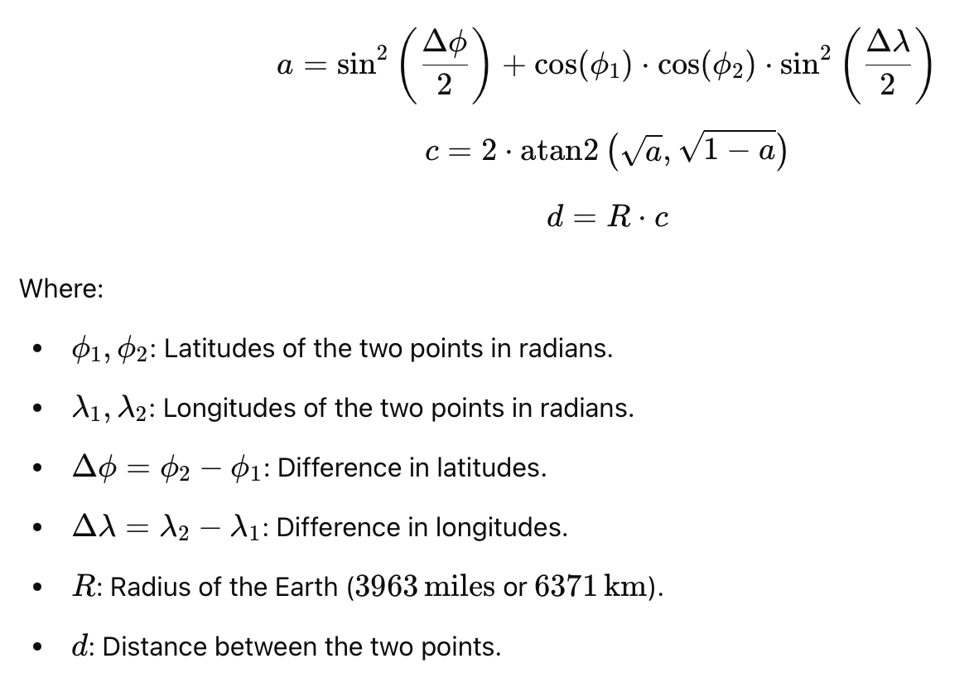fence length in miles. This accounts for Earth's curvature, ensuring precision.
3. **Data Processing Pipeline**:
   * The dataset, consisting of thousands of wolf sightings, is processed to compute:
     + The coordinates of points forming the convex hull.
     + The total fence length required to enclose the habitat.
4. **Visualization**:
   * A geospatial map overlay visually demonstrates the transformation from raw wolf sighting data to the computed convex hull boundary, providing an intuitive understanding of the results.

### Impact

This project bridges the gap between computational geometry and wildlife conservation, offering a scalable and efficient solution for geofencing wolf habitats in Yellowstone National Park. By minimizing fence length while maximizing habitat protection, the solution ensures:

* **Public Safety**: Reducing human-wolf interactions within the park.
* **Ecological Balance**: Preserving the integrity of wolf habitats with minimal disruption.
* **Cost Optimization**: Providing a data-driven method to design cost-effective fencing solutions.

The approach is adaptable, with potential applications in geospatial management for other wildlife species and regions, making it a valuable tool for conservation efforts globally.