Installing the chrome web driver go to pypi website t
Beautiful soup:
pip install BeautifulSoup4
import requests
from bs4 import BeautifulSoup
I will use Python,Requests, and BeautifulSoup to scrap some pages from Wikipedia.
To scrap and extract any information from the internet, you’ll probably need to go through three stages: Fetching HTML, Obtaining HTML Tree, then Extracting information from the tree.
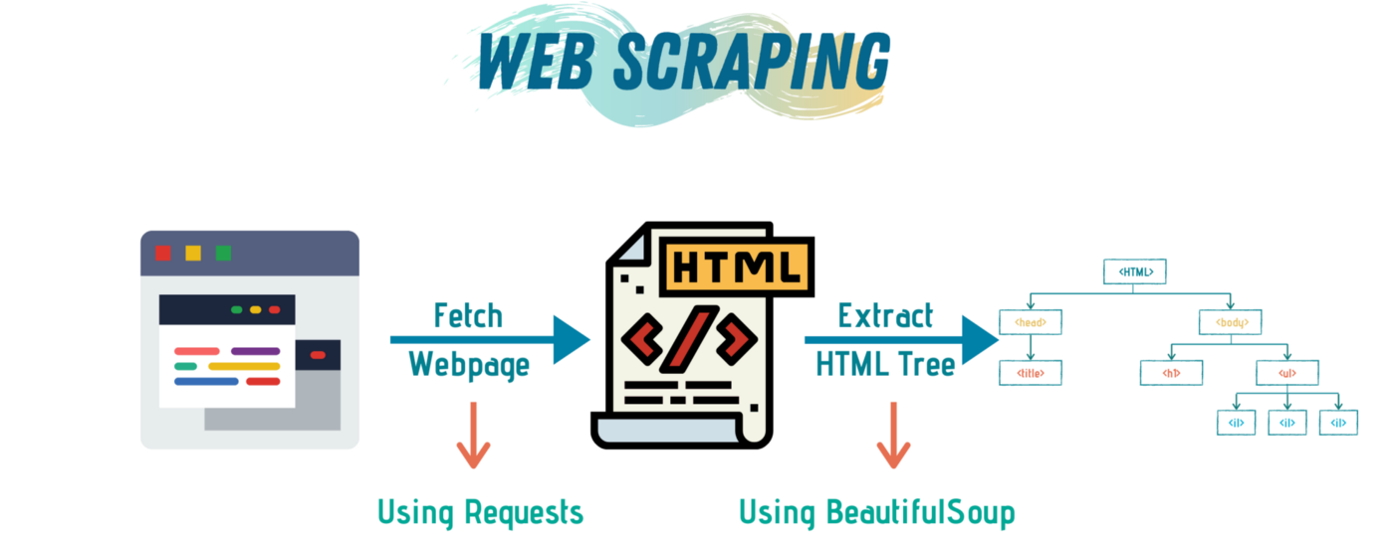

We will use the Requests library to fetch the HTML code from a specific URL. Then, we will use BeautifulSoup to Parse and Extract the HTML tree, and finally, we will use pure Python to organize the data.
Before we get scraping, let’s revise HTML basics quickly. Everything in HTML is defined within tags. The most important tag is <HTML> which means that the text to follow is HTML code.
In HTML, each opened tag must be closed. So, at the end of the HTML file, we need a closure tag </HTML>.
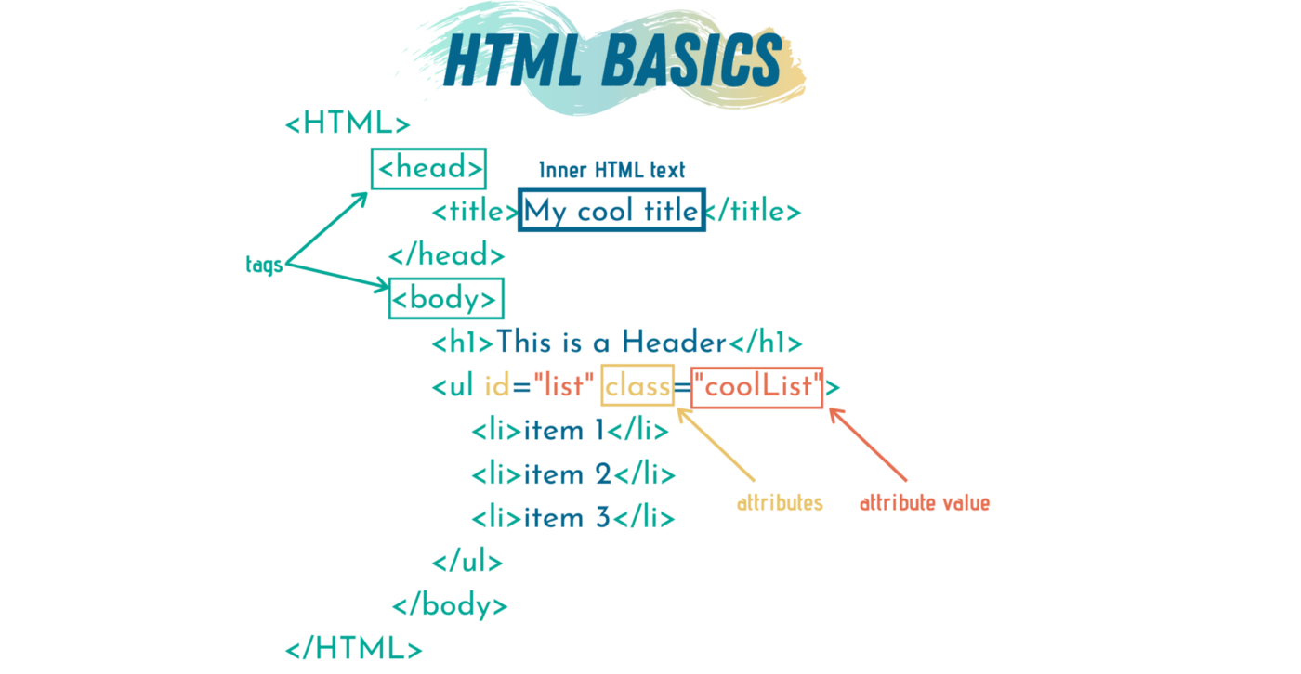

Different tags in HTML means different things. Using a combination of tags, a webpage is represented. Any text enclosed between an open and close tag is called inner HTML text.
If we have multiple elements with the same tag, we might — actually, always — want to differentiate between them somehow. There are two ways to do that, either through using classes or ids. Ids are unique, which means we can’t have two elements with the same id. Classes, on the other hand, are not. More than one element can have the same class.
Here are 10 HTML tags you will see a lot when scraping the web.
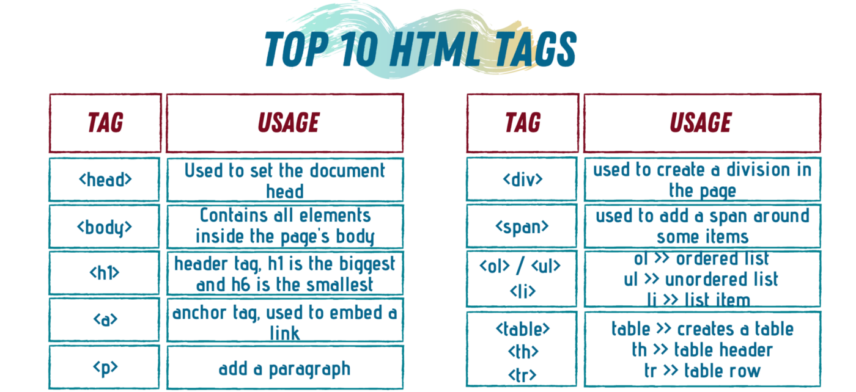

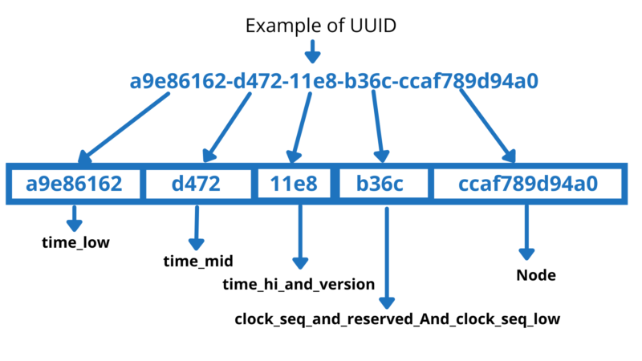
UUID
What?
UUID stands for Universally Unique Identifier. Sometimes is also call it a GUID( globally Unique Identifier). Python UUID module is used to generate a random object of 128 bits. This library generates unique IDs based on the system time and the network address of the computer. The UUID object is immutable and it contains some functions to create various unique IDs.

Pip install uuid4
syntax:
uuid.uuid4()
print(uuid.uuid4())

To create an mkdir:
Method #1:
path = '/home/lakshmi/Documents/DS/Selenium/Lego/raw_data'
os.mkdir(path)

Method #2:
os.mkdir(os.path.join(os.getcwd(),bot.selected_theme))

.Json error message:
Error Messgae #1:
dump() missing 1 required positional argument: 'fp'

corrected by adding dumps instead of dump
with open('data.json', 'w') as f:
f.write(json.dumps(Lego_dict))

Error #2
Object of type UUID is not JSON serializable

corrected by: defining class MyEncoder
from json import JSONEncoder, dumps

from json import JSONEncoder
class MyEncoder(JSONEncoder):
def default(self, o):
self.o = o
return o.__dict__
but still throwing error# 3
Error#3:
TypeError: encode() missing 1 required positional argument: 'o'

Zoya gave this script
“
JSONEncoder_olddefault = JSONEncoder.default
def JSONEncoder_newdefault(self, o):
if isinstance(o, uuid): return str(o)
return JSONEncoder_olddefault(self, o)
JSONEncoder.default = JSONEncoder_newdefault

“ but still not working.
Anwers:

import json
from uuid import UUID

class UUIDEncoder(json.JSONEncoder):
def default(self, obj):
if isinstance(obj, UUID):
# if the obj is uuid, we simply return the value of uuid
return obj.hex
return json.JSONEncoder.default(self, obj)

//*[@id="main-content"]/div/div[1]/div/div[1]/div[1]/div/div/div/div[2]/div/div/div/ol/li[2]/button
//*[@id="main-content"]/div/div[1]/div/div[1]/div[1]/div/div/div/div[2]/div/div/div/ol/li[2]/button/img
//*[@id="main-content"]/div/div[1]/div/div[1]/div[1]/div/div/div/div[2]/div/div/div/ol/li[3]/button/img

TypeError: 'builtin_function_or_method' object is not subscriptable

The “TypeError: 'builtin_function_or_method' object is not subscriptable” error is raised when you try to use square brackets to call a function. This error is raised because Python interprets square brackets as a way of accessing items from an iterable object. Functions must be called using parenthesis.

/html/body/div[1]/main/div/div[1]/div/div[1]/div[1]/div/div/div/div[2]/div/div/div/ol/li[2]/button

