**Assignment 2**

**Part A**

Milestone1:

Milestone 2:

Milestone 3:

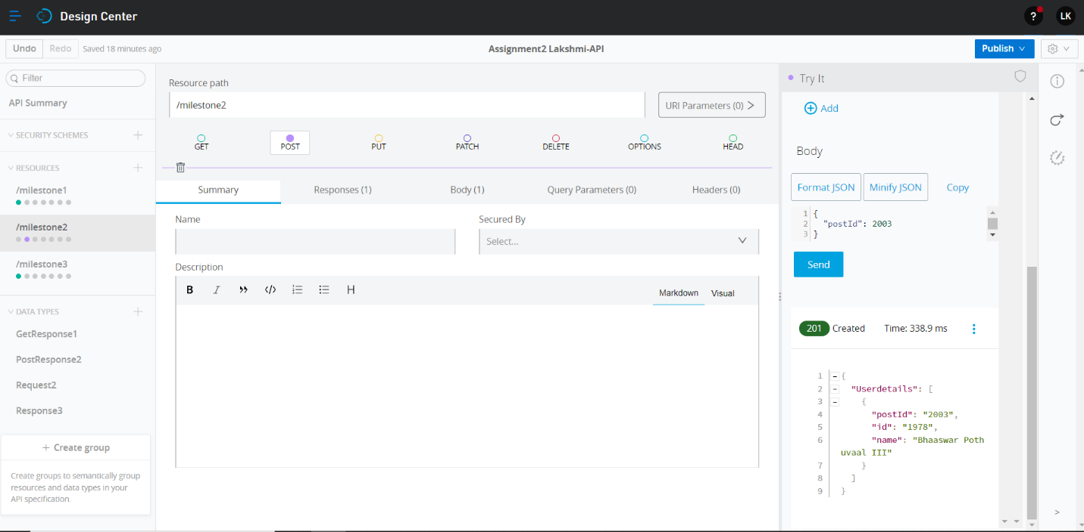

Milestone 4:

**Part B**

Milestone 1: 3 requests made

Milestone 2:

Milestone 3:

Milestone 4: milestone 6 included

Milestone 5:

Milestone 6 included