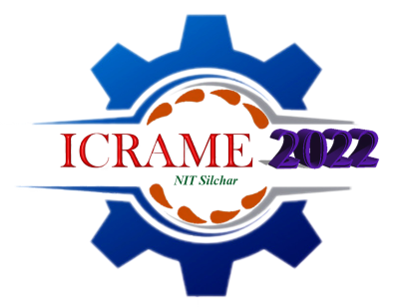International Conference on Recent Advancement of Mechanical Engineering (ICRAME-2022)

04-06 February 2022

**Registration form**

|  |  |  |  |  |  |  |  |  |  |
| --- | --- | --- | --- | --- | --- | --- | --- | --- | --- |
| *First Name: | | | *Family Name: | | | | | | |
| *Title: (Prof., Dr, Mr. Ms. etc.) | | | | | Male □ Female □ | | | | |
| Category: Student Faculty/Academician Industry | | | | | | | | | |
| * Participant’s Affiliation(Organization or University): | | | | | | | | | PHOTO (*Please paste recent colour Photo here) |
| *Mailing Address: | | | | | | | | | |
| *City: | | | | | *State/Province: | | | | |
| *Country: | | | | | *ZIP/Post Code: | | | | |
| *Tel.: | | *E-mail: | | | | | Fax: | | |
| *Paper ID Code |  | | | | | | | | |
| *Paper Title |  | | | | | | | | |
| *Paper Author (s)  (List as the same order in the final paper) |  | | | | | | | | |
| *Paper Pages: | | | | | | Additional Page: | | | |
| *Transaction Details | | | | | | | | | |
| *Amount | Registration Fee :-  Additional page Fee- | | | | | | | | |
| *Transaction Reference No |  | | | *Date | | | |  | |
| *Signature of the Participant |  | | | | | | | | |

**\* Compulsory items.**